**QUẢN LÝ DỰ ÁN PHẦN MỀM**







| **Project name:** | **The Tool For Content Management** |
| --- | --- |
| 21127065 | Trần Bình Kha |
| 21127333 | Nguyễn Việt Kim |
| 21127334 | Lê Vũ Ngân Lam |
| 21127337 | Trần Tùng Lâm |
| 21127466 | Hoàng Anh Tú |
| 21127505 | Ngô Xuân Hiếu |
| 21127545 | Đặng Quốc Thái |
| 21127597 | Đỗ Dự Đức |
| 21127150 | Nguyễn Hoàng Nhật Quang |

C:\Users\tdqua_000\Dropbox\SS-Slides\DeCuong-CDIO\Template CDIO v4.2\Templates\Hinh anh\LogoTruong.png

**TABLE OF CONTENTS**

[**I. Architecture 3**](#_dax6hyu6nanj)

[**II. Detailed 3**](#_g2xlj3uy7i5x)

[1. Front-End: Next.js Application 3](#_phduyinr3ka)

[1.1. Web Browser 3](#_ncsy3yj0t9ha)

[1.2. Next.js App 3](#_txaxtfuk6qbk)

[1.3. Clerk Auth 3](#_7nwwahxfkap3)

[2. API Gateway 3](#_bgz5df7azjf1)

[3. Back-End Services 3](#_xogsr3kzkg2t)

[3.1. Content Writer 3](#_5g6qqtm2sf1m)

[3.2. Images and Videos 3](#_vd5yxrrr4exy)

[3.3. Social Networks 4](#_mi9f4dmjxal5)

[4. External Integrations 4](#_i0gkb5peqeqf)

[4.1. OpenAI 4](#_58stwgrmxbv5)

[4.2. NeonDB 4](#_iia8f6r6xg96)

[4.3. DrizzleORM 4](#_1ybdoqimfyvp)

[4.4. Uploadthing Cloud 4](#_3tg9q84l4o8k)

[4.5. Clerk Authentication 4](#_lx07dz9sv3lu)

[5. Workflow Summary 4](#_60ptnxqrns9e)

[**III. Deployment 4**](#_2kpctqik8mw7)

[1. Front-end deployment with Vercel 5](#_wdck1ys3x4ec)

[2. Database deployment with NeonDB 5](#_jyx9hm6ejw7u)

[3. Media storage deployment with Uploadthing cloud 5](#_heg8s47dy6yu)

[4. Environment with external API services 5](#_hqgbnb9fhhsx)

# Architecture

**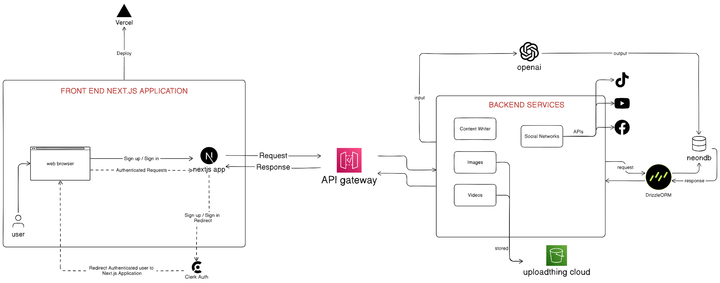**

Figure 1: TFCM Architecture diagram

# Detailed

### 1. Front-End: Next.js Application

#### 1.1. Web Browser

* Users interact with the application through a web browser. They can sign up, sign in, and make authenticated requests to the Next.js app.

#### 1.2. Next.js App

* The front-end application is built with Next.js, a React framework, and is deployed using Vercel.
* The app handles user authentication via Clerk Auth.
* It processes sign-up and sign-in requests and, once authenticated, redirects the user to the appropriate pages within the application.
* Authenticated requests from the web browser are sent to the Next.js app, which then communicates with the API gateway for further processing.

#### 1.3. Clerk Auth

* Clerk Auth is used for handling authentication. It manages the sign-up and sign-in process, and redirects authenticated users back to the Next.js application.

### 2. API Gateway

* The API gateway acts as an intermediary that processes requests from the Next.js app and routes them to the appropriate back-end services. It also handles the responses from these services and sends them back to the Next.js app.

### 3. Back-End Services

#### 3.1. Content Writer

* This service likely generates or manages content for the application. It may interact with external APIs, such as OpenAI, to create or manipulate content.

#### 3.2. Images and Videos

* These services handle image and video processing, respectively. They store processed media in the "uploadthing cloud".

#### 3.3. Social Networks

* This component integrates with social media platforms like TikTok, YouTube, and Facebook. It uses APIs to interact with these platforms, possibly for sharing content or retrieving social media data.

### 4. External Integrations

#### 4.1. OpenAI

* The application integrates with OpenAI to process input and generate outputs, possibly for content creation or other AI-driven features.
* OpenAI: <https://openai.com>

#### 4.2. NeonDB

* NeonDB is the database used to store application data. It communicates with the back-end services through DrizzleORM, a type of Object-Relational Mapping (ORM) framework.
* NeonDB: <https://neon.tech>

#### 4.3. DrizzleORM

* DrizzleORM facilitates the interaction between the back-end services and NeonDB, managing database queries and responses.
* DrizzleORM: <https://orm.drizzle.team>

#### 4.4. Uploadthing Cloud

* This service is used to store media files like images and videos processed by the back-end services.
* Uploadthing: <https://uploadthing.com>

#### 4.5. Clerk Authentication

* Clerk is a complete suite of embeddable UIs, flexible APIs, and admin dashboards to authenticate and manage your users.
* Clerk: <https://clerk.com>

### 5. Workflow Summary

* A user accesses the application via a web browser.
* They sign up or sign in through the Next.js app, which uses Clerk Auth for authentication.
* Upon successful authentication, the user is redirected to the application’s authenticated section.
* The Next.js app sends requests to the API gateway, which routes them to the appropriate back-end services.
* The back-end services perform necessary operations, which may include interacting with OpenAI, processing media files, or communicating with social networks.
* Data is stored in NeonDB, managed by DrizzleORM.
* Processed media is stored in the Uploadthing cloud.
* The responses are sent back through the API gateway to the Next.js app, which then updates the web browser for the user.

This architecture efficiently separates the front-end from the back-end services, uses modern frameworks and tools for scalability, and integrates robust external services for enhanced functionality.

# Deployment

The deployment aspect of this architecture involves the use of several platforms and services to ensure the application is efficiently deployed, managed, and scalable. Here’s a detailed look at the deployment setup:

### 1. Front-end deployment with Vercel

* The Next.js application, which forms the front-end of this architecture, is deployed on Vercel.
* Vercel provides a seamless integration with Next.js, allowing for automatic deployments from repositories like GitHub, GitLab, or Bitbucket.
* Each time code is pushed to the repository, Vercel automatically builds and deploys the latest version of the application.
* Vercel handles tasks such as server-side rendering (SSR), static site generation (SSG), and serverless functions, providing a scalable and performant environment for the Next.js app.
* The deployment process includes setting environment variables, building the application, and ensuring zero-downtime deployments by leveraging Vercel's infrastructure.

### 2. Database deployment with NeonDB

* NeonDB, the database service, is deployed in a cloud environment optimized for high performance and availability.
* The database deployment includes setting up automated backups, scaling configurations, and security measures such as encryption and access controls.
* DrizzleORM facilitates database interactions, ensuring that the back-end services can efficiently perform CRUD operations.

### 3. Media storage deployment with Uploadthing cloud

* The Uploadthing cloud service is used to store images and videos processed by the back-end services.
* This service can be deployed on object storage solutions like Amazon S3, Google Cloud Storage, or Azure Blob Storage.
* Deployment involves configuring the storage buckets, setting up access policies, and integrating with the back-end services for seamless media uploads and retrievals.

### 4. Environment with external API services

* The integration with external services like OpenAI and social media platforms (TikTok, YouTube, Facebook) involves deploying API clients and handling authentication.
* These integrations are configured during the deployment process to ensure secure and efficient communication with the external services.