Introduction: The influence of temperature on host-parasite dynamics is complex but vital to understand to make predictions about the severity of disease outbreaks with climate change. For part of my undergraduate thesis, I investigated how mean temperature and the frequency and duration of heatwave cycles altered host survival when exposed to a parasite. I carried out a 6-week experiment in which the host was exposed to various treatments. Hosts experienced one of two different mean temperatures, 9 different heatwave durations and were either exposed to a parasite or used as controls. In total, 432 hosts were used in the experiment, with 12 replicates per specific treatment.
The study system used was Pasteuria ramosa, a bacterial, castrating parasite and its host, Daphnia magna, a small planktonic crustacean that lives in freshwater ecosystems and typically reproduces asexually (Ebert and Ebert, 2005). For this assignment, I aimed to make a that would accurately predict whether the host survived. The factors used to make the prediction were the mean temperature of the treatment, heatwave duration, parasite exposure and the production rate of offspring production by the host.

Methods: A correlation matrix and VIF (Variance Inflation Factor) test were carried out to ensure that none of the factors being used were highly correlated with one another. A Logistic Regression Model was then used to predict whether Daphnia individuals would survive the experiment based on the predictor variables. Label encoding was carried out in order to assign integer values to categorical variables so that they could be interpreted by the model (e.g. 6-day heatwave treatments = 2). Then X and y values were assigned, and the data was split into the training (80% of the data) and testing (20%) sets before being scaled to avoid factors with a larger numerical spread (e.g. reproductive rate) from dominating the model. The model’s performance was then assessed by analysing performance metrics and by using a confusion matrix and ROC curve. Finally, Youden’s J optimal threshold was calculated to obtain the prediction probability of survival that renders the model most accurate the (yields the highest amount of true positive results compared to false negatives).

Results: In the correlation matrix, none of the factors were highly correlated with one another other than the reproductive rate of the Daphnia and whether they were exposed to P. ramosa, which scored a correlation coefficient of -0.79 and could be problematic. However, in the VIF test, none of the factors had a VIF score of more than ~2.7, indicating that there is no significant variance inflation of any coefficients due to correlation with other factors. Unlike a correlation matrix, a VIF how much the variance of a regression coefficient is inflated due to linear dependence with all predictor variables, which is more relevant than pairwise comparisons for a regression model.
However, the parasite used in the experiment is a castrating parasite and therefore, it is not surprising that exposure status is highly correlated with reproductive rate. Furthermore, parasite exposure would be biologically upstream of reproductive rate which is a more proximal predictor of survival. Cross-validation revealed that when exposure status was removed from the model, the mean accuracy and standard deviations improved from 0.7391 ± 0.0420 to 0.7681 ± 0.0205 rendering the model more accurate and robust.
Hence, the final model only used treatment, mean temperature and reproductive rate to predict survival. The model’s performance was visualised using a confusion matrix and ROC curve (see figure 1). Youden’s J statistic was also calculated to interpret how the model’s performance could be maximised. A threshold of 0.536 would maximise the model’s ability to distinguish survivor hosts from dead ones. This means that accuracy would be highest when individuals are only classed as alive if the model assigns a 53.6% chance of survival rather than the default 50% chance. At this classification threshold, the rate of true survivors detected would be 81.5% while false survivors would only be predicted 18.2% of the time, resulting in a J-value of 0.633.

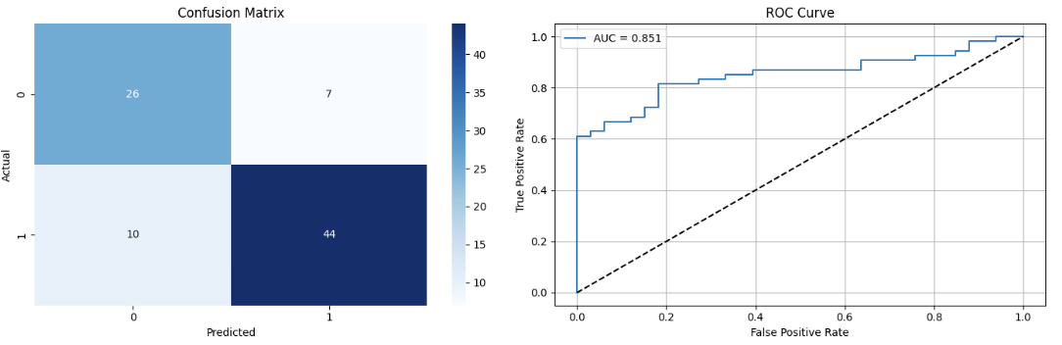
Figure 1: the confusion matrix on the left shows the number of true positives (bottom right) and negatives (top left) correctly predicted as well as false positives (top right) and false negatives (bottom left). Positives (or survivals) are indicated with a 1 and negatives (or deaths) are labelled with a 0. The ROC Curve (blue line) on the right shows the rate of true positives compared to false positives as the rate of false positives increases as compared with a model which randomly predicts host survival (dotted line).

Summary: Using three of the four available predictor variables resulted in an accurate model that could correctly predict whether Daphnia hosts would survive the experiment ~77% of the time. However, this still leaves room for improvement. Part of the issue is likely the small dataset since there only 432 individuals used in this experiment. However, other factors such as genetic variability could have a role to play in the host’s likelihood of survival. Future studies should aim to run experiments like this using temperature variations from past real-world heatwave events to test if host survival can still be reliably foretold. If these types of models can accurately predict the mortality rate of disease outbreaks according to temperature for various animal species, they could then play a major role in ecological conservation by being able to predict how vulnerable animal populations are to disease outbreak from forecasted heatwave events.

References:
Ebert, D. and Ebert, D., 2005. Ecology, Epidemiology, and Evolution of Parasitism in Daphnia. National Center for Biotechnology Information (US).

