UNIVERSITY OF HERTFORDSHIRE
School of Computer Science

Computer Science Specialist Project
BSc Honours Computer Science

Final Project Report
May 2013

“Design and implementation of a secured chat application”

Loudovikos Geromitsos

Supervisor’s name: H. Georgiou

Abstract

In the '90s the use of the Internet saw a great rise amongst home computers. Since then, the users have been introduced to several communication tools which enabled them to interact over the Internet with one or more people from all over the world at the same time.
This project looks into such a tool that enables people to chat at a massive scale. Codenamed “Java Chat”, it comes with two programs, a server and a client, and it utilizes a famous Internet protocol for text messaging called IRC (Internet Relay Chat), enhanced with extra functionality to allow users to securely chat with other users over a network.
The server program, called “Java Internet Relay Chat daemon” (Java IRCd), is compatible with every chat client that follows the IRC specification (i.e. every IRC Client). However, it is intended to be used with the actual chat program developed through this project called “Java Chat Client” which makes use of its own encryption system in order to securely exchange messages with other users of “Java Chat Client”.
This project was a very educational and fun experience, as it provided the opportunity to enhance and refine my Java programming knowledge and skills as well as revive old chatting memories of a beloved Internet protocol.
Prologue

In this book’s chapters, we will begin with an introduction to the project and its main objecting and analyse the final time plan.

Then we will proceed onto the analysis and design of the software and then onto the implementation.

Finally, the entire project will be evaluated. At the end of this book you can find appended pictures, bibliography and references.

Acknowledges

I am indebted to the following people for their help and support:

To my professors at IST College for providing me the required knowledge grounds to pull this off.
To my family – thank you for supporting my studies.

To Dee – thank you old friend, for being the inspiration to start off with this project.

Table of Contents

1. Introduction 6
1.1. Aims and Objectives 6
1.2. What has been learned 6
1.3. Time Plan 7
2. Analysis and Design 9
2.1. Present System 9
2.2. Problems in the Present System 9
2.3. Suggested Solution 10
2.4. Design documents 10
2.4.1. Use case diagrams 10
2.4.2. “Chat Session” Activity Diagram 11
2.5. STORYBOARD 12
3. Implementation 13
3.1. Description 13
3.2. Software development 13
3.2.1. The server 14
3.2.2. The client 27
3.3. Applet 37
3.4. UML Class Diagrams 37
3.5. Testing 38
4. Evaluation and Conclusions 39
4.1. Objectives evaluation - Reflection 39
4.2. Future Improvements - Hints 39
5. References 41
6. BIBLIOGRAPHY 44
7 Appendices 44
Appendix A. Detail Project Specification / Plan 44
Appendix B. Weekly Reports 54
Appendix C.UML Diagrams 59
Appendix D.Front-end screenshots 63
D.1. CD contents 63
D.2. Website and Applet screenshots 69
Appendix E. Installation and setup 70
E.1. CD contents 70
E.2. Using the System 70
Declaration 71

1. Introduction

1.1. Aims and Objectives
The aim of this project was to build a secure chat system where users can exchange messages in a network environment through a server to which they are connected.

The server will be listening for connection requests from clients, will establish socket connections with them, and will receive and parse their messages. Based on the message it parsed, it should be able to execute a command from a set of commands and send messages back to the client as a reply or route the message to the requested destination. It should broadcast messages that were intended to be public in the appropriate public channels and pass encrypted private messages onto the appropriate clients where they will be decrypted.
Clients may address their messages to the server itself or to other clients, and if the case is the latter, they can choose whether the message will be made publicly available to the users of a chatroom or whether it will be sent as a private message to a specific user. Moreover, clients are endowed with the task of encrypting the private messages they send as well as decrypting those they receive.
With the basic set of commands, the users will be able to create channels (chatrooms), join or leave channels, set, see or change a channel’s topic (headline), change their nicknames, send messages at channels and send private messages to other users by either choosing the user’s nickname from a list or by manual input of the specific nickname in their client’s Graphical User Interface.

1.2. What has been learned
Designing and implementing the above system was quite the learning experience. The application demanded the existence of a server that could handle concurrently multiple connections and support hundreds of users as well the existence of a protocol of communication between the server and the clients.
As a result, in the process of building the system, valuable knowledge was acquired in multi-threaded and network programming. It contributed in better understanding of those technologies and thus in improving flexibility of writing programs that enable processes to communicate with each other across a computer network. An important learning phase was during the work on the actual communication between the programs, which required to correctly implement a protocol used by both the server and the client when sending and receiving character streams in order to understand each other. The aftermath of that was to gain knowledge on the applied technologies such as socket input streams, socket output streams and blocking queues, and to become more familiar with the IRC protocol.

While doing research for the secure part of the system, valuable knowledge was acquired in symmetric-key and public key encryption in Java as well as in widely-adopted encryption algorithms such as the AES algorithm.
What is really worth mentioning, however, was the discovery of new grounds in Graphical User Interfaces, as the Client’s GUI was the hardest to make due to little experience in graphics. The work on the GUI was an opportunity to become familiar with Java’s GridBagLayout manager, the various event listeners, styled documents and complex regular expressions.

1.3. Time Plan

Work on this project officially began in early 2013, during the first week of January.

The table below illustrates the amount of time that was required for this project and for each task separately:

Task | Effort
- Detailed Project Specification / Plan | 25 hours
- Requirement analysis | 50 hours
- UML diagrams | 20 hours
- Research | 140 hours
- Implementation / Programming | 150 hours
- Writing report | 120 hours
- Testing | 20 hours
Total Hours | 525 hours

It was estimated that the analysis and design of the entire system as well as the implementation of the server program would have been carried out by the end of February in order to proceed with the implementation of the client program.

During that period, many hours were spent on research, which where fitted in between the days for the analysis and design, and which involved reading material related to object-oriented design, graphical user interfaces, general Java programming and cryptography. Some helpful books were Haase’s “Filthy Rich Clients”, Liskov’s “Program Development in Java”, “Internet Programming with Java” by J. Panayiotopoulos and “Cryptography and Cryptanalysis techniques” by V. Katos. On the Internet, the Oracle’s website was an excellent source with quite a lot of helpful material that was applied while creating the client. The initial time plan for the research was exceeded with more than a hundred and forty hours spent.

Although the server program was completed only a few days after the estimated time, the analysis and design of the client was troublesome and it had to be combined with implementation tests and efforts which resulted in the analysis and design of the client being many weeks overdue, until it was finally completed by the end of March.

It was estimated that the work on the client program would have been completed by mid-March; however that was not the case until the first week of May. Meanwhile, work was being done on the project’s report to make up for the lost time. It required approximately a hundred and twenty hours and it was completed on time by mid-April, apart from a few sections that would be added later on due to the unfinished client program.

The remaining time was used for correcting bugs – mainly on the client – and for testing how the programs work together and also with other IRC software, although tests were also being carried out throughout the implementation of the system, during the various coding phases.

2. Analysis and Design
2.1. Present System
Nowadays, there are countless of chat solutions that make use of the Internet. Most of them target home computers while others target mobile phones and devices. Some of them fall into the instant messaging category (IM) of online chat software, allowing two or more users (who are usually contacts of each other) or a group of participants to chat over the Internet, while other types of chat offer synchronous conferencing between hundreds of people in virtual environments that are known as chatrooms. One of the oldest families of chat software that falls into the second category is the Internet Relay Chat family. The IRC is indeed one of the oldest protocols on the Internet and even today it is one of the most widely used.

2.2. Problems in the Present System
Although the IRC specification has not changed in the past decade, there have been numerous new server and client solutions presented to the public. People choose between IRC servers that provide better performance and flexibility, easier and faster setup experience and better security and monitoring mechanisms amongst other features. Furthermore, every IRC Client has its very own unique Graphical User Interface that offers different customization options and automations and it is very common of clients to have their own scripting engine. Different chat software can be simple-looking and ready out of the package with little customizations available, complete-looking and highly customizable with plenty of features or a little bit of both. There can be many defining factors in choosing the preferred IRC software. However, there are three common concerns among users. Security, simplicity and automation.

The IRC is insecure as the traffic is unencrypted and the plaintext can be sniffed and logged over the internet. Other security concerns are related to personal data being publicly displayed such as hostnames or IP addresses or cases of users appearing in results of search queries, but most of them are usually dealt with, depending on each server’s settings.
Regarding simplicity, it is a common merit for every piece of software that respects it. IRC can be complex for the average beginner administrator or for the simple user of an IRC client. The average user expects easy access to the channels (chatrooms) and their lists of nicknames, while the average administrator expects easy management of the server and assignment of operators among other features.
As far as automation is concerned, all the communication in the IRC works by typing and sending commands to a server. Most users are unaware that even behind a simple message that they type to another user is concealed an entire command that is attached to it before it is sent away. Even advanced users that have become familiar with the dozens of IRC commands, prefer to click buttons than having to manually input a command. It is expected by every client program to have an abstract user interface and conceal as much as it can of the IRC commands by offering panels of buttons and other graphical tools that send them in the background and by implementing mechanisms that automatically send commands, for example, upon specific events.

2.3. Suggested Solution
Through this project we will design two IRC programs, a server and a client, that will be fairly easy to use and that can endlessly expand by implementing in their code new features and commands. Combined, they form a secured chat application that will provide users with a secured environment where they can chat and exchange ideas and opinions in multiple channels and private conversations.

The server will encrypt any private information of the users that may appear in public areas (e.g. public channels) such as IP addresses and/or hostnames. Apart from that, it will play the role of the router by receiving messages from clients, which in some cases will be encrypted, and forwarding them to the appropriate clients.
The client will send messages to other clients through the server and direct them at public channels or to specific users in private conversations. In case of a private conversation, the sender will be able to encrypt its message before sending it to the server and it will be decrypted by the recipient. That way, the server will be unaware of what the actual message is.

2.4. Design documents

For the needs of the analysis we’ve prepared UML use case diagrams and an activity diagram.

2.4.1. Use case diagrams

In Appendix C – Figure 1 and Appendix – Figure 2 we illustrate the use case diagram for the server and client respectively.

The server should be able to accept and store socket connections in order to communicate with the specific clients, and send and receive messages concurrently. Thus, the server should be able to do at least three tasks concurrently: create new socket connections (by listening for connection requests and accepting them), read messages from the socket input stream and send messages through the output stream of the socket.

The client should be able to configure servers through some configuration module and delete them or modify them later on. In order to store the configuration there should be a directory to store files and a class that can read and write to them. The files should store strings that represent nicknames and other properties that a user can have in an IRC network.

The client should be able to connect to a configured server and communicate with it in order to send messages to remote clients. It should be able to concurrently run the tasks of reading messages from the server and sending messages to it. During both tasks it may need to transform its GUI environment accordingly while expecting for a server reply or once it receives it (e.g. create a new tab when joining a new chatroom). As some of the server’s replies may contain encrypted messages from remote clients, the program should be able to parse those specific messages and decrypt them.

The users of our system are administrators of the server and ordinary users of the client.

2.4.2. “Chat Session” Activity Diagram

In Appendix C – Figure 3 we demonstrate a regular chat session.

2.5. Storyboard

Below is a rough storyboard of how a chatroom should appear on the client’s side.

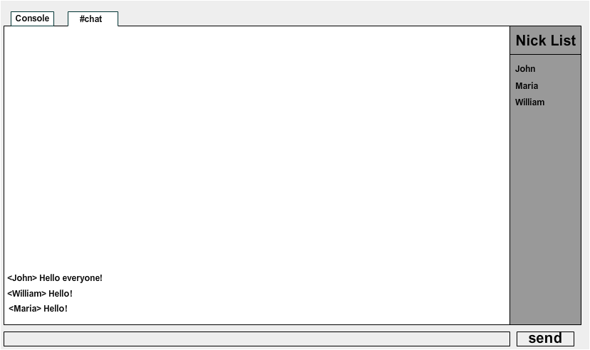

3. Implementation
3.1. Description

The Server and Client programs were both coded in the Java programming language, an object-oriented language ideal for the implementation of our system, supported by all common operating systems.

They were developed using the Netbeans Integrated Development Environment, which is a free, open source Java IDE that can run on all popular operating systems. Netbeans also supports other languages, some of which that were used in this project are PHP and HTML5. The table below illustrates the platform that was used for the development:

Development Environment: | NetBeans IDE 7.0.1 (Build 201107282000)
Java: | 1.6.0_24; Java HotSpot(TM) 64-Bit Server VM 19.1-b02
System: | Windows 7 version 6.1 running on amd64

Netbeans was chosen for the development of this project as it offers a well-structured and friendly user interface with various automations for faster and cleaner coding, efficient project management and authoring of bug-free code. To name some of its features, it supports syntax highlighting, code formatting plus removal of trailing spaces, automatic import of libraries and code tooltips with Java documentation (JavaDocs). Moreover, it is being developed by the Oracle Corporation which also develops the Java language and as a result the Netbeans IDE is always equipped and updated with the latest cutting-edge technology on Java.

3.2. Software development

Both the Server and the Client were based on the Internet Relay Chat (IRC) protocol described in RFC 1459 which was published in 1993 by Jarkko Oikarinen (IRC help, 1997). As a result, they are able to connect and communicate with all other existing IRC Servers and Clients that correctly implement the protocol.

That enables us to separate the implementation and testing of the Server from that of the Client and use it with other fully-functional IRC Clients in order to test its functionality and proper implementation of the protocol. Similarly, we can test the functionality of the Client by connecting it to fully-functional IRC Servers of popular networks.

That said, in the following sections we will separately look into the implementation of the Server and Client program.

3.2.1. The Server

The Server was built as a daemon that runs as a background process, lacking a graphical user interface. It is simply switched on and off to listen for connections from the clients.

At the startup, the main method calls the static method getConfiguration() of the Config class which implements a singleton design pattern, allowing its instantiation to just one object which is meant to be created exclusively by the main method. The getConfiguration() method returns the Config object which in turn retrieves server properties from files. The Config class and its methods will be extensively explained later on in this chapter.

Afterwards, the main method proceeds to create a ServerSocket object which is instantiated with a server port number. The default IRC protocol port number is 194 (Internet Assigned Numbers Authority, 2013), however, port number 6667 may be used as an alternate port in case that the connection to the default one fails (World Wide Web Consortium, 1996). The officially assigned port number belongs to a privileged range of ports (0-1024) and on Unix systems our daemon would require superuser privileges in order to use it (Wikipedia – IRCd, 2013). We provide the server socket’s constructor with the 6667 as the port number, since it is the most popular port that in nowadays the IRC Servers are running on and since as our daemon will not require superuser privileges to open it. The newly created ServerSocket object setups a server socket bound to port 6667 which will listen for incoming connection requests to the socket.

Ultimately, the main method enters an infinite “while” loop in which it waits for incoming connection requests and accepts them. In every loop, the method is blocked until a new connection request is received (Oracle Corporation on ServerSocket Class, n.d.). Then, the connection is accepted and a new Socket object is made for the newly created socket connection. Next, we instantiate a Connection object with the above Socket object and store it in a hashmap with a temporary nickname for the user (since he/she hasn’t sent his/her preferred nickname at the time), because we want to be able to manage it at an early stage. The “Connection” class has as main purpose to handle all the communication between the server and its clients and will be extensively explained later on in this chapter. Finally, we put the new connection in its own thread, because we want every single connection to be running concurrently while the main program is listening for more connection requests and generates new threads.

Main() then moves onto the next loop step and the above process is repeated endlessly, until the server is switched off.

3.2.1.1. Class Config

This class has a private constructor and thus restricts access to it by any other class. A single final object of the class is a private field that belongs to the class itself and it is returned through the getConfiguration() accessor.

The constructor tries to load a properties file called “config.properties” in a try-catch block and in case of an exception – when the file is not found – it outputs an error message about the missing file. That specific file contains the configurable parameters of the server. Each parameter is stored in the file as a string that consists of a key and its corresponding value (Oracle Corporation on Properties Class, n.d.), thus the naming of the keys in the file must be strictly followed otherwise the constructor will be unable to locate them and extract their values.
If the configuration file has been successfully loaded, it proceeds to read values from certain properties in the file, notifying the console with errors about any properties that were not found. Finally, it assigns the values of those properties to the corresponding fields of the class so that they can be used in other parts of the program, later on during runtime. More specifically, the constructor modifies the serverName and keySeed fields.

3.2.1.2. Class Connection

This class implements the Runnable interface, allowing its objects to run in threads concurrently with the main program. Each object handles the communication with just one client and is instantiated with the Socket object that is used for that specific connection.

The class has two static HashMaps to store the server’s connections and channels and a static ArrayList to store temporary user IDs.
The first HashMap, called “serverConnections”, stores pairs of nickname strings (those are the keys of the hashmap) and Connection objects. In short, it holds the nicknames and connection properties of all connected users.
The second HashMap, called “serverChannels”, stores pairs of channel name strings (those are the keys of the hashmap) and Channel objects. In short, it is a table that holds all the channels that have been created on the server.
The ArrayList is a list that holds nickname strings that were randomly generated by the server and assigned to new users. Although those nicknames are removed after the user chooses his/her preferred nickname, the list holds them until that time in order to avoid nickname collisions.

As the above fields are static, they belong to the class and are shared by all instances of it (Java Tutorial Hub, n.d.). Any change applied to them affects their value for all the instances. These resources should be used by all objects of the class, however, in order to avoid any malfunction (e.g. avoid messing a hashmap’s iteration) we need to restrict asynchronous access and/or modification of those fields. Access to the resource should be allowed only to one thread at a time. Each thread should wait for its turn to access and/or modify a common shared resource until all other threads have finished operating on it (Code Project, 2004). For that purpose, we’ve created a static final Mutex (Mutual Exclusion) object for all the threads to lock on, which synchronizes them whenever those fields have to be accessed and/or modified in methods that are running at the same time across multiple threads.
The specific code in those methods is surrounded with “Synchronized” blocks where the mutex is applied on and they are used with care since they slow down the execution of the program by blocking the surrounded code for all the rest threads.

The constructor of the class takes a Socket object as input and instantiates a Socket object of the class with its value. When a new object of the class is constructed, it creates three new objects that will be eventually destroyed along with it when it ceases to run. Namely, it creates an instance of the User, the InputStreamProcessor and the OutputStreamProcessor class. The first one stores information about the connected client and the other two handle all the received messages and all to-be-sent messages respectively. The aforementioned three classes will be extensively explained later on, in their own sections.

Method: run()

The run() method calls the doCommunication() method in a try-catch-finally block. As the latter may throw an exception, it is caught by the “catch” block where we try to close the socket and terminate the connection to the specific client. Once an exception occurs, the “try” block exits and the control is transferred to the catch block, ensuring that if something went wrong in the communication between our server and the client, the socket will be closed. Ultimately, the “finally” block always executes when the “try” block exits, ensuring that the code in the “finally” block will be executed even if an unexpected exception occurs (Oracle Corporation – The Java Tutorials, n.d.). The “finally” block marks the end of communication with a specific client, his removal from the server and the table of connections (i.e. the “serverConnections” hashmap). The “finally” block informs all channels (chatrooms) where the user was in, that he/she has disconnected, removes the connection from the serverConnections table and frees the initial ID that was assigned to it by the server.

Method: doCommunication()

When the method doCommunication() starts running we want two tasks to be done at the same time, concurrently for every socket connection. Send messages to the client and receive messages from it. In the main() method we assigned to a thread the task of handling the connection while main() continued to listen for more connection requests. Likewise, in this method, we will receive messages from the client and create a new OutputStreamProcessor thread which will be endowed with the task of sending messages to the client.

However, before proceeding to receive messages from the client, we are doing a check for multiple connections from the same IP address or hostname, because we want to control the traffic load from a specific host and save up on resources. For that purpose, we get the remote socket address and retrieve the IP which we will provide as an input to the checkForMultipleConnections() method which returns an integer. If that number is greater than the number of connections that we allow from a host, then we inform the client that his connection will be terminated and close the socket. Otherwise, we proceed to read his messages. A BufferedReader reads every line from the socket’s input stream and calls the method processLine() of the InputStreamProcessor with that line as an input.

Method: checkForMultipleConnections()

This method, which is used in the aforementioned doCommunication() method, takes an IP address string as an input, looks into the serverConnections table for matching values and returns an integer for the number of connections originating from that IP.

3.2.1.3. Class OutputStreamProcessor

This class also implements the Runnable interface, allowing its objects to run in a thread concurrently with the Connection object that created them (i.e. the producer thread). Each instance serves as a processor for messages that are intended to be sent through the output stream of a socket.
The constructor takes the Connection object as an input and instantiates a Connection object of the class with its value.

Each instance of this class has a LinkedBlockingQueue called “messageQueue” with a capacity of 1000 string elements (i.e. messages). This queue is used to store the messages that we intend to send to the client in a FIFO order, storing the newer messages at the tail of the queue. Thus, when we are ready to send them, they get extracted from the head of the queue, starting from the message that has been stored in it for the longest time (Oracle Corporation on LinkedBlockingQueue Class, n.d.). This type of queue was chosen over other types of queues because it orders its elements in FIFO order by default (unlike priority queues) and because of its asynchronous behaviour since we can insert new messages without waiting for older messages to be taken out of the queue (as in a SynchronousQueue), and because we can freely take out the older messages. Most importantly, whenever the queue is empty, the thread will wait until a new message is inserted and that is convenient for the following implementation of the thread.

Method: run()

When the thread starts running it enters a try-catch block where it waits for new messages to be inserted into the queue and crafts them in a special way before sending them. This happens as follows:

The “try” block consists of an infinite while loop. In each loop step the oldest message is extracted from the queue and is stored in a string. Since the message will be sent to another IRC program, we need to adhere to the protocol. According to the RFC 1459 § 2.3, “IRC messages are always lines of characters terminated with a CR-LF (Carriage Return - Line Feed) pair”, thus we designate two characters, CR and LF, as message separators. In the Java language, these two characters are represented by the \r and \n escape characters respectively. First, we remove any such characters from our message and then add the CR-LF separator at the end of it. Finally, we convert the string into an array of bytes and send it through the output stream of the socket, taking good care to clear the stream from any bytes right afterwards.

The process is repeated for all the rest messages in the next loop steps. If the message queue is empty the execution will be blocked and the thread will wait until a new message is inserted. If it is interrupted while waiting, then an InterruptedException will be thrown, passing control to the “catch” block that will clear the queue and try to close the socket and terminate the connection to the specific client.

Method: send()

This method takes a string as an input and adds it to the queue. The string is the message to send to the client.

Method: sendGlobal ()

This method takes a string as an input and calls send() with that string as parameter. The string is a special IRC message that contains the server’s name in its prefix.

Method: sendNotice()

This method also takes a string as an input and calls send() with that string as parameter. The string is an IRC notification message that contains the server’s name in its prefix.

Method: sendQuit()

This method takes as an input a string that represents a channel’s name. It loops through every Channel object in the Connection.serverChannels table and removes the corresponding connection from its nickList (list of nicknames), sending a message to inform the users of all the rest connections. Finally, if the nickList is empty it removes the Channel from the Connection.serverChannels table.

3.2.1.4. Class InputStreamProcessor

Its constructor works the same way as the constructor of the OutputStreamProcessor class. This class has only one method called processLine() which receives a string as an input. Its sole purpose is to process messages that are received from the client.

Method: processLine()

According to RFC 1459 § 2.3 and § 2.3.1, the IRC messages have the following format:
:<prefix> <command> <params> :<trailing>

An example of a message that contains all the above may be:

:Louis!JavaChat@localhost PRIVMSG #chatroom :Hello!
The only required part is the name of the command which in the above example is PRIVMSG. Everything else is optional and can be mixed and matched (Delnay, 2010). A few other examples:
:Louis!JavaChat@localhost QUIT :Goodbye people!
:Louis!JavaChat@localhost MODE #chatroom +S
:Louis!JavaChat@localhost JOIN #chatroom
PING :localhost

The commands in the above examples are QUIT, MODE, JOIN and PING.

The processLine() method analyses the message in order to extract all the above pieces and stores a string for the prefix, a string for the command, an array of strings for the command parameters and a string for the trailing parameter.

The InputStreamProcessor class imports an enumeration called “Command” from the Commands class, which is a set of command objects.

The processLine() method takes into consideration the full syntax of the message that contained the command, including all of its parameters, and if it meets the requirements it compares the name of the command that is extracted from the message to the names of all the objects in the enumeration.
If it matches an object it calls the execute() method of that object which, as its name suggests, will execute the requested command.

3.2.1.5. Class Commands

This class contains an enumeration that has a set of predefined constants which represent the commands. The fields of the enumeration (i.e. the commands), which are static and final, are all written in uppercase letters since they are constants. Those are all the commands that our server knows of and that it can execute upon a request from a client.

The enumeration that contains the commands is a special type of class known as “enum type” and it can contain other fields and methods below its constants as well as a private constructor (Oracle Corporation on Enum Types, n.d.).

For the needs of the commands’ implementation we’ll be using a popular enum type technique (Michael Feathers - Artima Developer, 2005) as on Artima Developer’s website and Opengroove Blog (2009), according to which every constant of the enumeration can be initialized by a call to its private constructor and thus every constant is an instance of the enumeration and can have instance-specific methods.
In other words, each command-constant is an object that is initialized by a call to the enum’s private constructor and behaves as an instance of the enum. It can have its own fields and methods and it is required to implement all abstract methods defined by its parent class. The enumeration has such an abstract method called “execute” which is implemented by all of the commands. That way we keep consistency through our code.

The aforementioned constructor takes as an input two integers; the minimum and maximum parameters that the specific command can have. A few examples may be:

JOIN(1, 2) {},
PING(1, 1) {},
PRIVMSG(2, 2) {};
In the above examples, the JOIN command has a minimum of one parameters and a maximum of two parameters, the PING command has one and one and the PRIVMSG two and two.

The table below illustrates all of the supported commands, their minimum and maximum parameters and their methods.
The method execute() which is common in every command, takes as input a Connection object that represents the connection where the command request came from, a string which is the prefix of the IRC message and an array of strings which contains the given parameters of the command.

Command | Min | Max | Methods
JOIN | 1 | 2 | execute(Connection, String, String[])  Checks the syntax of provided channel names and calls doJoin() for each specified channel.  doJoin(Connection, String)  Takes a channel name as input and reads the  Connection.serverChannels table to see whether a Channel by that name already exists and if it doesn’t it creates it and adds it in the table. If it existed, it checks whether the Connection that was given as input to this method already exists in the nickList of that Channel and if it didn’t it adds it, allowing the user to join the Channel.
MODE | 0 | 2 | execute(Connection, String, String[])  Reads the string parameters of the array and then calls methods of the OutputStreamProcessor object in order to add in its queue an appropriate message to send to the client.
NICK | 1 | 1 | execute(Connection, String, String[])  Reads a nickname from the array of strings that was given in the input and the user’s current nickname value from the corresponding User object and calls either the doStartUpNick() or the doSwitchNick() method based on whether it is the first nickname request from the user or a request for a new nickname. If the case is the latter, it searches in the keys of the Connection.serverConnections table to determine whether the nickname already exists.  doStartUpNick(Connection, String)  Reads a nickname from the input and sets it as the client’s nickname. It removes the old nickname key from the Connection.serverConnections table and re-adds the connection with the new nickname. It also removes the temporary nickname that was assigned by the server to this connection, from the Connection.temporaryIDs list.  doSwitchNick(Connection, String)  Similar to the doStartUpNick() method.  generateGuestNick()  It utilizes a math formula (Stack Overflow, 2008) and the Math.Random() method to generate a random number, from a certain range of numbers, that is appended to a string which is returned by the method.
PART | 1 | 2 | execute(Connection, String, String[])  Similar to the doJoin() method of JOIN, however, it removes connections from the nickList and the Connection.serverChannels table instead of adding new ones.
PING | 1 | 1 | execute(Connection, String, String[])  Reads a string from the array in the input and then calls method send() of the OutputStreamProcessor object in order to add a message in its queue as a reply to the client.
PRIVMSG | 2 | 2 | execute(Connection, String, String[])  Reads recipient strings from the array in the input and for every channel recipient sends a message to a channel by a call to the broadcast() method of Channel, whereas for every user recipient it sends a message to the appropriate user by a call of the send() method of OutputStreamProcessor.
QUIT | 1 | 1 | execute(Connection, String, String[])  Reads a string from the array in the input and calls method sendQuit() of the OutputStreamProcessor object.
TOPIC | 1 | 2 | execute(Connection, String, String[])  Reads a channel name string from the array in the input and may modify the corresponding Channel’s topic. It sends a message to the channel by a call to the broadcast() method of Channel, if the topic has changed and a message that informs the appropriate user about the current channel’s topic by a call of the send() method of OutputStreamProcessor.
USER | 1 | 4 | execute(Connection, String, String[])  Reads strings from the array in the input, sets accordingly the client’s ident name and description, and sends message replies by calls to the sendGlobal() method of OutputStreamProcessor.
USERHOST | 1 | 5 | execute(Connection, String, String[])  Reads nicknames from the array of strings in the input and sends as reply a message with all of the corresponding hostmasks.
WHO | 0 | 2 | execute(Connection, String, String[])  Reads nicknames or channel names from the array of strings in the input and sends as reply a message with information about them.

3.2.1.6. Class Channel

This class has an empty constructor. The fields of Channel are a protected “name” field, a private “topic” field and a private ArrayList<Connection> called “nickList” that stores all the Connection objects that are associated with a specific Channel object. The class features a few accessors and mutators for the fields above, and a couple of other methods which are explained below.

Method: broadcast()

Takes as an input a Connection object and a string that has a message, and sends that message to all connections in the aforementioned nickList, except to the specified connection.

Method: send()

Takes a string as an input and calls the above broadcast() method by passing it a null Connection and the string as parameters. Thus, the broadcast() method will send the message to all connections in the nickList.

3.2.1.7. Class User

This class has an empty constructor. It has fields for storing user information such as tempEntryNick, nick, ident, hostname and description and also accessors and mutators for all of them. The class has a number of other methods which are explained below.

Method: getHostmask()

Returns a string that represents a user’s hostmask. A hostmask combines many of the aforementioned fields in the following format:
nick!ident@hostname (description)

Method: encryptHostname()

This method receives a hostname string as an input and encrypts it according to an implementation illustrated at Stack Overflow (2013), which uses a 128-bits private key and the AES algorithm to transform the provided string. AES returns the encrypted string in the form of a byte array which is then encoded and re-converted to a string with a Base64 encoder that utilizes the following character set (Java Espresso – Base64 encoding and decoding in Java, 2011): [A-Za-z0-9+/]

Finally, the method segments and structures the string in a certain format that is similar to formats used in popular IRC servers for displaying hostnames and returns a string of the encrypted hostname.

Method: decryptHostname()

This method receives an encrypted hostname string as an input and follows a reverse procedure to bring it back to its original form, before it was encrypted with the method encryptHostname(), and returns a string of the original hostname.

Method: generateKey()

This method returns a symmetric Key which is generated by the AES algorithm from a 128-bits key seed.

Method: generateTemporaryUserID()

This method generates a random number from a specified range of numbers, appends it to a string that serves as a temporary user ID, adds it to the Connection.temporaryIDs list and returns the string.

3.2.2. The Client

The Client features a Graphical User Interface which was mainly built with Java’s Abstract Window Toolkit (AWT) and Swing which is Java’s primary GUI toolkit.

The main method simply creates a new instance of the GUI class which is a JFrame.

3.2.2.1 Class GUI

This class, as its name suggests, is responsible for creating the main Graphical User Interface of our program.

The GUI constructor makes use of a static method from the Config class called makeDir() that takes a directory path as an input, checks whether that directory exists, and if it doesn’t it proceeds to create it. We have defined the path of that directory as a constant in the Config class. It will be used later on to save property files that store preferences for servers.
Right afterwards, the constructor sets a few window parameters such as the window’s position on screen, its title and its icon. It is set to appear at the center of the user’s screen with a fixed initial size as well as a minimum allowed size in order to avoid any layout annoyances when the window shrinks too much. Finally, the constructor calls the makeLayout() method that will create the layout of the window, before setting all the content to visible on the screen.

Method: makeLayout()

The makeLayout() method creates a number of buttons, textfields and labels as well as a number of containers and panels that will host them. Some of those containers are defined as fields of the class and have global visibility in our code. As all of this class’s fields they are also declared as static in order to be used and manipulated by other parts of the program.

For our JFrame and for most of the panels, we are using a GridBagLayout to layout the components, since it is one of the most flexible layout managers that the Java platform provides (Oracle Corporation on GridBagLayout, n.d.).

As illustrated in Appendix D – Figure 1, the GUI consists of two main panels; the top panel and the bottom panel.

The top panel is instantiated with a CardLayout in which we add two JPanels which we want to be able to toggle. The first JPanel is the main panel of the client that holds a JTabbedPane that serves as the container for the chatrooms and for all chatting activity and the second JPanel is a help panel that displays a list of supported commands, their proper formats and a description for each one.
The JTabbedPane is the top card in the deck and it has an initial permanent tab called “Console” that contains a “consolePanel”. At the start-up, the consolePanel contains a StartUp connection panel that is used to connect to a server but later on its sole purpose will be to output server replies and messages of our client.

The bottom panel contains the message box where we type out messages and a panel of four buttons, equipped with action listeners. In order to add functionality to those buttons, makeLayout() creates an object of the class ListenersCollection that holds all of the action listeners to be used by the GUI class so as to separate functionality from the layout of the components. As illustrated in Appendix D – Figure 2, those buttons, from left to right, are the send, configuration, help and “about” button.

The configuration button opens a window where the user can save his/her server preferences, as shown in Appendix D – Figure 3.
The help button toggles a panel that contains documentation about the supported IRC commands, as shown in Appendix D – Figure 4.
The “about” button opens an “About” window where the user can view information about the current version of the program, as shown in Appendix D – Figure 5.

Method: addTab()

This method receives a MessagePanel and a Connection object as an input and adds a new tab to the tabbed pane. The new tab features a label title and a close button according to an implementation described at Paperjammed (2012).

Method: removeTab()

This method receives a MessagePanel as an input and removes a tab that matches its title from the tabbed pane.

Method: preprocessMessage()

This method is called whenever the user types a command in the message box and tries to send it. It reads the text that was typed, displays a message in the Console if needed, and modifies it accordingly before using the send() method of OutputProcessor to send it to the server. Finally, it clears the text from the message box.

3.2.2.2 Class ListenersCollection

This class has fields of various event listeners for the elements of the GUI class and accessor methods for each one of them. We will explain what each listener does.

The “messageboxListener”:

It is a KeyAdapter for the message box (i.e. the field where the user types his/her messages) that checks whether the user has pressed the Enter button or has performed a Ctrl-Z sequence. In the first case a call is made to the GUI.preprocessMessage() method which will process the message that the user has typed and then proceed to send it. In the second case, it will call the GUI’s UndoManager to undo the last edit in the message.

The “nickInputListener”:

It is a KeyAdapter for the text field where the user types his/her nickname at the StartUp connection panel. It modifies the field’s text if the nickname is over its maximum allowed length and if it has a wrong format or illegal characters.

The “tabChangeListener”:

It is a ChangeListener for the tabbed pane that modifies the window’s title and the GUI.currentView whenever the selected tab changes.

The “sendButtonListener”:

It is an ActionListener for the button that sends our messages. When the button is pressed it calls the GUI.preprocessMessage() method which will process the message that the user has typed and then proceed to send it.

The “configButtonListener”:

It is an ActionListener for the configuration button. When the button is pressed it creates a new Config window at relative position to the GUI window. If a Config window is already opened, it simply brings it to front.

The “helpButtonListener”:

It is an ActionListener for the help button that is used to display a help panel for commands. Whenever it is pressed the CardLayout which was dicussed in the GUI class switches from the main panel to the help panel and vice versa.

The “aboutButtonListener”:

It is an ActionListener for the “About” button that is used to display an “About” dialog regarding the client software. When the button is pressed it creates a new AboutWindow window at relative position to the GUI window. If an AboutWindow window is already opened, it simply brings it to front.

The “connectButtonListener”:

It is an ActionListener for the “Connect” button at the StartUp connection panel, which makes the initial connection to a server. If all requirements are met, it tries to establish a socket connection with a server and put it in its own Connection thread. It then clears the GUI.consolePanel by removing all content from the panel and fills it with a new ConsoleOutputPane panel. Finally, it registers the connection to the server as required by the IRC protocol by sending a USER command after a NICK command with user information attached to the message (Stack Overflow, 2010). If the connection fails, an exception is caught and an error message flashes for a set amount of time.

3.2.2.3 Class AboutWindow

This class is a JFrame that displays information about the client software. The about dialog was inspired by the Icechat IRC Client (2013)

The constructor of this class takes two integers as parameters, which are screen coordinates and sets the frame’s location at those coordinates. It sets a few more window parameters such as the window’s title and icon, and also creates a sequencer to play a midi audio file (Java Tips, n.d.). Finally, the constructor calls the makeLayout() method that will create the layout of the window, before setting all the content to visible on the screen.

Method: makeLayout()

This method sets a gridbag layout manager for the frame and lays out the various components that are comprised of labels, buttons and a text area.

3.2.2.4 Class Config

This class is a JFrame that displays server configuration. It is used to configure new servers and delete existing ones.

The constructor of this class takes two integers as parameters, which are screen coordinates and sets the frame’s location at those coordinates. It sets a few more window parameters such as the window’s title and icon. Finally, the constructor calls the makeLayout() method that will create the layout of the window, before setting all the content to visible on the screen.

Method: makeLayout()

This method sets a gridbag layout manager for the frame and lays out the various components that are comprised of panels, labels, buttons, textfields and event listeners for the buttons and the textfields.

There are six textfields where the user can configure the following properties: Server Name, Server Port, Nickname, Ident Name, Full Name, Quit Message.
Each one of them has its own PropertyChangeListener that controls the size and format of the value that was typed in the field.
There are several regular expressions used (Java2s - Java regular expression metacharacters, n.d.) to control the format of the aforementioned properties and to disallow any illegal characters.
For instance, a server name cannot contain any illegal filename characters such as: \ / : * ? " < > | It may only contain alphanumeric, underscores, hyphens and dots.
An IRC nickname or ident name cannot start with a number (Stack Overflow – Regular expression to match IRC nickname, 2011) and it can contain any of the following characters: - _ [ ] | ^ ` { } \

Method: makeDir()

This method takes a directory path as an input, checks whether that directory exists, and if it doesn’t it proceeds to create it.

Method: fillSettingsPanel()

This method creates a new FileManager object that reads the current selected server’s properties from a “.properties” file and fills all the textfields of the Config frame with the corresponding values.

Apart from constants that represent textual commands there are fields for numeric commands which consist of three digits. Those are sent as numeric replies from server to other servers or to clients and cannot originate from clients. Since a constant cannot begin with a number, those fields start with an “n” that stands for number, followed by the three digits. (https://www.alien.net.au/irc/irc2numerics.html)

Method: getList()

This method receives as an input an array of files, extracts all the filenames from their file paths and populates the list of a JComboBox with the filenames. Finally, it returns the JComboBox component.

3.2.2.5 Class RightClickMenu

This class is used to construct a mouse listener for a right-click context menu that can be used in various documents and text fields to cut, copy, paste and select text. The entire implementation for this class was based on a solution from the Stack Overflow website (2010).

3.2.2.6 Class MessagePanel

The constructor creates a text pane that holds a styled document in which we want to append text and configures the feel and look of the panel. Among other settings, it adds a MouseListener to the text pane which pops up a right-click context menu. This class, apart from accessors and mutators, has one method called drawMessage() which is inherited by all of its subclasses.

Method: drawMessage()

This method takes as input a message string and a SimpleAttributeSet keyword that will define how to color the message when we output it on the document.

Every MessagePanel object has a document of fixed buffer size. The drawMessage() method draws a message to it with respect to its limit of characters. It checks whether the document’s length exceeds the limit of the buffer and removes the overlength from the begin of the document.
As these documents are used in separate tabs of the GUI’s tabbed pane we’ve added a check to see whether the tab where we’ll append the message is currently the selected one. If it is not, we append the message to the document and then use a timer to flash the background and foreground colors of the tab for a set amount of time (Web development helpdesk, 2009).

3.2.2.7 Class ConsoleOutputPane

This class inherits all of its fields and methods from the MessagePanel class. Its constructor takes a Connection object as input and only adjusts some fields of the parent class. Objects of this class serve as IRC Console areas.

3.2.2.8 Class QueryOutputPane

This class inherits all of its fields and methods from the MessagePanel class. Its constructor takes a Connection object as input and only adjusts some fields of the parent class. Objects of this class serve as IRC private chat (query) areas.

3.2.2.9 Class ChannelOutputPane

This class inherits all of the fields and methods of the MessagePanel class. Objects of this class serve as IRC channel (chatroom) areas. Its constructor takes a Connection object as input. It creates various panels and a JSplitPane to separate the chat area from the nicknames list (a.k.a. nickList) of the chatroom, as shown in Appendix D – Figure 6.

For the list of nicknames we’ve imported the class JXList from an external library. More specifically, the “swingx-1.6.1.jar” library container (Java2s – swingx.jar, n.d.). The JXList is basically a JList that offers extended functionality such as methods for auto sorting the elements of the list. It was preferred over the ordinary JList because we want to sort the nicknames of the list in an ascending alphabetical order.

Method: addNickListRecord()

This method takes a nickname string as an input and adds it to the DefaultListModel of the nicknames list.

Method: delNickListRecord()

This method takes a nickname string as an input and removes the first occurrence from the DefaultListModel of the nicknames list. Nicknames are unique in an IRC network; there can’t be more than one of the same nickname in the list.

Method: modifyNickListRecord()

This method takes a nickname string as an input and an integer that represents a position in the list model. Then, it changes the nickname at that position with the nickname that was given in the input.

Method: setDividerLocation()

This method is used to set the initial location of the JSplitPane’s divider, and it is based on an implementation found at Darevay’s blog (2011). It takes as an input the JSplitPane and a double proportion that represents the divider’s preferred location and it adjusts the divider’s location once the split pane is correctly realised and on screen.

3.2.2.10 Class Connection

It is almost identical to the Connection class of the Server program. There is no check for multiple connections in the doCommunication() method and there is no checkForMultipleConnections() method. One main difference is that every instance of this class has its own HashMap for channels, called “joinedChannels”, instead of a common shared resource for all objects. That’s because a server has a list of created channels which is available to all connections (i.e. to all the clients), while a client has a list of channels that it has joined for every server (i.e. for each one of its active connections).

3.2.2.11 Class InputStreamProcessor

This class is identical to the InputStreamProcessor class of the Server program, except for a different enumeration import. It imports a set of server replies from the ServerResponses class.

3.2.2.12 Class OutputStreamProcessor

This class is mostly the same as the OutputStreamProcessor class of the Server program. The send() method, however, does a number of operations before adding a message in the queue.
The class imports an enumeration called “Command” from the ClientCommands class. The send() method analyses the message and if the user has typed a command (any message starting with a forward slash “/”) it checks whether that command is an object of the aforementioned enumeration and if it is, it proceeds to execute the command.

Method: sendPrivMsg()

This method does almost the same as the send() method, but it executes only a specific command from the enumeration, which is the “PRIVMSG” command.

3.2.2.13 Class ClientCommands

This class is similar to the “Commands” class of the Server program. It contains an enumeration that has a set of predefined constants which represent client directives. By client directives, we mean operations that our client program has to perform before sending the actual command to the server.

It features two methods for the encryption and decryption of messages that are exchanged in a private conversation. These methods are encryptMessage() and decryptMessage() and they are implemented in the same way that the Server programs encrypts and decrypts hostnames.

3.2.2.14 Class ServerResponses

This class is also similar to the “Commands” class of the Server program. It contains an enumeration that has a set of predefined constants which represent server replies. Whenever a server reply is received, the client proceeds to execute the corresponding execute() method, in the same way that the Server executes its commands in the “Commands” class that we have previously discussed.

3.2.2.15 Class User

This class is identical to the “User” class of the Server program, except for that it has no methods implemented.

3.2.2.16 Class HelpPanel

This class is a JPanel (i.e. it extends the JPanel class) and has a single method implemented, the makeLayout(), that is called in its constructor. The help panel’s main purpose is to display a list of available commands and their descriptions.

Method: makeLayout()

This method lays out the components of the panel which are labels and textareas.

3.2.2.17 Class FileManager

This class has methods that manage information in .properties files.

Method: putProperties ()

This method receives as an input a filename and an ArrayList<String> of property values and writes them to a .properties file with that name. If the given file does not exist, it creates it via the openFile() method.

Method: getProperties()

This method receives a filename as input, reads properties from a .properties file and returns an ArrayList<String> with all of the property values.

Method: openFile ()

This method receives a filename as input and returns a FileInputStream object. If the specified file was not found, it creates it.

Method: deleteServer()

This method receives a filename as input and deletes the file if it is not being used. It returns true if the file was successfully delete, else it returns false.

3.3. Applet

We also made an Applet version of the client for the web and a website to support it, as shown in the screenshot in Appendix D.2. Note: The website logo and favicon do not belong to the author of this project and were found randomly through Google Images.

The Applet’s code is almost identical to that of the standard version.

The main differences are that the “HelpPanel”, “AboutWindow” and “Config” classes have been removed as well as the “Help”, “About” and “Config” buttons that made use of them. As a result, the FileManager class has also been removed since it was used solely by the Config class.
The Config class has been replaced by a new Config class. An instance of that class simply reads values from HTML object parameters (defined in <param> tags) and changes the values of Config static fields. Some of those parameters are server name, server port and nickname.
The GUI class has been removed and all of its contents (methods etc.) were moved into the JApplet class.

3.4. UML Class Diagrams

The server class diagram is shown in Appendix C – Figure 4 and the client class diagram in Appendix C – Figure 5.

3.5. Testing

I’ve tested the Server program by connecting to it from various well-known IRC Clients such as mIRC, Icechat and ChatZilla and also from the IRC Client that I personally developed. I tried out each one of the commands that the Server program supports by sending requests (i.e. typing commands to the server) from the aforementioned client programs and simulated chatting sessions between the different clients.

The testing was performed not only on a single computer but also in a LAN at the IST labs, to verify that the server works properly in a network environment.

During the above tests the Client program’s functionality and implementation of the IRC protocol was being tested as well. However, it was put to the real test by connecting it to fully-functional Servers.

I connected to a few popular IRC networks such as ICQ (irc.icq.com) and I joined public channels to chat with hundreds of other users. I tested how well joining and leaving channels worked and having private chats with other users. Finally, I left my program unattended for many hours in order to verify that it would reply to ping requests and stay connected to the server.

The communication worked as expected in all of the above tests, flawlessly for as much of the IRC specification that has been implemented. I configured the client to display diagnostic messages whenever it receives a command that it cannot understand. As the basic set of commands has been implemented, the client could work fine in connection with fully-functional servers.

4. Evaluation and Conclusions

4.1. Objectives evaluation – Reflection

This was a very hard project for me to complete. Although I am very satisfied with my progress and learning in Java programming, and relieved that I can present an application that works as it was initially planned, I am disappointed by the final look and feel of my work as I failed to implement many of the program features that I came up with during the implementation stage.

Due to being very inexperienced with Java Swing and Graphical User Interfaces, I consumed too much time in the analysis and design of the client program and I was forced to proceed with its implementation while the analysis was still incomplete. Even so, I stumbled upon problems in the GUI for longer than I expected, exceeding by far the initial estimated time plan for the implementation.
I lost valuable time researching about solutions and studying programming in order to overcome all the issues that I had in its implementation, exceeding by far the initial estimated time plan for research.
As a result, I did not manage to fulfil any the objectives for a 1st class grade work.

On the bright side, I’m very pleased that I managed to implement a popular protocol and make my programs communicate properly with other fully-functional popular programs, as it was something that I always wanted to achieve.

4.2. Future Improvements - Hints

In future versions I was thinking to implement more IRC commands at both the server and the client such as the “LIST” command to display a list of all the channels of the server.
The client should be able to connect to multiple servers, which is something that has been left unfinished at the moment. The user will be able to browse through Consoles and Channels for different connections and the start-up screen that is currently locked on one server will be gone and be replaced by a panel of configured servers, which can be independently selected by the user to connect to.
I was planning to add more functionality to the message box, such as an input history. That way, the user can press a key on his/her keyboard (e.g. the up arrow) and cycle through previous messages.
Also, I was planning to add more functionality to the scrollbars by making them automatically scroll to bottom when the user types a message and by coloring the scrollbar’s track area whenever a new message arrives and the scrollbar is not adjusted to the bottom.
The tabs also require more functionality. A good improvement would be to make them draggable.
Further improvements may be sets of smilies to replace character sequences. Also, color codes (those are part of the IRC specification) that will add foreground and background colors to the standard messages.

Finally, I was planning to improve the security on both programs. The server should have anti-DDoS mechanisms to drop any harmful connection and anti-flood mechanisms to disconnect any user for excess text flood in the public channels.
The client could be improved as far as security is concerned, by storing its requests to the server for a limited amount of time while waiting for the server’s reply. The amount of time to store a request could be determined perhaps by measuring the latency in the communication between the two programs. The security will be improved that way, if we consider that a reply from the server may direct the client to even change its GUI. Thus, the client should check whether the reply was generated upon a request of his.

5. References

- [IRC help, 1997]
http://www.irchelp.org/irchelp/rfc/rfc.html , accessed on 13/5/2013

- [IANA, 2013]
http://www.iana.org/assignments/service-names-port-numbers/service-names-port-numbers.xml , accessed on 13/5/2013

- [World Wide Web Consortium, 1996]
http://www.w3.org/Addressing/draft-mirashi-url-irc-01.txt , accessed on 13/5/2013

- [Wikipedia – IRCd, 2013]
http://en.wikipedia.org/wiki/IRCd , accessed on 13/5/2013

- [Oracle Corporation on ServerSocket Class, n.d.] http://docs.oracle.com/javase/1.4.2/docs/api/java/net/ServerSocket.html , accessed on 13/5/2013

- [Oracle Corporation on Properties Class, n.d.]
http://docs.oracle.com/javase/6/docs/api/java/util/Properties.html , accessed on 13/5/2013

- [Java Tutorial Hub, n.d.]
http://www.javatutorialhub.com/java-static-variable-methods.html , accessed on 13/5/2013

- [Code Project, 2004]
http://www.codeproject.com/Articles/7953/Thread-Synchronization-for-Beginners , accessed on 13/5/2013

- [Stack Overflow, 2012]
http://stackoverflow.com/questions/13058801/threads-calling-both-static-and-non-static-method , accessed on 13/5/2013

- [Oracle Corporation – The Java Tutorials, n.d.] http://docs.oracle.com/javase/tutorial/essential/exceptions/finally.html , accessed on 13/5/2013

- [Oracle Corporation on LinkedBlockingQueue Class, n.d.]
http://docs.oracle.com/javase/1.5.0/docs/api/java/util/concurrent/LinkedBlockingQueue.html , accessed on 13/5/2013

- [Delnay, 2010]
http://calebdelnay.com/blog/2010/11/parsing-the-irc-message-format-as-a-client , accessed on 13/5/2013

- [Oracle Corporation on Enum Types, n.d.]
http://docs.oracle.com/javase/tutorial/java/javaOO/enum.html , accessed on 13/5/2013

- [Michael Feathers - Artima Developer, 2005]
http://www.artima.com/weblogs/viewpost.jsp?thread=128338 , accessed on 13/5/2013

- [Opengroove Blog, 2009]
http://me.opengroove.org/2009/10/single-file-irc-server.html , accessed on 13/5/2013

- [Stack Overflow, 2008]
http://stackoverflow.com/questions/363681/generating-random-number-in-a-range-with-java , accessed on 13/5/2013

- [Stack Overflow, 2013]
http://stackoverflow.com/questions/14486814/aes-encrypt-with-openssl-decrypt-using-java , accessed on 13/5/2013

- [Java Espresso – Base64 encoding and decoding in Java, 2011]
http://java-espresso.blogspot.gr/2011/10/base64-encoding-and-decoding-in-java.html , accessed on 13/5/2013

- [Oracle Corporation on GridBagLayout, n.d.]
http://docs.oracle.com/javase/tutorial/uiswing/layout/gridbag.html , accessed on 13/5/2013

- [Paperjammed, 2012]
http://paperjammed.com/2012/11/22/adding-tab-close-buttons-to-a-jtabbedpane-in-java-swing/ , accessed on 13/5/2013

- [Stack Overflow, 2010]
http://stackoverflow.com/questions/2968408/how-do-i-program-a-simple-irc-bot-in-python , accessed on 13/5/2013

- [Icechat, 2013]
http://www.icechat.net , accessed on 13/5/2013

- [Java Tips, n.d.]
http://www.java-tips.org/java-se-tips/javax.sound.midi/how-to-load-and-play-midi-audio.html , accessed on 13/5/2013

- [Java2s - Java regular expression metacharacters, n.d.]
http://www.java2s.com/Tutorial/Oracle/0360__Regular-Expressions-Functions/RegularExpressionMetacharacters.htm , accessed on 13/5/2013

- [Stack Overflow – Regular expression to match IRC nickname, 2011]
http://stackoverflow.com/questions/5163255/regular-expression-to-match-irc-nickname , accessed on 13/5/2013

- [Stack Overflow – Right click context menu, 2010]
http://stackoverflow.com/questions/2793940/why-right-click-is-not-working-on-java-application , accessed on 13/5/2013

- [Web development helpdesk, 2009]
http://helpdesk.objects.com.au/java/how-to-make-a-flashing-tab-in-jtabbedpane , accessed on 13/5/2013

- [Java2s – swingx.jar, n.d.]
http://www.java2s.com/Code/Jar/s/Downloadswingxjar.htm , accessed on 13/5/2013

- [Darevay Blog – A less abominable fix for setDividerLocation]
http://blog.darevay.com/2011/06/jsplitpainintheass-a-less-abominable-fix-for-setdividerlocation/ , accessed on 13/5/2013

6. Bibliography

Haase, C. & Guy R. (2007) “Filthy Rich Clients: Developing Animated and Graphical Effects for Desktop Java Applications”

Liskov, B. & Guttag J. (2000) “Program Development in Java: Abstraction, Specification, and Object-Oriented Design”

Panayiotopoulos, J. (2003) “Internet Programming with Java”

Katos, V. & Stephanidis G. (2003) “Cryptography and Cryptanalysis techniques”

7. Appendices

Appendix A. Detail Project Specification / Plan

University of Hertfordshire - IST College
School of Computer Science
Computer Science Project

Detailed Project Specification / Plan

Front Cover

Assignment Title: | Detail Project Specification | Date work assigned: | 8/1/2013
Submission Deadline: | 15/2/2013, 16:00 | Estimated Effort: | 25 hours
Module Title: | Design and implementation of a secured chat application | Project Code: | 6FTC1032
Tutor: |  | GROUP / INDIVIDUAL? | INDIVIDUAL

This assignment is an individual assignment and worth 2% of the overall assessment for this module.
***************************************************************************************************
INDIVIDUAL ASSIGNMENT – Please complete BOX A:
(Comments on this assignment by students can be made on the back of the assignment briefing sheet).
By completing BOX A below, I certify that the submitted work is entirely mine and that any material derived or quoted from the published or unpublished work of other persons has been duly acknowledged. [ref. UPR AS/C/6.1, section 7 and UPR AS/C/5 (Appendix III)].
Please print your forename and surname in capitals, provide your; - ID number, the study year code (CSA3), actual time spent on the assignment and your signature.

BOX A
Student Forename  (in CAPS please) | Student Surname  (in CAPS please) | Student ID Number | Year Code | Actual Time Spent by the Student (hours) | Signature of Student

This sheet must be submitted with the assignment, signed and BOX A filled in.
LATE SUBMISSION WILL DELAY PROJECT START
IF YOU DELAY MORE THAN 2 WEEKS THEN YOU CANNOT DO PROJECT.

Personal Data:
Your First Name: | Loudovikos
Your Surname: | Geromitsos
Your father’s name: | Stamos
Your University ID Code:
Your University email address: | loudovikos.geromitsos@cs10.ist.edu.gr
Degree Title (award you are registered on) | BSc Honours Computer Science
Supervisor’s Name: | Harris Georgiou

I certify that the work submitted is my own and that any material derived or quoted from the published or unpublished work of other persons has been duly acknowledged. I certify that I have (or will have by the deadline) end by email a copy of my submission to csproject@cs.ist.edu.gr, and that the send copy is the same as the hard copy.

Signed…………………………………………………………(Student’s Signature)
Received By: (Name and Signature) | Date and Time

Feedback on the Assignment:
The work is acceptable. Minor corrections – comments may exist. Please see inline text and discuss it with your supervisor
The work is not accepted as it is. Please make the corrections asked and resubmit. Please see inline text and discuss it with your supervisor

Feedback By: | Date

Computer Science

Project Specification / Plan

1 Project Title

“Design and implementation of a secured chat application”.

2 Aims of the Project

The aim of this project is to build a chat system that consists of a server and a client program, both programs implemented with the Java programming language.
The server will be listening for connections from the clients, establish socket connections with the clients, receive and read encrypted messages from them and pass them onto the other clients where they will be decrypted.

The server will only be a daemon without a graphical user interface that will support a list of commands which can be used by the clients (i.e. commands sent to the server by the client in order to achieve an expected result).

With the basic set of commands, the users will be able to create channels (chatrooms), join or leave channels, send messages at channels, change the channel’s topic, change their nicknames and send private messages by either choosing a user’s nickname from a list or by manual input of his nickname.

The client will be a standalone program implementing a Graphical User Interface.

3 Tasks & Deliverables

I intend to show in my report that I have made an adequate attempt at completing the following tasks:
- Problem statement and analysis
- Implementation of the system and encryption of messages
- Create Use Case Diagrams to show what the system can do
- Create Activity Diagrams to demonstrate chat sessions between clients
- Identify the user groups for the system
- Identify each group’s specific requirements
- Identify what data the system needs to store in order to fulfil the requirements
- Identify the classes of the system
- Create Class Diagrams to describe the structure of the system, show the system’s classes, their attributes and their methods, and the relationships among the classes.
- Methodology. Describe how server-client connections are carried out and the protocol for their communication.
- Create Storyboards to demonstrate the Client’s Graphical User Interface.
- Write documentation for the system’s operations and the supported server commands.
- Evaluate the system
- References for all learning material used and for all code lookups

For a second class mark I will complete the following tasks:

- Propose further ideas and server commands
- Create an applet for the Client to connect to the Server through the web
- Design a webpage for the applet
- Create a list of server commands and what they do, for the above website

For a first class mark I will complete the following tasks:

- Connection of the server with a database to hold user information
- Create server commands for nickname registration and identification
- Create server commands for channel registration
- Create message flood protection mechanism
- Create word censors to censor and replace words in the messages

AND I intend to produce:
A working chat client that can be configured to connect to a server and with which the user can choose an initial nickname (which can be changed later on) to participate in public discussions with many other users or in private chats with another user. I will be able to show a client interface where the user can send messages in existing channels or choose a nickname from the channel’s list to directly send a message to a user, in a chat that takes place in a different tab or window. The user will be able to create new channels where other users can join him. Finally, I will be able to demonstrate a series of different commands sent by the client that are recognized by the server, the basic set of those has been described in the aims of this project.

The entire analysis and implementation of the project will be supported by documentation and the aforementioned UML diagrams.

4 What should the markers be looking for when assessing the project?

I will focus my efforts on creating a stable system that is fairly well-structured (by applying sufficient decomposition of the initial problem) at its basic stage with all the basic operations and that can support multiple client connections on the server by correct and good usage of threads. I’ll focus on making the system able to be easily modified and expanded (e.g. by adding new server commands) and the client user-friendly and clean-looking.

5 What practical skills will you be demonstrating?

Program Design / Object-Oriented Programming;
Network Programming;
Multi-Threaded Programming;
Writing (formal, semi-formal, structured) / Documentation;
Program Testing / Formal Verification;
User Interface Design / Interface Programming;
Requirements Elicitation / Analysis;

6 Specialism

General Computer Science (CS)
7 Pre-requisite modules

7a Which of the Semester A core modules will your project work build upon?

Module Name Project Type | CS | AI | NW | SE
FOOD A: Further Object Oriented Development A | √ | x | x | √

7b Which other module(s) will you draw upon for inspiration / information?

CSDE: Computer Science Development Exercise
OSCN: Operating Systems and Computer Networks
PPD2: Programming and Program Design 2

8 Background to the problem

Different clients operated by users need to exchange encrypted messages with each other in a secured environment where no one else with access to the network will be able to decode them, unless he participates in the chat. The users need to be able to chat in public channels with multiple other users and in private with specific users as well.

In order to do all the above, a server will play the role of the router by receiving encrypted messages from clients who have connected to it and forwarding them to the appropriate clients for decryption.

It’s a project that will provide users with a secured, flexible environment, where they can chat and exchange ideas and opinions in multiple channels that they create by using a clean, user-friendly User Interface. Moreover, they can make use of the server’s supported commands to improve their chat experience. Basic commands involve creating new channels and changing nicknames, but what’s more interesting in the project is that it can endlessly expand by building code to support new commands.

9 Requirements

For this project I’ll be using the NetBeans IDE, the Java programming language and Java libraries to develop it and to design the Graphical User Interface. For instance, I’ll make use of the JFrame library to implement the GUI. The system can work and can be tested on a single machine running the server and one or more client, but can be optionally tested also at a lab’s Local Area Network on different machines (e.g. the server running on one while the clients connect from the rest) or through the Internet.

The system should be able to:

- Listen for incoming client connections at the server side.
- Provide a server address to connect to at the client side.
- Choose a nickname at the client side.
- Get the user’s nickname from the client and generate a nickname.
- Create a new thread for each client connection.
- Wait for client messages at the server side.
- Distinguish plain messages from commands.
- Process the messages and pass them to other clients or execute commands.
- Create new channels or participate in a channel at the client side.
- Query a user from a channel list of nicknames (users).
- Save message logs at the client side.
- Quit and terminate the connection to the server.

10 Target platform for development and demonstration of finished product (if any)

For the development:

Development Environment: | NetBeans IDE 7.0.1 (Build 201107282000)
Java: | 1.6.0_24; Java HotSpot(TM) 64-Bit Server VM 19.1-b02
System: | Windows 7 version 6.1 running on amd64

For the demonstration:

Any home or lab computer with an Operating System that is running Java SE 7 and that has a modern browser such as Mozilla Firefox version 18.0.2.

11 Reading / references
11a Preparatory reading
- IST College documents on Final Year Project and notes from all programming lectures of this year and last year.
11b Reading for the project
- I’ll need to refine my knowledge on Java Socket connections, threads, GUIs and whichever other technology I will be implementing. The oracle website will be a good guide.
12 Outline Plan

Project hours: 350
Research hours: 80
Programming hours: 100
Testing: 20
Report: 150

By end of February | I’ll have completed the UML Diagrams and the Server program and begin working on the client.
End of February - end of March | By the mid of March I’ll have completed the Client program and till the end of March I’ll be refining the entire system (both Server and Client) and start adding A class functionality.
April – mid of April | I’ll be writing the report, each task at the time.
Mid of April – end of Easter | I’ll refine the whole report and meanwhile I’ll be testing my application.

13. Resource requirements
Do you anticipate needing any resources to complete your project (other than those that you can provide yourself or those provided as standard by IST in its Labs or software that we allow you to download and install in your own machines)? (delete the one does not apply)
In general we cannot provide software to students other than what you can find on LAB PCs, neither we can install any even free – open source. It is your responsibility to provide the machine on which you install and run such software if the module leader agrees.
But in that case your supervisor has first to agree on the software or hardware you will use.
Resources may include hardware, software, services, etc.

NO

If you answer "yes", then in this box you should identify what equipment and other resources you think you are likely to need, and state what effect it will have on your project if they are not available.
NOTE: the University will not be able to supply you with any resources you say you require.
Resource Needed | Effect on the project if not available

Ask your supervisor to comment and sign below if he agrees that you will use your own resources, as described above.

Name of Supervisor(s): ____________________________________________
Supervisor’s Comments:
Supervisor’s Signature …………………………………………… Date ……………….

14. Safety Considerations
Do you intend to conduct any experiment, or other work, which may place you, or another individual, at risk of illness, injury or death?
NO
If your answer is “Yes”, please consult your individual tutor about the suitability of the work you propose to undertake.

15. Ethics Approval
The Faculty of Science, Technology and Creative Arts operates research involving human subjects through a set of guidelines (Ref 1). A project may need ethics approval if it involves work of any kind on human subjects. This includes asking friends to evaluate a system, asking people to fill in questionnaires, conducting interviews (e.g. to elicit system requirements), observing people’s behaviour, collecting data about people (including those who are no longer alive), and a range of other activities. Approval for a particular protocol, e.g. questionnaires, interviews, experiments, etc. is given by the Faculty’s Ethics Committee. In deciding whether you need to seek approval the following questions will help you decide
If the subjects involved are all CSITA3 students, or project tutors for the module, or members of staff in the Computer Science Department, you will not normally need to get ethics approval – but you should check with your tutor before conducting the evaluation.
If you just intend to ask a friend, relative or tutor to give an opinion on your report, and you do not intend to include their comments in your final submission, you will not need ethics approval. If you just intend to use data that have already been collected and published by someone else, you may answer “No”.
You will need to print this page, sign it and ask your supervisor to sign it also, and submit it before you start your project.
NOTE: If you go ahead with a project that needs ethics approval and you do not get it, we will be required by University regulations to fail it. The same will happen if you do not submit a signed copy of this page.

Name of Supervisor(s): ____________________________________________

- Does the proposed research involve human subjects No

- Does the research use personal data? No

- Does the research constitute a physical or psychological threat to the subject?
No
- Could the subjects, or their opinions, personal information, etc. be identified by others at any stage during or after the investigation? No
- Would the data be available to anyone other than the subject and researcher?
No
- Can the research in any reasonable way be considered to infringe the subjects right to confidentiality or freedom? No

If the answer to any of the questions 1-6 above is ‘Yes’, then you must complete protocol form EISethics1. Your supervisor will help you with the form. There is no deadline for seeking ethics approval, except that each application should be made at least two weeks before you intend to carry out the work to which it refers. If the answer to all questions 1-6 above is ‘No’, then you just submit this page and do not need to proceed further with Ethics Committee approval.
Signatures:

Student’s Name: _________________________________
Signature …………………………………………………… Date ……………….

Supervisor’s Name: ______________________________
Signature …………………………………………………… Date ……………….
Appendix B. Weekly Reports

From: "loudovikos geromitsos" <loudovikos.geromitsos@cs10.ist.edu.gr>
Subject: GeromitsosLoudovikos-WR01
Date: Tue, 26 Feb 2013 13:02:59 +0200
To: xgeorgio@ist.edu.gr
Cc: csproject@cs.ist.edu.gr,loudovikos.geromitsos@cs10.ist.edu.gr

What I have done:
- I have created rough Storyboards and rough Use Case, Activity and Class Diagrams with notes for uncertain aspects of the system and things that I might change in due course.
- I have almost completed writing the Server program. Almost, because I am still thinking of how to further decompose it, organize it and use more efficient ways to achieve the same results, mainly for my own convenience and to minimize/avoid any confusion while I am writing the Client.
- I have written a small part of the Client's GUI as I am still researching and gathering knowledge on how to make Graphical User Interfaces.
What I have learnt:
- I have gained a good amount of knowledge on Client-Server protocols of communication, notably the IRC protocol described in RFC 1459.
- I have learnt to make use of new classes and their methods and improved my theoretical knowledge on the ones I that had already gotten to use before, and I also improved my practical skills on technologies I had used in labs such as threads and sockets.
What problems I am currently facing:
- Changing and organizing frames and implementing tabs.
What I intend to do next:
- Create better Storyboards for the frames and panels that I intend to use and decide on their relations.
- Write the code for those frames and provide them a basic feel and look, in order to add all the elements and their functionality later on.
- I'll focus on the windows that appear the earliest during an attempt to configure the Client and to connect to the Server to begin a chat session. Then, I'll start adding functionality to them and test them while I am connected to the Server.

From: "loudovikos geromitsos" <loudovikos.geromitsos@cs10.ist.edu.gr>
Subject: GeromitsosLoudovikos-WR02
Date: Tue, 05 Mar 2013 21:38:34 +0200
To: xgeorgio@ist.edu.gr
Cc: csproject@cs.ist.edu.gr,loudovikos.geromitsos@cs10.ist.edu.gr

What I have done:
- I have finished writing the Server program with the basic set of commands. Users can connect to the server, change their nickname, join or part channels, send messages (and receive them) at channels, see the list of users in each channel and send private messages to connected users.
- I have written the basic layout of the Client's GUI and the connection of the Client to the Server while I am still researching and gathering knowledge on how to make Graphical User Interfaces.
What I have learnt:
- I have gained a good amount of knowledge on Java's layout managers, mainly how to work with the GridBagLayout.
What problems I am currently facing:
- Achieving the desired Client appearance by using Java's layout managers.
What I intend to do next:
- Utilize all the basic server commands on the Client-side.
- Work on my report.

From: "loudovikos geromitsos" <loudovikos.geromitsos@cs10.ist.edu.gr>
Subject: GeromitsosLoudovikos-WR03
Date: Tue, 12 Mar 2013 22:30:18 +0200
To: xgeorgio@ist.edu.gr
Cc: csproject@cs.ist.edu.gr,loudovikos.geromitsos@cs10.ist.edu.gr

What I have done:
- I have further decomposed the Server program by modifying and moving certain methods and creating new classes to handle certain tasks. This was done not only to simplify and clean up the code, but to also stay in line with the Client's structure. The general structure of my programs that I had planned during the analysis stage has not been greatly affected, and these modifications/additions were required to overcome technical issues that came up during the writing of the Client as well as to be able extend the code later on.
- I have made progress with the Client's GUI and the communication of the Client with the Server while I am still researching and gathering programming knowledge for the methods that I'm planning to implement next.
- I have written a part of my project and made a plan of what to do next.
What I have learnt:
- I have gained a good amount of knowledge on blocking queues.
What problems I am currently facing:
- Still trying to achieve the desired Client appearance by using Java's layout managers.
- Some technical problems such as parsing character streams and implementing correctly the chosen protocol of communication, using threads on the Client to achieve asynchronous communication with the Server and a few other minors.
What I intend to do next:
- Utilize all the basic server commands on the Client-side.
- Do more progress with my report and write down all of the research and work that I've carried out so far.

From: "loudovikos geromitsos" <loudovikos.geromitsos@cs10.ist.edu.gr>
Subject: GeromitsosLoudovikos-WR04
Date: Tue, 19 Mar 2013 20:28:57 +0200
To: xgeorgio@ist.edu.gr
Cc: csproject@cs.ist.edu.gr,loudovikos.geromitsos@cs10.ist.edu.gr

What I have done:
- I have made more progress with my project's report.
- I now have a functional Client.
What I have learnt:
- I have gained a good amount of knowledge on the JTabbedPane class and Tabbed Panes.
What problems I am currently facing:
- Various technical problems in using server commands on the Client and displaying results with its GUI.
What I intend to do next:
- Finish work on the Client program and solve all the issues.
- Do more progress with my report and write down all of the research and work that I've carried out so far.

From: "loudovikos geromitsos" <loudovikos.geromitsos@cs10.ist.edu.gr>
Subject: GeromitsosLoudovikos-WR05
Date: Tue, 26 Mar 2013 23:04:23 +0200
To: xgeorgio@ist.edu.gr
Cc: csproject@cs.ist.edu.gr,loudovikos.geromitsos@cs10.ist.edu.gr

What I have done:
- I have made more progress with my project's report.
- I corrected various bugs on the Client.
What I have learnt:
- I have gained a good amount of knowledge on the JTabbedPane class and Tabbed Panes.
What problems I am currently facing:
- Various technical problems in using server commands on the Client and displaying results with its GUI.
What I intend to do next:
- Finish work on the Client program and solve all the issues.
- Do more progress with my report and write down all of the research and work that I've carried out so far.

From: "loudovikos geromitsos" <loudovikos.geromitsos@cs10.ist.edu.gr>
Subject: GeromitsosLoudovikos-WR06
Date: Tue, 02 Apr 2013 22:11:40 +0200
To: xgeorgio@ist.edu.gr
Cc: csproject@cs.ist.edu.gr,loudovikos.geromitsos@cs10.ist.edu.gr

What I have done:
- I have made more progress with my project's report.
- I corrected various bugs on the Client.
What I have learnt:
- I have gained a good amount of knowledge on the JTextPane class.
- I have gained a good amount of knowledge on the AES encryption algorithm.
What problems I am currently facing:
- Various technical problems in using server commands on the Client and displaying results with its GUI.
What I intend to do next:
- Finish work on the Client program and solve all the issues.
- Do more progress with my report and write down all of the research and work that I've carried out so far.

From: "loudovikos geromitsos" <loudovikos.geromitsos@cs10.ist.edu.gr>
Subject: GeromitsosLoudovikos-WR07
Date: Tue, 09 Apr 2013 22:24:34 +0200
To: xgeorgio@ist.edu.gr
Cc: csproject@cs.ist.edu.gr,loudovikos.geromitsos@cs10.ist.edu.gr

What I have done:
- I have made more progress with my project's report.
- I corrected various bugs on the Client.
What problems I am currently facing:
- Various technical problems in using server commands on the Client and displaying results with its GUI.
What I intend to do next:
- Finish work on the Client program and solve all the issues.
- Do more progress with my report.

From: "loudovikos geromitsos" <loudovikos.geromitsos@cs10.ist.edu.gr>
Subject: GeromitsosLoudovikos-WR08
Date: Tue, 16 Apr 2013 22:30:18 +0200
To: xgeorgio@ist.edu.gr
Cc: csproject@cs.ist.edu.gr,loudovikos.geromitsos@cs10.ist.edu.gr

What I have done:
- I have finished writing my project's report.
- I corrected various bugs on the Client.
What problems I am currently facing:
- Some technical problems in using server commands on the Client and displaying results with its GUI.
What I intend to do next:
- Finish work on the Client program and solve all the issues.
- Improve my report.

Appendix C. UML Diagrams

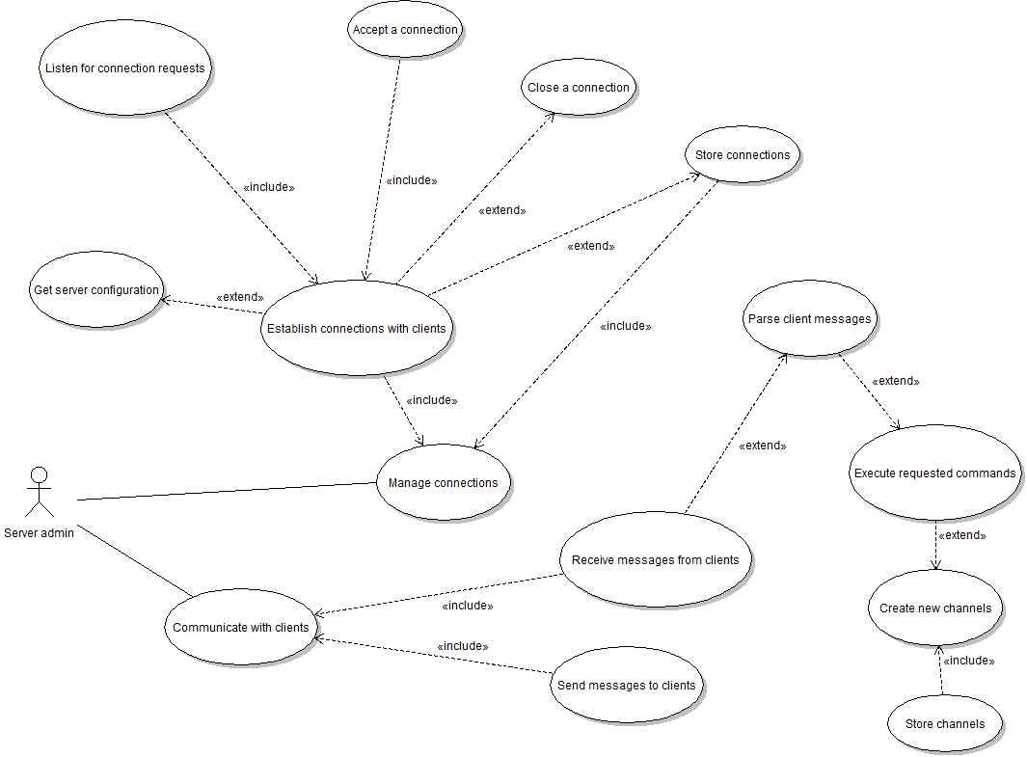

Appendix C - Figure 1: Server use case diagram

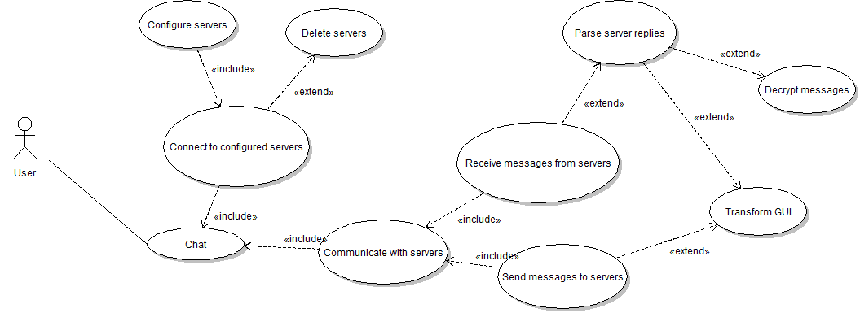

Appendix C - Figure 2: Client use case diagram

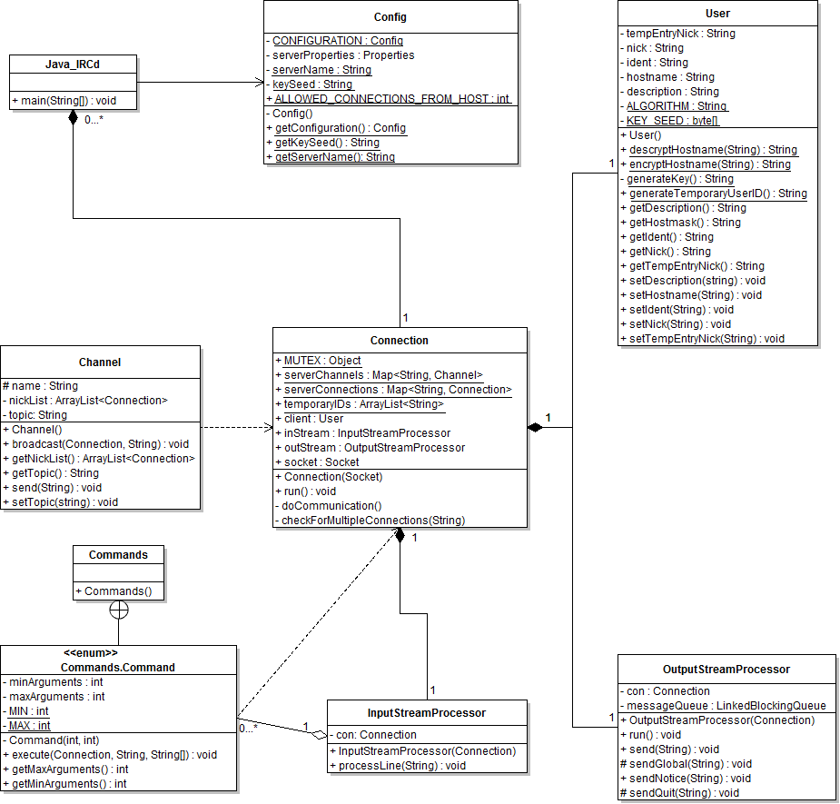

Appendix C - Figure 4: Server class diagram

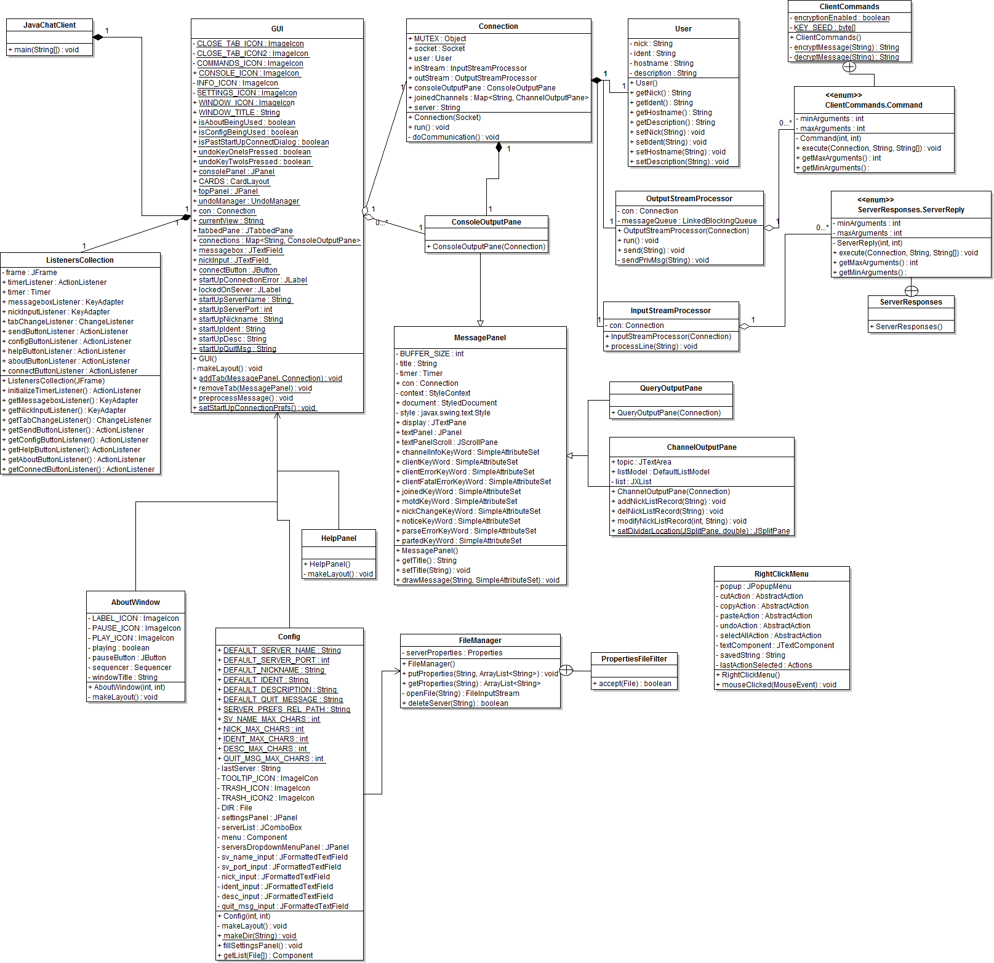

Appendix C - Figure 5: Client class diagram
Appendix D. Front-end screen shots

D.1. Client GUI screenshots

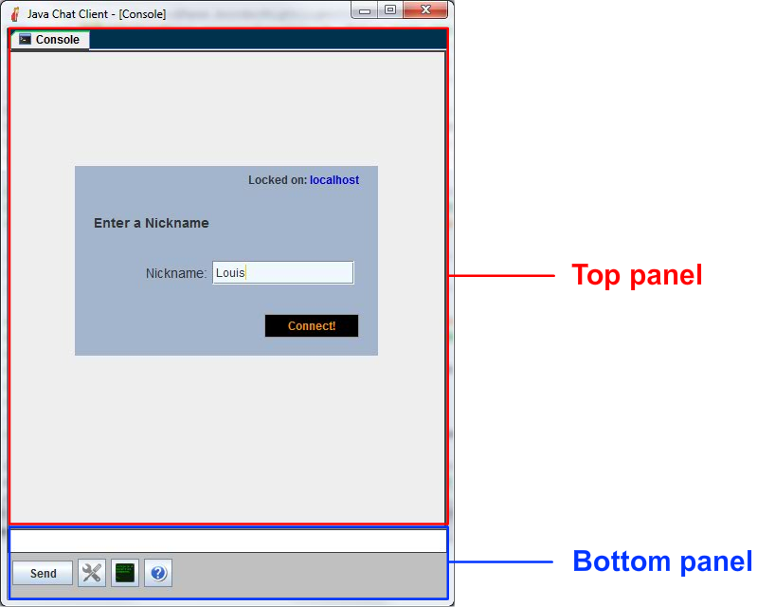

Appendix D - Figure 1: “Main panels” Screen

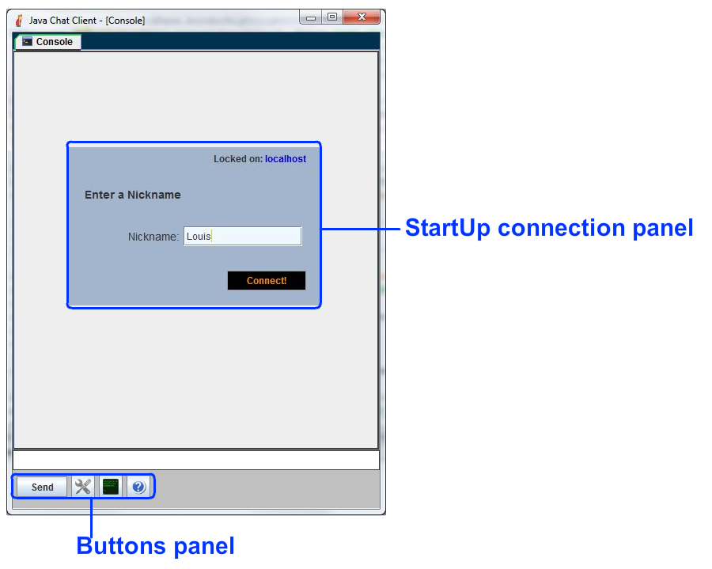

Appendix D - Figure 2: “StartUp” Screen

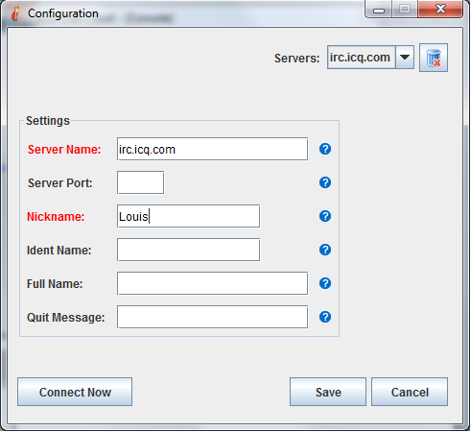

Appendix D - Figure 3: “Configuration” Screen

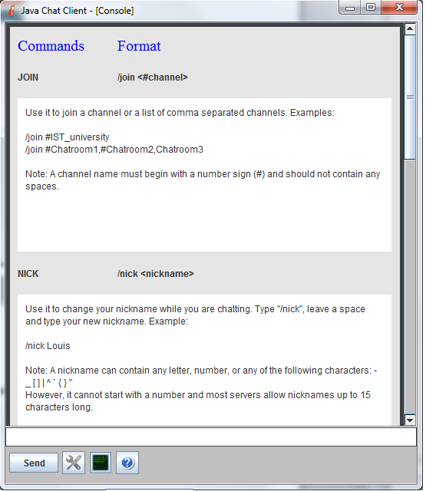

Appendix D - Figure 4: “Help panel” Screen

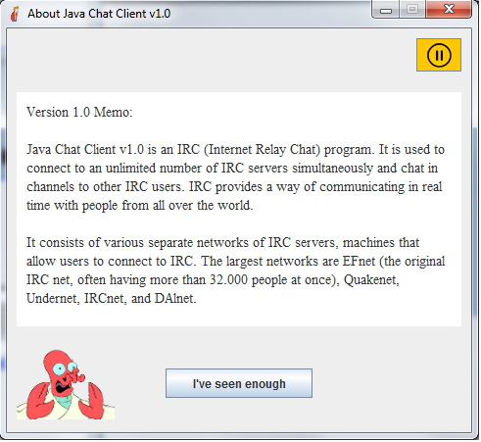

Appendix D - Figure 5: “About” Screen

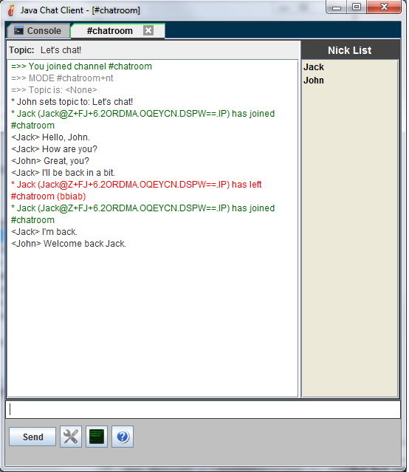

Appendix D - Figure 6: “Chatting in a chatroom” Screen

D.2. Website and Applet screenshots

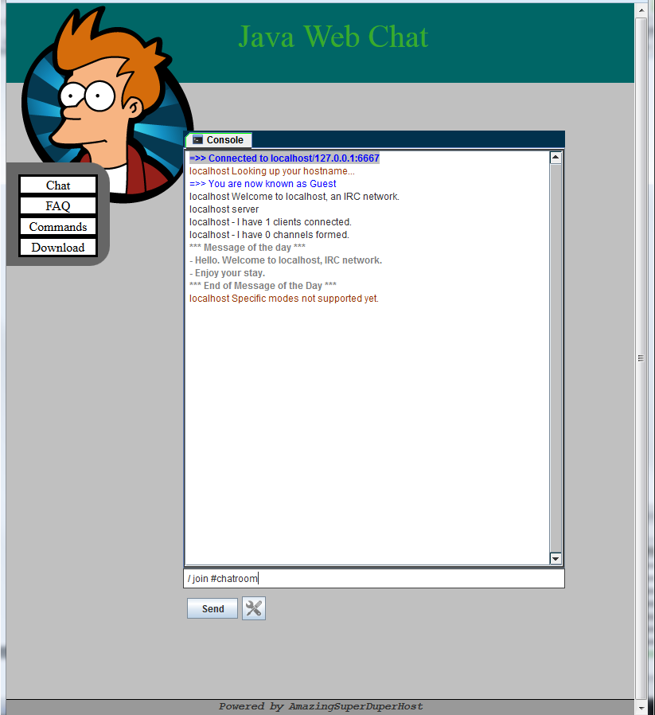

Appendix D.2. - Figure 1: “Applet” Screen

Appendix E. Installation and setup
E.1. CD contents
Into the CD the following folders are located:
- Source Code Folder: containing all the project source code
- Diagrams Folder: containing the UML diagrams
- Screenshots Folder: containing all the screenshots of the programs
- Fpr_Geromitsos_Loudovikos.doc : the present document
- DPP Folder: contains the Detail Project Proposal

E.2. Using the System

The server can be switched on and off. Run the program in order to be able to connect to it with your preferred client.

This client is used like any other IRC Client.

Declaration Statement
UNIVERSITY OF HERTFORDSHIRE
School of Computer Science
BSc Honours Computer Science Specialist Project

Year: 2012 - 2013.

STUDENT’S NAME: ………………………………………………………………

Declaration
I certify that this assignment is my own work, that it has not been copied from elsewhere, that any extracts from books, papers, the internet or other sources have been properly acknowledged as references or quotations. In my project deliverables, where-ever I use information from any source such as book, paper, internet, fellow students, I have included a reference to that source. I have done this even if I have put the information in my own words.

Where I use the exact words of another (maybe with omissions) I have put the section in quotation marks and included a reference to the source.

In addition, I agree that this assignment may be subject to electronic analysis for the detection of collusion, plagiarism and other forms of unfair advantage.

All the material delivered for assessment is the property of the University, and is considered as Public material. The University has the right to publicize in any appropriate way, including electronic means.

All the programs and the code submitted are to best of my knowledge, free of any viruses, Trojans, or any kind of “hidden” code. All databases and other utilities are free of passwords and other protection mechanisms that make them inoperative to other users, unless these are explicitly stated in my report.

I am aware of the duty to seek ethics approval should my project require it.

I have read and understood the “Guidelines to Students on Examination Offences, Plagiarism and Collusion”.

Signature of Student:

Date:

