# Sudoku Solver

Sudoku is a puzzle with a 9x9 grid. Each grid is separated into 3x3 squares, columns and rows. The goal of the game is to fill the grid with numbers from 1 to 9 within certain restrictions: numbers should not be repeated in the 3x3 squares, the columns or the rows. When drawn, an unsolved sudoku will look like this:

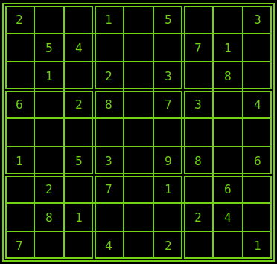 To solve such a puzzle a human would carefully look at all the already filled cells and fill the ones where there aren’t many options or preferably only one. However to program such a _____ would be tedious and unnecessary. A simpler solution would be to go through all the empty cells one by one and check whether we can put any of the numbers from 1 to 9. If so we put the number and continue onto the next cell.

This can be achieved pretty easily by looping through all the cells and also the numbers 1-9 for each of them. The we check whether the cell can be put into that specific cell of the sudoku. If so we insert it otherwise we go on to the next cell.

The algorithm would look something like this:

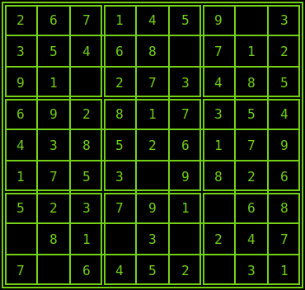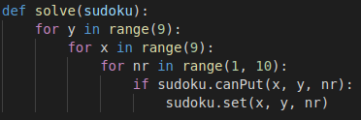

However with this approach we quickly run into a problem where some of our cells are being left empty. This is a result of a cell going through all the values and not finding any that fit that specific cell. Does that mean that the sudoku has no solution? No. It just means that we have hit a dead end and that one or more of the values we put in the previous cells needs to be changed. With the current approach of using for loops to go through all the cells it would be hard to make a system to go back to previous cells (though not impossible). It is much easier to make our function recursive to go through each of the cells and when we hit a dead end we just return to the previous call of the function, I.e. the previous cell.

Our new function looks like this:

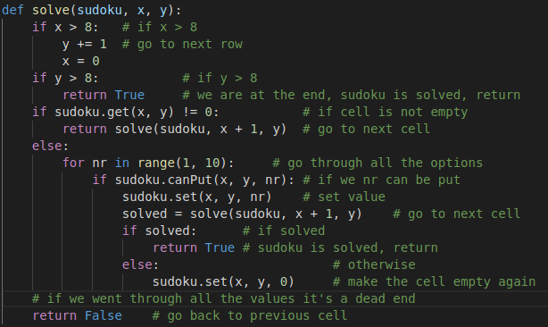

When executing this new function we get the desired output:

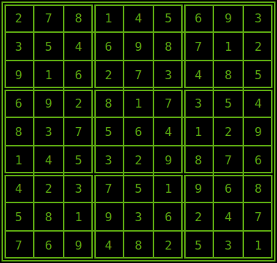

# **Notes**

- To run the project execute the python script main.py. The program will present you with a prompt and ask you to enter a command. All the commands will be listed on the right of the grid. If you need any help with the commands type `help <command>` to show help about any command.

- Otherwise if you just want the solving algorithm without the prompt there is a script solve.py which will load the test.sdk file present on the project and solve it.

- The algorithm for solving the sudoku in main.py and solve.py are a bit different because of some implementation details but the logic is still exactly the same.

- If you find this project on github it’s because I put it there and not because I plagiarized :) . My username is peTheProgrammer. Repository: <https://github.com/peTheProgrammer/Sudoku>