Lesson 1 of 7
Introduction
👋 Welcome, GenAI Pioneer!

At L'Oréal, our AI journey is rapidly evolving. We started with the powerful Generative AI of the L'OréalGPT Standard Chat, but today, we are moving towards a more powerful future: Agentic AI.
This journey progresses from simple chat to specialised agents, the L'OréalGPT Métier Companions. To lead this transformation, we need YOU, to become a key player in this revolution.

Your Roadmap: The 5-Phase Lifecycle
Bringing a Métier Companion to life is a structured journey. This 5-phase lifecycle is your roadmap to success!
Throughout this journey, keep in mind that change management is key and must be applied at every step.
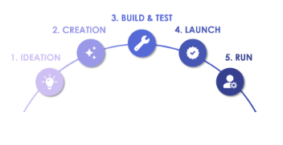
The Dream Team
In the world of Métiers Companions, success relies on the collaboration of 4 distinct roles. Each persona brings a unique expertise to the table.
Companion Owner: The Project Manager
The one responsible for the Companion throughout its lifecycle and associated change management.
They also animate these communities:
- Admins, who help the Owner in editing and updating the Companion
- Testers, who give feedbacks during the BUILD & TEST phase
- Users, the target audience

GenAI Métier Champion: The Strategic Leader
They represent a specific Métier at Global level for all Companions within their scope. They validate the Companions creation and go-live, ensuring their business value.
🔗List of GenAI Métier Champions
GenAI IT Champion: The Technical Expert
As members of the Agentic Line-Up, they are the key partner to advise and support the Companion Owner on all technical aspects.
🔗List of GenAI IT Champions
GenAI Core Team: The Global Overseer
This central team monitors all Companions, manages the L'OréalGPT evolution, and supports the worldwide scaling of GenAI.
They also animate the Champions and Companions Owners Communities.

Before embarking on the journey, it is essential to know the key partners who will accompany you:
🔗 List of GenAI Métier Champion
🔗 List of GenAI IT Champion

Lesson 2 of 7
1 - IDEATION: From idea to project
👋 Welcome to the first step of our journey!
It’s where we move from a business problem to a clear, validated Companion initiative.
What is a Companion?
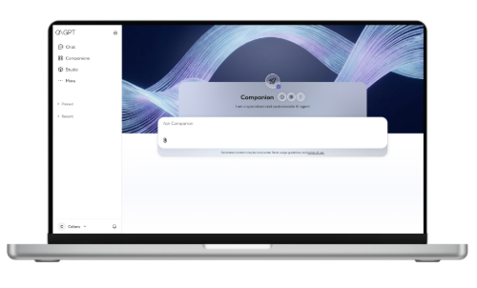

Companions are customisable AI Agents on L’OréalGPT. They can help to:
- Automate content creation, analysis, or data retrieving
- Guarantee consistency & save time on repetitive, structured business tasks
- Boost efficiency & quality by minimizing manual formatting and routine work
There are 3 types of Companions:
- Métier Companions are developed for particular job functions or departments, providing tailored expertise and resources to whole teams.
- Companions meet the very specific needs shared by a small team. They can be shared among up to 25 collaborators.
- My Companions let individual users personalise their own AI assistant for their personal daily tasks.
Up to 10 per collaborator!

 | Métier Companion: Specific to Métier | Team Companion: Specific to your Team | MyCompanion: Specific to You
Creation Cost | ✅ Free | ✅ Free | ✅ Free
Code skills | ❌ No need | ❌ No need | ❌ No need
Users | ✅ Unlimited | ✅ Up to 25 users | ❌ No sharing (or switch into a Team Companion)
Creation on L'OréalGPT | ❌ Only via a Service Request in MyServices | ✅ On "Studio" or starting from a MyCompanion | ✅ On "Studio"
Validation process | ✅ Métier Validation | ❌ No validation needed | ❌ No validation needed
Do's & Don'ts | ✅ Terms of Use of L'OréalGPT | ✅ Terms of Use of L'OréalGPT | ✅ Terms of Use of L'OréalGPT
Today, we are focusing on Métier Companion
What are the Métier Companion's Capabilities?
A Métier Companion is highly configurable. Here are the basic capabilities:
Instructions (System prompt)
Design tailored instructions that defines the Companion's behavior, scope, and response format.
Files Upload
Give the Companion up to 10 files in its Documents to provide more context or a template to follow, and up to 1000 documents in its Library (working with AKS).
Web Search
Allow your companion to search the Internet if the user wants to obtain up-to-date information.
AI Model
Choose which model you want to empower your companion with, based on their specific characteristics (thinking mode, accepted file types…)
User Experience
Support your users by completing your Companion's profile page (name, descriptions, feedback form, contact email, tutorial, announcement banner, background image...)
Accuracy Score
Evaluate the quality of your Companion by running automatic tests on a Q&A dataset.
Apps Connections
Activate the apps connections in order for the Companion to understand and act in your L'Oréal Workspace (Confluence, Outlook emails & calendar, Microsoft To Do, People & Organisation, OneNote, Teams...)

What are the Companion's Advanced Capabilities?

Advanced Capabilities
Enhance a simple Companion with Agent Tools to create a Companion with Advanced capabilities.

Tools are function calls that connect your Companion to external data sources or applications, unlocking powerful, specialized capabilities. Today, Advanced Capabilities are available on L'OréalGPT for Métier Companions:
- 📚 Agentic Knowledge Search (AKS) - formerly RAG
- 📊 Conversational Analytics (SDDS)
- 📱App Connection - with Model Context Protocols (MCPs)
The following sections focus on these capabilities.

SOON! Companions Agentic System
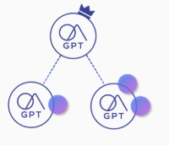
This is the future of Agentic AI, where multiple specialized Companions can collaborate to solve a complex problem, orchestrated by a Master Companion. Coming in 2026!
Focus on 📚 Agentic Knowledge Search Capability
📚 Agentic Knowledge Search Capability transforms a Companion into an expert chatbot.
It allows users to ask questions in natural language and get reliable answers sourced directly from a large library of text-based files (PDFs, PowerPoints, Words.) uploaded by administrators.
Technically, this capability is provided by Agentic Knowledge Search (formerly RAG). An agent is reading all the names and descriptions of the documents inside the Library, and retrieve answers from the most relevant ones.

When to use it? This capability is ideal for:
- Q&A Use Cases: Instantly answering frequent questions about one specific topic/documentation.
- Large Knowledge Bases: Useful for extensive collection of documents (>10 files, up to 1000 files).
- Text-Based Content: The tool is designed to work better with textual information (no Excel or complex schemas)
Exemple of Live Companions:
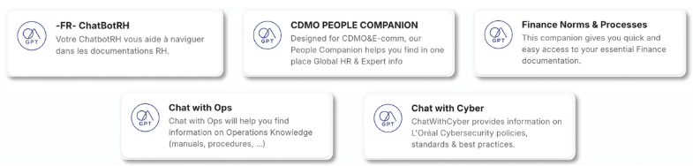

Focus on 📊 Conversational Analytics Capability
SPECIFIC AUTHORISATION REQUIRED FOR ANALYTICS COMPANIONS
Please note that Conversational Analytics Advanced Capability requires CDAO involvement.
⚠️CONTACT YOUR GENAI DATA PARTNER & METIER CHAMPION(opens in a new tab)
⚠️CONTACT YOUR LOCAL CDAO for initiative validation
⚠️ DAPA VALIDATION
📊 Conversational Analytics Capability transforms a Companion into a Data Analyst Assistant.
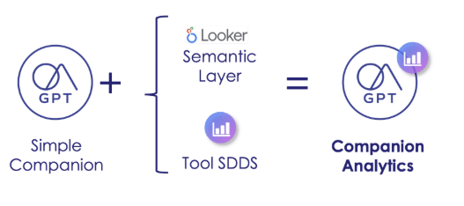
Powered by a connection to the Beauty Tech Data Platform (SDDS/CDS) and a Semantic Layer (LookML), it allows users to query complex datasets and generate visualizations using simple, natural language.

When to use it? This capability is ideal for:
- Data Exploration: Quickly finding specific figures, trends, and insights within SDDS.
- Instant Visualization: Generating graphs and charts on the fly to support analysis and presentations.
- Democratizing Data: Enabling non-expert users to access and understand business data without technical BI skills.
Exemple of Live Companions:
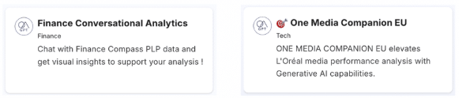
Focus on📱App Connection (or "MCP")
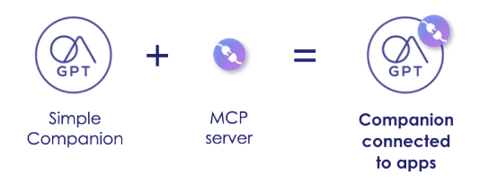
📱App Connection transform a Companion into a connected agent that understands and acts in your L'Oréal workspace.
App connections are available natively for all Companions, and can be activated directly in the Companion settings.
It allows users to ask questions in natural language to:
-get reliable answers sourced directly from their apps (Outlook, Confluence, OneNote etc.)
-request actions to be performed inside their apps (e.g., send an email, schedule a meeting etc.)

Technically, this capability is provided by Model Context Protocol (MCP). It is a universal connector that allows the AI to 'act' and 'talk' directly to apps.
Note that your IT team can develop specific MCP servers on the Agentic Platform.
Is a Métier Companion the right solution?
As seen above, Métier Companions are powerful - but not always the answer!
How many boxes does your use case tick? ✅
- You want to automate a repetitive, structured and text-based task or process a large quantity of data.
- Your use case relies on specific, internal knowledge (like internal processes, brand guidelines, expert documents...).
- Your solution requires language and reasoning, not just precise mathematical outputs.
- The user experience should be within the L'OréalGPT interface.
- Your target audience is a large group of collaborators (>25 employees).
- You have clear objectives and expected benefits for this Companion.
- You have all the necessary documentation, and it's organised, accessible and contains no personal data.
- You are ready to dedicate the necessary time and resources to build, test, and maintain the project.
... If you have checked all the boxes, then there is no doubt: Métier Companion should be the right solution!
Preparing Companion Creation
Once the Companion solution is chosen, the final step of Ideation is to prepare for a successful kickoff - follow these steps:
Numbered divider1
IDENTIFY THE KEY PLAYERS
Before starting, it's crucial to assemble the core team that will drive the project forward. Ensure the following roles are assigned:
- •
Companion Owner(s): The project manager responsible for the Companion's entire lifecycle and associated change management, AND a delegate.
- •
Admins: The people who will have the rights to build and configure the Companion in the Studio, in addition to the Companion Owner.
- •
Beta Testers: A dedicated group of users who will test the Companion and provide feedback before its official launch.
Numbered divider2
COMPLETE THE PRE-VALIDATION FORM

To begin, the Companion Owner must fill out the 🔗Métier Companion Pre-validation Form.(opens in a new tab)
This form helps to structure the project's scope, objectives, and expected benefits. It also confirms that a Métier Companion is the right solution for the business need.
Need help? Your GenAI IT Champion may give you expert advice during this ideation phase.
🔗 List of GenAI IT Champion
Numbered divider3
VALIDATE THE IDEA WITH YOUR GENAI MÉTIER CHAMPION
The completed Pre-Validation form must then be presented to the GenAI Métier Champion. Their official validation is a mandatory prerequisite before requesting the Companion's creation.
🔗 List of GenAI Métier Champion
Let's test your understanding...
Requires a correct answer to continue
1/3 A marketing team wants an AI tool to help them draft social media posts for the entire brand. It must always generate posts following strict templates and tone of voice. What is the most efficient solution to propose?
A Métier Companion with Knowledge Search (RAG).
Tell the team to use the Standard Chat of L'OréalGPT for this task.
A Métier Companion, with a detailed system prompt. (good answer)
A Companion is not the right solution. (good answer)
SUBMIT

Requires a correct answer to continue
2/3 A collaborator wants an AI that can open their Excel file, apply complex formulas across several tabs, and automatically generate a pivot table from the results. What should you recommend?
A Métier Companion, with all the calculations in the system prompt.
A Métier Companion with Conversational Analytics Capability.
Suggest uploading the Excel file into the Standard chat.
Advise that a Companion is not the right tool for direct Excel file manipulation and precise calculations. (good answer)
SUBMIT

Requires a correct answer to continue
3/3 A collaborator is starting a complex study based on 10 articles (PDFs). They need a personal assistant to help them; they will have to carry out numerous iterations over several months to complete this research. What is the most efficient solution for them?
Suggest they use CreAITech to analyze the documents.
A Métier Companion, configured with a detailed system prompt and the 10 uploaded files.
Use the L'OréalGPT Standard Chat and upload the articles in one conversation.
Guide them to create their own "MyCompanion"
SUBMIT

2 - CREATION: The official kick-off
The team is ready, the idea is validated ✅
Welcome to the Creation Phase! This step turns your validated concept into a real, tangible DRAFT Companion inside L'OréalGPT. Let's discover the 3 important steps for this phase:
- 1
Create Admins & Testers Groups in ServiceNow
- 2
Submit a Service Request in MyServices
- 3
Access to DRAFT Companion
Groups Creation in ServiceNow
Before we can create the Companion, the Companion Owner, is responsible for creating 2 user groups in ServiceNow (with potential assistance from the GenAI IT Champion) :
- Admins Group: those who will build/manage the Companion.
- Testers Group: those assisting during testing.

How to create a Companion's Group?
Access the right Service request
The process is managed through ServiceNow. Here is the step-by-step guide.
First, navigate to the correct Service Request in ServiceNow. The path is: MyServices > IT Services & Equipment > BTDP Google Group Creation. Direct link here(opens in a new tab).
Group Nomenclature
You will need to provide four key pieces of information:
- IT Organisation: Select the IT Organisation the Companion Owner belongs.
- Name of the group: Enter the name following the nomenclature:
⚠️ For Admins Group: GENAI-[COMPANION_NAME]-ADMINS
⚠️ For Testers Group: GENAI-[COMPANION_NAME]-TESTERS
Owners & Members
⚙️ Group Owners: Owners manage the group's membership. This role must include:
- The Companion Owner (you).
- Your GenAI Métier Champion (mandatory for validation).
👤 Group Members:
- Admins: Add users who will help you build and configure the Companion
- Testers: Add users who will test and validate the Companion's performance before launch + your GenAI IT Champion (mandatory).
It will always be possible to add/remove members from the group after it has been created, using the Security Groups & Distribution Lists Management SR
Submit & Verify if the group is created
Submit the form. The requester receive a confirmation email once the action is completed.
If you have any doubts, you can check that the group has been created successfully:
- Go to the list of GCP Groups(opens in a new tab).
- Type your group's name in the search bar.
✅ If your group appears: Success! It has been created correctly.
❌ If your group does not appear: There was a problem during creation. Please report an incident in ServiceNow on the Active Directory application(opens in a new tab) requesting "eplication of your account to Google Cloud Platform.

How to create a Companion's Group?
The process is managed through ServiceNow. Here is the step-by-step guide.
START
Submit the Creation Service Request in MyServices
With the groups created, the Companion Owner must now formally request the creation of the Companion by submitting a Service Request on My Services:
🔗 Service Request - Create a Métier Companion

After submission, the GenAI Métier Champion will receive the request and approve or reject it.
The Companion Owner is kept informed of the status of their request at all times by going to My Tickets(opens in a new tab) on My Services.
Access DRAFT Companion
After approval, the Companion is automatically created on L'OréalGPT. It is tagged “DRAFT” throughout the BUILD & TEST phase, until it is ready to go LIVE.
COMPANIONS PAGE (EXPLORE)
To begin testing, both ADMINS and TESTERS can now access the Companion from the Explore page.
STUDIO PAGE
The Studio section is exclusively for ADMINS (and Companion Owners). Access it from the left menu to build the Companion.

Let's test you understanding...
Requires a correct answer to continue
1/1 To successfully complete the Creation Phase and have your DRAFT Companion created, which of the following actions are absolutely required?
- Build a first Proof of Concept using "MyCompanion".
- Have the GenAI Métier Champion validation. (good answer)
- Create an Admins group in ServiceNow. (good answer)
- Create a Testers group in ServiceNow.
- Put all your target audience in the Testers group.
- Upload the Companion's knowledge documents to a SharePoint and include the link in the request.
- Have the Service Request approved on My Services. (good answer)
SUBMIT

3 - BUILD & TEST: Customise a reliable Companion
Welcome to the most hands-on phase of the journey! 🤝
This is where we transform the DRAFT Companion from an empty shell into a smart, reliable AI agent. It's an iterative process of configuration, testing, and refinement.
Overall Process
The goal is clear: to build, test, and refine the Companion until it meets the highest quality standards, ready for its users.
Find below the step-by-step process of the BUILD & TEST phase:
- Step 1
Discover the Admin Page
The first task for the Admins is to familiarise themselves with their new workspace. They must go to the L'OréalGPT “Studio” to find and explore the companion's administration page.
To help with this, a guided tour launches automatically on the first visit.

- Step 2
Configure and Customize
The Admins will now write the Instructions (system prompt), upload the knowledge documents, and choose the best settings to reach the target Companion's behaviour.
The GenAI IT expert is to provide advice and best practices for each of these actions.

- Step 3
Test the Companion's Quality
Once the first version is built, it's time for testing. The Companion Owner has two essential methods for this:
  - Quantitative Testing: Using the Automatic Evaluation tool to get a precise, objective accuracy score (⚠️Some use case are not yet supported by Automatic Evaluation. See below for more details).
  - Qualitative Testing: the DRAFT Companion is accessible for the group of Testers to collect real-world feedback on usability and relevance.

- Step 4
...and iterate!
Based on the results from both automated tests and user feedback, the Companion Owner will go back to Step 2, refine the configuration, and then re-test.
This "build-test-refine" loop is repeated until the Companion consistently achieves the minimum 80% accuracy score and/or meet the expectations of the testers.

Let's deep dive!
Now that you have an overview, let's dive into the most critical parts of this phase. Read through the next few sections to find answers to all your questions!
⬇️ ⬇️ ⬇️
How to write good Instructions?
The Instructions, also called System Prompt, are the Companion's brain 🧠. It's the most critical part to define its behavior, tone, and skills.
Let's use the C.R.A.F.T. method to structure it perfectly!

🎯 CONTEXT (WHY)
Give the Companion the essential background it needs to respond accurately, just like you would brief a new intern!
Exemple: Project goal, current challenges, entity's specifics, key concepts...

🎭 ROLE (WHO)
Assign a specific persona to the Companion. Define who or what do you want it to be in the conversation.
Exemple: HR assistant, creative copywriter, formal financial analyst, IT expert...

✅ ACTION (WHAT)
State the precise task(s) for the Companion to perform. Use clear, unambiguous action verbs.
Exemple: Summarise key findings, generate 5 taglines, extract the action plan...

🎨 FORMAT (HOW)
Specify the exact structure of the desired output to make it immediately usable.
Exemple: as a markdown table, in the form of an email, in English, very formal...

🔄 TRY
A System Prompt is a living document. Test, analyze the output, and refine the instructions.
Exemple: Add a control step to limit hallucinations, define the out-of-scope handling...

For example, here is a correctly written and clear System Prompt for the "L'OréalGPT FAQ" Companion:
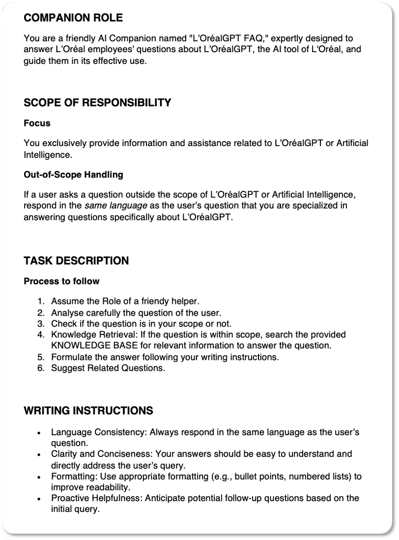

TIP#1 - Don't want to start from a blank page?
Use the Instructions Generator by clicking the ✨ icon. It will guide you through the CRAFT principles to build a solid prompt step-by-step.
Use also the Instructions Rewriter to modify only the selected part of the instructions!
TIP#2 - Power-Up your Instructions with variables
Make your prompt dynamic by adding variables. These placeholders, like {user.country} or {current_date}, automatically insert contextual data to tailor your Companion's responses.
How to Add Variables?
In the Instructions box, simply type { or click on the icon circled in red. A menu will appear, allowing you to select from a list of available variables.
How to incorporate them properly in your Instructions?​
- Declare the variables at the beginning of your instructions.​
- Write your conditional rules.

How to chose the best model?
Why have a choice? Each model offers a unique trade-off between speed, reasoning complexity, skills, and cost. It directly determines which advanced settings are available.
You can see these specifics at a glance in the "LLM Model" dropdown:

Short description highlights the strengths of each model.
Small icons (🌐, 📎, 💡) next to each name instantly show you which settings it supports.
Model | Strenghts | Supported file types | Thinking steps | Web Search
Gemini 3.1 Pro | Polyvalent, complex reasoning | - TXT, PDF, DOC, PPT & Email (max 52Mo)  - Image (max 52Mo)  - Audio (max 1M token or 8hours)  - CSV (max 305Ko)  - Video (max 45min with audio 1hour without) | Always activated | ✅
Gemini 3.6 Flash  Gemini 3.5 Flash  Gemini 3.5 Flash Lite | Fast & efficient  Eco-friendly 🌱 |  | Yes and can be deactivated | ✅
GPT 5.6 Terra &  GPT 5.4 | Creative, Research | - Image (max 20Mo) | No | ✅
Claude 4.6 & 5 Sonnet | Code, Mathematics | - TXT, PDF, DOC, PPT & Email (max 52Mo)  - Image (max 52Mo) | Yes and can be deactivated | ✅
DeepSeek  🇨🇳 For China only  ⚠️ Not available for Companions yet | Polyvalent, Chinese language | N/A | Yes | ✅
Let's see if you can match the need to the right model!
Match the need to the right model!
- My goal is pure creativity.Selectable item
- The Companion needs to generate a Python script and perform complex logical calculations.Selectable item
- The users need to compare Videos & PDF reports.Selectable item
- My main priority is to generate content that is idiomatically perfect in Chinese.Selectable item
- I want to minimise my Companion's environmental impact.Selectable item
- Gemini 3.1 ProSelectable item
- Claude 5 SonnetSelectable item
- GPT 5.4Selectable item
- Gemini 3.5 FlashSelectable item
- DeepSeek (for China only)Selectable item
SUBMIT

Which settings should I activate?
As seen just before, selecting a model gives access to some settings.
Let's see in which cases they should be activated or deactivated.

📎 Enable clipping in prompt
WHAT IT DOES:
Enables users to upload their own files directly into the chat for immediate analysis.
WHEN TO USE IT:
- Activate it for interactive Companions designed to work with user-provided files.
- Deactivate if the Companion should only use its pre-loaded knowledge, to avoid user confusion.

💡 Display Thinking Steps
WHAT IT DOES:
Structures and displays its reasoning in steps before giving the final answer.
WHEN TO USE IT:
- Activate for complex tasks to improve accuracy and aid debugging (Build & Test phase)
- Deactivate for simple tasks (e.g., translation) to reduce latency.

🌐 Enable Web Search
WHAT IS DOES:
Allows the Companion to search the live Internet for real-time information.
WHEN TO USE IT:
- Activate for tasks requiring up-to-date external info.
- Deactivate when the Companion must act as a "sandboxed" expert on internal data, to prevent unwanted external noise.

What difference between Documents & Library?
As seen previously, the 🧠 Instructions are like the Brain of the Companion. Let's focus on 2 other ways to personnalise your Companion:
📎 Documents
WHAT IT DOES:
Documents tab lets you attach up to 10 files (PDF, DOCX, PPT). The complete content will be attached to every prompt sent to the Companion.
📎 Just like attachements in an email: they are as important as the text itself in getting your message across to your recipient.
WHEN TO USE IT:
Essential references that the Companion must have at all times in order to respond correctly to the user.

📚 Library
WHAT IT DOES:
Constitutes an external knowledge base that the Companion can search to answer a specific question. The Library is powered with the Agentic Knowledge Search (AKS) tool.
📚Just like a library: you can search it to find the information you need, without having to carry everything around with you all the time!
HOW TO USE IT:
Files can be uploaded one by one, or all at the same time thank to the SharePoint folder sync.
Consult the the 🔗documentation(opens in a new tab) to follow the best practices.
WHEN TO USE IT:
Large knowledge base that the Companion does not need to know in its entirety at all times, but must sometimes be able to look up to find an answer.

Your Turn! Can you sort the following items into the correct category? Drag each item into either Documents or Knowledge.
- Document ?
- Library ?

What are the best practices for uploading files?
Whether you use the 🔗 Documents tab or an advanced 📚 Library base, the quality of your source files is paramount. The principle is simple: garbage in, garbage out!
GOLDEN RULES FOR UPLOADING FILES IN THE COMPANION:
⚠️ Minimize C3 Content
Avoid uploading highly confidential information unless strictly necessary and validated. If so, don't forget to check the “C3 - Highly Confidential” box in the disclaimer section of the companion's Profile page.
🧹 Remove Noise
Ensure documents contain only essential information. Delete irrelevant slides, boilerplate text, or purely decorative images.
✍️ Prioritize Text
Companions excel at reading text. A knowledge base of clean, well-structured text is most effective than complex schemas or tables.
⚖️ Ensure Consistency
Check for and remove any conflicting information between documents to avoid unreliable answers.
⚡️Keep it Efficient
Try to keep individual files under 50MB and under 1000 pages. Break down very large documents into smaller, more focused ones if possible.

How to automatically evaluate the Companion?
Before any Métier Companion goes live, we must prove its quality. The Automatic Evaluation tool is the best quality gate to measure accuracy.
The goal is to reach a minimum accuracy score of 80%, mandatory to LAUNCH the Companion!
Please note:
The Automatic Evaluation feature is highly effective for Companions designed to provide predictable, fact-based answers (like a Q&A bot).
However, for Companions focused on creativity, brainstorming, or tasks that require multiple user iterations, this scoring is less relevant. In these cases, reaching the 80% minimum accuracy score is not a mandatory requirement for launch.

📋 How to build a good Q&As dataset?
The Companion Owner must provide the "ground truth" by creating a list of minimum 50 questions and their expected answers. To do so, download the Q&A Template and follow these guidelines:
- Cover the Companion Scope: Questions must reflect the Companion's main purpose and most frequent use cases.
- Test the Boundaries: Include out-of-scope questions to ensure the Companion answers "I don't know" instead of hallucinating.
- Define the "expected" answer: it should be the ideal response in terms of content, tone, and format.
Now ready to launch Evaluations and track the evolution of the Companion's accuracy!
The Companion Owner needs to also conduct qualitative testing with their group of testers. This provides essential real-world feedback on usability and relevance.
How to give access to a new person (admin or tester)?
During the Build & Test phase, the DRAFT Companion is opened to a group of testers defined in the CREATION phase. They may need to add or remove people from this group as the project evolves.

How to manage members of a Companion's Group?
The process is managed through ServiceNow. Here is the step-by-step guide.
  - Access the Right Service Request
First, navigate to the correct Service Request in ServiceNow. The path is: Categories > IT Services & Equipment > Security Groups & Distribution Lists Management. Link here.
  - Fill in the Request Details
You will need to provide four key pieces of information:
    - Request type: Select "Add or remove members from list".
    - Name of Distribution List: You must enter the exact name of the Testers Group as informed in the CREATION phase (nomenclature: GENAI-COMPANION_NAME-TESTERS).
TIP: You can check the names of your groups in Access page on L'OréalGPT
    - User(s) to ADD: Type the names of the collaborators to add to the group.
    - User(s) to REMOVE (if applicable): Type the name of the employees to remove.

  - Submit and Await Approval
Once the form is submitted, a request is sent to the managers of the group. They must approve the request to finalize the changes.
    - 🔧 AFTER 48 HOURS - to verify that the group has been updated successfully:
    - Go to the L'Oréal Google Groups list using this link(opens in a new tab).
    - Go to the L'Oréal Azure Groups list using this link(opens in a new tab).
    - Type your group's name in the search bars and click on "Members".
    - If the lists are updated: Success!
    - If not, there was a problem of sync between Azure and Google during update. You can ask GPTo(opens in a new tab) to help you!

Let's test your understanding...
Requires a correct answer to continue
1/1 What are the conditions that must be met to successfully complete the BUILD & TEST phase?
- Activating all the settings available
- Achieving the 80% accuracy score (if applicable) (good answer)
- Completing the guided tour
- The Companion Owner is happy with the results
- Meeting the expectations of the Testers (good answer)
SUBMIT

