Artificial Intelligence Project#3
111550132 張家睿
- Research Question and Motivation:

- Environments:
All experiments in this study were implemented using Python 3.11. The reinforcement learning environments were constructed using the public library Gymnasium (v1.1.1), with the Arcade Learning Environment (ale-py v0.10.2) specifically utilized for the Atari tasks.
- Tasks 1: Ant-v5
Ant is a MuJoCo environment. It has continuous action space. (Link)
  - Algorithms:
In this task, I chose 4 different algorithms to experiment with the performance. They are Soft Actor-Critic (SAC), Twin Delayed Deep Deterministic Policy Gradient (TD3), Advantage Actor-Critic (A2C), Proximal Policy Optimization (PPO).
Algorithm | On/Off Policy | Action Space | Exploration | Stability | Suitable Tasks
SAC | Off-policy | Continuous | High | High | Robotic control, high exploration
TD3 | Off-policy | Continuous | Medium | High | Precision control
A2C | On-policy | Discrete/Continuous | Medium | Medium | Small-scale game
PPO | On-policy | Discrete/Continuous | Medium | High | General RL tasks, stable training
I chose these algorithms cause there’re action space is continuous, and they are easy implemented.
  - Training:
Use train_ants.py to train and use test_ant.py to show the average reward.
In the training process, the model will use EvalCallback to save the best model every 5000 steps.
python train_ant.py –algo {SAC, TD3, A2C, PPO}
All algorithms are trained in 1,000,000 timestamps.
Learning Rate: 3e-4
  - Experiments:
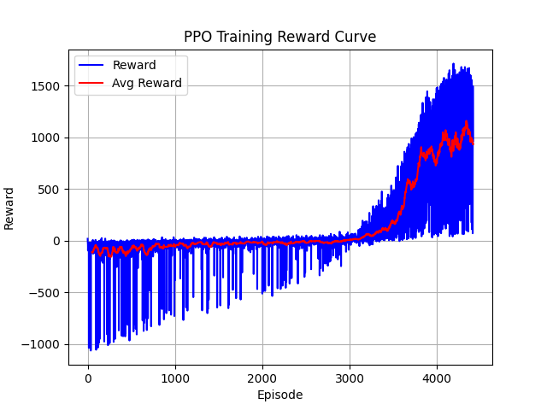
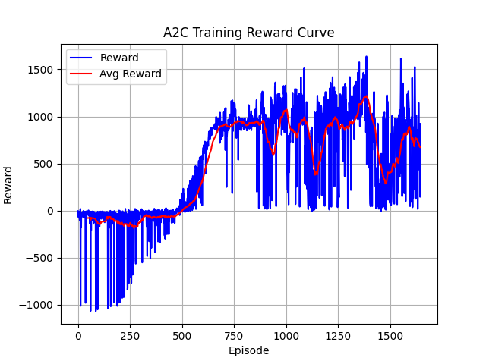
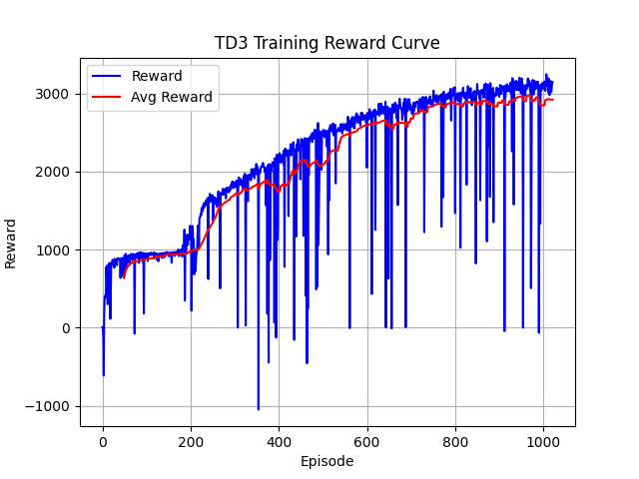
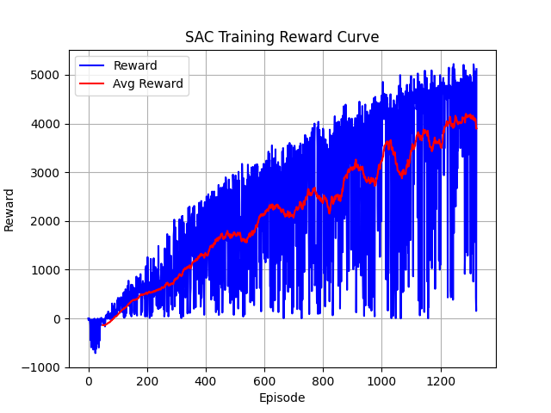
Test all the same conditions to see which algorithm can have a higher score. Below is the training curve of 4 algorithms.

  - Results:
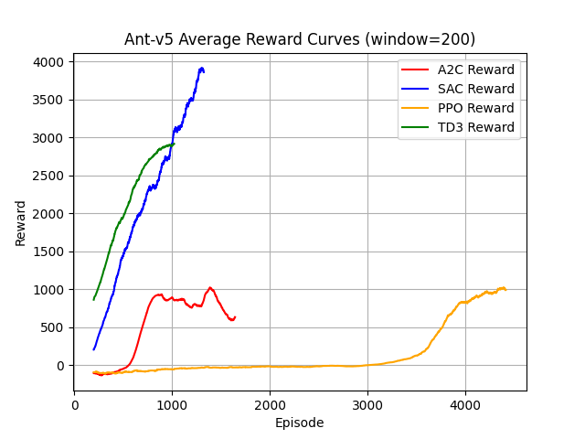
Below is the average training curve of 4 algorithms. Because four algorithms have different winning rates and same timestamps, they have different episodes of various lengths.
Use test_ant.py to test 4 models’ Reward.
A2C: 1583.1945
SAC: 4248.4953
PPO: 1257.5466
TD3: 3408.3335
The performance of four algorithms is SAC > TD3 > A2C > PPO.
  - Discussion:
When using the same length of timestamps and single environment, SAC can have the best performance in Ant-v5. However, SAC and TD3 are
off-policy algorithms, so they can’t be trained in multi environments. Maybe A2C and PPO can tie them in multi environments.

- Tasks 2: Breakout-v5
Breakout is an Atari environment. It has discrete action space. (link)
  - Algorithms:
In this task, I chose Advantage Actor-Critic (A2C), and Proximal Policy Optimization (PPO) for different experiments. The information of the 2 algorithms is listed in the Ant-v5 Algorithms.
  - Training:
Use train_breakout.py to train and use test_ breakout.py to show the average reward.
python train_breakout.py --num-envs 8 –algo {A2C, PPO} [--clip]

All algorithms are trained in 20,000,000 timestamps.
A2C Learning Rate: 7e-4
PPO Learning Rate: 2.5e-4
  - Experiments 1:
ClipRewardEnv is a wrapper that clips the rewards to -1, 0, or 1:
$$\left\{\begin{matrix}Positive rewards are clipped to 1 \\ Negative rewards are clipped to -1 \\ 0 rewards remain 0\end{matrix}\right.$$
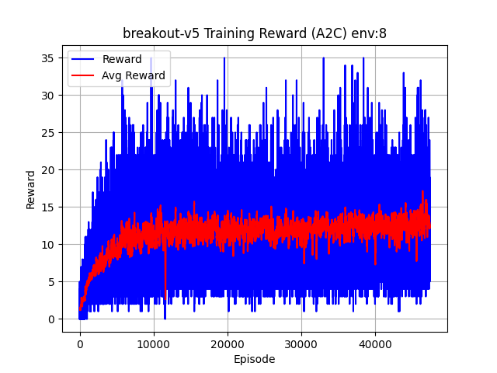
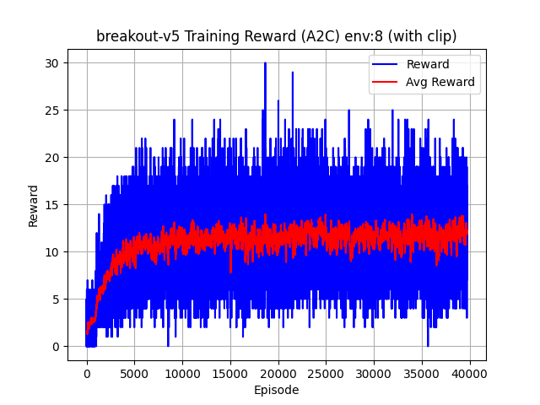
Test adding ClipRewardEnv to the model in A2C and PPO algorithms. And observe whether it can improve the score. Below is the training curve of A2C, A2C with ClipRewardEnv, PPO, PPO with ClipRewardEnv.
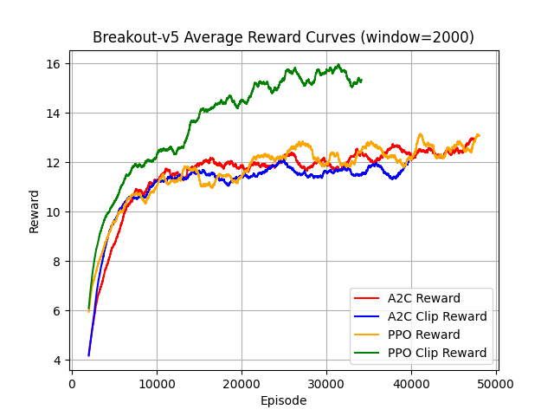
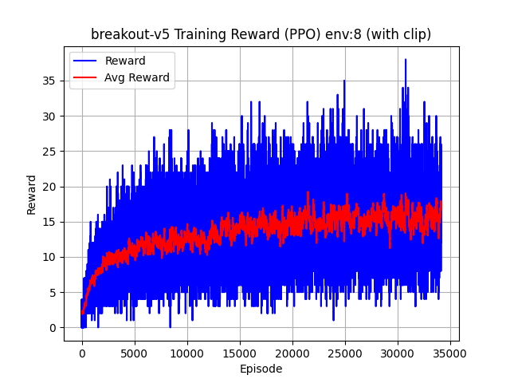
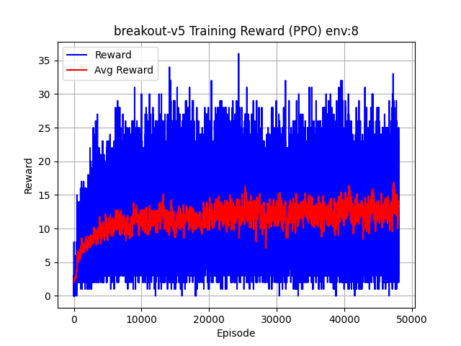
  - Results 1:
Use test_breakout.py to test 4 models’ Reward.
A2C: 16.733
A2C (with Clip): 14.233
PPO: 11.74
PPO (with Clip): 18.9
The performance of four algorithms is PPO (with Clip) > A2C > A2C (with Clip) > PPO
  - Discussion 1:
When using the same length of timestamps and 8 environments, PPO (with Clip) can have the best performance in Breakout-v5. Also, adding clip reward can improve PPO algorithm’s performance, but can’t improve A2C algorithm’s performance. However, when I checked the video clips, there was a horrible problem: the game won’t progress when the agent does not "FIRE" the ball, so it took a lot of timestamps to wait for the agent to start the game. So, I have to do another Experiments.
  - Experiments 2:
FireResetEnv is a wrapper that will automatically fire after reset. Avoid the issue when the agent didn’t press the "FIRE" key to start the game.
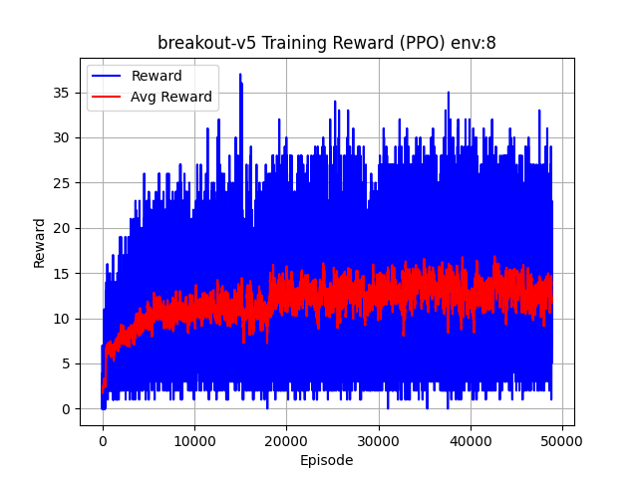
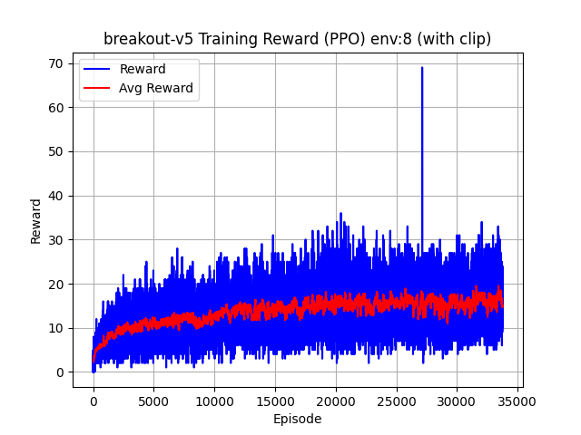
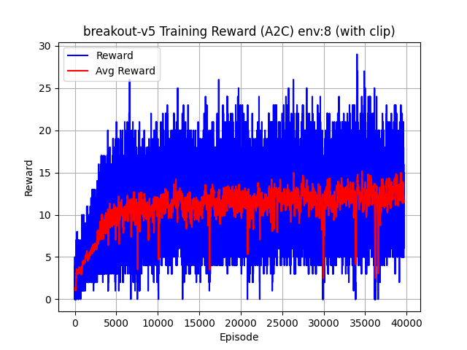
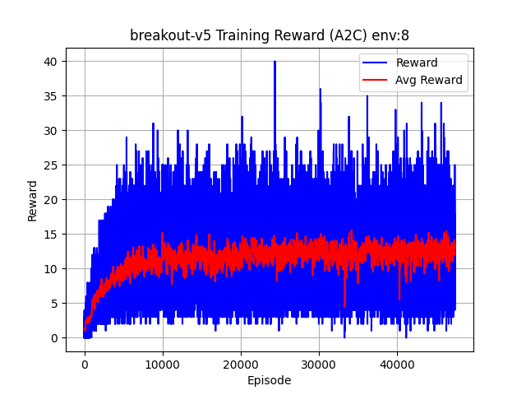
Test adding FireResetEnv to A2C, A2C with ClipRewardEnv, PPO, PPO with ClipRewardEnv 4 algorithms. And observe whether it can improve the score. Below is the training curve of 4 algorithms adding FireResetEnv.

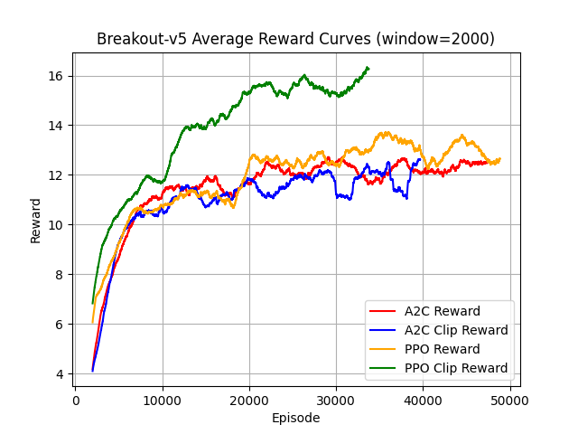
  - Results 2:
Use test_breakout.py to test 4 models’ Reward.
A2C: 14.84
A2C (with Clip): 22.38
PPO: 9.32
PPO (with Clip): 26.06
The performance of four algorithms is PPO (with Clip) > A2C (with Clip) > A2C > PPO
A2C (with Clip) switch place with A2C.
  - Discussion 2:
When using the same length of timestamps and 8 environments, PPO (with Clip) can still have the best performance in Breakout-v5. However, the previous discussion that “adding clip reward can’t improve A2C algorithm’s performance” is wrong. When adding FireResetEnv, the same length of timestamps can have move moves than before. It can be view as, not adding FireResetEnv, but enlarge length of timestamps. “Adding clip reward can improve A2C algorithm’s performance”, but it needs long enough timestamps.

- References:
[1] Claude Code was used as an AI coding assistant for implementation.
- Appendix

