Physical AI Homework 3:
A Robot Manipulation Framework
111550132 張家睿
- About task 1
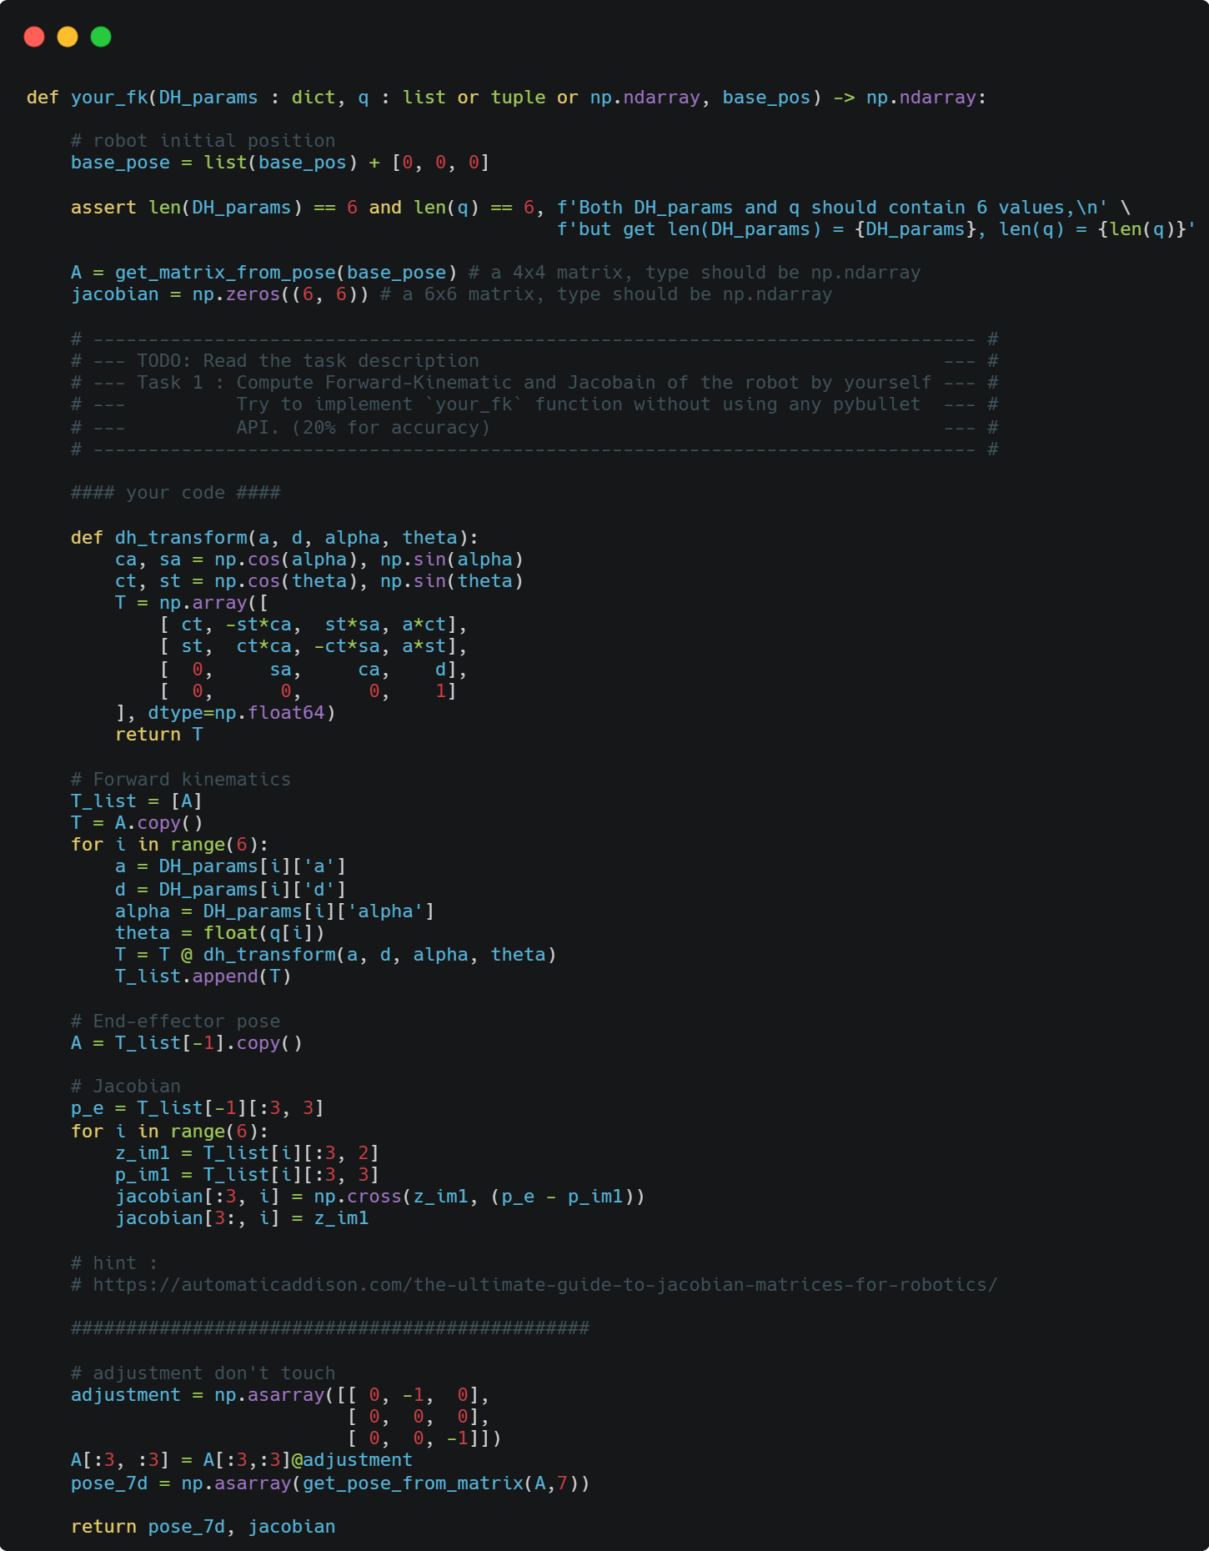
  - Briefly explain how you implement your_fk() function
Implement your_fk() by chaining classic Denavit–Hartenberg transforms from the world-to-base pose to the end-effector, then building the geometric Jacobian in the world frame. First, form T_w0 from the given base position. For each of the 6 revolute joints I right-multiply the classic DH link transform T_{i}=R_{z}(θ_{i})T_{z}(d_{i})T_{x}(a_{i})R_{x}(α_{i}), accumulating a list of world-to-frame matrices. The final transform A=T6 gives the end-effector pose. Then apply the fixed alignment matrix provided by the assignment to A_{0:3,0:3} so the tool frame matches the grader’s convention, and convert A to a 7D pose [x,y,z,qx,qy,qz,qw]. For the Jacobian, using geometric formulas for revolute joints expressed in the world frame, each column i is J_{v,i}=z_{i−1}×(p_{ee}−p_{i−1}) and J_{w,i}=z_{i−1}, where z_{i−1} and p_{i−1} come from T_{i−1} and p_{ee} is the end-effector position. The function returns the 7D pose and the 6×6 Jacobian.
  - What is the difference between D-H convention and Craig’s convention (Modified D-H Conveition)?
Classic DH and Craig’s Modified DH differ in frame assignment and parameter indexing. In classic DH, each link’s parameters (a_{i},α_{i},d_{i},θ_{i}) are defined with respect to frame i, and the link transform is ordered R_{z}(θ_{i})T_{z}(d_{i})T_{x}(a_{i})R_{x}(α_{i}). In Craig’s modified DH, the link parameters (a_{i−1},α_{i−1}) are associated with the previous frame i−1, and the transform is ordered R_{x}(α_{i−1})T_{x}(a_{i−1})R_{z}(θ_{i})T_{z}(d_{i}). So the intermediate frames and the DH tables are different and not interchangeable, even though both conventions produce the same physical end-effector pose when applied consistently.
  - Complete the D-H table in your report following D-H convention
i | d | α (rad) | a | θ_{i} (rad)
1 | d1 | π/2 | 0 | θ₁
2 | 0 | -π/2 | 0 | θ₂
3 | d3 | π/2 | a3 | θ₃
4 | 0 | -π/2 | a4 | θ₄
5 | d5 | π/2 | 0 | θ₅
6 | 0 | π/2 | a6 | θ₆
7 | d7 | 0 | 0 | θ₇
- About task 2
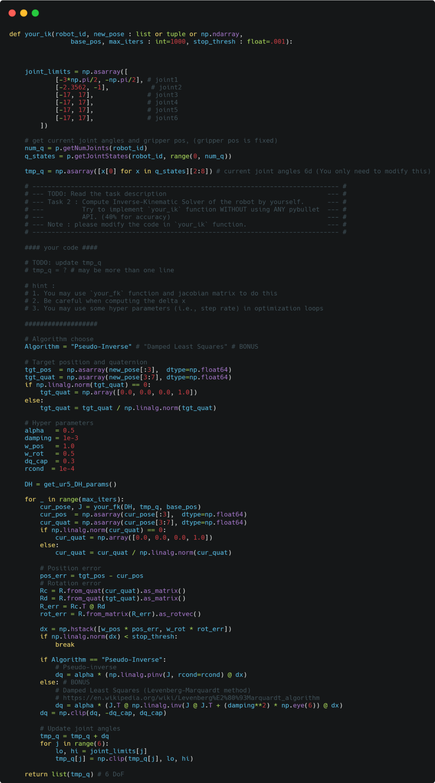
  - Briefly explain how you implement your_ik() function

Initializes the current 6-DoF arm configuration by reading joints from PyBullet, parses the target pose into position and a normalized quaternion, and sets step size, weighting, and safety caps. Next, in each iteration, it calls your own your_fk() to get the current end-effector pose and the 6×6 geometric Jacobian, forms a 6D space error by combining translational error with an orientation error computed as the rotation vector of R_{c}⊤R_{d}, and, if that error is above the threshold, computes a joint update either with a Pseudo-inverse Δq=α×pinv(J)dx or, in the bonus branch, with damped least squares Δq=α×J⊤(JJ⊤+λ²I)⁻¹dx. The update is clipped to avoid overshoot, applied to the joint vector, and hard clamped to joint limits, repeating until the error is small enough or the iteration budget is exhausted, at which point it returns the converged solution.
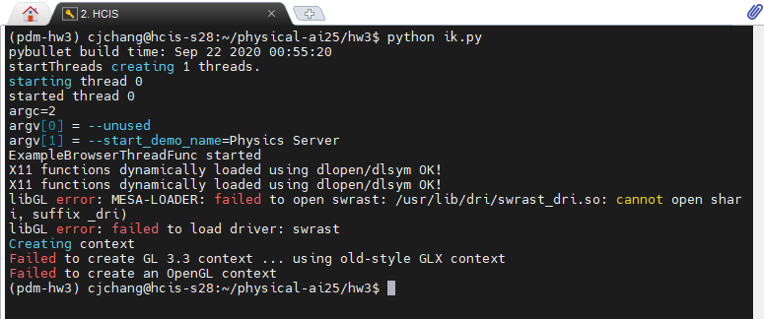
  - What problems do you encounter and how do you deal with them?
I use shh to connect to server with x11-forwarding. Normally it can shows GUI on the size of my monitor. However, it always shows up openGL issue. I solve it by replacing X11 ssh (MobaXterm) with Remote Desktop (NoMachine).
  - Bonus! Do you also implement other IK methods instead of pseudo inverse method? How about the results?
Yes, I implement Damped Least Squares(Levenberg-Marquardt method). You can change the algorithm by changing the 88th line .
Damped Least Squares is more stable and numerically more resistant to near singularities.
- About task 3
  - Compare your results between your_ik function and pybullet_ik
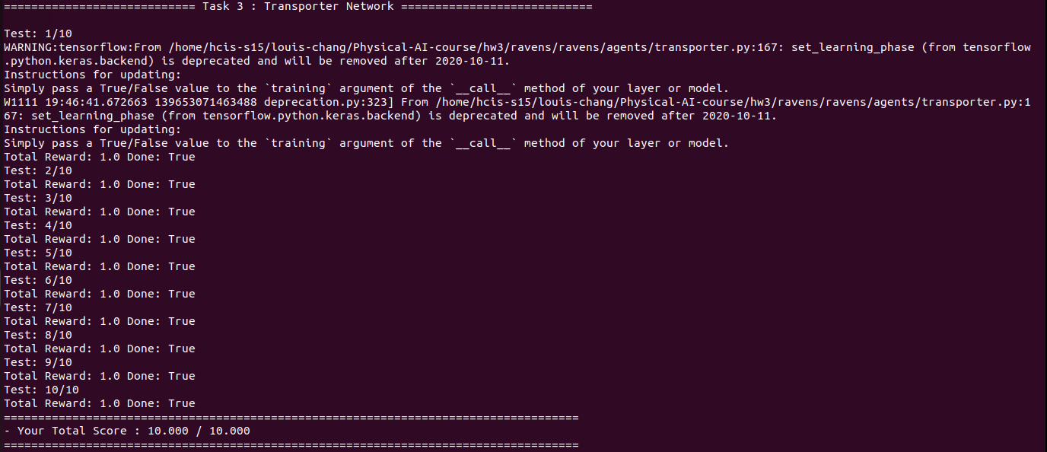
Both your_ik() and pybullet_ik() can get full point in task 3. pybullet_ik() might be a little bit faster.

