**ASSIGNMENT 01**

1. To compile a C/C++ program, firstly, we must have a source code. Then, there are three stages we need to go through:

* Pre-processing: to carry out the program’s behaviors.
  + Remove comments in the program
  + Expand the macros and header so that it is ready to be compiled.
* Compiling: to convert the source code into assembly language so that the computer can understand.
  + Return warning about any errors.
  + If an error is found, then the compilation process will be terminated.
* Linking: to link all the function calls and produce an executable or a library.
  + Link to any external libraries we want to use in the program.
  + If no errors occur, we will have an executable file or library by the compiler.

1. 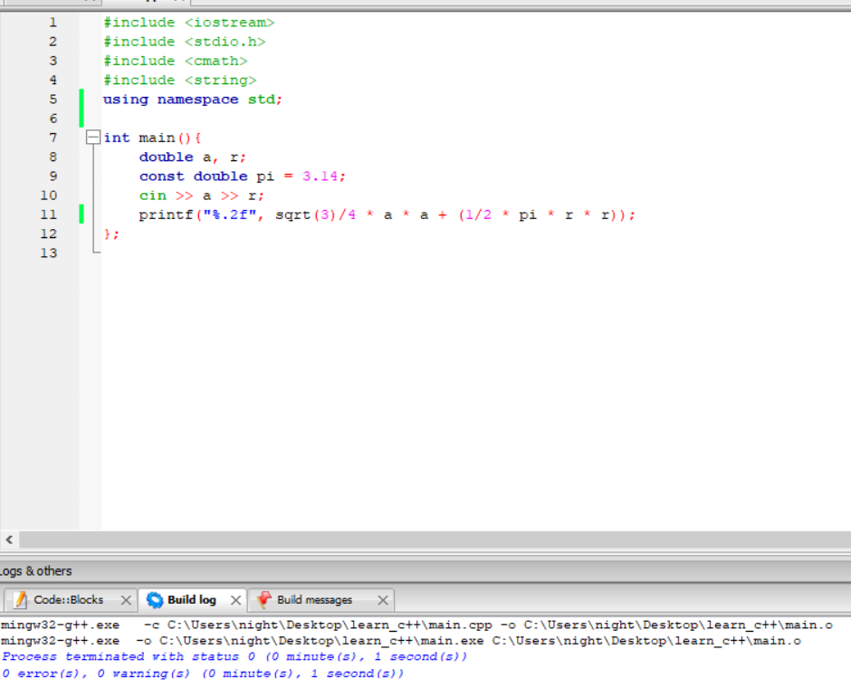I installed MinGW(GCC) in Code::Blocks. I wrote a source file, then I compiled it. It showed the compile result in the Build log.