the problem s that i have to deploy it to git hub as a web site portfollio.

we first arragen the link do the index can be outsite.

then we creted a repository from git hub so we could pass all the web site in that repository.

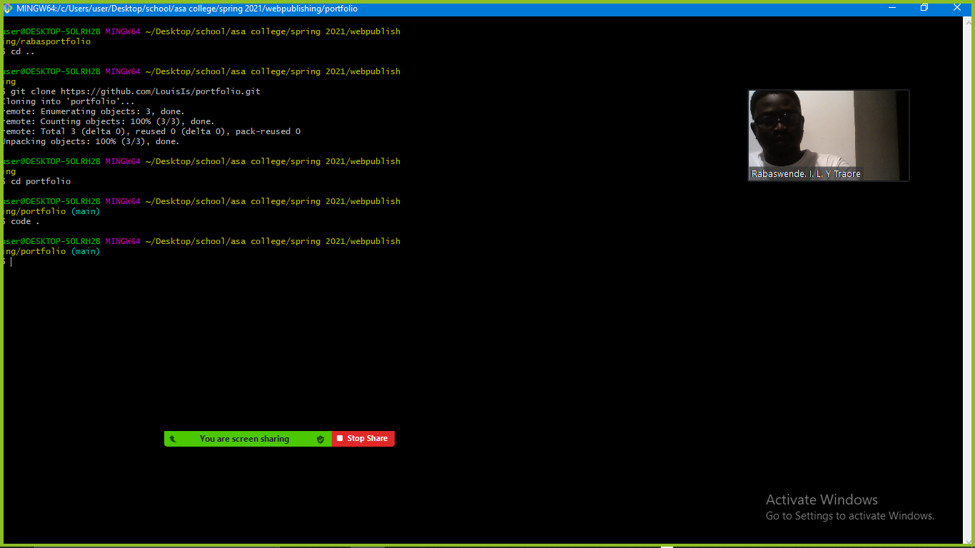

In the the code >> terminal

Git add

$ git commit -m "first commit" && git push

And wait for the result in the website