<https://www.youtube.com/watch?v=DUsOXMJQ-xw> – Occupant safe exit

***Tips for CANoe :***   
**Create a testenv :**

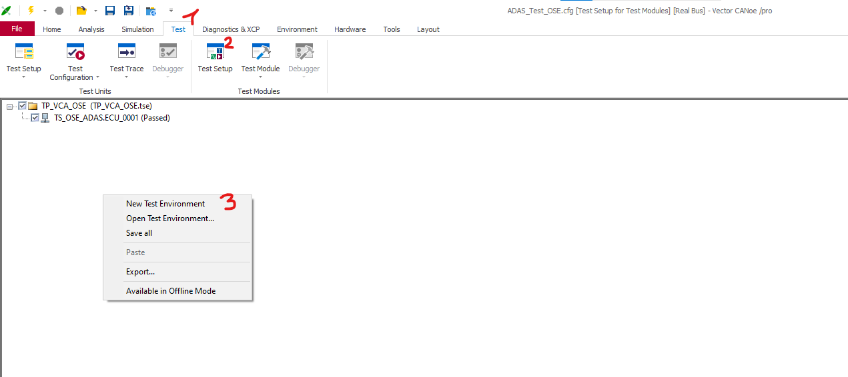

Create a new test env for you CAPL tests and place it in /TP_VCA/CAPL_tests_folder

**Create test Module:**

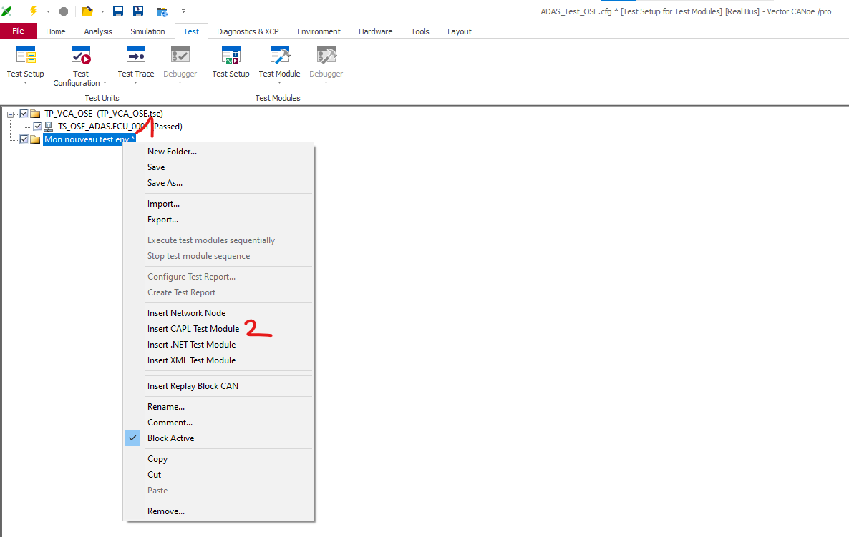

To open test on CAPL editor, right click and edit.

Create CAPL Test Module and place it in /TP_VCA/CAPL_tests

**Add include to your test:**

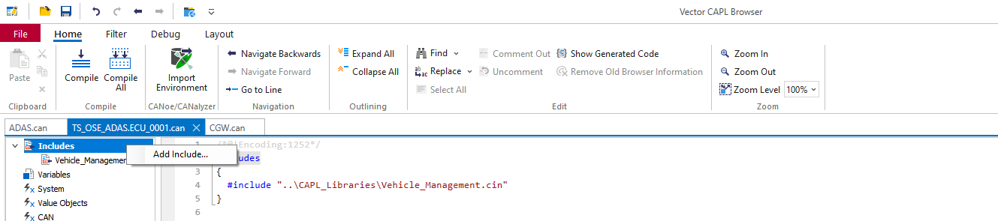

Take file “\CAPL_Libraries\Vehicle_Management.cin”

**Now time to open and implement test 1 !**

**Execute test :**

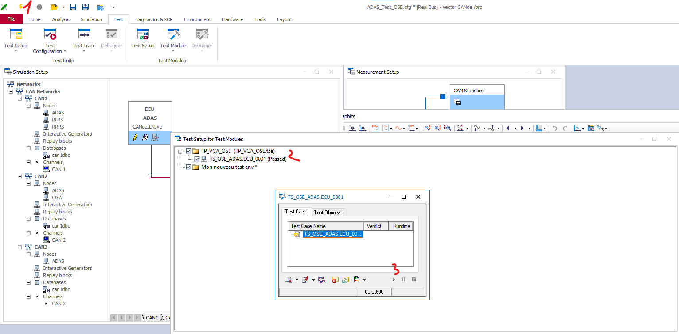

Launch configuration to start CAN message sending (1) / Double click on test (2) / Play (3)

***Tips for CAPL functions:***

* checkSignalMatch(signal , value); // check if you signal match a value
* Set a signal: $CANX::ECU::FRAME::SIGNAL = value;
* TestWaitForTimeout(timeout) // wait for some time.
* TestWaitForSignalMatch(signal, value, timeout); //Wait for your signal to match a value