**The University of Sydney**

**Faculty of Engineering**

**School of Electrical and Information Engineering**

**Year 2021**

A thesis submitted in partial fulfilment of a Bachelor of Engineering Honours (Software Engineering) Degree

|  |  |
| --- | --- |
| **Student Name** | **Louis Angelo Policarpio** |
| **SID** | **470358803** |
| **Unit of Study Code and Name** | **Thesis A**  **ELEC** **4712** |
| **Supervisor** | **EIE: Dr. Vera Miloslavskaya, Prof. Branka Vucetic**  **External: Prof. Masahiro Takatsuka** |
| **Title** | **Interactive visualisation of**  **Self-organising map** |

© Copyright 2013

Contents

1. Introduction 3

2. Literature Review 4

2.1. SOM 4

2.1.1. SOM Training 4

2.1.2. SOM Visualisation 4

2.2. Projection of sphere to 2D space 6

2.2.1. Equal-area projections 6

2.2.2. Adaptive composite map 7

2.2.3. Aitoff’s equal-area using Lambert azimuthal projection 7

2.2.4. Adaptive Equal-area Projection using Wagner’s method 8

2.2.5. Wanger’s transformation method combined with Lambert azimuthal projection 10

2.2.6. Šavrič and Jenny’s final selection of projections 11

2.2.7. Final set of projections for adaptive composite map projection 12

2.4. Geodesic dome 13

2.4.1 Data structure of the geodesic dome 13

3. Methodology 16

3.3. Geodesic Dome 16

3.3.1. Data structure 16

3.3.2. Convert Geodesic dome to sphere 16

3.4. 2D projection 16

3.4.1. Lambert azimuthal projection 16

3.4.2. Wagner projection 16

3.5. Interactive methods 16

3.5.1. Zooming 16

3.5.2. Scrolling/panning 16

3.5.3. Selecting 16

4. Results 16

4.1. Distortion analysis 16

5. Conclusion 16

6. References 17

Progress report 18

UPDATEAD PROJECT PROPOSAL 19

# 1. Introduction

A self-organizing map (SOM) is a artificial neural network used to simplify high-dimensional data into low-dimensional data whilst maintaining the data’s topological structure, developed by Professor Teuvo Kohonen in the 1980s [1]. The purpose of dimensionality reduction is to aid in “data analysis, clustering problems, and visualization of high dimensional datasets” [2]. There are two main procedures when implementing a SOM, they are training and mapping/visualisation. Training is the process of high-dimensional data into low-dimensional data, and visualisation is the process mapping the low-dimension data to map that is interpretable.

When building a SOM, the following factors need to be considered, lattice structure, lattice size, and weight vector initialization method. Lattice structure refers to the shape of each grid. The lattice size refers to the number of nodes within the lattice. The weight vector initialisation method is the method in which the weights are assigned to each vector in the lattice. Changes in the structure and the size can impact the visualisation of the SOM, whereas the initialisation method impacts the efficiency of the training process [2].

The structure of the lattice can vary in dimension, for example, a flat 2D plane grid or a 3D spherical grid can be used. The different dimensions have their advantages and disadvantages, a 2D SOM allows for greater readability however it reduces accuracy of the visualisation due to the problem known as the border effect. The border effect occurs due to the nodes on the edge/ border of a 2D SOM lattice having fewer neighbouring nodes. Fewer neighbouring nodes means that the nodes on the edge will have a lower chance of being updated. There have been some mathematical solutions to solve the border effect such as “the heuristic weighting rule method by Korhonen (2001) and local-linear smoothing by Wand and Jones (1995)” [3], however, the simplest method is to use a 3D lattice [3].

The most straightforward way to create a 3D lattice is to connect boundaries (left connected to right or top connected to bottom), forming a torus. The torus lattice removes the border effect; however, it reduces the readability and area of each grid varies greatly. It is important for a SOM to have “equal geometrical treatment” as it can impact the accuracy off the visualisation. The preferred method for a 3D lattice is a spherical lattice, which has greater readability than a torus and more equal sized grids, whilst combatting the border effect [3].

However, a spherical visualisation is still harder to read and interpret than a 2D lattice. The curved surface of a sphere distorts distance, and as a sphere is a 3D shape all data cannot be viewed at once. This work aims to propose a solution to this issue by presenting methods to project the sphere into 2D and providing interactive interface.

# 2. Literature Review

## 2.1. SOM

### 2.1.1. SOM Training

The SOM training involves placing a lattice on the multidimensional dataset. A value in the dataset is then selected, and the closest node in the lattice is selected and moved towards it. The process is repeated and as it progresses the lattice nodes move into the centres of clusters in the data set. The moving process is referred to as training and function that determines how the nodes move is known as the neighbourhood function. [2] The neighbourhood function selects the winning element in the data set by calculating the Euclidian distance for the current lattice node, from that the winning node and its neighbouring nodes weight vectors are adjusted. The adjustment will continue with the neighbours of the neighbouring nodes until the update radius is reached (the distance from the winner node) [4]. After training has been completed the lattice with its updated weight vectors is the result.

### 2.1.2. SOM Visualisation

There are numerous visualisation methods used to represent a SOM. Common consist of class representation maps, U-matrix and component planes. Class representation maps are a 2D representation of the SOM, which observes the frequency of dataset classes in each node of the lattice. There are many methods of implementing class representation maps. In Ponmalai and Kamath’s paper, the class representation is focused on the frequency in which a class appears in each node, assigning a unique colour to each class. There are 2 methods outlined in the paper. The first method simply identifies the class of highest frequency in the node and displays its colour. The second gets the average colour using the frequency of each colour. The first method results in clearer visualisation as the classes and the borders between them are easier to understand. The second method alone is generally not preferred as the average colour is hard to interpret [2]. As the number of classes increases the harder it is to interpret the data. However, Brereton’s paper utilises the best matching unit (BMU) to colour the node. In this implementation, each node in the lattice represents a node. The BMU is derived by calculating the Euclidean distance between each dataset element and each node. The class with the closest BMU will colour that node. If there are nodes of equal distance an average of the colours will be used. [5]. Using either method of class representation would be suitable for the interactive 2D projection of the spherical SOM. This is as they provide a clear visualisation of the SOM.

The U-matrix was developed by Ultsch and Siemon [5]. Ponmalai & Kamath’s paper states that it illustrates the spacing of the nodes in the lattice [2]. Whilst Brereton's paper states that it illustrates, “the similarity of a unit to its neighbours”. Both outlined methods aim to display the shape of the data, however, Brenton's method gives a clearer representation of the groupings of the data. Moreover, both methods do not give information on individual classes, but the overall grouping. Either method of implementing U-matrices would be suitable, as both methods display a single visualisation of the data that can be applied to a 2D lattice.

Component planes create separate visualisations for each class, depending on the method of the visualisation of the classes may vary. For example, in Brenton’s paper, the BMU of each node is used [5], whilst in Ponmalai & Kamath’s weight vectors are used [2]. The component planes allow for comparison of classes, and a greater understanding of each class, however, it does not achieve one of the main goals of the SOM reducing the dimensions of the data. This method can be implemented however would require the creation on several visualisations so more care would be need so that the system runs efficiently and without error.

From the mentioned visualisation methods, the class representation and a U-matrix are best suited for implementation in the interactive spherical SOM and its 2D projection. However, implementation of the visualisation feature is outside the scope of the thesis, as the focus of this thesis is the 2D projection and interactive visualisation of a spherical SOM. Once that is complete either of the visualisation methods can be utilised on the 2D projection and interactive visualisation of a spherical SOM.

## 2.2. Projection of sphere to 2D space

There are various methods to project a sphere into 2D space, and for years cartographers have been developing projection methods. When projecting a sphere into 2D space it is inevitable for there to be distortion, therefore properties that need to be retained (not distorted) need to be selected and prioritised. There are 4 main categories of projections based on what geometric properties they aim to preserve.

The categories of projections are equal-area, conformal, equidistant and compromise. Equal area projections aim to maintain the same area of the grids on the projection; however, this does not mean the shape of each grid is the same. Conformal projections aim to preserve the local angles and shapes on the projection; and are generally only essential for surveying and navigating with a protractor. Equidistant projections preserve the distances between points along a direction and are used to determine distances between different points. Compromise projections make sacrifices in area, angle, and distances to “balance the distortion” [6]. In a SOM, it is most important to retain an equal area, therefore, equal-area projections are the preferred projection method.

### 2.2.1. Equal-area projections

Equal-area projections aim to maintain the area of each grid in the lattice, not angles or shapes. This can be visualised by placing ellipses on the sphere and comparing the transformation of the ellipses after the projection. For equal-area projection, the area of the ellipses should be similar for all ellipses on the projection whilst the shape and angles of the ellipses can vary, which can be seen in figure 1 [7]. For equal-area projections either lines or points are used to represent the poles of the sphere. If points are used there will be large amounts of distortion on the poles. When lines are used there will still be distortion but to a lesser degree, however, the grids will be compressed vertically [3]. As distortion is more uniform when poles are lines, it is the more suited option for equal-area projections in SOMs.

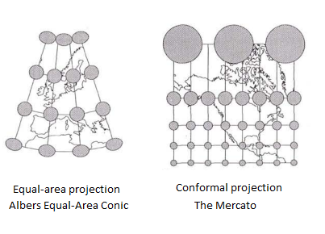

Figure 1- comparing the area of maps using circles

### 2.2.2. Adaptive composite map

As the created projection is going to be interactive, we can look at how interaction is handled on Web maps [8]. Web map creators have faced issues with online maps and making them interactive. The issue of interactive maps is that when users zoom and interact with the map areas of the map become more distorted. Cartographers have come up with two solutions to this issue, first, apply the same protection for different scales. Secondly, cartographers can change the map projection based on the scale and location that the user is viewing. The second method is known as the adaptive composite map, whilst in the first method “excessive distortions” at certain scales are inevitable [8]. The map transitions and combines different projections providing an equal area for all scales and views of the map.

### 2.2.3. Aitoff’s equal-area using Lambert azimuthal projection

David Aitoff proposed a transformation method in 1889. The method utilises the following equal-area projections methods: Hammer, the Eckert–Greifendorff, quartic authalic projections and the Lambert azimuthal projection. To perform the transformation with the Lambert azimuthal projection, we multiply the abscissa (the distance from the vertical axis) by a chosen factor, then divide its longitude by that given factor. The process of the transformation can be seen in figure 2 and the bellow equation where B is the selected factor [8]. This method allows for adaptive equal-area projections. However, this method utilises points for the projection poles, as previously stated making 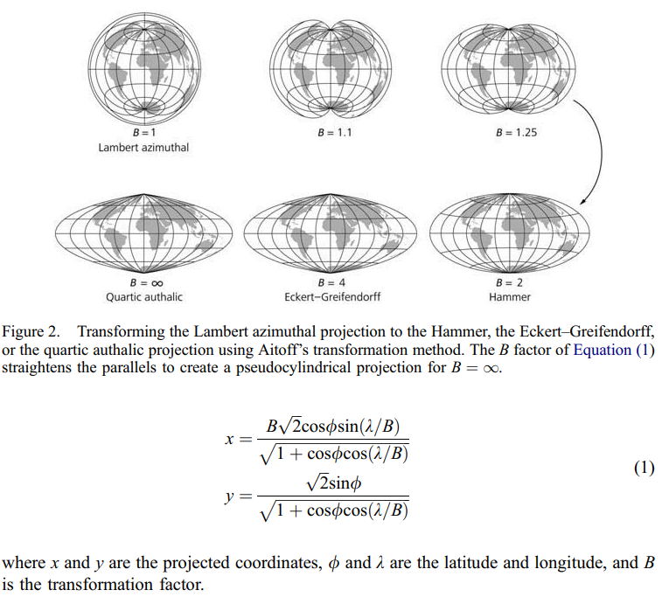the points of the projection points leads to more distortion at the poles.

Figure 2- Aitoff’s equal-area using Lambert azimuthal projection

The formula for the Lambert azimuthal projection:

$$x = \frac{B\sqrt{2}cosɸsin⁡(λ/B)}{\sqrt{1+cosɸcos⁡(λ/B)}}$$

$$y = \frac{\sqrt{2}sinɸ}{\sqrt{1+cosɸcos⁡(λ/B)}}$$

Where x and y are the coordinates, ɸ and 𝛌 respectively are the latitude and longitude transformation factor and B is the factor that straitens the abscissa.

### 2.2.4. Adaptive Equal-area Projection using Wagner’s method

The optimal solution of an Adaptive Equal-area projection would be to have a projection that transforms from the Lambert azimuthal projection, has lines as poles and retains an equal area whilst it transforms. However, a method that meets these requirements has not been found. Therefore, the Wagner’s transformation method may be used instead.

Wanger’s method was proposed by Karl Heinrich Wagner in 1932 [9]. There are three versions of this method, however, only one maintains the area. In this work when referring to Wagner’s transformation method, the method prescribed in Canters (2002) [10] as Wagner’s second transformation method is outlined in figure 3. The transformation process begins with creating a segment on the sphere, bounded by the bounding parallel (ɸB) and bounding meridian ( 𝛌­B), which are mirrored by the equator and meridian, respectively (step 1 figure 3). After that, the sphere is projected onto the newly created segment (step 2 figure 3). Next, the segment is scaled using the scale factor calculated using the below formula (step 3 figure 3)

$$scale factor= \frac{1}{\sqrt{m∙ n}}$$

$$where, m=sinɸ_{B} , n= \frac{λ_{B}}{π}$$

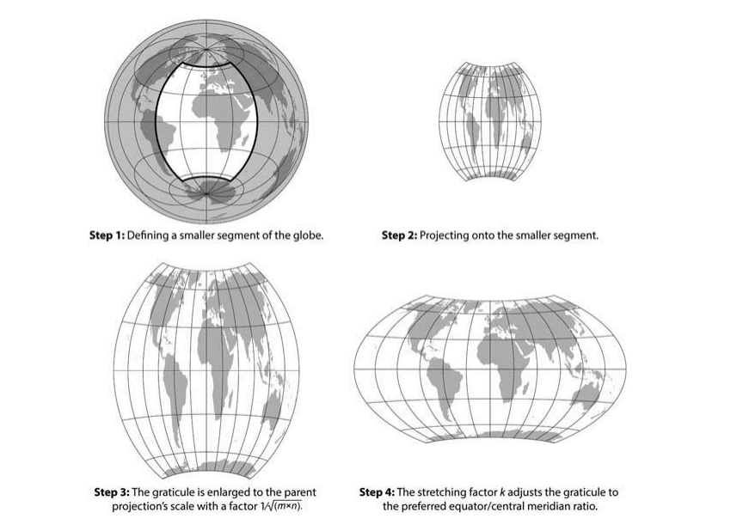 Finally, the segment is then stretched using stretching factor k. The value of k varies depending on the desired equator, meridian ratio (step 4 figure 3). After stretching the segment is now the final Wagner projection. The general formula for Wanger’s method is:

Figure 3 - Equal-area Projection using Wagner’s method

$$x=\frac{k}{\sqrt{m∙n}}f_{x}\left(θ,nλ\right)$$

$$y=\frac{1}{k\sqrt{m∙n}}f_{y}(θ,nλ)$$

Where fxand fy are the coordinates on the original projections, sinθ = m $∙$ sinɸB, m = sinɸB, n = 𝛌B/𝛑 [8].

### 2.2.5. Wanger’s transformation method combined with Lambert azimuthal projection

To allow for an adaptive equal-area projection with lines as poles Lambert azimuthal with Wagner’s method can be used. The following formula can be used to generate the Lambert azimuthal projection with Wagner’s transformation method:

$$x= \frac{k}{\sqrt{m∙n}}∙\frac{\sqrt{2}∙cosθ sinnλ}{\sqrt{1+ cosθ cosnλ} }, \\ y= \frac{1}{k\sqrt{m∙n}}∙\frac{\sqrt{2}∙sinθ }{\sqrt{1+ cosθ cosnλ} },$$

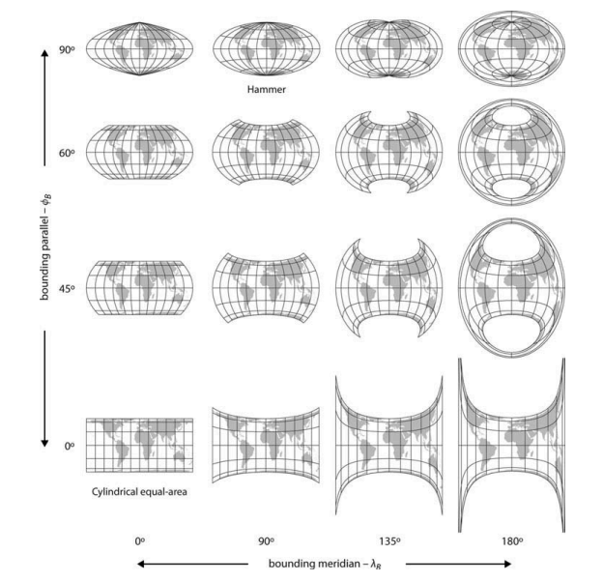where ɸ and λ are the latitude and longitude, sinθ = m $∙$ sinɸ, m, n and k are from variables used in Wagner’s transformation, in which, m = sinɸB, n = 𝛌B/𝛑, k = $\sqrt{{p∙sin\frac{ɸ_{B}}{2}}/{sin\frac{λ_{B}}{2}}}$, such that ɸB and 𝛌­B  are the bounding parallel and the bounding meridian [8]. The resulting projections can be seen in figure 4 where p =2.

Figure 4 - Wanger’s transformation method combined with Lambert azimuthal projection

As the degree of the bounding parallel increases the lines of latitude are more bent, the same occurs for the bounding meridian and the lines of longitude. Moreover, the bounding meridian increases the length of the poles. Several key projections can be generated using this method. First a cylindrical projection is formed when both the bounding parallels and meridians are 0°. When the parallel is 90° Aitoff’s transformation method with the Lambert azimuthal projection can be seen with Aitoff’s transformation being formed with a pounding parallel and meridian of 90° and 180° [8].

Šavrič and Jenny assessed the projections generated from the Lambert azimuthal projection with Wagner’s method via two factors distortion analysis and aesthetic appearance. Distortion analysis was done through computing indices for scale and angular distortion. Aesthetics were assessed through expert opinion, in which map projection experts created the projections that they believed were graphically the best to them [8].

The results for the scale distortion analysis were as follows. Projections with [8]:

* lowest angular distortion:
  + Bounding parallel < 50°
  + 2 > ratio p >2.7
* Lowest Scale distortion:
  + 35° > Bounding parallel > 75°
  + 1.7 > ratio p > 2.4

As previously stated, angular distortion is not important for SOMs whilst scale distortion may aid in improving the readability of the SOM. Thus, when generated projections should aim to fall in the above criteria for lowest scale distortion.

The results from the aesthetic analyse found that experts aimed to balance the stretching in the equator and the shape distortion on the sides (“Australia, South America, and East or South-East Asia” on a map of earth). All expects chose projections with lines as poles and curved borders on the meridians. Half of the experts set the ratio p to 2 as it reflects the real ratio, and the length of the poles were adjusted to balance the distortion that the p ratio caused. Moreover, most projections created were in the criteria for the lowest scale distortion [8].

### 2.2.6. Šavrič and Jenny’s final selection of projections

Through the aforementioned analysis of distortion and aesthetic appearance, Šavrič and Jenny selected four candidates to include into the adaptive projections. The candidates include the projection with:

1. the best scale distortion index
2. the best angular distortion index
3. the mean values of the expert’s suggestions
4. equator and meridian ratio of 2

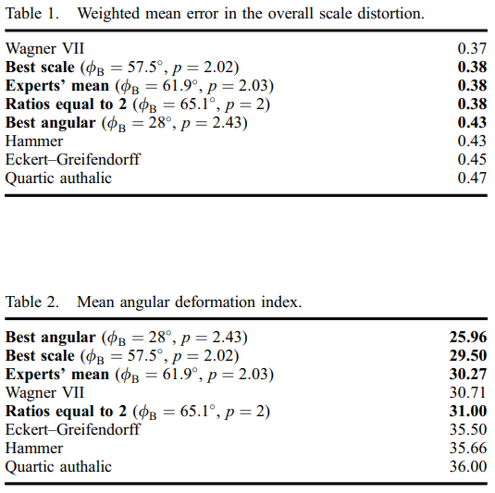Table 1 shows these four candidates (in bold) as well as other common projections that can be transformed using Wagner’s method on the Lambert azimuthal projection and ranks them by mean error in scale distortion. All methods except the best angular distortion have the same amount of error in scale distortion and performed better then most of the other common projection methods (aside from Wagner VII). The best angular distortion does not perform as well due to its meridian begins curved. Curved meridians cause compression on the polar areas and stretching along the sides of the projection, thus would not be the optimal projection to use. The remaining three have the same mean error in scale distortion and visually are similar, the difference being the lengths of the central meridian and pole lines. The experts’ mean has better mean angular deformation and thus is recommended to be included in the transformations [8].

### 2.2.7. Final set of projections for adaptive composite map projection

The set of maps Šavrič and Jenny selected for adaptive composite map projection are:

1. The new equal area pseudo-cylindrical projection created from the average of expert results (ɸB = 61.9, p = 2.03). Which is suggested to be used as the original map.
2. The Lambert azimuthal projection (with λB = 180, ɸB = 90, and p = $\sqrt{2}$)
3. Cylindrical equal-area projection, for large scale mapping ( λB = 0, ɸB = 0, and p = 2).
4. Wagner VII (with λB = 60, ɸB = 65, and p = 2). [8]

Utilising these maps allows for equal area projecrtions with lines as poles suited to the SOM. The transfromation also allows for interaction through zooming in on the projection which would be a usefull feaeture for the interactive SOM.

## 2.4. Geodesic dome

A lattice is needed in the creation of SOM and maintaining uniformity in the grids of the lattice is essential for producing accurate SOM visualisations. Therefore, for spherical SOMs a lattice structure should aim to maintain the number of direct neighbours and the distances between those neighbours. There are only 5 methods in which uniformity can be achieved: through the platonic polyhedra which consist of the tetrahedron, cube, octahedron, icosahedron and dodecahedron. A Geodesic dome is created through tessellation on the platonic polyhedra. The method of tessellation was made by Fuller in 1975 [12], in which tessellation occurs through dividing the faces of the polyhedron into triangles. The subdivision is done so that the new edges are parallel to the edges of the polyhedron face. Out of the 5 platonic polyhedra, the closest to a sphere is the icosahedron. The icosahedron geodesic dome has the smallest variance in edge length, relatively uniform neighbours (all nodes having 6 neighbours except the 12 from the original icosahedron). Therefore, as the icosahedron geodesic dome is the closest to a sphere, has uniform distances and a uniform number of neighbours it is the most suitable lattice shape for a spherical SOM [3].

### 2.4.1 Data structure of the geodesic dome

Data structures for SOMs need to have “fast vertex indexing”, due to many of the neighbourhood searches required in the training process. Wu and Takatsuka’s article [9] states 3 methods for creating a data structure for geodesic domes utilised for SOMs. The two commonly implemented methods, the first being to create the adjacency matrix for all the vertices. The second is to use an array containing all vertices and have each element of that array contain pointers to its neighbours. The first method has drawbacks in space efficiency taking O(n2), where n is the number of grids, due to its use of adjacency matrices. The second method uses pointers instead thus doesn't have the same issue; however, greater care is needed due to many pointers. Moreover, both methods have issues with further tessellation.

The third method is Wu and Takatsukas solution to the problems of the other two methods, reducing the size complexity to O(n), not relying on many pointers and allowing for further tessellation on the sphere [12]. For the third method, the dome is unwrapped into a 2D lattice with the axes U and V as shown in figure 5. The lattice is then skewed such that U and V are orthogonal. Thus square grids are created by joining the two triangular grids and removing the centre diagonal line as seen in figure 6 and the full transformed matrix in figure 7. As the lattice is formed from unwrapping a sphere all vertices around the perimeter of the matrix will be duplicated (e.g A, A’’,…, A’’’’ from figure 5 are the same point) these points are stored in the data structure to ensure that they are maintained. There are only a small number of duplicates thus the size complexity is not affected and remains at O(n) [11].

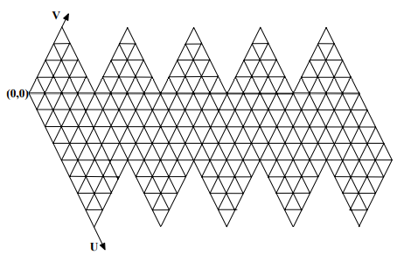

Figure 5 - unwarped with triangular grid

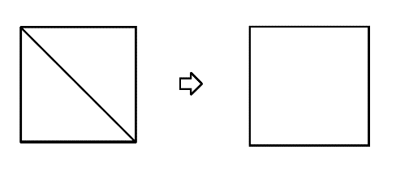

Figure 6 - merging grids to make squae grids

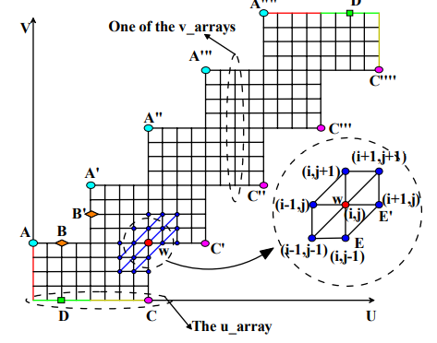

Figure 7 - final indexed grid

For this thesis, a simplified data structure will be utilised as performing the SOM training process and thus neighbourhood searches are not within the scope. However, it is recommended when implementing a 2D projection and interactive visualisation of a spherical SOM to use the third method proposed by Wu and Takatsuka as it solves errors from the other two implementations, reducing the size complexity to O(n), not relying on many pointers and allowing for further tessellation of the sphere.

# 3. Methodology

## 3.3. Geodesic Dome

### 3.3.1. Data structure

### 3.3.2. Convert Geodesic dome to sphere

## 3.4. 2D projection

### 3.4.1. Lambert azimuthal projection

### 3.4.2. Wagner projection

## 3.5. Interactive methods

### 3.5.1. Zooming

### 3.5.2. Scrolling/panning

### 3.5.3. Selecting

# 4. Results

## 4.1. Distortion analysis

# 5. Conclusion

# 6. References

|  |  |
| --- | --- |
| [1] | M. Dubravko, "Brief Review of Self-Organizing Maps," Zagreb, 2017. |
| [2] | R. Ponmalai and C. Kamath, "Self-Organizing Maps and Their Applications to Data Analysis," Lawerence Livermore National Laboratory, 2019. |
| [3] | Y. Wu and M. Takatsuka, "Spherical Self-Organizing Map Using Efficient Indexed Geodesic Data Structure.," *Neural networks 19.6,* p. 900–910, 2006. |
| [4] | K. Teuvo, "NeuralNetworks," *Essentials of the self-organizing map,* vol. 37, pp. 52-65, 2013. |
| [5] | R. G. Brereton, "Self organising maps for visualising and modelling," *Chemistry Central journal,* vol. 6, no. 2, pp. 4-15, 2012. |
| [6] | Jenny, B. Šavrič, Bojan, Arnold, Nicholas, Marston, Brooke, Preppernau and Charles, "A Guide to Selecting Map Projections for World and Hemisphere Maps," in *A Guide to Selecting Map Projections for World and Hemisphere Maps*, 2017, pp. 213-228. |
| [7] | D. R. Steinwand, J. A. Hutchinson and J. P. Snyder, "Map Projections for Global and Gontinental Data," *Photogrammetric Engineering & Remote Sensing,,* vol. 61, no. 12, pp. 1487-1.49, 1995. |
| [8] | B. Šavrič and B. Jenny, "A new pseudocylindrical equal-area projection for," *International Journal of Geographical Information,* vol. 28, no. 12, pp. 2373-2389, 2014. |
| [9] | D. Aitoff, "Projections des cartes géographiques," *Atlas de géographie moderne,* 1889. |
| [10] | K. Wagner, "Die unechten Zylinderprojektionen: Ihre Anwendung und ihre Bedeutung für," *Mathematisch-Naturwissenschaftliche Fakultät,* 1931. |
| [11] | F. Canters, Small-scale map projection design, London: New York: Taylor & Francis, 2002. |
| [12] | Y. Wu and M. Takatsuka, "the Geodesic Self-Organizing Map and Its Error Analysis.," in *Proceedings of the Twenty-eighth Australasian conference on Computer Science-Volume 38*, vol. 5, Australian Computer Society, Inc., 2005, pp. 343-351. |

# Progress report

As a part of ELEC 4172 part A, the following work has been completed. First, the scope and topic of the thesis was discussed with supervisors. The topic chosen was the implementation of a web application of an interactive spherical Self-organising Map (SOM). Brief research of SOMs was completed and a general understanding of the process involved was attained. After that, the Topic Registration form was completed.

After further discussion with supervisors, the Topic proposal was then completed. For the proposal, more research was done on SOMs and a brief description of SOM and its applications was written. Furthermore, the problem statement and methodology was established outlining the problem that the Thesis would address and how it would be achieved. Then a schedule outlining key milestones and tasks was created along with a Gantt Chart for the whole thesis.

Once Completed the Topic proposal was Further research was done into SOMs and possible libraries and software that would aid in the thesis. In the next meetings, the thesis topic was further discussed and a change in scope was made. This was to make the scope of the thesis feasible within the given time frame.

During the next weeks, more formal research was conducted. This involved looking into credible academic sources, such as journals, published books and conferences. After obtaining and interpreting these academic sources the introduction to the thesis was made. The introduction went over an overview of SOMs, spherical SOMs and projection spherical SOMs into 2D.

The Literature review was worked on next. First, the structure of the literature review was established, this was achieved through discussing topics of the review with the supervisors and was changed through the process of researching for the literature review. I then began researching for the review. Supervisors provided some scholarly articles as a starting point for the research. I then looked into other credible academic sources, such as n journals, published books and conferences that were relevant to the topics we had previously discussed. Once enough sources were obtained, I began writing the literature review. As It progressed more sources and topics were added and progress in the review and understanding was assessed by supervisors until the review was completed.

# UPDATEAD PROJECT PROPOSAL

**Title:** Interactive visualisation of self-organising map

**Proposer:** Louis Angelo Policarpio

**Supervisor:**

**EIE**: Dr. Vera Miloslavskaya, Prof. Branka Vucetic

**External**: Prof. Masahiro Takatsuka

**Background:**

A self-organising map (SOM) is an unsupervised machine learning technique, it is used to group multidimensional data. The maps grouping allows for correlations in data to be made apparent through graphs and visualisations. This technique can be used in numerous fields such as health (e.g., show the possible relationships between ailments and other data such as age, gender, etc) and finance (e.g., help predict market trends).

The structure of the lattice can vary in dimension, for example, a flat 2D plane grid may be utilised, or a 3D spherical grid can be used. The different dimensions have their advantages and disadvantages, using a 2D SOM allows for greater readability however it reduces accuracy of the visualisation, due to the problem known as the border effect. The border effect occurs due to the nodes on the edge/ border of a 2D SOM lattice having fewer neighbouring nodes. The preferred method for a 3D lattice is spherical, which has greater readability than a torus and more equal sized girds, whilst combatting the border effect [3].

**Problem Statement:**

However, a spherical visualisation is still harder to read and interpret than a 2D lattice. The curved surface of a sphere distorts distance, and as a sphere is a 3D shape all data cannot be viewed at once.

**Methodologies**

The proposed solution is the creation of a web-application, presenting a method to project a sphere into 2D with interactivity. In other works, this Projection and interaction method can be utilised with SOMs to increase their readability.

**Schedule**

The main tasks of this project are:

* Planning
* Literature review
* Designing
* Testing
* Implementation
* Reporting

**Updated Thesis Gantt chart**