Mates-Rates Rent a Car User Manual

Louis Yanagisawa(n10221221)

This program is designed to help the user managed a fleet of vehicles and customers while also letting other users rent vehicles from the fleet.

**How to Open**

Open the folder MRRC then open MRRC.sln to open the program

**Running the program**

With the program open press f5 on the keyboard or click the start button on the top middle of the screen to start the program. This should open up a new console menu which you will first be greeted by:

### Mates-Rates Rent-a-Car Operation Menu ###

Or to run the program directly go MRRC/MRRC/bin/Debug and then open the MRRC application

**Files**

The program is fitted with 3 custom files: customers.csv, fleet.csv and rentals.csv. These files are located in the data folder which can be found be going through MRRC -> data. The file paths of these files are specified in the command line argument sections.

For example, currently there is

Command line arguments:

"../../..Data/fleet.csv"

"../../../Data/rentals.csv"

"../../../Data/customers.csv"

In the debug menu of the MRRC application which can be accessed by oping MRRC.sln, right clicking MRRC in the solution explorer of the left of the screen, clicking properties and then opening Debug* and if you wish to change these folders or the location you can replace the current file paths with your own.

**Program usage**

When the program is started you will be met with the main menu

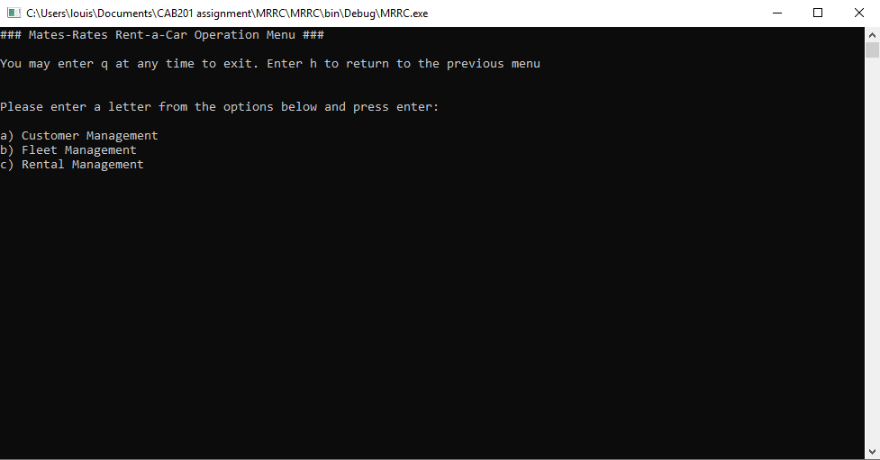

From the main menu you will have 4 options. When entering keys you must press enter after you select the key.

Pressing a) will take you to the Customer Management Menu.

Pressing b) will take you to the Fleet Management Menu.

Pressing c) will take you to the Rental Management Menu.

Pressing q) will close the program.

Pressing h) will not have any effect on this menu as there is no previous menu and pressing h will take you to the main menu which is the menu you are currently on.

**Customer Management Menu**

When entering the Customer Management Menu you will be met with

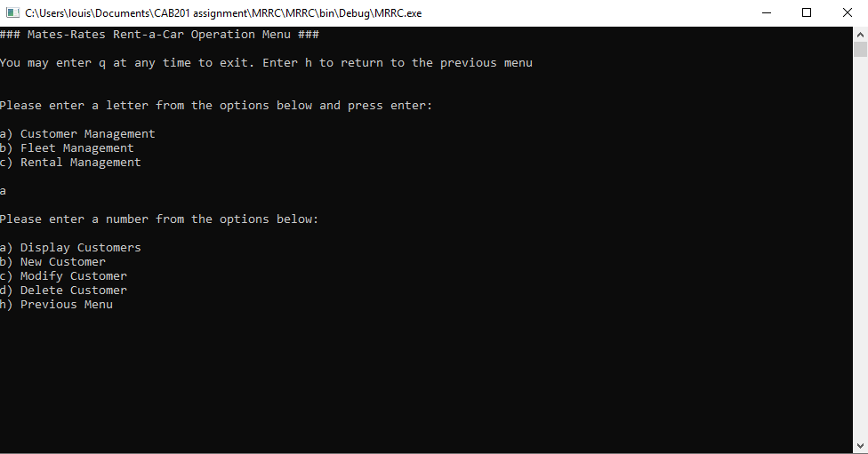

You will have the following options by pressing keys and then enter on the keyboard:

a) Will displays all customers from the customers.csv files with headings describing each attribute

b) Will prompt you to enter a new customer by entering in their details and then it will add them to the customer list and csv file. You do not need to enter in the Customers ID as it will automatically generate a unique ID for them. It will then print to the screen the customer you successfully added

c) Will ask you to enter in the customers ID you wish to modify and then it will prompt you to enter all the new customer details you wish to update. It will then print to the screen all the new customer details of the customer you modified

d) Will ask you to enter in the customers ID you wish to delete and will print to the screen whether the customer was successfully deleted or not.

q) Will close the program

h) Will take you to the previous menu which is the main menu

**Fleet Management Menu**

When entering the Fleet Management Menu you will be met with

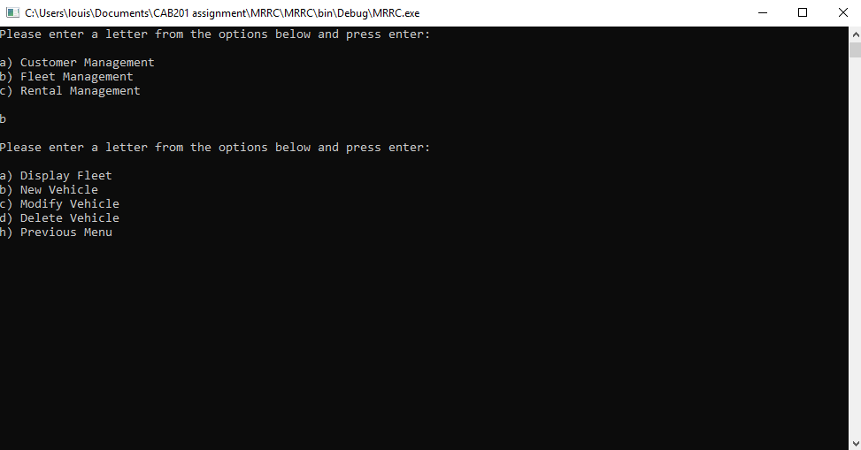

You will have the following options by pressing keys on the keyboard:

a) Will display the entire fleet from the fleet.csv file with headings to describe each attribute

b) Will prompt you to enter a new vehicle by entering in their details and then it will add the vehicle to the fleet list and csv file. It will then print if the vehicle was successfully added or not

c) Will ask you to enter in the registration of the vehicle you want to add to the list and then prompt you to enter in all the details of the new vehicle

d) Will ask you to enter in the registration of the vehicle you want to delete and will print whether the vehicle was successfully deleted or not.

q) Will close the program

h) Will take you to the previous menu which is the main menu

Rental Management Menu

When entering rental management menu you will be met with

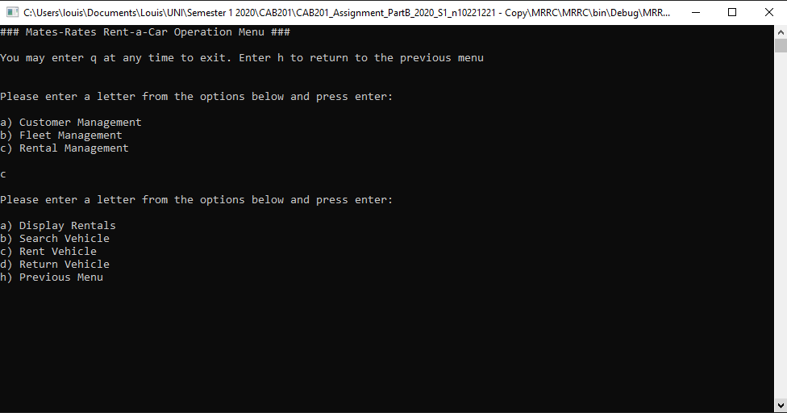

You will have the following options by pressing keys on the keyboard:

a) Will display all the rented vehicle and customer ID’s from the rentals.csv file

b) Will ask you what vehicle details you want to search for and return a list of vehicles that meet the criteria

c) Will ask you to enter in the registration of the vehicle you want to rent, the ID of the customer that is going to rent it and how long to rent the vehicle and return how much it will cost

d) Will ask you to enter in the registration of the vehicle you want to return

q) Will close the program

h) Will take you to the previous menu which is the main menu