Lab1

1. Algorithm(expressed both in C and flow chart)

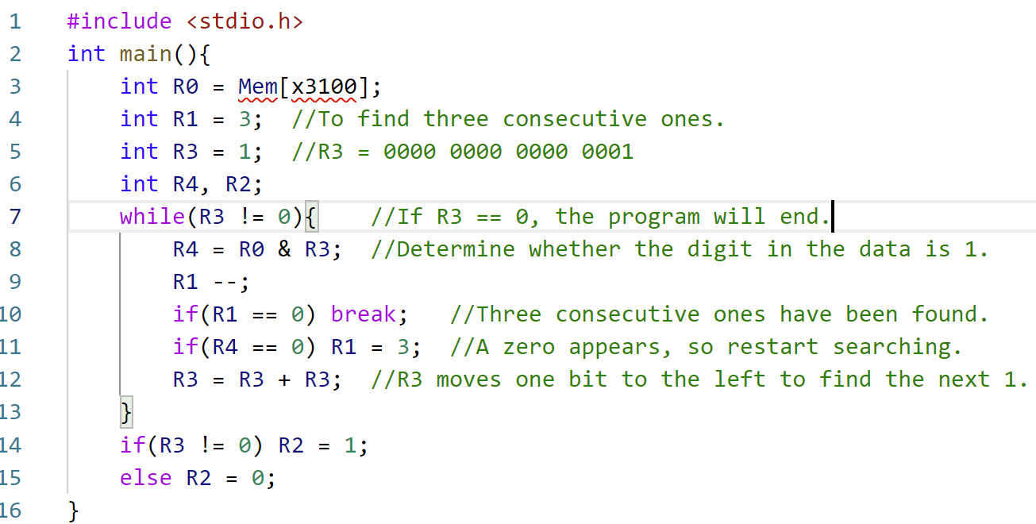

1. Essential parts of your code with sufficient comments.

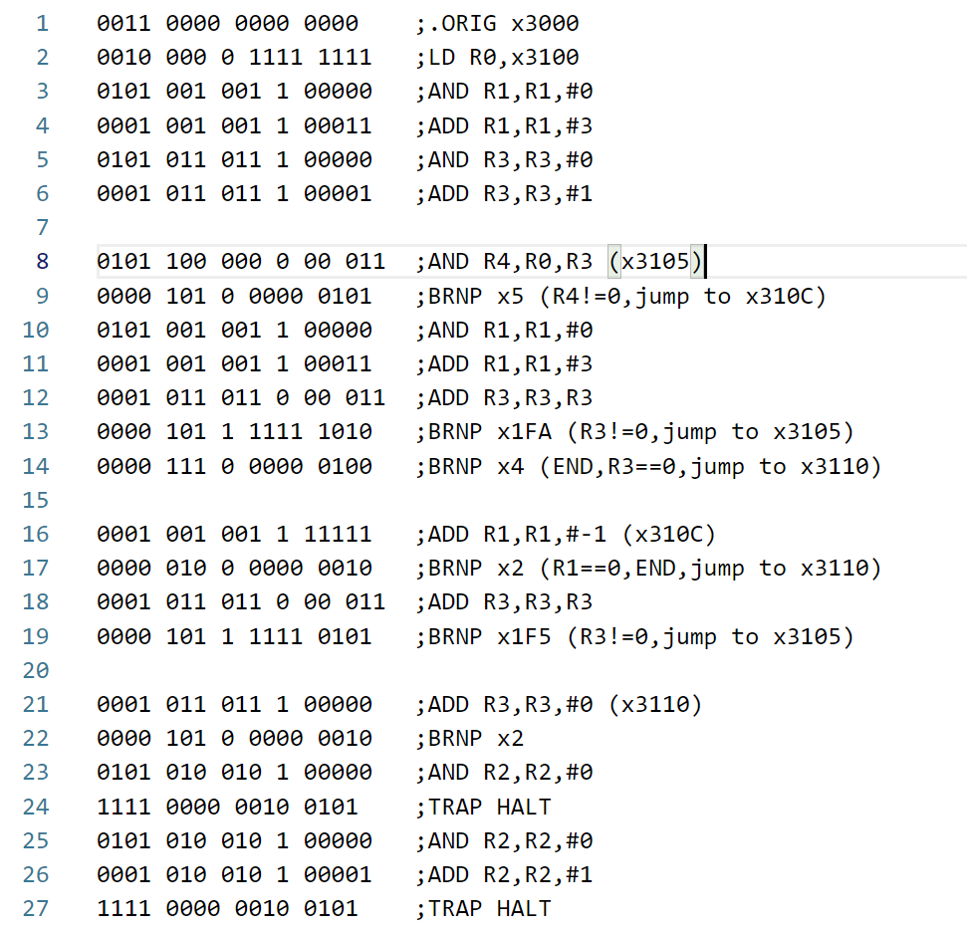

R0 stores the values loaded from x3100, R1 acts as the counter, and R3 is used to separate each bit. The program initializes R3 to be 1 and R1 to be 3.

R4 = R3 & R0, when R4=1, R1 will be subtracted by 1; If 0 is encountered, R1 is reset to 3 and the search and count are restarted. Once R1=0, which means we have 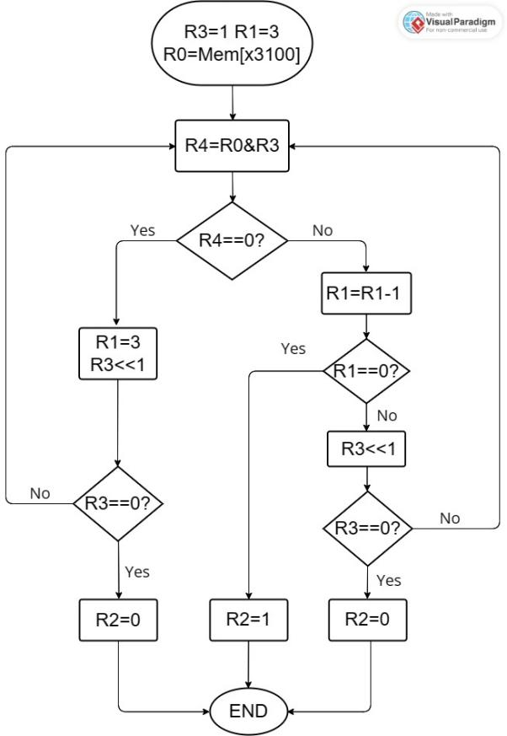found 3 consecutive 1 bits, then the program will jump out of the loop and assign register R2 to 1.

Here R3 becomes R3+R3 after each loop, which has the same function as moving one bit to the left, from the 0 bit (0000 0000 0000 0001) to the last bit (1000 0000 0000 0000 0000). The program ends when R3 overflows to zero (0000 0000 0000 0000), and meanwhile, assign register R2 to 0.

1. Q&As

Q : What is the key part of the code that implements the function?

A : The program mainly uses a register as a counter and initializes it to 3, and then performs a 16-bit loop judgment according to the shift method.