Lab2

1. Algorithm(expressed both in C and flow chart)
2. 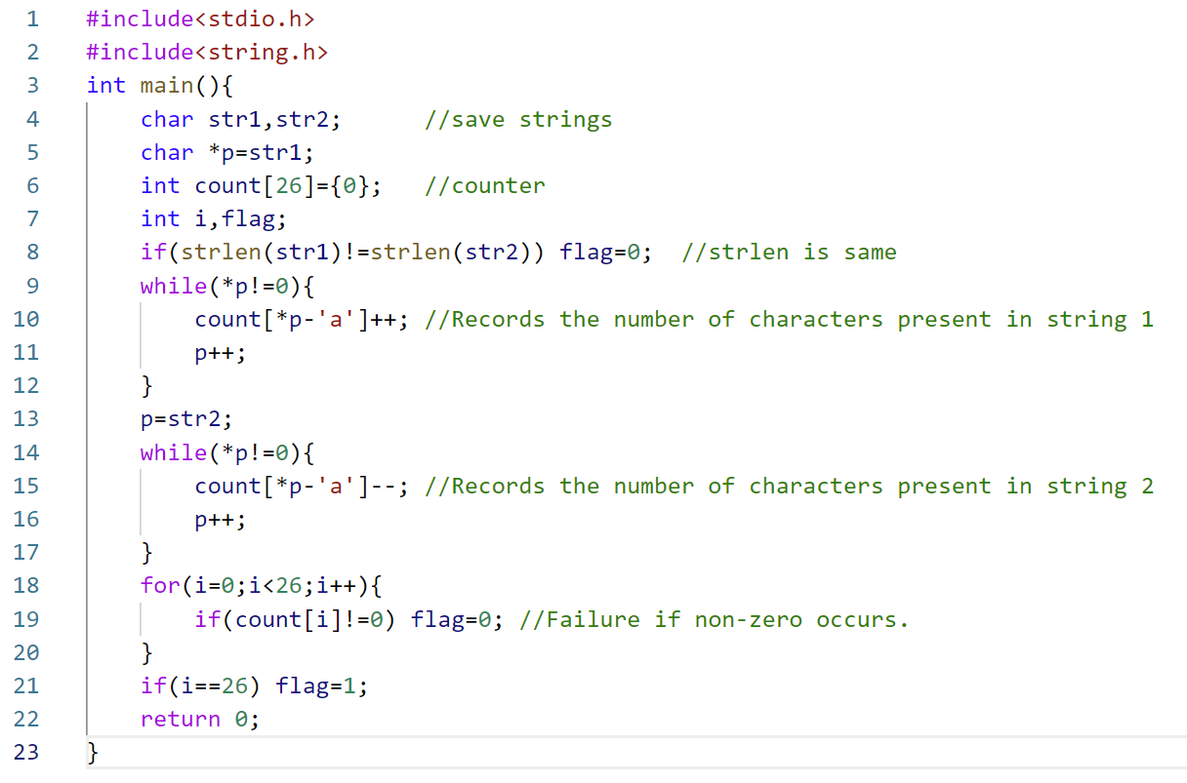Essential parts of your code with sufficient comments.

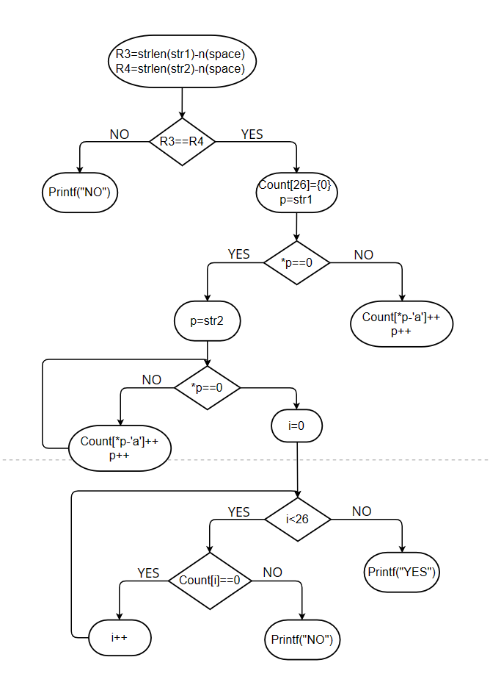

Starting from the first address of str1 and str2, each letter that appears is incremented by R3 and R4 respectively. And the two strings are compared to see if they contain the same number of letters. The Spaces that appear in it are skipped.

Define a count array of 26 numbers to record the number of each letter. For rst1 strings, the number of letters corresponding to the occurrence is increased by one. Conversely, for rst2 strings, the number of letters corresponding to the occurrence is decreased by one. Finally, compare each number in the array to see if it is 0. If there are 26 zeros, it is successful.

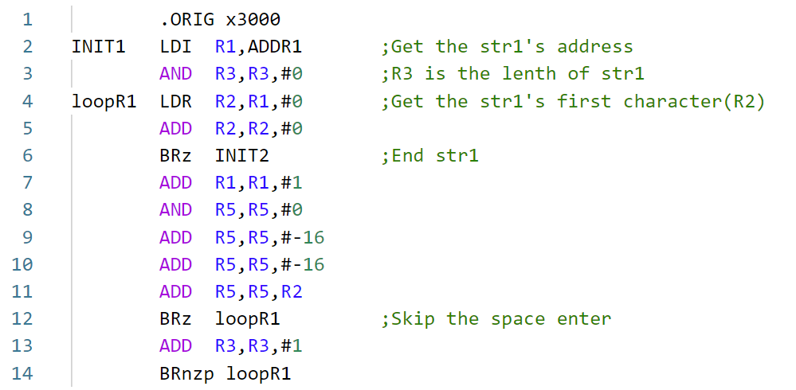

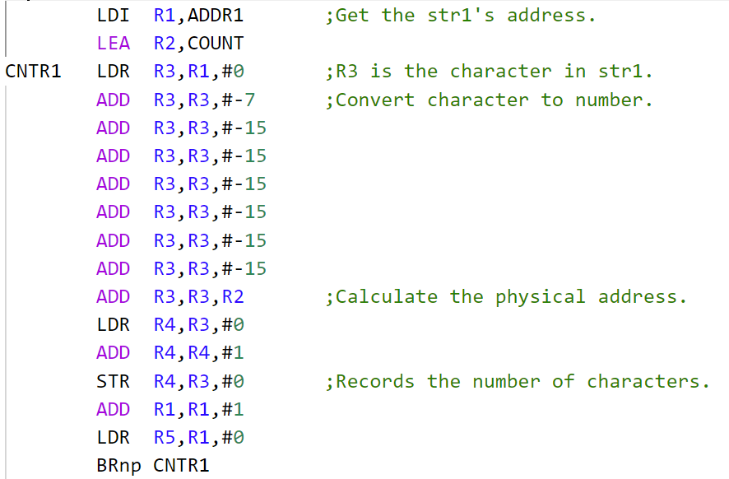

1. Q&A

Q : What is the key part of the code that implements the function?

A : Define a count array of 26 numbers to record the number of each letter. In the case of Spaces, the jump continues the loop. When recording the number of letters, consider combining the upper and lower case categories.