Lab4

1. Algorithm

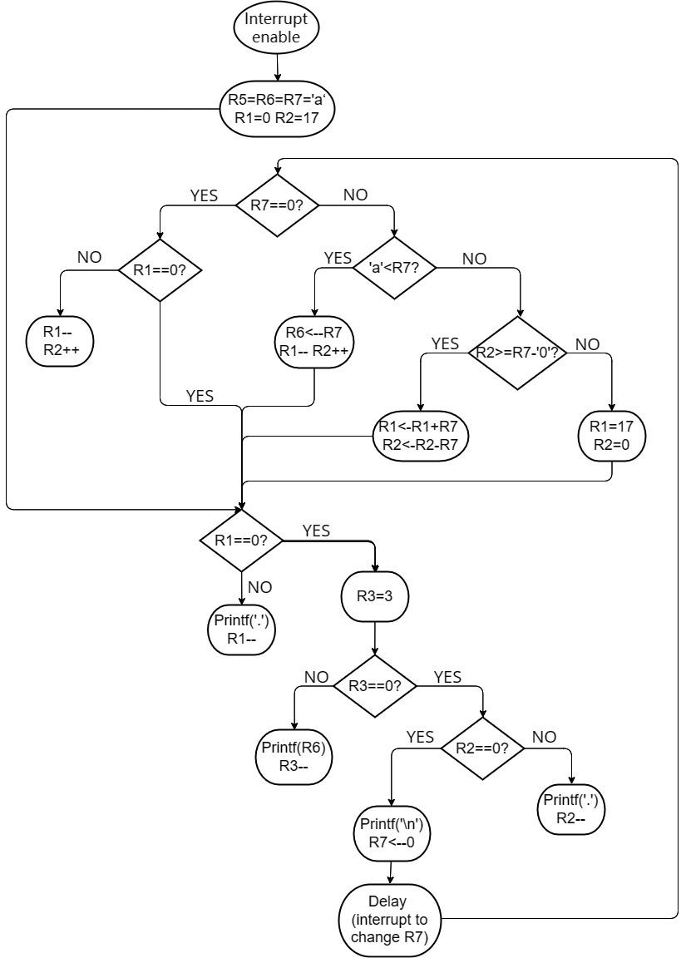

1. Essential codes
2. System booting code set KBSR to x4000 to allow interrupts, and assign x180 in the interrupt table as the Interrupt service routine address x0800.

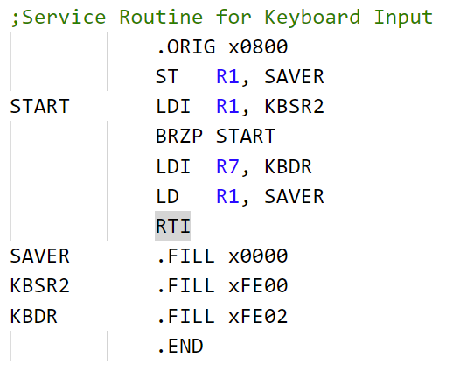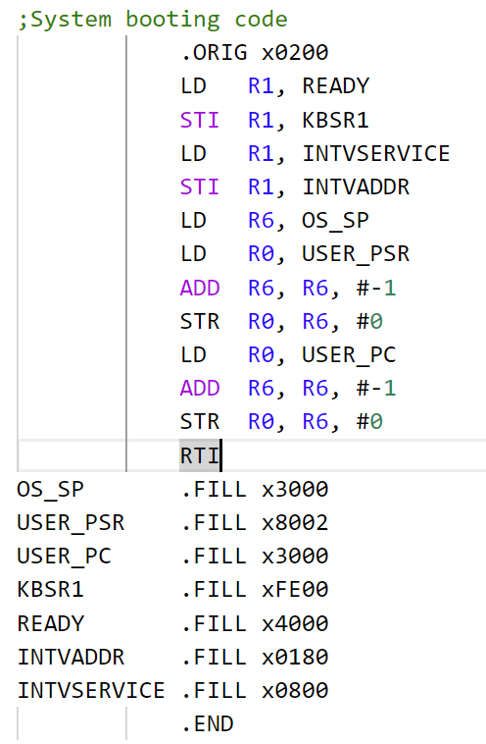

(2) The interrupter assigns the keyboard input value to R7.

(3) Determine whether there is a keyboard interrupt based on whether R7 is 0. If there is an interruption, assign a new value to R5, and if R7 is a number, R6 keeps the letter of the last loop unchanged, judging whether the bird wants to go up or down. If R7 is a letter, change the bird's letter R6 and drop one space

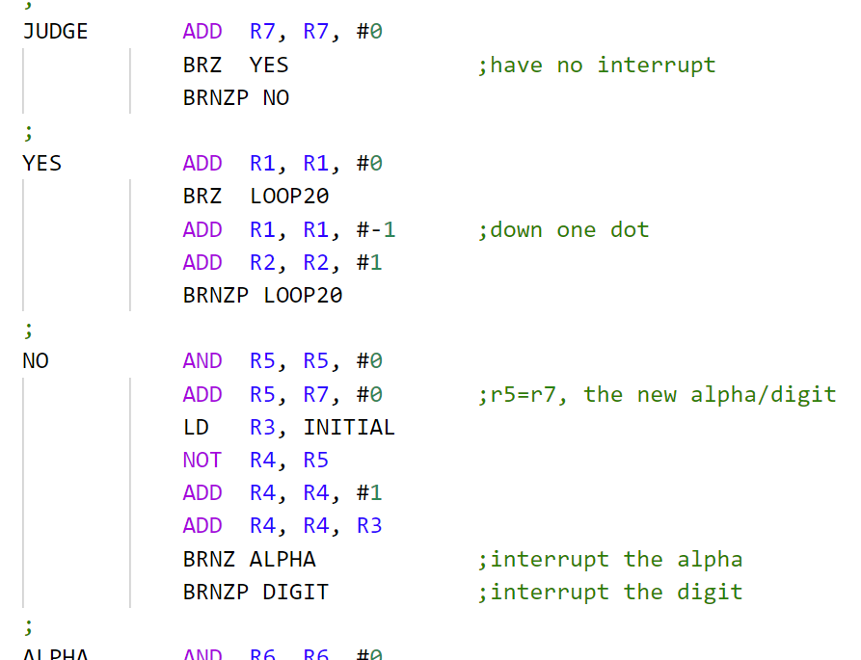

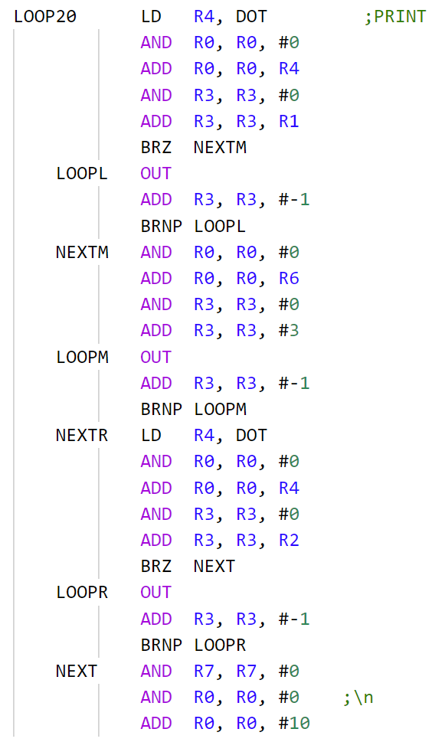

1. The output loop uses out to output 20 characters separately, where the values of R1,R2 are recorded, that is, the air values of the left and right. At the end of the loop, assign R7 to 0 to indicate the end, and wait for the next loop or interrupt.
2. Q&As

Q : Can I interrupt a print line before it finishes?

A : Yes. However, because the time in the output line is much less than the delay time, we can wait for the end of the output line and then consider loading the newly input keyboard value into the register for the next loop output.