HCI Evaluation Activity
KML Carwash & Auto Detailing
Using Heuristic Evaluation (Expert Analysis) — Lesson 3

Deployed URL | https://kml-carwash-and-auto-detailing.vercel.app/
Evaluator | Patrick James Magno (Evaluator)
Evaluation Method | Heuristic Evaluation — Nielsen's 10 Usability Heuristics (Expert Analysis)
Course | HCI 102 — Human-Computer Interaction

Heuristics Applied in This Evaluation
- Heuristic 1: Visibility of System Status
- Heuristic 2: Match Between System and the Real World
- Heuristic 3: User Control and Freedom
- Heuristic 4: Consistency and Standards
- Heuristic 5: Error Prevention
- Heuristic 8: Aesthetic and Minimalist Design

1. Evaluator Comments — Patrick James Magno
The following issues were identified by evaluator Patrick James Magno upon reviewing the deployed KML Carwash website:

Issue 1 — Navigation Readability (Heuristic 8: Aesthetic and Minimalist Design)

"The navigation links appear cramped together with no visible spacing between items. At a glance, items like GALLERY, SERVICES, ABOUT, REVIEWS, and CONTACT look like a single continuous word — GALLERYSERVICESABOUTREVIEWSCONTACT. This violates the principle of minimalist design and hurts readability."

Issue 2 — Missing Font Fallback / Visibility of Content (Heuristic 1: Visibility of System Status)

"When the Google Fonts CDN is unavailable or slow (which is common on mobile networks), the hero section text becomes invisible because no fallback system fonts are defined. The user sees a large black area with no heading text, giving no indication of the page purpose."

Issue 3 — No Pricing Information (Heuristic 2: Match Between System and the Real World)

"The Services section lists four packages with timing information but no pricing. In the real world, customers want to know the cost before visiting. Omitting this forces users to call or visit just to get basic information, which breaks the natural mental model of browsing a service business."

Issue 4 — Ambiguous Theme Toggle Label (Heuristic 4: Consistency and Standards)

"The dark/light mode toggle shows the label 'LIGHT' when the site is in dark mode. This is confusing — does it mean the current mode is 'light' or that clicking will switch to 'light'? Standard UI convention is to show what will happen (the target state), not the current state."

Issue 5 — Single Contact Method (Heuristic 3: User Control and Freedom)

"The only way to contact KML is via a phone call. Many users in 2024 prefer messaging apps like WhatsApp over direct calls. Providing only one contact method limits user freedom and may result in lost leads from customers who do not want to call."

Issue 6 — No Directions Link (Heuristic 2: Match Between System and the Real World)

"The address is shown in the footer but there is no Google Maps link or 'Get Directions' button. A real-world customer who wants to visit will instinctively look for a navigation shortcut. Not providing one creates unnecessary friction."

3. Before and After Screenshots

3.1 Hero Section & Navigation
The screenshots below compare the original design (Before) with the revised design (After) in the hero and navigation areas. Red annotations highlight identified issues; green annotations mark applied fixes.
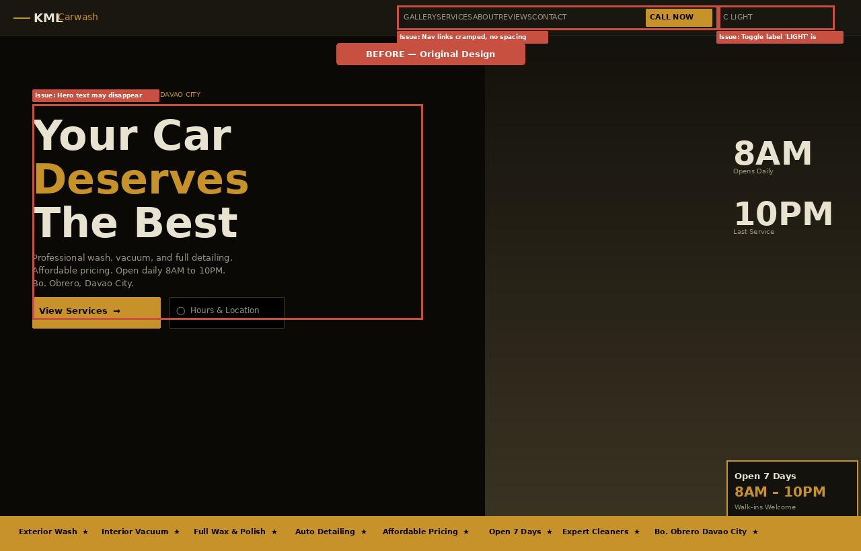

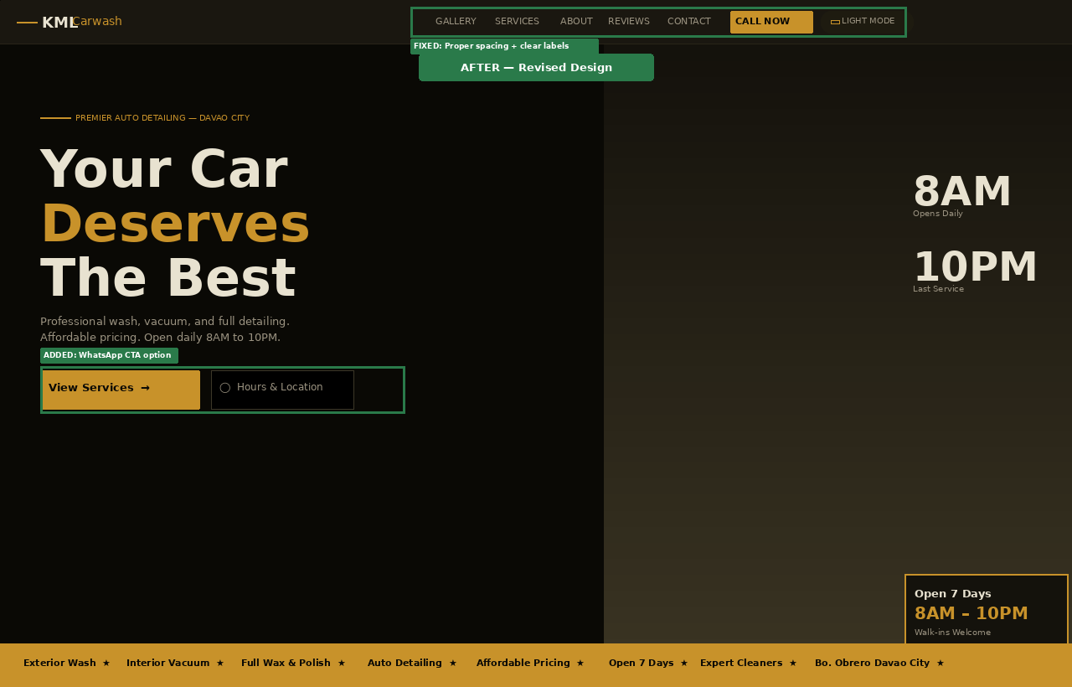

3.2 Services Section — Pricing Transparency Fix
The following comparison shows the Services section before and after the addition of pricing range pills on each service card. This addresses the "Match Between System and the Real World" heuristic.
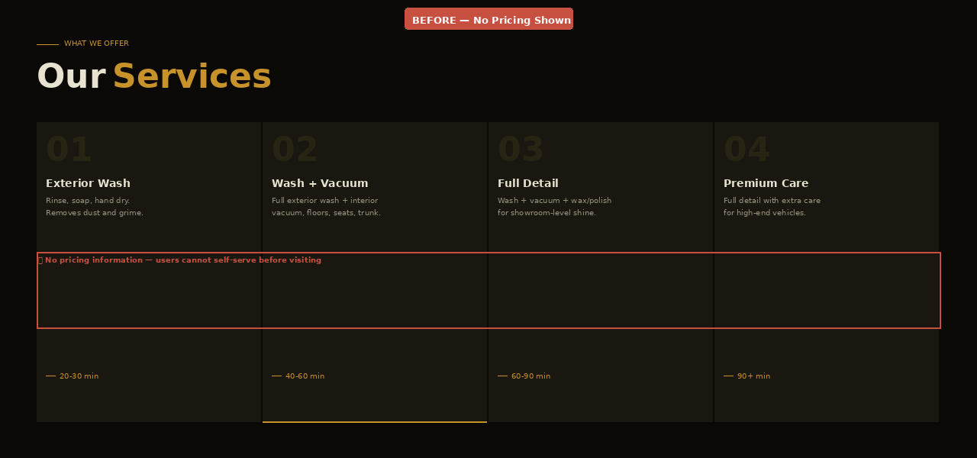

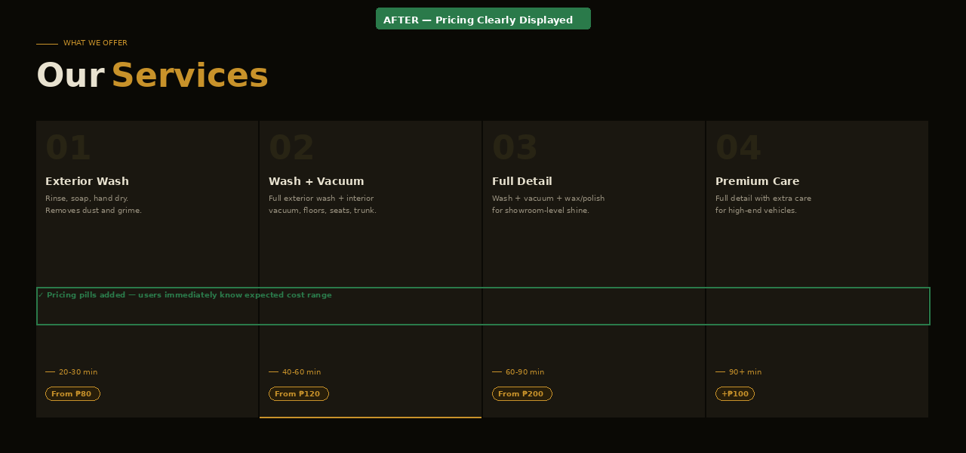

4. Short Reflection
Before this evaluation activity, I thought the KML Carwash website was functional and visually complete. I had focused most of my effort on the aesthetic — the dark luxury theme, gold accents, real photos, and animations. I believed that looking good was the same as being usable. This evaluation changed that perspective entirely.

When Patrick James Magno reviewed the site as an outside evaluator, the feedback came from a completely different angle. He did not see the intentions behind the design or the hours spent building it. He saw only what a first-time user would see: navigation links that blurred together, a hero section that went blank when fonts failed, services that showed no price, and a theme toggle whose label meant nothing clear. Each of these issues was invisible to me because I had been too close to the work.

The most impactful lesson was about the Gulf of Execution described in Norman's Model. I had made the site visually impressive but had not asked the basic question: "Does the user know what to do and how to do it?" A cramped nav bar, no pricing, and an ambiguous toggle all leave users guessing. Good interface design is not just about what looks attractive — it is about making the right actions obvious, the right information available, and the user's path frictionless.

Applying the Heuristic Evaluation method also showed me that having a second set of eyes — especially someone with no prior knowledge of the site — is essential. My own testing always found the features because I already knew where they were. A real evaluator navigates with genuine uncertainty, and that uncertainty reveals the true gaps in the design.

The revisions I made — spacing nav links, adding fallback fonts, showing pricing, clarifying the toggle, adding a WhatsApp button and a directions link — were not dramatic visual changes. But they make the site significantly more usable. That distinction between visually polished and genuinely usable is the core insight I am taking away from this activity.

— KML Carwash & Auto Detailing, HCI 102 Evaluation

