
OPTIMIZATION MODELS AND APPLICATIONS
Final Project Report
AN EMISSION-AWARE EXTENSION OF THE CROWD-SHIPPING PROBLEM WITH TIME WINDOWS, TRANSSHIPMENT NODES, AND DELIVERY OPTIONS
GROUP 3
Dong Boi Thi (M11451802)
To Nguyen Tan Phuong(M11451804)
NATIONAL TAIWAN UNIVERSITY OF SCIENCE AND TECHNOLOGY
2025

Table of Contents
Table of Contents
ABSTRACT 4
CHAPTER 1. INTRODUCTION 5
1.1 Background 5
1.2 Reference Study 5
1.3 Research Gap and Motivation 5
1.4 Research Objectives 6
1.5 Research Questions 6
1.6 Scope and Contribution 6
1.7 Report Structure 7
CHAPTER 2. ORIGINAL CSPTW-TN-DO PROBLEM 8
2.1 Delivery System and Customer Types 8
2.2 Main Decisions 9
2.3 Original Cost Objective 9
2.4 Main Constraint Groups 10
2.5 Solution Approaches in the Reference Study 11
CHAPTER 3. EMISSION-AWARE MULTI-OBJECTIVE EXTENSION 12
3.1 Extension Principle 12
3.2 Dedicated vehicles Operational Emissions 13
3.3 Occasional drivers Incremental Emissions 13
3.4 Total Emissions 14
3.5 Why Cost and Emissions Are Normalized 14
3.6 Empirical Boundary Anchors 14
3.7 Normalized Cost and Emissions 15
3.8 Weighted Scalar Objective 16
3.9 Numerical Safeguard for Negative Normalized Values 16
3.10 Modeling Assumptions 17
CHAPTER 4. SOLUTION FRAMEWORK AND RELIABILITY GATES 18
4.1 Methodological Source and Exact Formulation 18
4.2 ALNS Workflow 18
4.3 Initial Solution Construction 20
4.4 Destroy, Repair, and Local Search 20
4.5 Adaptive Operator Weights 21
4.6 Simulated Annealing Acceptance 22
4.7 Fidelity and Feasibility Gates 22
4.8 Feasibility-Consistency Correction and Final Rerun 23
CHAPTER 5. BENCHMARK CONSTRUCTION AND EXPERIMENTAL DESIGN 24
5.1 Source Data and Derived Benchmark Instances 24
5.2 Final ALNS Production Matrix 25
5.3 Normalization Anchor Generation 26
5.4 ALNS Search Budget 27
5.5 Objective and Emission Parameters 27
5.6 Exact-Solver Configuration 27
5.7 Run Inclusion and Data-Integrity Rules 29
5.8 Analysis Measures 29
6.1 Experiment Completion and Validation 31
6.2 Exact C101-Derived Results 31
6.2.1 Exact Anchor Incumbents 31
6.2.2 Weighted-Sum Exact Results 32
6.2.3 Comparison of the Two epsilon_levels Configurations 33
6.3 ALNS Completion and Validation 33
6.4 C101-Derived ALNS Results 33
6.5 R101-Derived ALNS Results 34
6.6 Improvement from the Initial Construction 35
6.7 Relative C101–R101 Comparison 36
6.8 Cost–Emission Outcomes 38
CHAPTER 7. DISCUSSION, LIMITATIONS, AND FUTURE WORK 40
7.1 Interpretation of the Main Findings 40
7.2 Cost–Emission Relationship 40
7.3 Influence of Spatial Structure 40
7.4 Practical Interpretation 41
7.5 Limitations 41
7.6 Future Work 42
CHAPTER 8. CONCLUSION 43
REFERENCES 44
APPENDIX A. FINAL ALNS PARAMETER SUMMARY 45
APPENDIX B. Production Experiment Summary 45
APPENDIX C. AUTOMATED DEPLOYMENT AND REPRODUCIBILITY GUIDE 45

ABSTRACT
The Crowd-Shipping Problem with Time Windows, Transshipment Nodes, and Delivery Options (CSPTW-TN-DO) combines dedicated vehicles, occasional driverss, customer pick-up points, transshipment nodes, capacity restrictions, and time-window requirements. The reference study formulates the problem with a cost-minimization objective and develops both an exact mathematical model and an Adaptive Large Neighborhood Search (ALNS).
This project reconstructs the main problem structure and the reported ALNS framework, then extends the objective to include estimated operational emissions from dedicated vehicles and occasional drivers detours. Because cost and emissions have different units and numerical scales, empirical boundary anchors are used to normalize both objectives before they are combined in a weighted scalar function.
Before the production experiment, the implementation was checked through structural, behavioral, and numerical verification. The final benchmark contained 120 ALNS runs across C101-derived and R101-derived instances. Each instance was tested using five lambda values and twelve matched seeds under the same code revision, hardware environment, and 301-iteration limit. All runs completed successfully and passed the final feasibility validator.
For the C101-derived instance, the intermediate lambda settings generally produced lower mean cost and lower mean emissions than the cost-oriented baseline. The lowest mean cost was obtained at λ = 0.50, while the lowest mean emissions were obtained at λ = 0.75. For the R101-derived instance, the relationship was weaker and non-monotonic. The λ = 1.00 setting produced the lowest mean emissions, while λ = 0.75 resulted in higher mean cost and emissions than λ = 0.
The exact C101-derived formulation was also evaluated through two weighted-objective configuration packages under a 300-second time limit. Both packages produced the same weighted-sum incumbents to the reported precision. A separate epsilon-constraint stage was attempted but did not return a retained feasible incumbent within the computational limit. The exact evidence therefore consists of the validated anchor and weighted-sum solutions. The findings provide controlled evidence on cost–emission behavior rather than a complete Pareto frontier or a claim of zero-gap global optimality.
Keywords: Crowd-shipping; last-mile delivery; Adaptive Large Neighborhood Search; multi-objective optimization; operational emissions; transshipment nodes; alternative delivery points.

CHAPTER 1. INTRODUCTION

1.1 Background
Last-mile delivery is one of the most difficult stages of a distribution system. E-commerce growth increases parcel volume, while customers expect faster delivery and more flexible service. Logistics providers must therefore coordinate route distance, customer preferences, vehicle capacity, delivery time windows, and operating cost.
Traditional home delivery is not always efficient. A dedicated vehicle may need to visit many individual locations, while unsuccessful delivery attempts can create additional travel and handling effort. Crowd-shipping and alternative delivery points provide more flexible options. Occasional driverss can deliver parcels along their existing trips, while customers may collect parcels from assigned pick-up locations.
Transshipment nodes provide another delivery mechanism. A dedicated vehicle can leave parcels at a transfer point, and an occasional drivers can collect them later. This mechanism may increase the number of feasible crowd-shipping assignments, but it also creates a synchronization requirement. The occasional drivers cannot collect a parcel before the dedicated vehicle reaches the transfer point and completes the handoff.

1.2 Reference Study
Yu, Jodiawan, and Redi (2022) introduced the Crowd-Shipping Problem with Time Windows, Transshipment Nodes, and Delivery Options, abbreviated as CSPTW-TN-DO. The problem integrates dedicated vehicles, occasional driverss, transshipment nodes, alternative delivery points, three customer types, time windows, and capacity restrictions.
The reference study formulates the problem as a Mixed Integer Nonlinear Programming model, applies linearization so that it can be solved by CPLEX, and develops an Adaptive Large Neighborhood Search for larger instances. The original objective minimizes total distribution cost, including dedicated vehicles travel cost and compensation for the additional distance traveled by occasional driverss.
For its computational experiments, the reference study generated extended CSPTW-TN-DO instances from Solomon VRPTW benchmark data.

1.3 Research Gap and Motivation
The reference model is cost-oriented. However, the lowest-cost delivery plan is not automatically the lowest-emission plan. An occasional drivers may be inexpensive from the company’s perspective but may create a long additional detour. In another case, delivery consolidation through an alternative delivery point may reduce both cost and emissions by replacing several customer visits with one delivery location.
The reference study also identifies environmental impact as a relevant direction for future work. This project follows that direction by extending the objective layer rather than redesigning the underlying search algorithm.

1.4 Research Objectives
The project has five objectives:
- To reconstruct the main CSPTW-TN-DO model logic and the reported ALNS framework.
- To extend the original cost-only objective with estimated operational emissions.
- To verify the implementation through fidelity, feasibility, and numerical checks.
- To conduct a controlled experiment under different cost and emission priorities.
- To interpret solution behavior across clustered and randomly distributed spatial structures.

1.5 Research Questions
The study addresses the following research questions:
- Can the reconstructed framework generate feasible and internally consistent solutions for the tested instances?
- How can cost and emissions be combined without allowing one raw numerical scale to dominate the objective?
- How do solution cost, emissions, and variability change across the five lambda values?
- Does the clustered C101-derived structure behave differently from the random R101-derived structure?
- What conclusions are supported by the exact-solver and ALNS results, and what claims remain outside the current evidence?

1.6 Scope and Contribution
This project does not propose a new ALNS. The reported operator structure and main parameter settings are reconstructed as the solution framework for the emission-aware extension. Limited safeguards are introduced only when the new objective creates numerical or feasibility cases that are not covered by the original cost-only setting.
The project contribution has three levels.
Contribution level | Project contribution
Modeling | Extension from a cost-only objective to a normalized cost–emission objective.
Computational | A paper-based exact formulation and ALNS reconstruction used to evaluate cost, emissions, routing decisions, feasibility, and runtime.
Reliability | Fidelity checks, a shared validator, deterministic benchmark generation, and a controlled production experiment.

The original routing model and ALNS design are inherited from the reference study. The main contribution of this project lies in the emission-aware objective, normalization procedure, validation framework, and experimental analysis.

1.7 Report Structure
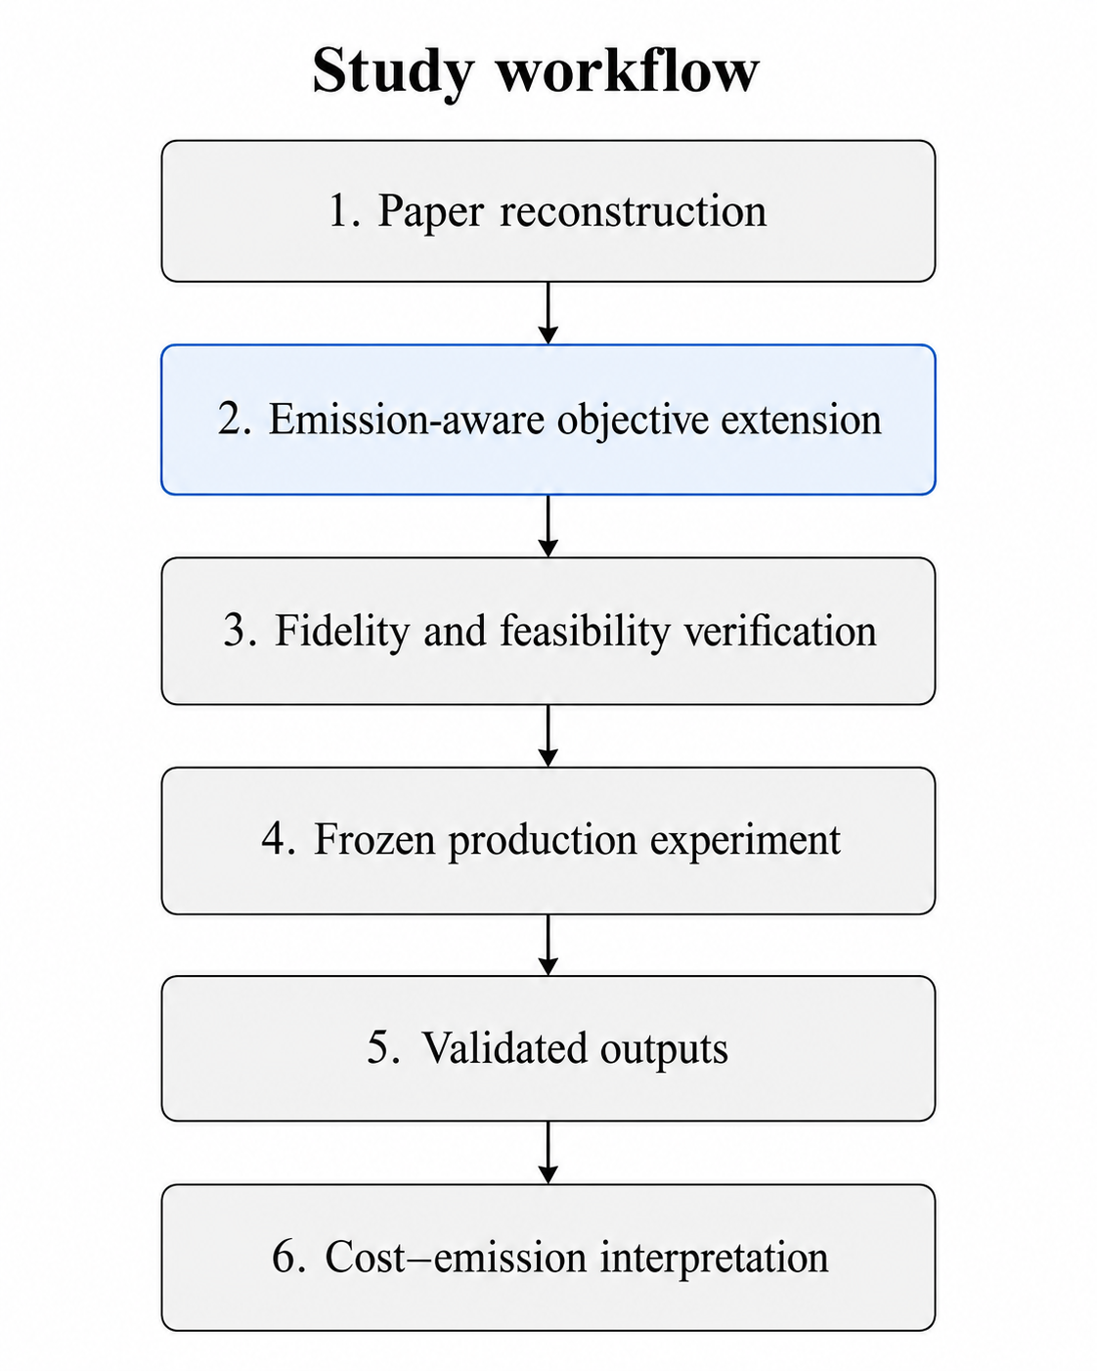
The report follows a step-by-step research process. It begins with the reconstruction of the reference framework, followed by the emission-aware objective extension. The implementation is then checked through fidelity and feasibility gates before the controlled production experiment is executed. The validated outputs are finally used for the cost–emission analysis. The overall workflow is shown in Figure 1.
Figure 1. Overall research workflow of the study.

CHAPTER 2. ORIGINAL CSPTW-TN-DO PROBLEM

2.1 Delivery System and Customer Types
The CSPTW-TN-DO system combines several delivery resources and service options. Dedicated vehicles perform company-operated routes from the depot. Occasional driverss may accept delivery tasks along their existing trips. Alternative delivery points allow customers to collect parcels from assigned locations, while transshipment nodes support parcel transfers from dedicated vehicles to occasional driverss.

Table 1. Main entities and operational roles in the CSPTW-TN-DO system.

Element | Function in the system
Depot | Starting and ending location for dedicated vehicles and a possible pick-up point for occasional driverss.
Dedicated vehicle (DV) | Company-owned vehicle that serves customers, alternative delivery points, and transshipment nodes.
Occasional drivers (OD) | External driver with an existing origin and destination who may accept delivery tasks.
Alternative delivery point (ADP) | Customer pick-up location used to consolidate deliveries.
Transshipment node (TN) | Transfer location where a dedicated vehicle supplies parcels for an occasional drivers.
Customer | Demand node with a delivery preference and, for home delivery, a service time window.

The customer set is divided into three types.

Table 2. Available delivery options by customer type.
Customer type | Delivery requirement | Available service
Type 1 | Home delivery only | Dedicated vehicle or occasional drivers
Type 2 | ADP delivery only | Dedicated vehicle delivers to the assigned ADP
Type 3 | Home delivery or ADP | Dedicated vehicle, occasional drivers, or assigned ADP
Type 3 customers provide the greatest flexibility because the model may choose between home delivery and ADP delivery. The selected option must still satisfy routing, capacity, and time-related requirements.
The main delivery modes and transfer relationships are illustrated in Figure 2.
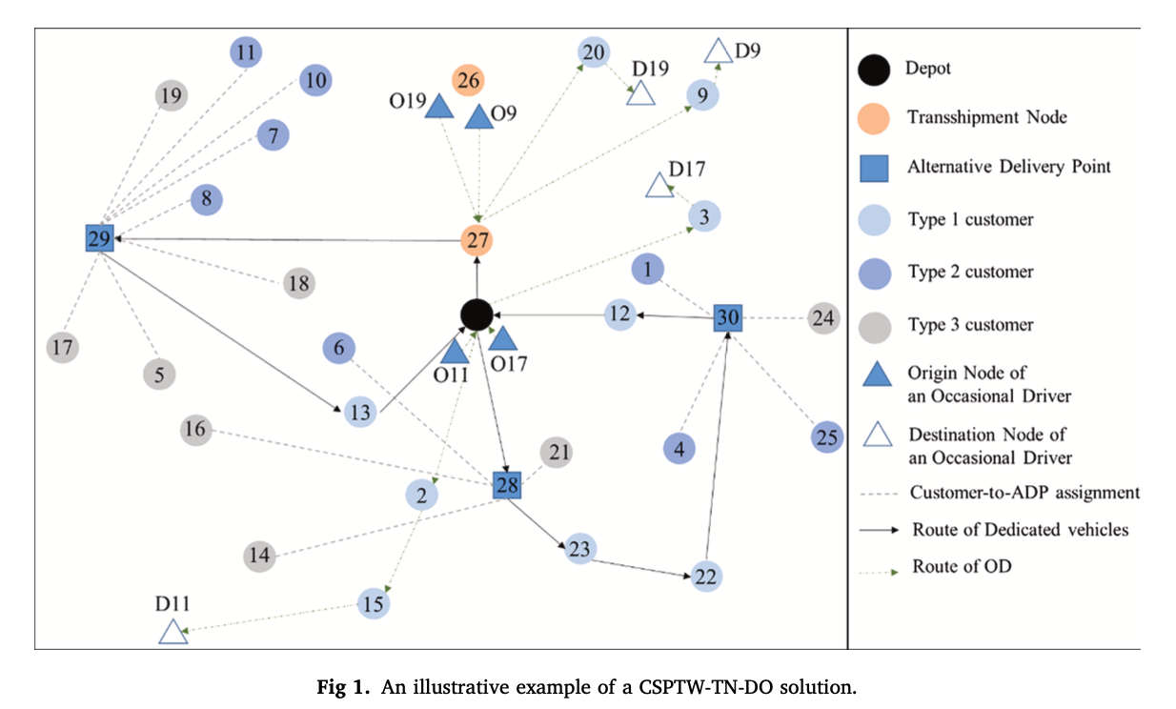
Figure 2. Main delivery modes and transfer relationships in the CSPTW-TN-DO system. Adapted from Yu et al. (2022).

2.2 Main Decisions
The original problem makes several linked decisions:
- which delivery option is selected for each customer
- whether a home-delivery customer is assigned to a dedicated vehicle or an occasional drivers
- which alternative delivery point is used for an eligible customer
- which pick-up point is assigned to each occasional drivers
- how dedicated vehicles and occasional drivers routes are sequenced
- how parcel loads and service times are coordinated
- whether each transshipment handoff is feasible.
These decisions are interdependent. For example, assigning a customer to an occasional drivers may require a pick-up point, a feasible detour, sufficient driver capacity, and a valid parcel handoff time.

2.3 Original Cost Objective
The original objective minimizes total distribution cost:
$$\min{Z}= Z_{D}+ Σ_{k∈CS}Z_{k}^{CS} \left(1\right)$$

where $Z_{D}$ is the total dedicated vehicles cost and $Z_{k}^{CS}$is the compensation paid to occasional drivers k.

The dedicated vehicles cost is calculated from the selected route arcs:

$$Z_{D}= Σ_{k∈N_{DV}}Σ_{i}Σ_{j≠i}c_{ij}x_{ijk} \left(2\right)$$

where $c_{ij}$is the travel cost from node (i) to node( j), and $x_{ijk}$ equals one when dedicated vehicle k travels directly from (i) to ( j).

$$Z_{k}^{CS}= ρD_{k}^{extra} \left(3\right)$$

where $ρ$ is the compensation factor and $D_{k}^{extra}$ is the additional distance caused by the delivery task.

The additional distance is defined as:

$$D_{k}^{extra}= D_{k}^{used}- D_{k}^{direct} \left(4\right)$$
where $D_{k}^{used}$is the traveled distance after accepting delivery tasks and $D_{k}^{direct}$is the original direct distance from the driver’s origin to destination.
Only the additional distance is included because the driver’s original trip already existed before the delivery assignment. The same incremental-distance concept is later used in the emission formulation for occasional driverss.

2.4 Main Constraint Groups
The original formulation contains several detailed constraints. For clarity, they are grouped into five main categories.
Table 3. Main constraint groups in the original CSPTW-TN-DO formulation.
Constraint group | Main control | Operational interpretation
Delivery-option constraints | Home-delivery or ADP selection | Each customer receives one valid delivery option.
Vehicle-assignment constraints | DV or OD assignment | Each home-delivery customer is served once.
DV routing constraints | Route flow, capacity, load, and time windows | Each dedicated vehicle follows a feasible route.
OD routing constraints | Pick-up point, customer sequence, capacity, and availability | Each occasional drivers route remains feasible.
TN synchronization constraints | DV supply before OD collection | Parcels must arrive at the TN before the occasional drivers collects them.

A representative synchronization condition is:

$$T_{p}^{DV}+ s_{p}≤ T_{pk}^{OD} \left(5\right)$$
where $T_{p}^{DV}$is the arrival time of the dedicated vehicle at transshipment node (p), $s_{p}$ is the required transfer service time, and $T_{pk}^{OD}$is the collection time of occasional drivers (k).
This condition explains why CSPTW-TN-DO is more complex than a standard Vehicle Routing Problem with Time Windows. A route may be short in distance but infeasible because the parcel has not yet arrived at the selected transshipment node.

2.5 Solution Approaches in the Reference Study
The reference study uses two solution approaches.
The exact formulation is intended for smaller instances. After linearization, the model can be solved as a Mixed Integer Linear Programming problem and can provide a feasible incumbent, lower bound, MIP gap, and, when the gap is closed, an optimality certificate.
For larger instances, the study uses Adaptive Large Neighborhood Search. The heuristic provides a practical solution method when the exact formulation becomes computationally expensive.
This project follows the same division of roles. The exact formulation is used as a small-instance reference, while ALNS is used for the final production experiment. The detailed reconstruction of both approaches is presented in Chapter 4.
The original framework therefore provides the operational and algorithmic baseline for the emission-aware extension introduced in Chapter 3.

CHAPTER 3. EMISSION-AWARE MULTI-OBJECTIVE EXTENSION

3.1 Extension Principle
The emission-aware extension retains the original delivery structure and feasibility conditions of CSPTW-TN-DO. Customer types, delivery options, vehicle capacities, time windows, and TN synchronization remain unchanged.
The main change is the evaluation of a feasible solution. Instead of considering only distribution cost, the extended model evaluates both distribution cost and estimated operational emissions.
The extension therefore adds three elements:
- emissions from dedicated vehicles routes
- emissions from occasional drivers detours
- a normalized scalar objective that combines cost and emissions.
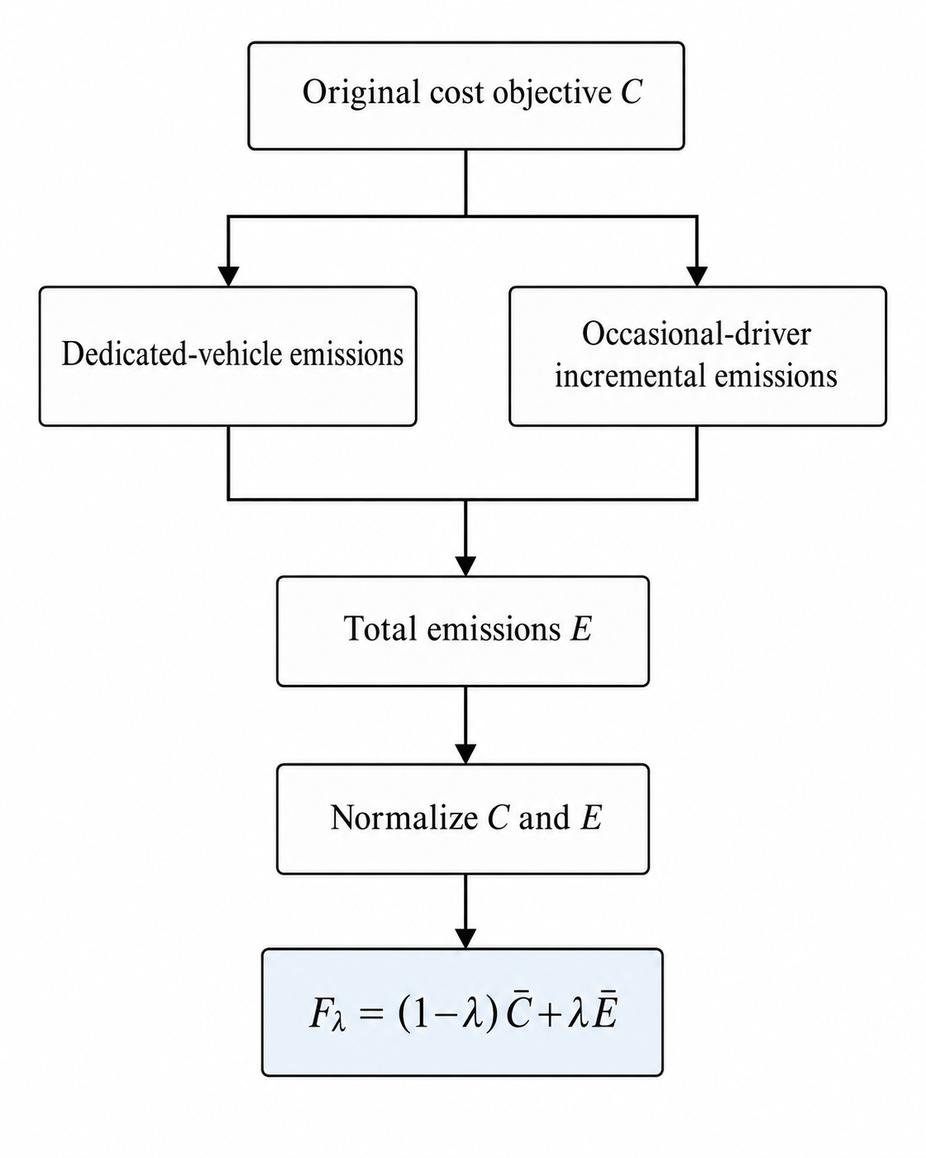
The overall objective-extension structure is shown in Figure 3.
Figure 3. Extension from the original cost objective to the normalized cost–emission objective.

3.2 Dedicated vehicles Operational Emissions
The total distance traveled by dedicated vehicles is:

$$D_{DV}= Σ_{k∈N_{DV}}Σ_{i}Σ_{j≠i}d_{ij}x_{ijk} \left(6\right)$$

where $d_{ij}$is the distance from node (i) to node (j), and $x_{ijk}$ equals one when dedicated vehicle (k) travels directly from (i) to (j).

Dedicated vehicles emissions are calculated as:
$$E_{DV}= e_{DV}D_{DV} \left(7\right)$$

where $e_{DV}$ is the dedicated vehicles emission factor per unit of distance.
The full dedicated vehicles route is included because the route is performed specifically for the delivery operation.

3.3 Occasional drivers Incremental Emissions
Occasional driverss already have an original trip from an origin to a destination. Therefore, the delivery system is responsible only for the additional travel caused by the parcel assignment.
The incremental-distance definition introduced in Section 2.3 is used:
$$D_{k}^{extra}=\max\left\{0, D_{k}^{used}- D_{k}^{direct}\right\} \left(8\right)$$

where $D_{k}^{used}$ is the route distance after accepting delivery tasks and $D_{k}^{direct}$ is the original direct-trip distance.

The maximum operator prevents the attributable distance from becoming negative.
The emissions of occasional drivers $k$ are:
$$e_{k}^{OD}D_{k}^{extra}$$

where $e_{k}^{OD}$ is the emission factor of occasional drivers $k$

Total occasional drivers emissions are:

$$E_{OD}= Σ_{k∈CS}e_{k}^{OD}D_{k}^{extra} \left(9\right)$$
This formulation avoids assigning the driver’s original personal trip to the delivery operation.

3.4 Total Emissions
Total operational emissions are calculated as:
$$E = E_{DV}+ E_{OD} \left(10\right)$$

or, in expanded form:

$$E=e_{DV}D_{DV}+\sum_{k∈CS}{e_{k}^{OD}}D_{k}^{extra} (10)$$

The model uses distance-based emission factors. The specific values used in the computational experiment are reported in Chapter 5.

3.5 Why Cost and Emissions Are Normalized
Cost and emissions have different units and numerical scales. Cost is measured in distribution-cost units, while emissions are measured using the selected operational emission factors.
A direct objective such as: $C + λE$
would be difficult to interpret because the two components are not measured on the same scale. The objective with the larger numerical range could dominate the result even when the intended decision priority is different.
Normalization is therefore applied before the two objectives are combined. This converts both measures into dimensionless values and allows $λ$ to represent the relative emphasis placed on each normalized objective.

3.6 Empirical Boundary Anchors
Two boundary solutions are used to define the normalization references.
Let $S_{C}$ represent the cost-oriented boundary solution and $S_{E}$ represent the emission-oriented boundary solution. Each solution provides both a cost value and an emission value.
The cost anchors are defined as:

$$C^{ideal}= C\left(S_{C}\right) \left(11\right)$$

$$C^{nadir}= C\left(S_{E}\right) \left(12\right)$$
The emission anchors are defined as:
$$E^{ideal}= E\left(S_{E}\right) \left(13\right)$$

$$E^{nadir}= E\left(S_{C}\right) \left(14\right)$$

Table 4. Relationship between the boundary solutions and normalization anchors.
Boundary solution | Cost reference | Emission reference
Cost-oriented solution $S_{C}$ | $$C^{ideal}=C\left(S_{C}\right)$$ | $$E^{nadir}=E\left(S_{C}\right)$$
Emission-oriented solution $S_{E}$ | $$C^{nadir}=C\left(S_{E}\right)$$ | $$E^{ideal}=E\left(S_{E}\right)$$
These values are empirical references obtained from the selected boundary solutions. They are not guaranteed theoretical ideal and nadir values.
The actual anchor-generation procedure used in the experiment is described in Chapter 5.

3.7 Normalized Cost and Emissions
The anchors defined in Section 3.6 are used to convert cost and emissions into dimensionless values.
Normalized cost is:
$$\bar{C}\left(S\right)=\frac{\left[C\left(S\right)-C^{ideal}\right]}{\left[C^{nadir}-C^{ideal}\right]} \left(15\right)$$

Normalized emissions are:
$$Ē\left(S\right)=\frac{\left[E\left(S\right)-E^{ideal}\right]}{\left[E^{nadir}-E^{ideal}\right]} \left(16\right)$$

A value of zero represents the related ideal anchor, while a value of one represents the opposite-boundary reference. Lower values are preferred for both normalized objectives.
Because the anchors are empirical, a later solution may produce a normalized value below zero or above one. This means that the solution falls outside the frozen reference range; it does not automatically indicate an invalid solution.
The two normalized objectives are combined in the weighted scalar function presented in Section 3.8.

3.8 Weighted Scalar Objective
The normalized objectives are combined as:
$$F_{λ\left(S\right)}= \left(1-λ\right)\bar{C}\left(S\right)+ λĒ\left(S\right) \left(17\right)$$

subject to:
$$0 ≤ λ ≤ 1 \left(18\right)$$

A lower value of $F_{λ}\left(S\right)$ is preferred.
Table 5. Interpretation of the environmental weight λ
λ | Objective emphasis
0.00 | Cost-oriented search
0.25 | Higher emphasis on normalized cost
0.50 | Equal weight on normalized cost and normalized emissions
0.75 | Higher emphasis on normalized emissions
1.00 | Emission-oriented search

The setting $λ=0.50$ gives equal weight to the two normalized objectives. It does not mean that one raw cost unit is equal to one raw emission unit.

3.9 Numerical Safeguard for Negative Normalized Values
The reference ALNS applies local search when the working solution is sufficiently close to the best solution found so far:

$$f\left(S^{w}\right)≤\left(1+δ_{LS}\right)f\left(S^{*}\right) (19)$$

where $S^{w}$is the working solution, $S^{*}$ is the current best solution, and $δ_{LS}=0.1$.

This rule works as intended when the objective value is non-negative. However, anchor-based normalization can produce a negative scalarized objective. In that case, multiplying $f\left(S^{*}\right)$ by $\left(1+δ_{LS}\right)$makes the threshold more negative and may cause even the current best solution to fail the eligibility condition.
To preserve the intended relative-gap logic, the project uses:
$$f\left(S^{w}\right)≤f\left(S^{*}\right)+δ_{LS}\left|f\left(S^{*}\right)\right| (20)$$
For non-negative objective values:

$$f\left(S^{*}\right)+δ_{LS}\left|f\left(S^{*}\right)\right|=\left(1+δ_{LS}\right)f\left(S^{*}\right) (21)$$

Therefore, the sign-safe condition is identical to the original rule when the objective is non-negative. It changes only the negative-objective case introduced by the normalization layer.
This adjustment is treated as a numerical compatibility safeguard rather than an algorithmic enhancement.

3.10 Modeling Assumptions
The emission-aware extension uses the assumptions summarized in Table 6.
Table 6. Main assumptions of the emission-aware extension.

Assumption | Use in this project | Main implication
Emission calculation | Constant distance-based factors | Load, speed, road gradient, and congestion are not modeled
OD attribution | Additional distance only | The driver’s original personal trip is excluded.
Travel conditions | Deterministic distance and time | Traffic uncertainty is not considered.
Vehicle modes | Comparative DV and OD factors | Detailed vehicle heterogeneity is not represented.
Environmental scope | Operational travel only | Vehicle production and lifecycle emissions are excluded.

These assumptions keep the extension consistent with the available benchmark data and the project scope. Their effect on interpretation is discussed in Chapter 7.

CHAPTER 4. SOLUTION FRAMEWORK AND RELIABILITY GATES

4.1 Methodological Source and Exact Formulation
The exact formulation and ALNS framework were reconstructed from Yu et al. (2022). The project-specific changes are concentrated in the emission model, objective normalization, numerical safeguards, validation process, and experimental design.
Table 7. Methodological inheritance and project-specific additions
Component | Original source | Use in this project
CSPTW-TN-DO delivery structure | Reference study | Reconstructed
Exact routing and assignment formulation | Reference study | Reconstructed, objective extended
Initial-solution procedure | Reference study | Reconstructed
Destroy operators | Reference study | Retained
Repair operators | Reference study | Retained
Local-search operators | Reference study | Retained
Adaptive operator weights | Reference study | Retained
Simulated annealing | Reference study | Retained
DV and OD emission model | This project | Added
Objective normalization | This project | Added
Weighted scalar objective | This project | Added
Sign-safe local-search condition | This project | Added as a numerical safeguard
Shared validator | This project | Added
Multi-seed experimental design | This project | Added

4.2 ALNS Workflow
The ALNS begins from a complete feasible solution. At each iteration, one destroy operator removes part of the current solution and one repair operator reinserts the removed components. Local search is applied to eligible working solutions, and simulated annealing determines whether the working solution replaces the current solution. Operator scores and weights are then updated according to their recent performance.

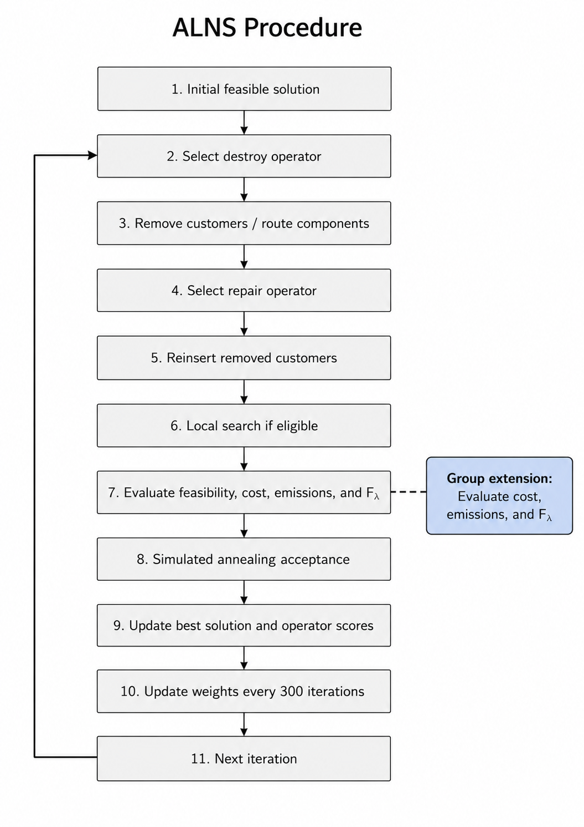
The emission-aware extension does not change the main search sequence. It changes the evaluation stage by adding emissions and the scalarized objective $F_{lambda}$.
Figure 4. Paper-based ALNS workflow with emission-aware objective evaluation. Adapted from the ALNS procedure of Yu et al. (2022).

4.3 Initial Solution Construction
The initial solution follows the three-stage logic reported in the reference study.
First, home-delivery customers are considered for insertion into occasional drivers routes. If an unused occasional drivers is selected, a depot or TN pick-up point must also be assigned. The insertion is accepted only when the resulting route remains feasible.
Second, TNs required by occasional drivers routes are inserted into dedicated vehicles routes. If the TN cannot be supplied within the required time, the related occasional drivers may switch to the depot, or the affected customers may return to the unassigned-customer list.
Third, the remaining customers are inserted into feasible DV, OD, or ADP alternatives according to their delivery types.
This procedure provides a complete feasible starting point for ALNS. The three-stage construction logic is inherited from the reference framework, while the extended objective is used to evaluate feasible insertion choices.

4.4 Destroy, Repair, and Local Search
Table 8. Main search components of the reconstructed ALNS.

Search stage | Main variants | Purpose
Destroy | 12 selectable entries from 10 paper families | Remove customers, ADPs, TNs, or route components to diversify the search
Repair | Best and regret insertions with deterministic and perturbed variants | Reconstruct a complete feasible solution
Local search | Eight move and swap entries | Improve promising DV and OD route combinations

The destroy stage includes random customer, ADP, and TN removal; worst-customer and worst-ADP removal; route removal; related removal; historical removal; neighborhood removal; and node-neighborhood removal. Deterministic and probabilistic variants result in twelve selectable destroy entries.
The repair stage contains six variants: best insertion, perturbed best insertion, 2-regret insertion, perturbed 2-regret insertion, 3-regret insertion, and perturbed 3-regret insertion. Best insertion selects the feasible position with the lowest incremental objective value. Regret insertion also considers how much the solution may worsen if a customer is not inserted into its best position immediately.
For customer i, the k-regret value is calculated as:
$$Regret_{i}^{k}=\sum_{j=2}^{k}{\left(f_{ij}-f_{i1}\right)} (22)$$
where $f_{i1}$ is the best feasible insertion value for customer i, and $f_{ij}$ is its $j-$th best feasible insertion value. A larger regret value means that delaying the insertion may lead to a much worse alternative. Therefore, customers with larger regret values receive higher insertion priority.
Local search applies move and swap operations within and between DV and OD routes. Each accepted move must preserve delivery-option, capacity, time-window, and TN-synchronization feasibility.

4.5 Adaptive Operator Weights
Destroy and repair operators are initially assigned equal weights. Their weights are updated according to their performance during each scoring segment:
$$w_{i}^{new}=\left(1-ζ\right)w_{i}^{old}+ζ\frac{π_{i}}{n_{i}} (23)$$
where:
- $w_{i}^{old}$is the current weight of operator $i$
- $w_{i}^{new}$is the updated weight
- $ζ$ is the reaction factor
- $π_{i}$ is the accumulated score of operator $i$
- $n_{i}$is the number of times operator $i$ was selected during the segment.
The reaction factor is:
$$ζ=0.1$$
Operators receive a score of 33 when they find a new global best solution, 15 when they improve the current solution, and 9 when they produce a worse but accepted solution. The weights are updated after every 300 iterations.
After the update, the selection probability of operator $i$ is:
$$P_{i}=\frac{w_{i}}{\sum_{j∈Ω}{w_{j}}} (24)$$

where $Ω$is the set of available destroy or repair operators. Operators with higher weights therefore have a higher probability of being selected in the next segment.

4.6 Simulated Annealing Acceptance
A working solution that improves the current solution is accepted directly. A worse solution may also be accepted according to the simulated annealing probability:
$$P_{accept}=\exp\left[-\frac{F\left(S^{w}\right)-F\left(S^{c}\right)}{T}\right] \left(25\right)$$

where:
- $S^{w}$ is the working solution;
- $S^{c}$is the current solution;
- $F\left(⋅\right)$ is the scalar objective value;
- $T$ is the current temperature.
The temperature is reduced after each iteration:
$$T_{n+1}=αT_{n} (26)$$

The cooling rate is $α= 0.9994$. At a high temperature, the algorithm is more likely to accept a worse solution. This helps the search move away from a local optimum. As the temperature decreases, worse solutions become less likely to be accepted.

4.7 Fidelity and Feasibility Gates
The reconstructed framework was checked before the final production experiment. The verification focused on the reported algorithm structure, operational feasibility, numerical consistency, and reproducibility.
Table 9. Verification gates applied before the production experiment

Gate | What was checked | Evidence used | Status
Structural fidelity | Operator inventory, parameter values, and solution representation | Controlled component tests and configuration review | Pass
Behavioral fidelity | Customer types, delivery options, capacities, time windows, and TN synchronization | Shared final validator | Pass
Numerical consistency | Cost, emissions, normalization, and $F_{λ}$ recomputation | Independent evaluator | Pass
Reproducibility | Lambda value, random seed, iteration count, configuration, and output files | Run manifests and deterministic seeds | Pass
Production readiness | Complete outputs, no duplicate runs, and final validator pass | Consolidated result checks | Pass

These gates do not prove that every undocumented implementation detail is identical to the original authors’ code. They show that the reported problem structure and ALNS components were reconstructed and tested against the computational contract used in this project.

4.8 Feasibility-Consistency Correction and Final Rerun
During the pilot experiment, an inconsistency was found between the repair-stage capacity check and the final validator. The issue concerned TN handoff demand when more than one dedicated vehicles route visited the same transfer node.
The repair-stage feasibility logic was aligned with the shared validator so that candidate solutions and final solutions used the same capacity interpretation. This correction did not introduce a new search operator or algorithmic enhancement.
However, a change in candidate feasibility can affect the trajectory of a stochastic search. For this reason, mixed-provenance pilot outputs were excluded from the primary analysis. The C101-derived and R101-derived production experiments were then executed under the same corrected code revision, hardware environment, seed set, and iteration budget.
After the regression checks were completed, the experiment settings were frozen. The final production design is presented in Chapter 5.

CHAPTER 5. BENCHMARK CONSTRUCTION AND EXPERIMENTAL DESIGN

5.1 Source Data and Derived Benchmark Instances
The customer coordinates, demands, service times, and time-window information were obtained from the Solomon Vehicle Routing Problem with Time Windows benchmark dataset available through the SINTEF repository.
The project uses the C101 and R101 instance families. C101 represents a clustered customer-location structure, while R101 represents a more randomly distributed structure. These two families were selected to examine whether spatial arrangement affects route consolidation, occasional drivers detours, solution variability, and the cost–emission relationship.
The original Solomon data describe a classical VRPTW with one depot, customer coordinates, customer demands, service times, vehicle capacity, and time windows. They do not contain occasional driverss, alternative delivery points, transshipment nodes, customer delivery types, or emission parameters.
The Solomon records were therefore used as the spatial, demand, service-time, and time-window foundation. They were transformed into CSPTW-TN-DO instances by adding:
- three customer delivery types
- dedicated vehicles settings
- occasional drivers origins and destinations
- alternative delivery points
- transshipment nodes
- customer-to-ADP assignments
- occasional drivers capacities and availability periods
- operational emission parameters
The final instances are referred to as C101-derived and R101-derived CSPTW-TN-DO instances. They are not unchanged Solomon VRPTW instances, and their objective values are not directly comparable with the published Solomon best-known solutions.
The spatial structures of the final instances are shown in Figure 5.
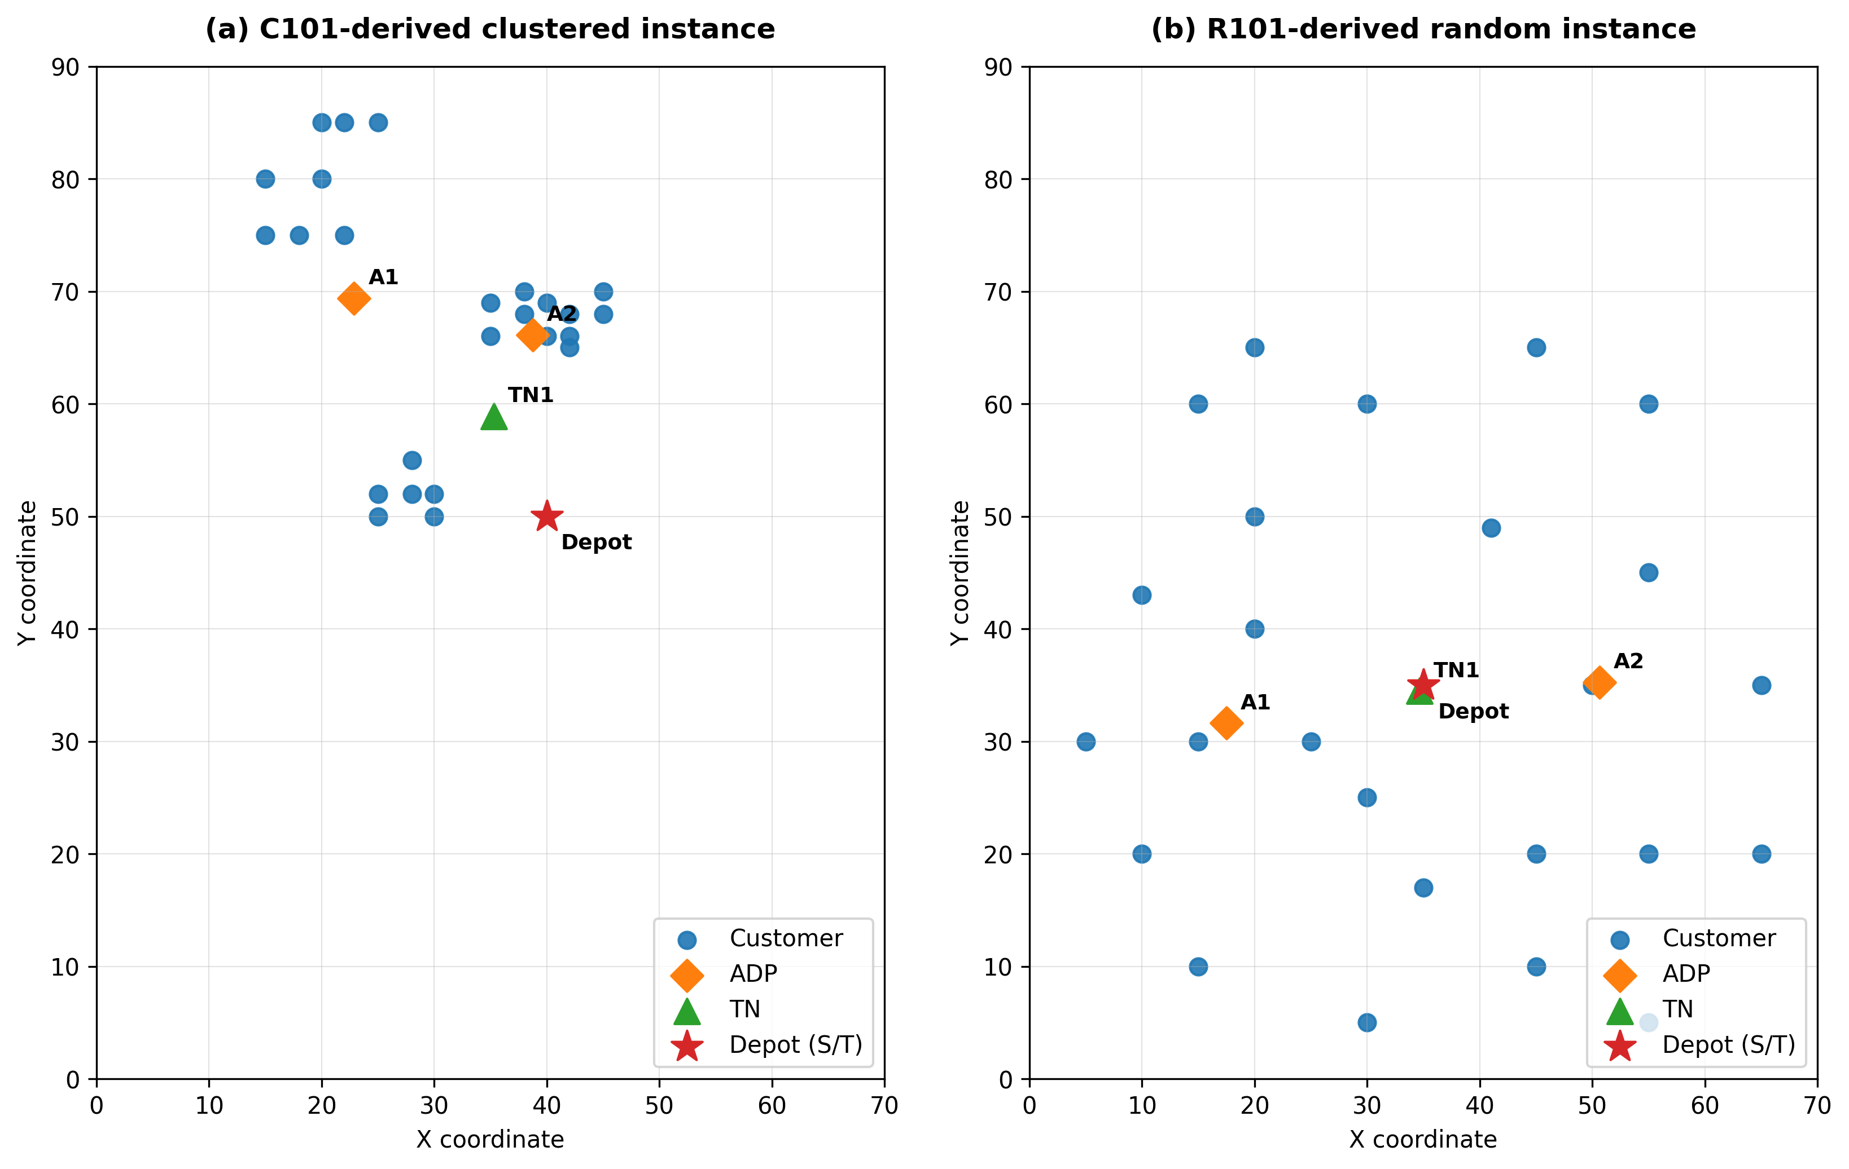
Figure 5. Spatial layouts of the C101-derived and R101-derived CSPTW-TN-DO instances.
Note: Customer coordinates are based on the Solomon VRPTW benchmark from the SINTEF repository. The ADP and TN locations were generated during the instance-construction process of this study.

5.2 Final ALNS Production Matrix
The same production design was applied to both derived instances.
Table 10. Final ALNS production matrix.
Setting | C101-derived | R101-derived
Solomon source | C101 | R101
Spatial structure | Clustered | Random
Customers | 25 | 25
Lambda values | 0, 0.25, 0.5, 0.75, 1 | 0, 0.25, 0.5, 0.75, 1
Seeds | 2029-2040 | 2029-2040
Seeds per lambda | 12 | 12
Iterations per run | 301 | 301
Planned runs | 60 | 60
Code revision | 1079caf | 1079caf
Hardware | MacBook Air M4 | MacBook Air M4

The total planned ALNS benchmark was:

$$2×5×12=120\text{ runs}\text{ (27)}$$
The matched seed set and common execution environment were used to support a controlled comparison between the clustered and random spatial structures.
This table defines the planned experiment. Run completion, missing combinations, duplicates, and validator outcomes are reported in Chapter 6.

5.3 Normalization Anchor Generation
Separate normalization anchors were used for the C101-derived and R101-derived instances because the two cases have different cost and emission scales.
For each instance, a cost-oriented boundary solution and an emission-oriented boundary solution were generated before the intermediate lambda settings were evaluated. The resulting cost and emission values were used to define as:
$$C^{ideal}, C^{nadir}, E^{ideal}, E^{nadir}$$

The anchors were frozen before the final production experiment. Therefore, all seeds and lambda settings for the same instance were evaluated using one consistent normalization scale.

Table 11. Empirical normalization anchors used in the production experiment.

Instance | $$C^{ideal}$$ | $$C^{nadir}$$ | $$E^{ideal}$$ | $$E^{nadir}$$ | Anchor source
C101-derived | 138.620394 | 140.106516 | 445.860718 | 450.764046 | Objective-specific exact-solver incumbents generated under a 300-second time limit.
R101-derived | 184.011763 | 326.629585 | 614.888095 | 1037.248717 | Empirical bounds from the feasible-solution calibration pool, including the initial paper solution and 60-/300-second objective-specific exact incumbents

These values are empirical references rather than guaranteed theoretical ideal and nadir points. They were not updated after the production experiment began, even when a later solution fell outside the original reference range.

5.4 ALNS Search Budget
The reference study uses 30,000 ALNS iterations and updates operator weights after every 300 iterations. The present experiment uses 301 iterations per run. This budget allows each run to complete one full 300-iteration operator-scoring segment and then perform one additional iteration after the first weight update.
The reduced budget was selected to keep the complete 120-run experiment computationally practical. It exercises the reported adaptive-weight mechanism at a basic level but does not reproduce the full computational effort of the reference study.

5.5 Objective and Emission Parameters
The main objective and emission parameters used by both the exact formulation and ALNS are summarized in Table 12.
Table 12. Objective and emission parameters used in the computational experiment.
Parameter | Value | Purpose
Lambda values | 0, 0.25, 0.50, 0.75, 1.00 | Control the relative emphasis on normalized cost and emissions
DV emission factor | 3.0 | Comparative emissions per unit of dedicated vehicles distance
OD emission factor | 1.0 | Comparative emissions per unit of occasional drivers additional distance
Local-search threshold (δLS​) | 0.1 | Define eligibility for local-search intensification
Normalization policy | Instance-specific frozen anchors | Maintain one consistent objective scale per instance
The emission factors are comparative modeling parameters rather than a full real-world carbon inventory.

5.6 Exact-Solver Configuration
The exact formulation was evaluated on the 25-customer C101-derived instance under a fixed computational budget. Its purpose was to generate objective-specific normalization anchors, provide a small-instance formulation reference, and observe solver behavior under the weighted scalar objective.
Two weighted-objective configuration packages were executed. Both packages used the same five lambda values, time limit, MIP-gap target, emission factors, and normalization anchors. The recorded configuration field epsilon_levels was set to 1 in the first package and 2 in the second package.
Table 13. Exact-solver configuration for the C101-derived instance.
Parameter | Value
Instance | C101-derived
Number of customers | 25
Primary objective mode | Weighted scalar objective
Lambda values | 0, 0.25, 0.50, 0.75, 1.00
Weighted-objective packages | 2
epsilon_levels settings | 1 and 2
Weighted runs per package | 5
Completed weighted runs | 10
Retained anchor objectives | Cost and emissions
Retained anchor incumbents | 2
Time limit | 300 seconds per solve
Target relative MIP gap | 5%
Feasible incumbent required | Yes
Shared-validator acceptance required | Yes
Zero-gap optimality required | No
The two retained anchor incumbents were generated from separate cost-oriented and emission-oriented exact solves. Their objective values were frozen as the empirical C101-derived normalization anchors reported in Table 11.
A separate epsilon-constraint stage was also planned. In that stage, transportation cost was minimized subject to an upper bound on total emissions. The first epsilon-constrained solve returned NOT_SOLVED within the 300-second limit and did not provide a retained feasible incumbent. The second epsilon level was therefore not completed. No epsilon-constraint result was included in the final result analysis.
The field epsilon_levels appearing in the two completed weighted-objective packages should not be confused with a successfully completed epsilon-constraint experiment. In the retained artifacts, the five reported lambda solutions were produced by the weighted scalar objective.
A weighted or anchor solve was retained only when it produced a feasible incumbent that passed the shared final validator. A result reaching the time limit without closing the gap was reported as feasible rather than as a zero-gap optimum. The retained exact results are presented in Section 6.2.

5.7 Run Inclusion and Data-Integrity Rules
A run was included in the final analysis only when all of the following conditions were satisfied:
- The run belonged to the final instance, lambda, and seed matrix.
- It used the frozen code revision and production environment.
- It reached the required stopping condition.
- The final feasibility validator passed.
- The required result, iteration-history, and manifest files were generated.
- No duplicate instance–lambda–seed combination was present.
- The reported cost, emissions, normalized values, and $F_{λ}$agreed with the independent evaluator.
Pilot outputs generated before the final feasibility alignment were excluded from the primary analysis. The number of completed and included runs is reported in Chapter 6.

5.8 Analysis Measures
The experimental outputs were evaluated through objective, search-performance, and statistical measures.
Objective measures:
- Total distribution cost
- Total operational emissions
- Scalarized objective $F_{λ}$
- Dedicated vehicles distance
- Occasional drivers additional distance
Search-performance measures:
- Improvement from the initial solution
- Runtime and completion status
- Number of new global-best solutions
- Accepted and rejected working solutions
- Number of worse but accepted solutions
Statistical measures:
- Mean
- Median
- Standard deviation
- Minimum
- Maximum
- Interquartile range
Relative cost change from the cost-oriented baseline is calculated as:
$$ΔC\left(\%\right)=\frac{C_{λ}-C_{0}}{C_{0}}×100 (28)$$

Relative emission reduction from the cost-oriented baseline is calculated as:
$$\text{Emission reduction}\left(\%\right)=\frac{E_{0}-E_{λ}}{E_{0}}×100 (29)$$
The relative measures are used when comparing C101-derived and R101-derived because their raw distance-based objective values are on different scales.
The next chapter reports the completion status and computational results obtained under this experimental design.
CHAPTER 6. RESULTS

6.1 Experiment Completion and Validation
The final analysis was conducted after checking run completion, duplicate combinations, stopping conditions, and feasibility status.
Table 14. Completion and validation summary of the final computational experiment.

Experiment | Planned runs | Completed runs | Included runs | Validation result
Exact weighted-sum package, epsilon_levels = 1 | 5 | 5 | 5 | All incumbents passed the shared validator
Exact weighted-sum package, epsilon_levels = 2 | 5 | 5 | 5 | All incumbents passed the shared validator
Exact anchor solves | 2 | 2 | 2 | Both incumbents passed the shared validator
Epsilon-constraint stage | 2 levels | 1 attempted | 0 | First solve returned NOT_SOLVED; no result retained
ALNS C101-derived | 60 | 60 | 60 | 100% pass
ALNS R101-derived | 60 | 60 | 60 | 100% pass
ALNS total | 120 | 120 | 120 | 100% pass

The final ALNS dataset contained all 120 planned instance–lambda–seed combinations. No combination was missing or duplicated. Every ALNS run reached the 301-iteration limit and passed the final feasibility validator.
The total recorded ALNS runtime was approximately 2.56 hours for C101-derived and 2.46 hours for R101-derived. The final exact analysis included the validated anchor and weighted-sum incumbents only. No epsilon-constraint result was retained.

6.2 Exact C101-Derived Results

6.2.1 Exact Anchor Incumbents
The cost-oriented and emission-oriented exact runs provided the empirical anchors used for C101-derived normalization.
Table 15. Exact anchor incumbents used for C101-derived normalization.
Anchor run | Cost | Emissions | Runtime (s) | Solver status | Relative MIP gap (%)
Cost-oriented anchor | 138.620394 | 450.764046 | 257.10–262.63 | OPTIMAL* | 4.62
Emission-oriented anchor | 140.106516 | 445.860718 | 300.01 | FEASIBLE | 15.45–15.46
*The solver reported the cost-oriented anchor as OPTIMAL after meeting the configured 5% relative MIP-gap tolerance. This status does not mean that the mathematical gap was zero.
Both anchor solutions passed the shared final validator. They were used as empirical normalization references and were not interpreted as theoretical ideal and nadir points for the complete feasible region.

6.2.2 Weighted-Sum Exact Results
The two weighted-objective packages used the same five lambda values, 300-second limit, 5% target MIP gap, emission factors, and normalization anchors.
The two epsilon_levels settings produced the same incumbents to the reported precision. Therefore, the weighted-sum results are presented once rather than repeated in two identical five-row tables.
Table 16. Weighted-sum exact-solver results for the C101-derived instance.
$$λ$$ | Cost | Emissions | $$F_{λ}$$ | Runtime (s) | Solver status | Relative MIP gap (%)
0.00 | 142.131 | 450.336 | 2.362 | 300.06 | FEASIBLE | 5.17
0.25 | 148.869 | 474.919 | 6.654 | 300.01 | FEASIBLE | 22.02
0.50 | 140.712 | 448.889 | 1.013 | 300.01 | FEASIBLE | 13.79
0.75 | 140.624 | 447.413 | 0.574 | 300.01 | FEASIBLE | 14.31
1.00 | 146.793 | 464.323 | 3.765 | 300.01 | FEASIBLE | 8.91
All five weighted-sum runs returned feasible validated incumbents and used approximately the full 300-second time limit. None of the runs certified zero-gap optimality.
The results did not form a consistent cost–emission curve. In particular, the ($λ$ =1.00) incumbent did not have the lowest reported emissions. This should be interpreted as incomplete exact-solver convergence under the fixed limit rather than evidence that a larger emission weight should increase emissions.

6.2.3 Comparison of the Two epsilon_levels Configurations
The weighted-sum experiment was executed through two configuration packages, with epsilon_levels set to 1 and 2. Both packages used the weighted scalar objective and produced the same feasible incumbents to the reported precision for all five lambda values. Their runtimes and relative MIP gaps were also nearly identical.
These results belong to the weighted-sum execution path. They do not indicate that both levels of the separate epsilon-constraint stage were solved successfully. The first epsilon-constrained solve returned NOT_SOLVED, and no epsilon-constraint incumbent was retained for analysis.
The available weighted-run artifacts do not show a numerical effect from changing the configuration field from 1 to 2 for the tested C101-derived instance. This observation should not be generalized to other solver modes or problem sizes.

6.3 ALNS Completion and Validation
Table 17. Completion and validation summary of the final ALNS benchmark.
Check | C101-derived | R101-derived
Expected runs | 60 | 60
Completed runs | 60 | 60
Unique lambda–seed combinations | 60 | 60
Duplicate combinations | 0 | 0
Validation pass rate | 100% | 100%
Iterations per run | 301 | 301
Total recorded runtime | Approximately 2.56 hours | Approximately 2.46 hours
Stopping condition | Iteration limit | Iteration limit
The completion and validation checks were performed before comparing objective values. This reduced the risk of drawing conclusions from incomplete, duplicated, or infeasible outputs.

6.4 C101-Derived ALNS Results
Table 18. C101-derived ALNS results by lambda.
$$λ$$ | Runs | Mean cost | Median cost | SD cost | Mean emissions | Median emissions | SD emissions | Mean  $$F_{λ}$$ | Mean runtime (s)
0.00 | 12 | 143.573 | 142.764 | 3.635 | 461.267 | 461.625 | 12.395 | 3.3326 | 149.2
0.25 | 12 | 141.990 | 141.309 | 1.959 | 456.464 | 456.744 | 7.488 | 2.2412 | 149.3
0.50 | 12 | 141.355 | 140.818 | 2.299 | 454.591 | 453.121 | 7.900 | 1.8102 | 147.8
0.75 | 12 | 141.894 | 141.230 | 2.531 | 454.200 | 450.491 | 7.308 | 1.8262 | 168.9
1.00 | 12 | 142.534 | 141.230 | 3.030 | 454.768 | 450.442 | 9.078 | 1.8165 | 152.3
All four lambda values above zero produced lower mean cost and lower mean emissions than the $(λ=0)$ baseline.
The lowest mean cost was obtained at $(λ=0.50)$ representing a reduction of approximately 1.55% from the baseline. The lowest mean emissions were obtained at $(λ=0.75)$, representing a reduction of approximately 1.53%.
The pattern was not fully monotonic. Increasing lambda from 0.75 to 1.00 did not reduce mean emissions further. The results therefore suggest that the intermediate weight settings helped the short ALNS runs find stronger solutions, but they do not show that increasing lambda always improves either objective.
One C101-derived run at $(λ=0)$ produced a negative normalized objective because its cost was lower than the frozen empirical cost anchor. The run completed all 301 iterations and passed the final validator. This provides observed evidence for the sign-safe condition introduced in Section 3.9.

6.5 R101-Derived ALNS Results
Table 19. R101-derived ALNS results by lambda.
$$λ$$ | Runs | Mean cost | Median cost | SD cost | Mean emissions | Median emissions | SD emissions | Mean  $$F_{λ}$$ | Mean runtime (s)
0.00 | 12 | 190.157 | 191.458 | 4.726 | 631.999 | 633.836 | 11.261 | 0.0431 | 148.8
0.25 | 12 | 190.251 | 193.941 | 5.526 | 626.375 | 633.091 | 10.389 | 0.0396 | 143.9
0.50 | 12 | 189.744 | 188.601 | 5.575 | 628.133 | 627.955 | 12.345 | 0.0358 | 143.7
0.75 | 12 | 193.015 | 195.010 | 4.306 | 634.044 | 634.365 | 9.094 | 0.0498 | 150.7
1.00 | 12 | 189.890 | 189.839 | 6.095 | 625.983 | 625.144 | 12.319 | 0.0263 | 150.9
The R101-derived results showed a weaker and non-monotonic response.
Compared with $(λ=0)$, the $(λ=1.00)$ configuration reduced mean emissions by approximately 0.95% and mean cost by approximately 0.14%. The $(λ=0.50)$ configuration also produced small reductions in both mean measures.
In contrast, $(λ=0.75)$, increased mean cost by approximately 1.50% and increased mean emissions by approximately 0.32%. The R101-derived outcomes therefore did not form a clear monotonic trade-off.

6.6 Improvement from the Initial Construction
Table 20. Mean improvement from the initial solution to the final ALNS solution.
Instance | Mean cost improvement range | Mean emission improvement range
C101-derived | 33.67%–34.69% | 31.38%–32.43%
R101-derived | 28.2%–29.4% | 27.3%–28.2%
ALNS improved the initial feasible construction under every tested lambda and both instance structures.
The improvement was larger for C101-derived than for R101-derived. This result may reflect greater consolidation opportunities in the clustered instance, although one instance from each family is not sufficient to establish a general spatial conclusion.
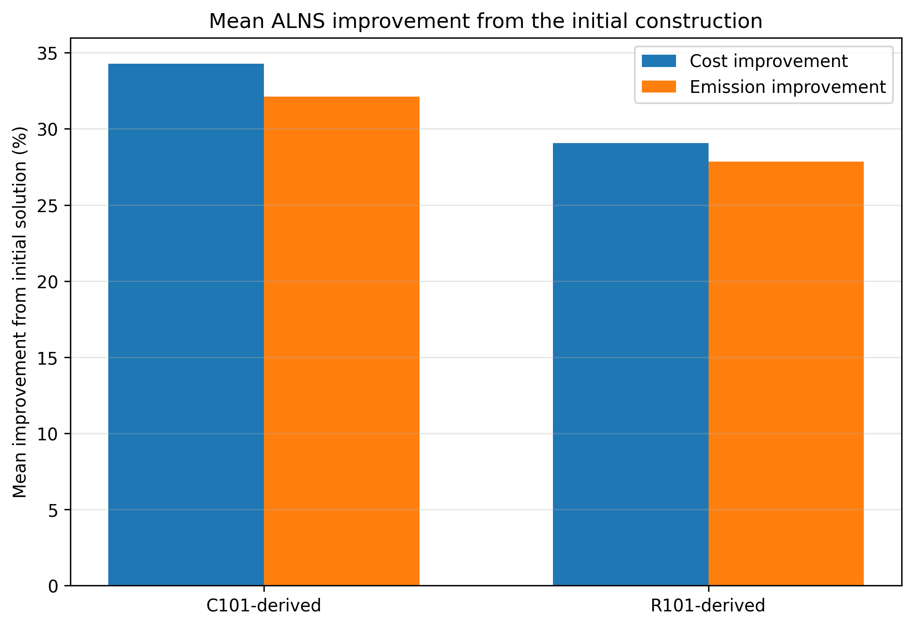
Figure 6. Mean ALNS improvement from the initial construction.
The figure compares the average percentage improvement in cost and emissions for the two derived instances.

6.7 Relative C101–R101 Comparison
Because the two instances have different raw distance scales, the comparison is based on changes from each instance’s own (\lambda=0) baseline.
Table 21. Relative changes from the (\lambda=0) baseline.
Instance | $$λ$$ | Cost change (%) | Emission reduction (%)
C101-derived | 0.25 | −1.10 | 1.04
C101-derived | 0.50 | −1.55 | 1.45
C101-derived | 0.75 | −1.17 | 1.53
C101-derived | 1.00 | −0.72 | 1.41
R101-derived | 0.25 | 0.05 | 0.89
R101-derived | 0.50 | −0.22 | 0.61
R101-derived | 0.75 | 1.50 | −0.32
R101-derived | 1.00 | −0.14 | 0.95
A negative cost change indicates a reduction relative to the cost-oriented baseline. A positive emission reduction indicates lower emissions.
The C101-derived instance improved both measures at every lambda above zero. The R101-derived response was less consistent, particularly at ($λ=0.75)$.
Figure 7 below shows that C101-derived reduced mean cost at every nonzero lambda, while the R101-derived response varied across the tested settings.

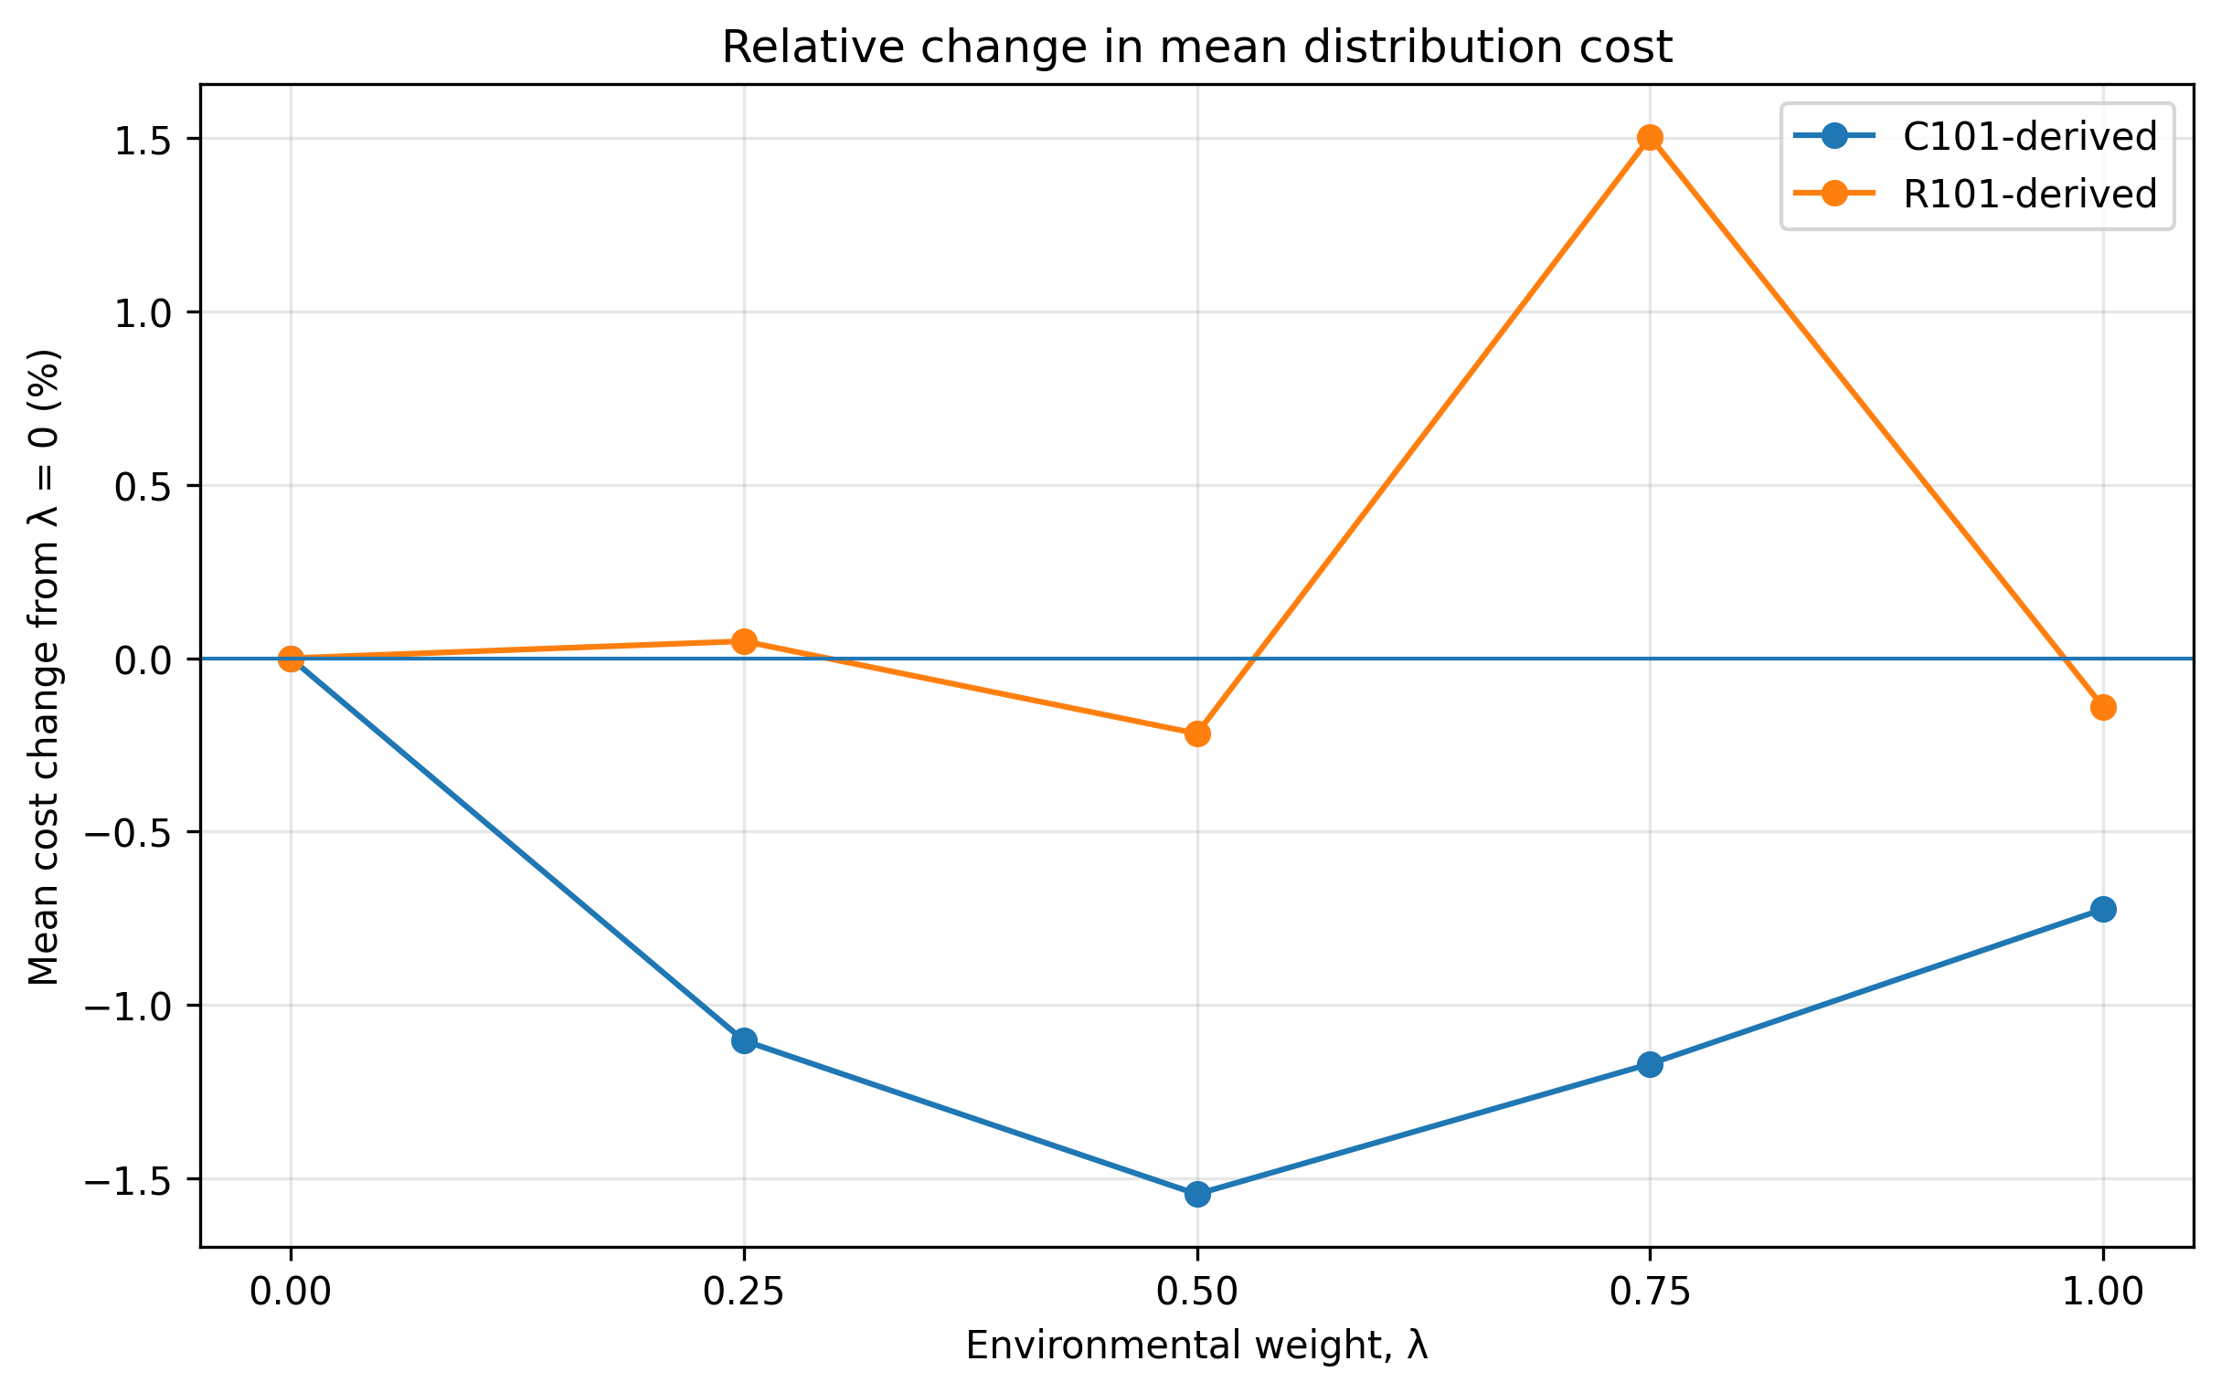
Figure 7. Relative change in mean distribution cost from the ($λ=0)$, baseline.

Figure 8 below shows that the largest mean emission reduction occurred at ($λ=0.75)$, for C101-derived and at ($λ=1.00)$ for R101-derived.
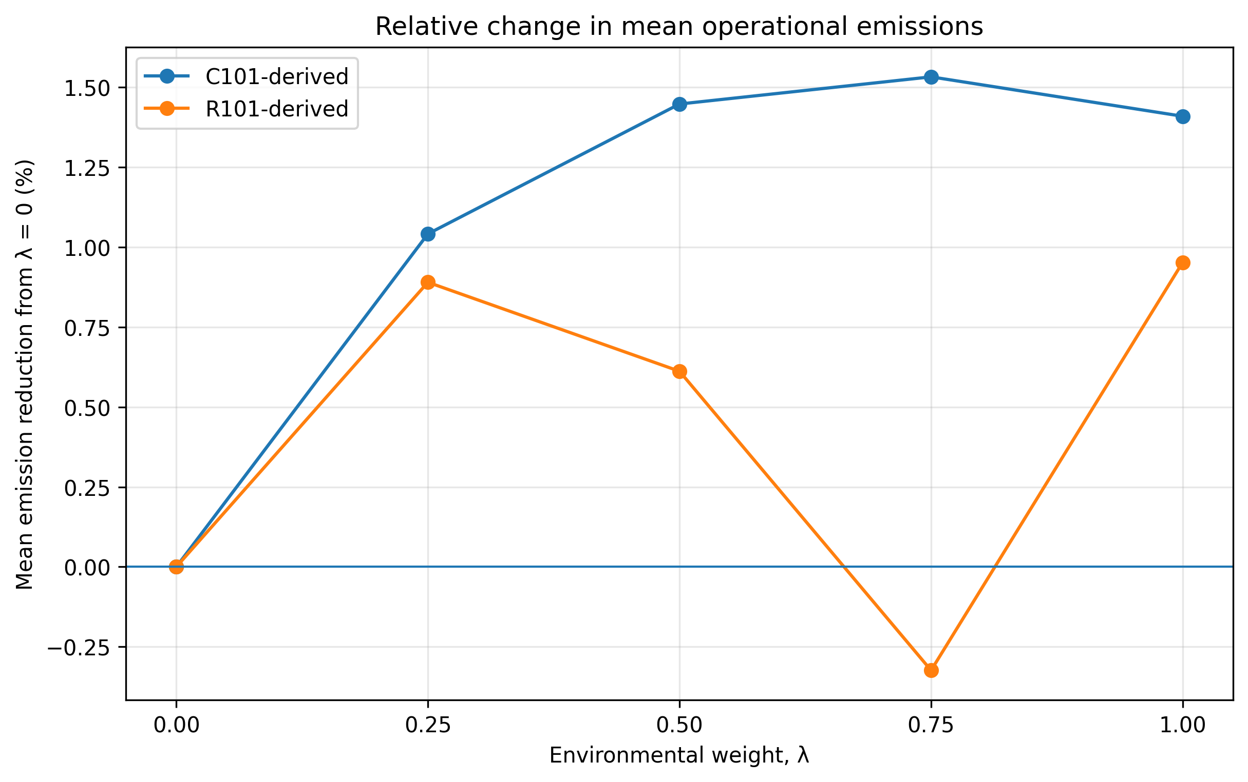
Figure 8. Relative change in mean operational emissions from the $(λ=0)$, baseline.

6.8 Cost–Emission Outcomes
The mean cost–emission points provide a direct view of how the five lambda settings behaved within each instance.
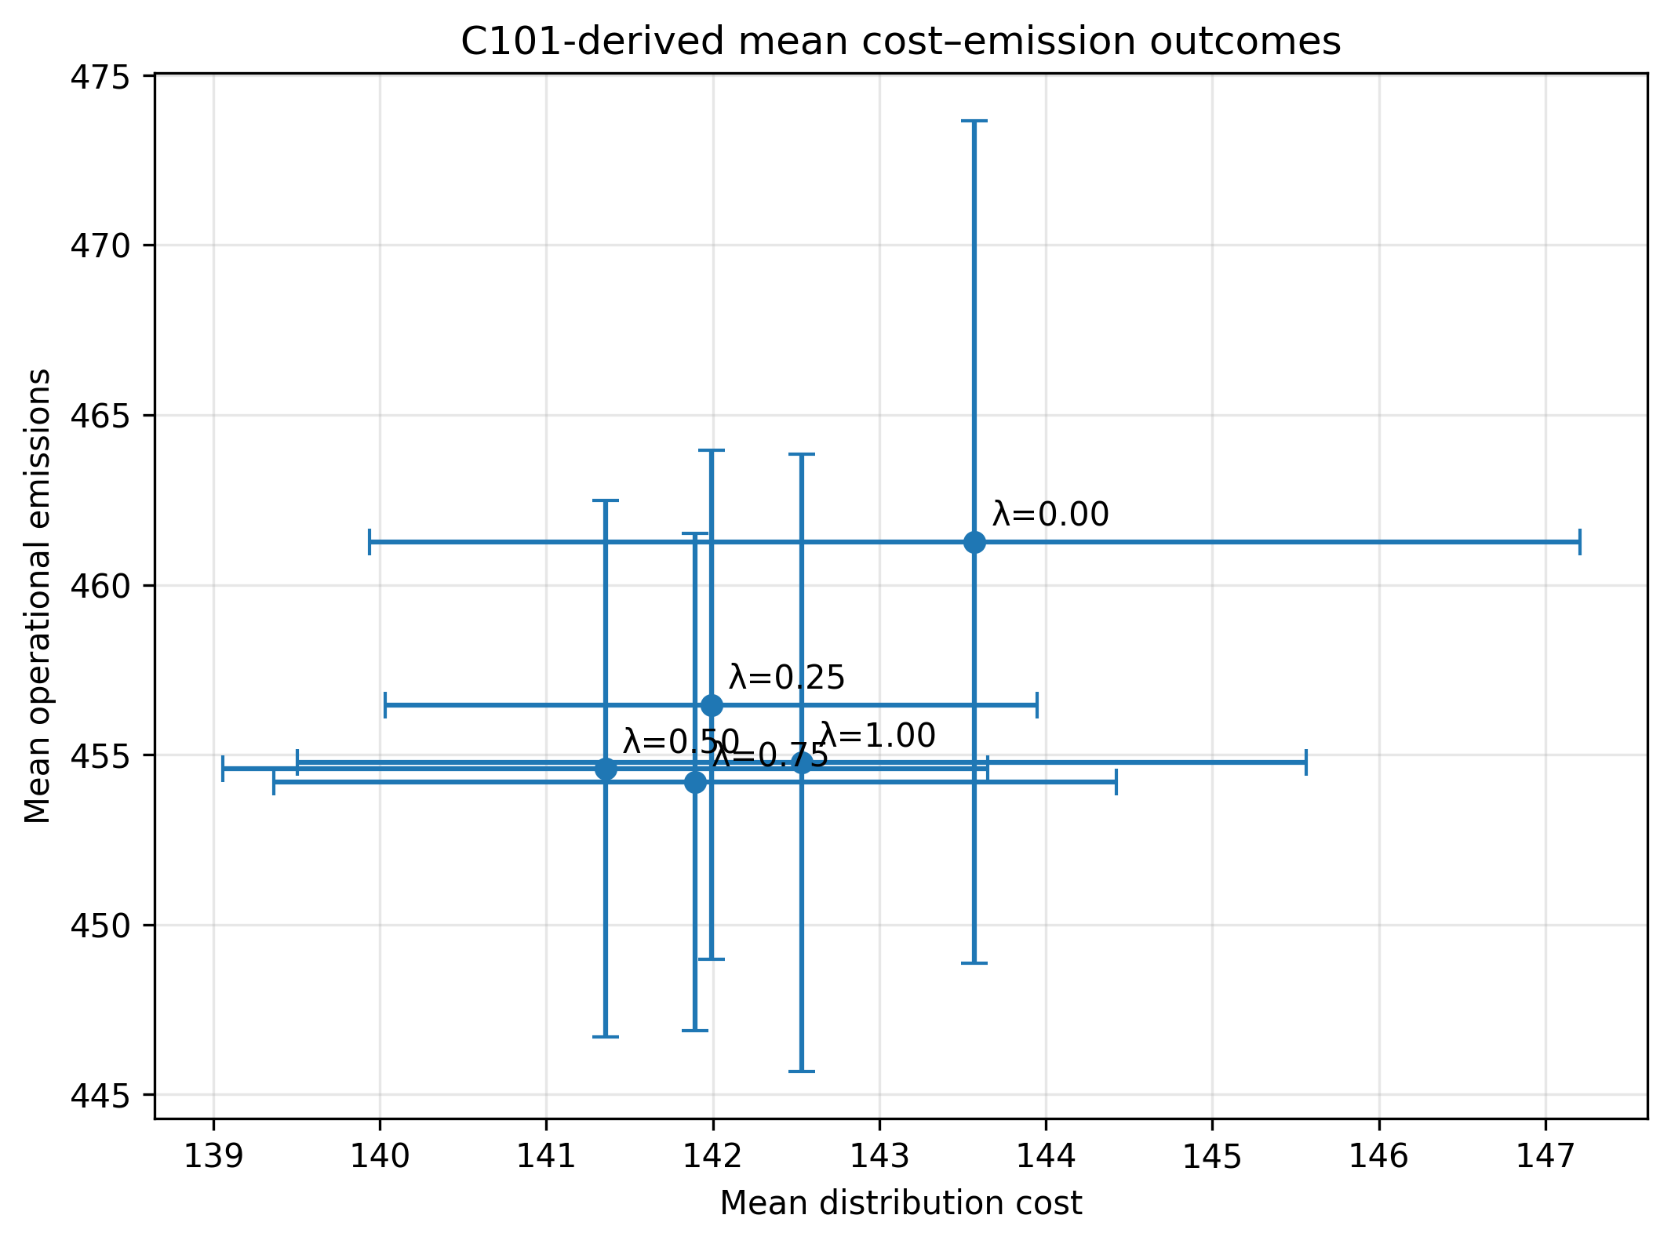
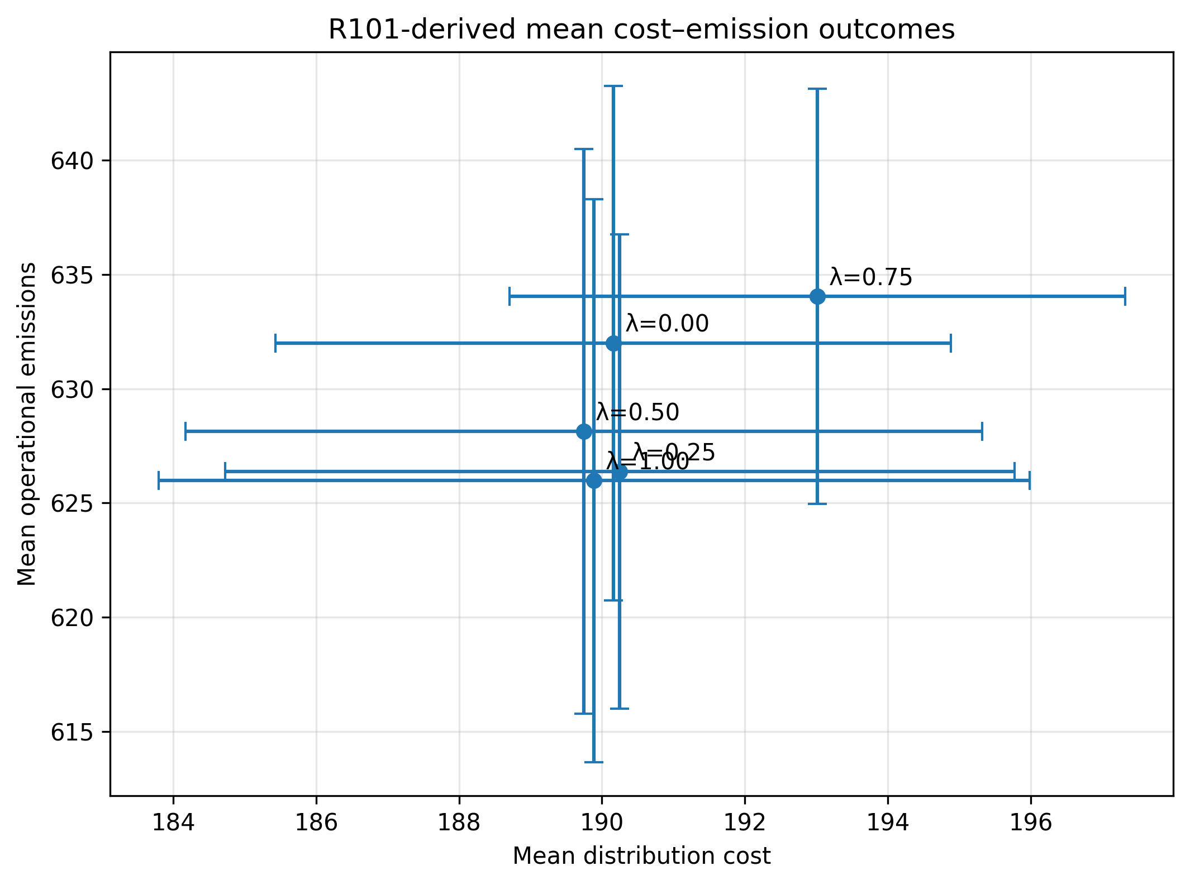
Figure 9. Mean cost–emission outcomes under the five lambda settings.
(a) C101-derived instance.
(b) R101-derived instance.
Note. Each point represents the mean of twelve ALNS runs. Error bars represent one standard deviation. The points are observed weighted-sum outcomes and should not be interpreted as a complete Pareto frontier.
For C101-derived, the intermediate lambda settings moved the mean outcomes toward lower cost and lower emissions relative to ($λ=0)$. For R101-derived, the points were more dispersed, and the ($λ=0.75)$, outcome was worse than the baseline on both measures.

CHAPTER 7. DISCUSSION, LIMITATIONS, AND FUTURE WORK

7.1 Interpretation of the Main Findings
All 120 planned ALNS runs were completed and passed the final validator. ALNS also improved the initial feasible solutions under every tested lambda value.
The two instances responded differently to the environmental weight. C101-derived showed a more stable improvement at the intermediate lambda settings, while R101-derived showed a weaker and non-monotonic pattern.
The findings indicate that the effect of lambda depends on more than the assigned objective weight. Spatial structure, stochastic search behavior, and the limited iteration budget also influence the observed outcomes.

7.2 Cost–Emission Relationship
Cost and emissions were partly aligned because both objectives were strongly affected by travel distance. A shorter dedicated vehicles route may reduce both cost and emissions. A shorter occasional drivers detour may also reduce both compensation and incremental emissions.
Cost and emissions were partly aligned because both measures were strongly affected by travel distance. A shorter dedicated-vehicle route may reduce both travel cost and emissions. A shorter occasional-driver detour may also reduce both compensation and incremental emissions.
For this reason, increasing the emission weight did not always create a direct cost increase. Some lambda settings improved both measures, while other settings produced weaker outcomes.
The 301-iteration budget may also contribute to the non-monotonic pattern because each lambda configuration was optimized independently. The reported points should therefore be interpreted as observed weighted-sum outcomes rather than a complete Pareto frontier.

7.3 Influence of Spatial Structure
C101-derived achieved larger improvements from its initial construction and showed a more stable response at the intermediate lambda settings. Its clustered pattern may provide more opportunities for route consolidation and shorter connections between nearby locations.
R101-derived showed greater variation and a less consistent response to lambda. Its dispersed pattern may create more varied route combinations and occasional drivers detours.
However, only one transformed instance from each spatial family was tested. The results suggest a possible spatial effect but do not support a general conclusion about all clustered and random instances.

7.4 Practical Interpretation
The model should be used as a decision-support tool rather than as a rule for selecting one universal lambda value.
For C101-derived, the intermediate lambda settings reduced both mean cost and mean emissions relative to the cost-oriented baseline. For R101-derived, the response was less consistent, and the same lambda setting did not always provide the same benefit.
The preferred lambda should therefore be evaluated together with instance structure, route distance, occasional drivers detours, ADP and TN use, and solution variability.

7.5 Limitations
The study has the following limitations:
- The implementation was reconstructed from the published methodology rather than from the authors’ original source code.
- The benchmark contained only two transformed 25-customer instances.
- Each ALNS run used 301 iterations, compared with 30,000 iterations in the reference study.
- The emission model used simplified distance-based factors and did not include load, traffic, speed, or detailed vehicle technology.
- The normalization anchors were empirical and frozen before production, so later solutions could fall outside the original zero-to-one reference range.
- Weighted-sum scalarization may not identify every nondominated solution.
- The exact weighted-sum runs returned feasible incumbents but did not certify zero-gap optimality within the fixed computational limit.
- Exact–ALNS equivalence was not fully established, so cross-model differences were not treated as heuristic optimality gaps.
- The observed C101–R101 differences may also be affected by the instance-generation settings.

7.6 Future Work
Future work should increase the ALNS iteration budget and allow several adaptive-weight segments.
The benchmark should also be extended to larger C, R, and RC instances, with several cases from each spatial family.
The emission model can be improved by including heterogeneous vehicles, load-dependent emissions, congestion, travel speed, and electric-vehicle characteristics.
Pareto-based or epsilon-constraint methods can be investigated to examine the cost–emission frontier more directly.
A shared canonical evaluator should also be developed to compare the exact formulation, ALNS, and final validator under the same solution contract.
Finally, real operational data can be used for customer demand, ADP and TN locations, occasional drivers trips, and emission factors.

CHAPTER 8. CONCLUSION
This project extended the cost-oriented CSPTW-TN-DO framework by adding estimated operational emissions from dedicated vehicles and occasional drivers detours. Cost and emissions were normalized and combined through a weighted scalar objective.
This project extended the cost-oriented CSPTW-TN-DO framework by adding estimated operational emissions from dedicated vehicles and occasional-driver detours. Cost and emissions were normalized using instance-specific empirical anchors and combined through a weighted scalar objective.
The final ALNS benchmark contained 120 completed and validated runs across the C101-derived and R101-derived instances. C101-derived showed a more stable response to the intermediate lambda settings, which generally reduced both mean cost and mean emissions. R101-derived showed a weaker and non-monotonic response.
ALNS improved the initial feasible solutions under every tested configuration. However, the experiment used a reduced 301-iteration budget, and the tested points should not be interpreted as a complete Pareto frontier. The exact weighted-sum runs returned feasible incumbents within the fixed time limit but did not certify zero-gap optimality.
The main contribution is an emission-aware extension of a paper-based routing framework, supported by feasibility checks and a controlled multi-seed experiment. The results show that cost and emissions can be partly aligned, but the effect of the environmental weight depends on instance structure and stochastic search performance.

REFERENCES
Archetti, C., Savelsbergh, M., and Speranza, M. G. (2016). The vehicle routing problem with occasional driverss. European Journal of Operational Research, 254(2), 472-480.
Demir, E., Bektas, T., and Laporte, G. (2011). A comparative analysis of several vehicle emission models for road freight transportation. Transportation Research Part D: Transport and Environment, 16(5), 347-357.
Demir, E., Bektas, T., and Laporte, G. (2012). An adaptive large neighborhood search heuristic for the pollution-routing problem. European Journal of Operational Research, 223(2), 346-359.
Kirkpatrick, S., Gelatt, C. D., and Vecchi, M. P. (1983). Optimization by simulated annealing. Science, 220(4598), 671-680.
Macrina, G., Di Puglia Pugliese, L., Guerriero, F., and Laporte, G. (2020). Crowd-shipping with time windows and transshipment nodes. Computers & Operations Research, 113, 104806.
Pisinger, D., and Ropke, S. (2007). A general heuristic for vehicle routing problems. Computers & Operations Research, 34(8), 2403-2435.
Ropke, S., and Pisinger, D. (2006). An adaptive large neighborhood search heuristic for the pickup and delivery problem with time windows. Transportation Science, 40(4), 455-472.
Yu, V. F., Jodiawan, P., and Redi, A. A. N. P. (2022). Crowd-shipping problem with time windows, transshipment nodes, and delivery options. Transportation Research Part E: Logistics and Transportation Review, 157, 102545.
Solomon, M. M. (1987). Algorithms for the vehicle routing and scheduling problems with time window constraints. Operations Research, 35(2), 254–265.
SINTEF. Solomon VRPTW benchmark instances: 100-customer problems. Accessed June 2026. https://www.sintef.no/projectweb/top/vrptw/100-customers/

APPENDIX A. FINAL ALNS PARAMETER SUMMARY

Parameter | Meaning | Paper value | Project value
$$ηmax$$ | Maximum iterations | 30,000 | 301
$$ηs$$ | Weight-update segment | 300 | 300
$$α$$ | Cooling rate | 0.9994 | 0.9994
$$τ$$ | Perturbation factor | 0.275 | 0.275
$$ζ$$ | Reaction factor | 0.1 | 0.1
$$\frac{\frac{σ1}{σ2}}{σ3}$$ | Operator scores | 33/15/9 | 33/15/9
$$δLS$$ | Local-search gap | 0.1 | 0.1 with sign-safe extension
$$\frac{Ωmin}{Ωmax}$$ | Removal size | 0.1|N| / 0.4|N| | Same
$$\frac{\frac{φ1}{φ2}}{φ3}$$ | Related-removal weights | 5/9/1 | Same

APPENDIX B. Production Experiment Summary

Item | Final value
Instances | C101-derived and R101-derived
Customers | 25 each
Lambdas | 0, 0.25, 0.5, 0.75, 1
Seeds | 2029–2040
Runs | 120
Iterations | 301
Commit | 1079caf
Hardware | MacBook Air M4
Validation rate | 100%
Enhanced mode | Disabled

APPENDIX C. AUTOMATED DEPLOYMENT AND REPRODUCIBILITY GUIDE
- Direct Download for Beginners: https://github.com/LouisePo82/CSPTW-TN-DO-Multiobjective-Optimization/releases/tag/final-report-evidence-v1
- Official GitHub Repository: https://github.com/LouisePo82/CSPTW-TN-DO-Multiobjective-Optimization

