2-fluoroethynylbenzene

(Last updated 28 January 2025)



Figure . The molecular diagram of 2-fluoroethynylbenzene.

# CSP studies

|  |  |
| --- | --- |
| REFCODE | AXUBUR |
| Formula | C8 H5 F1 |
| Common Name | 2-fluorophenylacetate |
| IUPAC Systematic Name | 2-fluoroethynylbenzene |
| Other Names | 1-ethynyl-2-fluorobenzene |
| CSD Refcodes | AXUBUR, AXUBUR01, AXUBUR02 |
| Scientist | Joe Ridout and Louise Price |
| Date | 2013 |
| Publication | Ridout J, Price LS, Howard JAK, Probert MR 2014. Cryst Growth Des 14, 3384-3391. |
| Search Identifier | A |
| Energy Model | 1 |
| Study_ID | 0 |
| Programs | Molpak, DMACRYS (2.0.8b4) |
| Location on S Drive | \CHEMISTRY_CPOSS\JoeRidout\2fluoroethynylbenzene |
| Potential Description | GDMA2.2(HF/6-31G(d,p)) + FIT |
| Energy Model | 2 |
| Study_ID | 1 |
| Programs | Study_ID=0, DMACRYS (2.0.8b4) with 0.55 GPa |
| Location on S Drive | \CHEMISTRY_CPOSS\JoeRidout\2fluoroethynylbenzene_0.55GPa |
| Potential Description | GDMA2.2(HF/6-31G(d,p)) + FIT + 0.55 GPa pressure |

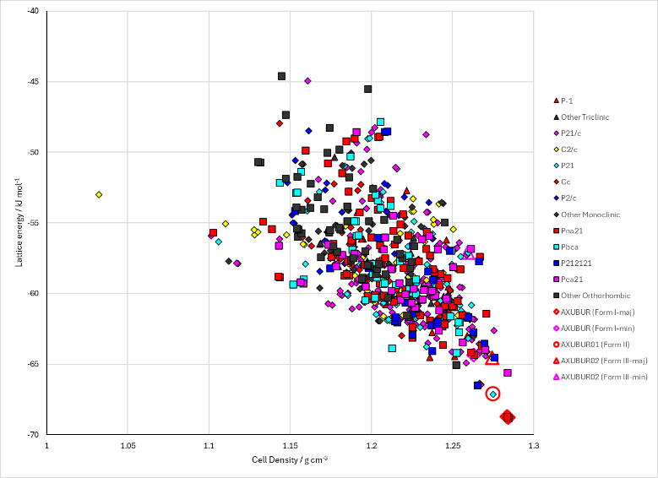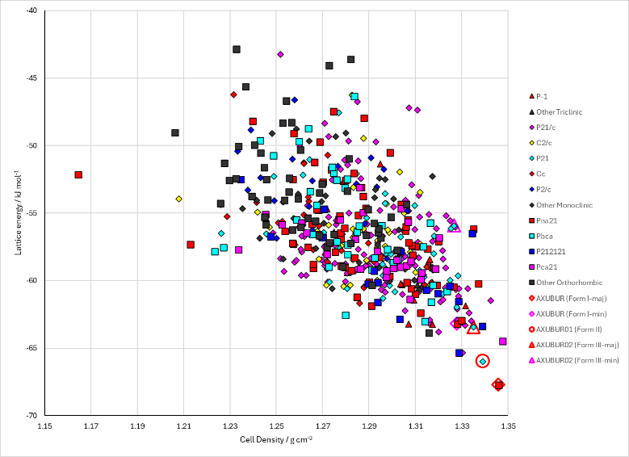

Figure . Crystal energy landscape of 2-fluoroethynylbenzene from previous work. Left: no pressure. Right: with 0.55 GPa of pressure applied during DMACRYS optimization.

# CSD structures (CSD version 5.45 with Mar, Jun and Sep 2024 updates)

Table . Crystallographic information for CSD entries for 2-fluoroethynylbenzene. Different polymorphs are coloured differently.

|  |  |  |  |  |  |  |  |  |  |  |
| --- | --- | --- | --- | --- | --- | --- | --- | --- | --- | --- |
| REFCODE | space group | Z’ | a / Å | b / Å | c / Å | α / ° | β / ° | γ / ° | density / g cm-3 | Form |
| AXUBUR | Pna21 | 1 | 7.584 | 13.088 | 6.198 | 90 | 90 | 90 | 1.297 | I |
| AXUBUR01 | P21 | 1 | 7.0506 | 5.932 | 7.4848 | 90 | 103.46 | 90 | 1.31 | II |
| AXUBUR02 | P21 | 1 | 3.9343 | 5.9336 | 12.962 | 90 | 98.467 | 90 | 1.333 | III |
| AXUBUR03 | P21 | 1 | 7.031 | 5.924 | 7.441 | 90 | 103.563 | 90 | 1.324 | II |
| AXUBUR04 | Pna21 | 1 | 7.578 | 13.024 | 6.171 | 90 | 90 | 90 | 1.31 | I |

Table . Experimental information for CSD entries for 2-fluoroethynylbenzene.

|  |  |  |  |  |  |
| --- | --- | --- | --- | --- | --- |
| REFCODE | space group | R factor | T / K | Year | Comments |
| AXUBUR | Pna21 | 6.36 | 90 | 2011 | Disordered. Sudden quenching of the liquid to 90 K.1 |
| AXUBUR01 | P21 | 3.63 | 90 | 2011 | Crystallized at 200 K with the turbo cooling option (1000 K/h). Then slowly cooling to 90 K for data collection.1 |
| AXUBUR02 | P21 | 3.46 | 293 | 2014 | Disordered. Isothermal freezing and subsequent pressure cycling.2 Rapid compression starting from ambient conditions. |
| AXUBUR03 | P21 | 4.45 | 293 | 2014 | Isothermal freezing and subsequent pressure cycling.2 Slow compression near the phase boundary. |
| AXUBUR04 | Pna21 | 5.2 | 293 | 2014 | Disordered. Isothermal freezing and subsequent pressure cycling.2 Rapid compression starting from ambient conditions. |

# Other notes

(1) Dikundwar, A. G.; Sathishkumar, R.; Guru Row, T. N.; Desiraju, G. R. Structural Variability in the Monofluoroethynylbenzenes Mediated through Interactions Involving “Organic” Fluorine. *Crystal Growth & Design* **2011**, *11* (9), 3954-3963. DOI: 10.1021/cg2005453.

(2) Ridout, J.; Price, L. S.; Howard, J. A. K.; Probert, M. R. Polymorphism Arising from Differing Rates of Compression of Liquids. *Crystal Growth & Design* **2014**, *14* (7), 3384-3391, Article. DOI: 10.1021/cg500331u.