Anisole

(Last updated 30 January 2024)



Figure . The molecular diagram of anisole.

# CSP studies

|  |  |
| --- | --- |
| REFCODE | HUPNIR |
| Formula | C7 H8 O1 |
| Common Name | Anisole |
| IUPAC Systematic Name | Methoxybenzene |
| CSD Refcodes | HUPNIR, HUPNIR01 |
| Scientist | Joe Ridout and Louise Price |
| Date | 2013 |
| Publication | Not published - see Smith EL; Ridout J; Sellars JD; Probert MR Crystengcomm 2019, 21(30), 4422 |
| Search identifier | A |
| Energy model | 1 |
| Study_ID | 0 |
| Programs | MOLPAK, DMACRYS (2.0.4) |
| Location on S Drive | \CHEMISTRY_CPOSS\JoeRidout\anisole |
| Potential Description | GDMA2.2(MP2/6-31G(d,p)) + FIT |

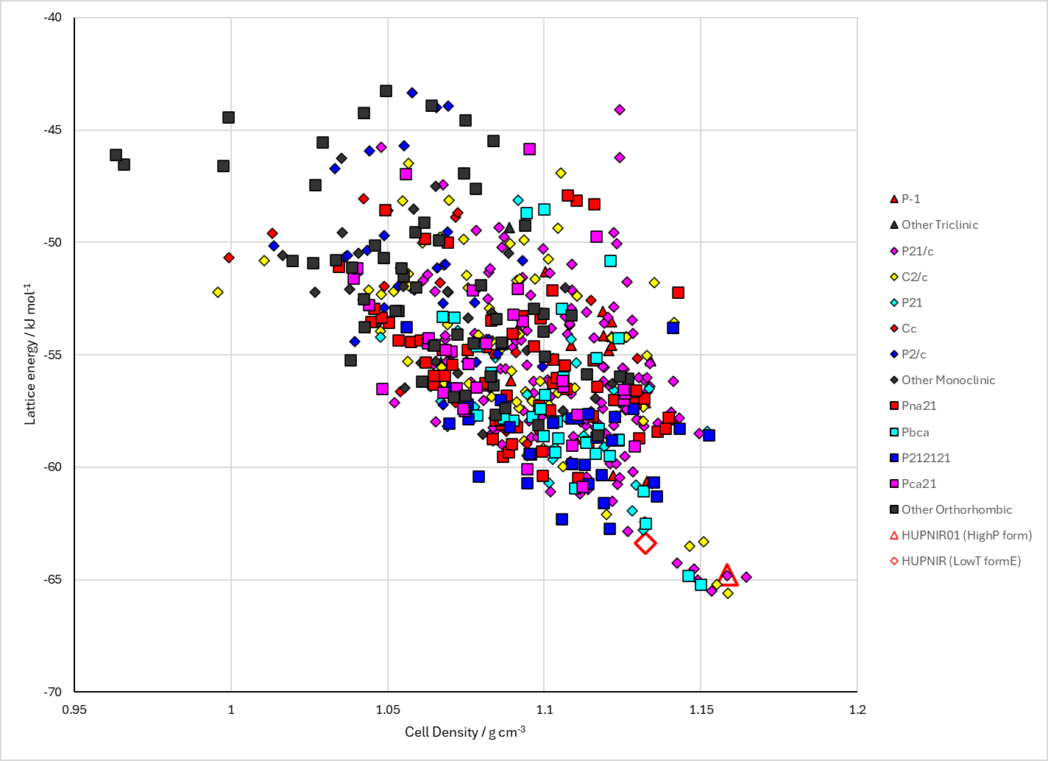

Figure . Crystal energy landscape of anisole from previous work.

# CSD structures (CSD version 5.43 with Mar, Jun, Sep and Nov 2022 updates)

Table . Crystallographic information for CSD entries for anisole. Different polymorphs are coloured differently.

|  |  |  |  |  |  |  |  |  |  |  |
| --- | --- | --- | --- | --- | --- | --- | --- | --- | --- | --- |
| REFCODE | space group | Z’ | a / Å | b / Å | c / Å | α / ° | β / ° | γ / ° | density / g cm-3 | Form |
| HUPNIR | P21/c | 2 | 13.4809 | 14.3767 | 6.2095 | 90 | 95.57 | 90 | 1.199 |  |
| HUPNIR01 | P21/c | 1 | 13.7 | 5.4468 | 7.8567 | 90 | 98.401 | 90 | 1.238 |  |
| HUPNIR02 | P21/c | 2 | 13.6132 | 14.5917 | 6.2617 | 90 | 95.935 | 90 | 1.161 |  |

Table . Experimental information for CSD entries for anisole.

|  |  |  |  |  |  |
| --- | --- | --- | --- | --- | --- |
| REFCODE | space group | R factor | T / K | Year | Comments |
| HUPNIR | P21/c | 3.72 | 100 | 2015 | Pure liquid cooled to 170 K in capillary, then temperature-cycled.1 |
| HUPNIR01 | P21/c | 3.62 | 296 | 2019 | Compressing pure liquid2 |
| HUPNIR02 | P21/c | 5.11 | 224 | 2019 | Cooling pure liquid2 |

# Other notes

1. R. W. Seidel and R. Goddard, *Acta Crystallographica Section C*, 2015, **71**, 664-666.

2. E. L. Smith, J. Ridout, J. D. Sellars and M. R. Probert, *CrystEngComm*, 2019, **21**, 4422-4426.