[(2,3-di-iodopentacene-6,13-diyl)bis(ethyne-2,1-diyl)]bis[tri-isopropylsilane]  
Blind Test XXVII

(Last updated 4 March 2025)



Figure . The molecular diagram of [(2,3-di-iodopentacene-6,13-diyl)bis(ethyne-2,1-diyl)]bis[tri-isopropylsilane].

# CSP studies

|  |  |
| --- | --- |
| REFCODE | XIFZOF |
| Formula | C44 Si2 I2 H52 |
| Common Name | Blind Test XXVII |
| IUPAC Systematic Name | 2-[2,3-diiodo-13-(2-triisopropylsilylethynyl)pentacen-6-yl]ethynyl-triisopropyl-silane |
|  |  |
| Search identifier | A |
| Scientist | Louise Price |
| Date | January 2021 |
| Publication | Hunnisett LM, et al, Acta Cryst B, 2024, 80(6), 517-547 |
| Energy model | 1 |
| Study_ID | 0 |
| Programs | MOLPAK, DMACRYS (2.0.8) |
| Location on S Drive | CHEMISTRY_CPOSS\BlindTest2020-2022\XXVII\MOLPAK\ |
| Potential Description | MOLPAK + DMACRYS + GDMA2.2(PBE1PBE/6-311G(d,p)+basis functions for Iodine) + GMDay_anisotropic_inc_I |
|  |  |
| Search identifier | B |
| Scientist | Louise Price |
| Date | February 2022 |
| Publication | Hunnisett LM, et al, Acta Cryst B, 2024, 80(6), 548-574 |
| Energy model | 1 |
| Study_ID | 3 |
| Programs | CCDC supplied crystal structures, DMACRYS (2.3.1.1) |
| Location on S Drive | CHEMISTRY_CPOSS\BlindTest2020-2022\XXVII\Sub2_bondopt\small_fit\ |
| Potential Description | CCDC supplied crystal structures + bonds_optimized_conf(PBE0/3-21G) + DMACRYS + GDMA2.2(PBE1PBE/6-311G(d,p)+basis functions for Iodine) + FIT_HalgrenI |
| Energy model | 2 |
| Study_ID | 1 |
| Programs | CCDC supplied crystal structures, DMACRYS (2.3.1.1) |
| Location on S Drive | CHEMISTRY_CPOSS\BlindTest2020-2022\XXVII\Sub2_bondopt\small_iso\ |
| Potential Description | CCDC supplied crystal structures + bonds_optimized_conf(PBE0/3-21G) + DMACRYS + GDMA2.2(PBE1PBE/6-311G(d,p)+basis functions for Iodine) + iso(GMDay_anisotropic_inc_I_FIT_aliphatic_UFF_Si) |
| Energy model | 3 |
| Study_ID | 2 |
| Programs | CCDC supplied crystal structures, DMACRYS (2.3.1.1) |
| Location on S Drive | CHEMISTRY_CPOSS\BlindTest2020-2022\XXVII\Sub2_bondopt\small_anis\ |
| Potential Description | CCDC supplied crystal structures + bonds_optimized_conf(PBE0/3-21G) + DMACRYS + GDMA2.2(PBE1PBE/6-311G(d,p)+basis functions for Iodine) + GMDay_anisotropic_inc_I_FIT_aliphatic_UFF_Si |
| Energy model | 4 |
| Study_ID | 6 |
| Programs | CCDC supplied crystal structures, DMACRYS (2.3.1.1) |
| Location on S Drive | CHEMISTRY_CPOSS\BlindTest2020-2022\XXVII\Sub2_bondopt\big_fit\ |
| Potential Description | CCDC supplied crystal structures + bonds_optimized_conf(PBE0/6-311G(d,p)) + DMACRYS + GDMA2.2(PBE1PBE/6-311G(d,p)+basis functions for Iodine) + FIT_HalgrenI |
| Energy model | 5 |
| Study_ID | 4 |
| Programs | CCDC supplied crystal structures, DMACRYS (2.3.1.1) |
| Location on S Drive | CHEMISTRY_CPOSS\BlindTest2020-2022\XXVII\Sub2_bondopt\big_iso\ |
| Potential Description | CCDC supplied crystal structures + bonds_optimized_conf(PBE0/6-311G(d,p)) + DMACRYS + GDMA2.2(PBE1PBE/6-311G(d,p)+basis functions for Iodine) + iso(GMDay_anisotropic_inc_I_FIT_aliphatic_UFF_Si) |
| Energy model | 6 (published) |
| Study_ID | 5 |
| Programs | CCDC supplied crystal structures, DMACRYS (2.3.1.1) |
| Location on S Drive | CHEMISTRY_CPOSS\BlindTest2020-2022\XXVII\Sub2_bondopt\big_anis\ |
| Potential Description | CCDC supplied crystal structures + bonds_optimized_conf(PBE0/6-311G(d,p)) + DMACRYS + GDMA2.2(PBE1PBE/6-311G(d,p)+basis functions for Iodine) + GMDay_anisotropic_inc_I_FIT_aliphatic_UFF_Si |

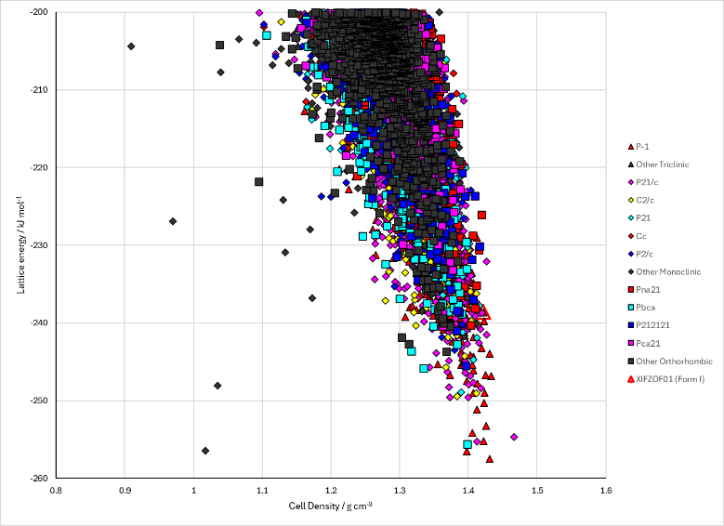

Figure . Crystal energy landscape of [(2,3-di-iodopentacene-6,13-diyl)bis(ethyne-2,1-diyl)]bis[tri-isopropylsilane]from previous work. Left: the full landscape for the MOLPAK search. Right: the landscape with the big basis set and anisotropic potential which was submitted for the energy ranking challenge of the Blind Test.

# CSD structures (CSD version 5.46 with Feb 2025 update)

Table . Crystallographic information for CSD entries for [(2,3-di-iodopentacene-6,13-diyl)bis(ethyne-2,1-diyl)]bis[tri-isopropylsilane]. Different polymorphs are coloured differently.

|  |  |  |  |  |  |  |  |  |  |  |
| --- | --- | --- | --- | --- | --- | --- | --- | --- | --- | --- |
| REFCODE | space group | Z’ | a / Å | b / Å | c / Å | α / ° | β / ° | γ / ° | density / g cm-3 | Form |
| XIFZOF | P-1 | 1 | 9.296 | 14.159 | 16.872 | 74.063 | 83.384 | 87.964 | 1.395 | I |
| XIFZOF01 | P-1 | 1 | 9.3659 | 13.706 | 16.4543 | 76.901 | 82.575 | 88.685 | 1.45 | I |
| XIGYUL | P-1 | 1 | 9.085 | 13.7059 | 17.0322 | 74.2537 | 83.7849 | 88.3236 | 1.458 | Solid solution |

All three crystal structures have the same packing of the core pentacene, although different disorder in the TIPS groups.

Table . Experimental information for CSD entries for [(2,3-di-iodopentacene-6,13-diyl)bis(ethyne-2,1-diyl)]bis[tri-isopropylsilane].

|  |  |  |  |  |  |
| --- | --- | --- | --- | --- | --- |
| REFCODE | space group | R factor | T / K | Year | Comments |
| XIFZOF | P-1 | 3.87 | 290 | 2023 | This was a private communication, that was later published as XIFZOF02 |
| XIFZOF01 | P-1 | 3.04 | 100 | 2023 | This was a private communication, that was later published as XIFZOF03 |
| XIGYUL | P-1 | 3.71 | 90 | 2023 | This was a private communication, that was later published as XIGYUL01 |

Make this table include whether polymorphs are solution-grown, sublimation grown, templated or otherwise. Add references.

# Other notes

Due to the size of the .res files and their number, only the 1000 lowest energy structures for Search A have been stored on Github. The other files are available from the authors on request. Please see the main instruction documentation for how to access these.