Carbamazepine



Figure . The molecular diagram of Carbamazepine.

# CSP studies

|  |  |
| --- | --- |
| REFCODE | CBMZPN |
| Formula | C15 H12 N2 O1 |
| Common Name | Carbamazepine |
| IUPAC Systematic Name | 5-carbamoyl-5H-dibenz[b,f]azepine |
| Other Names | 5H-Dibenz[b,f]azepine-5-carboxamide; Carbamazepine; Carbamezapine; Carbazepine; Epitol; Tegertol; Tegretol; Teril |
| CSD Refcodes | CBMZPN11; CBMZPN03; CBMZPN10; CBMZPN12; CBMZPB16 |
|  |  |
| Search Identifier | A |
| Scientist | Rui Guo |
| Date | 2016 |
| Publication | Unpublished |
| Energy model | 2 |
| Study_ID | 30 |
| Programs | Study_ID=12, DMACRYS (2.2.0.1) |
| Location on S Drive | CHEMISTRY_CPOSS\CarbamazepineSeries\Carbamazepine_PCM |
| Potential Description | GDMA2.2(PCMdielectric3(PBE0/6-31+G(d))) + FIT |
| Energy model | 1 |
| Study_ID | 12 (includes pDFT-D) |
| Programs | CrystalPredictor (2.1.01), CrystalOptimizer (2.4.m), DMACRYS (2.2.0.1) |
| Location on S Drive | \CHEMISTRY_CPOSS\CarbamazepineSeries\Carbamazepine_CO |
| Potential Description | CrystalOptimizer with PBE0/6-31G(d,p) Intra and GDMA2.2(PBE0/6-31G(d,p)) + FIT |
|  |  |
| Search Identifier | B |
| Scientist | Harriott Nowell, Panos Karamertzanis |
| Date | 2005 |
| Publication | Florence AJ; Johnston A; Price SL; Nowell H; Kennedy AR; Shankland N, J. Pharm. Sci., 95(9), 1918-1930 (2006) |
| Energy Model | 2 |
| Study_ID | 10 |
| Programs | Study_ID=0, dmaflex, DMAREL (4.1.1) |
| Location on S Drive | \CHEMISTRY_CPOSS\0-EarlySearches\home\louise_price.eminerals\carbamazepine_dmaflex |
| Potential Description | DMA + FIT SCF model, with DMAflex |
| Energy Model | 1 |
| Study_ID | 0 |
| Programs | MOLPAK, DMAREL (4.1.1) |
| Location on S Drive | \CHEMISTRY_CPOSS\0-EarlySearches\home\louise_price.eminerals\carbamazepine |
| Potential Description | DMA + FIT |

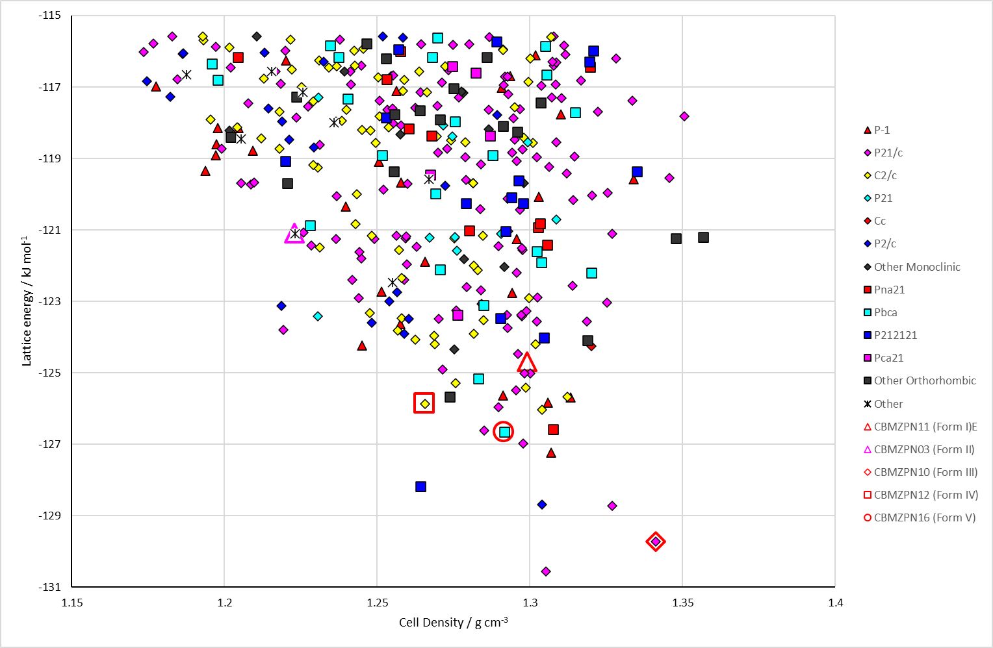

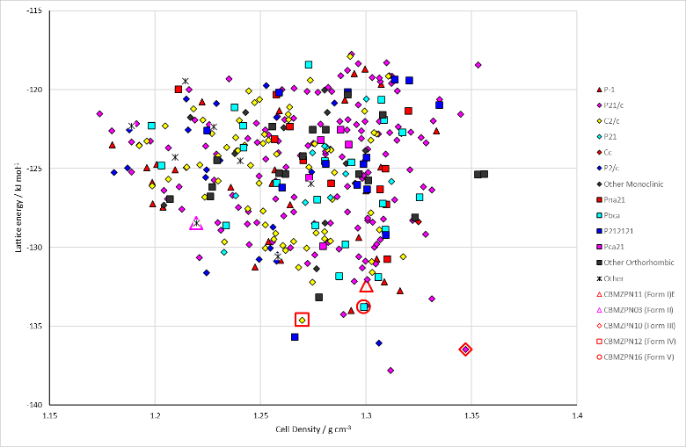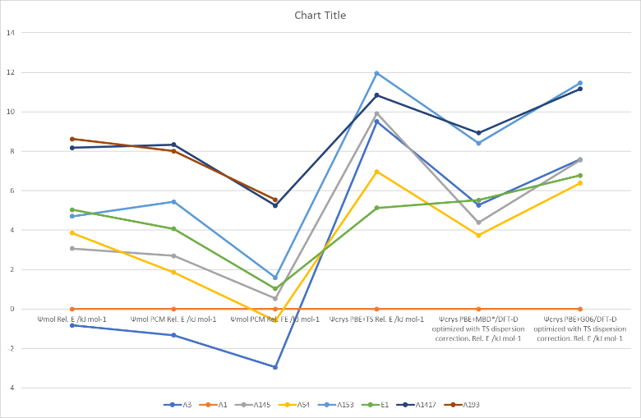

Figure . (Top) crystal energy landscape of Carbamazepine from Study_ID=12. (Bottom left) crystal energy landscape of Carbamazepine from Study_ID=30. (Bottom right) relative energies by method of key structures.

# CSD structures (version 5.43 with Mar, Jun, Sep and Nov 2022 updates)

Table . Crystallographic information for CSD entries for Carbamazepine. Different polymorphs are coloured differently.

|  |  |  |  |  |  |  |  |  |  |  |
| --- | --- | --- | --- | --- | --- | --- | --- | --- | --- | --- |
| REFCODE | space group | Z’ | a / Å | b / Å | c / Å | α / ° | β / ° | γ / ° | density / g cm-3 | Form |
| CBMZPN | P21/n | 1 | 7.537 | 11.156 | 13.912 | 90 | 92.86 | 90 | 1.343 | III |
| CBMZPN01 | P21/c | 1 | 7.529 | 11.148 | 15.47 | 90 | 116.17 | 90 | 1.347 | III |
| CBMZPN02 | P21/n | 1 | 7.534 | 11.15 | 13.917 | 90 | 92.94 | 90 | 1.344 | III |
| CBMZPN03 | R-3 | 1 | 35.454 | 35.454 | 5.253 | 90 | 90 | 120 | 1.235 | II |
| CBMZPN10 | P21/n | 1 | 7.537 | 11.156 | 13.912 | 90 | 92.86 | 90 | 1.343 | III |
| CBMZPN11 | P-1 | 4 | 5.1705 | 20.574 | 22.245 | 84.124 | 88.008 | 85.187 | 1.339 | I |
| CBMZPN12 | C2/c | 1 | 26.609 | 6.9269 | 13.957 | 90 | 109.702 | 90 | 1.296 | IV |
| CBMZPN13 | P-1 | 4 | 5.1856 | 20.5758 | 22.2411 | 84.1942 | 87.9756 | 85.1053 | 1.335 | I |
| CBMZPN14 | P21/n | 1 | 7.55 | 11.186 | 13.954 | 90 | 92.938 | 90 | 1.333 | III |
| CBMZPN15 | P21/n | 1 | 7.53 | 11.19 | 13.96 | 90 | 93.03 | 90 | 1.336 | III |
| CBMZPN16 | Pbca | 1 | 9.1245 | 10.4518 | 24.8224 | 90 | 90 | 90 | 1.326 | V |
| CBMZPN17 | P21/n | 1 | 7.4874 | 11.0406 | 13.7754 | 90 | 92.939 | 90 | 1.38 | III |
| CBMZPN18 | P21/n | 1 | 7.4874 | 11.0406 | 13.7754 | 90 | 92.939 | 90 | 0 | III |
| CBMZPN19 | P21/n | 1 | 7.487 | 11.041 | 13.775 | 90 | 92.9 | 90 | 1.38 | III |
| CBMZPN20 | P21 | 2 | 7.542 | 11.155 | 13.919 | 90 | 92.885 | 90 | 1.342 | III |
| CBMZPN21 | P21/n | 1 | 7.498 | 11.058 | 13.789 | 90 | 92.838 | 90 | 1.374 | III |
| CBMZPN22 | P21/n | 1 | 7.4893 | 11.0323 | 13.764 | 90 | 92.953 | 90 | 1.382 | III |
| CBMZPN23 | P21/n | 1 | 7.4893 | 11.0323 | 13.764 | 90 | 92.953 | 90 | 1.382 | III |
| CBMZPN27 | P21/n | 1 | 7.49441 | 11.0643 | 13.8036 | 90 | 92.9142 | 90 | 1.373 | III |
| CBMZPN28 | P21/n | 1 | 7.578 | 11.176 | 13.991 | 90 | 93.08 | 90 | 1.326 | III |
| CBMZPN29 | P21/n | 1 | 7.576 | 11.188 | 13.967 | 90 | 87.03 | 90 | 1.327 | III |
| CBMZPN30 | P21/n | 1 | 7.68 | 11.44 | 13.92 | 90 | 91.22 | 90 | 1.283 | III |
| CBMZPN31 | P21/n | 1 | 7.46 | 11.04 | 13.76 | 90 | 92.61 | 90 | 1.386 | III |
| CBMZPN32 | P21/n | 1 | 7.534 | 11.15 | 13.917 | 90 | 92.94 | 90 | 1.344 | III |
| CBMZPN33 | P21/n | 1 | 7.4907 | 11.058 | 13.7853 | 90 | 92.903 | 90 | 1.376 | III |
| CBMZPN34 | P21/n | 1 | 7.614 | 11.302 | 13.886 | 90 | 92.43 | 90 | 1.314 | III |
| CBMZPN35 | C2/c | 1 | 27.15 | 7.3 | 14.1 | 90 | 110.3 | 90 | 1.198 | IV |
| CBMZPN36 | P21/n | 1 | 7.46 | 11.04 | 13.76 | 90 | 92.61 | 90 | 1.386 | III |
| CBMZPN37 | P21/n | 1 | 7.547 | 11.158 | 13.92 | 90 | 92.87 | 90 | 1.34 | III |

Table . Experimental information for CSD entries for Carbamazepine.

|  |  |  |  |  |  |
| --- | --- | --- | --- | --- | --- |
| REFCODE | space group | R factor | T / K | Year | Comments |
| CBMZPN | P21/n | 4 | 295 | 1981 |  |
| CBMZPN01 | P21/c | 3.5 | 295 | 1981 | Recrystallization from ethanol1 |
| CBMZPN02 | P21/n | 8.4 | 295 | 1989 | Recrystallization from ethanol2 |
| CBMZPN03 | R-3 | 6.9 | 295 | 1987 | Slow evaporation from THF, CHF3 and CCl43 |
| CBMZPN10 | P21/n | 3.9 | 295 | 1981 | Recrystallization from ethanol4 |
| CBMZPN11 | P-1 | 5.06 | 158 | 2003 | Crystallized from the melt in a sealed capillary5 |
| CBMZPN12 | C2/c | 3.57 | 158 | 2002 | Crystallization in the presence of hydroxypropylcellulose6 |
| CBMZPN13 | P-1 | 17.96 | 160 | 2007 | Heating form III to above 165 °C7 |
| CBMZPN14 | P21/n | 4.04 | 300 | 2011 | Not reported8 |
| CBMZPN15 | P21/n | 0 | 295 | 2008 | Crystallized from a 5-component system9 |
| CBMZPN16 | Pbca | 4.5 | 123 | 2011 | Sublimation onto template10 |
| CBMZPN17 | P21/n | 3.06 | 293 | 2013 | Slow evaporation of supersaturated solution of methanol11 |
| CBMZPN18 | P21/n | 1.08 | 100 | 2013 | Slow evaporation of supersaturated solution of methanol11 |
| CBMZPN19 | P21/n | 0 | 0 | 2013 | Slow evaporation of supersaturated solution of methanol11 |
| CBMZPN20 | P21 | 3.95 | 298 | 2015 | Elaborate crystallization protocol using chips and microfluidic assemblies and coformers12 |
| CBMZPN21 | P21/n | 6.79 | 100 | 2016 | Not specified13 |
| CBMZPN22 | P21/n | 4.07 | 100 | 2016 | Not specified13 |
| CBMZPN23 | P21/n | 2.4 | 100 | 2016 | Not specified13 |
| CBMZPN27 | P21/n | 4.26 | 183 | 2017 | Thermal crystallization on a multireactor crystallization platform14 |
| CBMZPN28 | P21/n | 25.45 | 293 | 2016 | Crushing dry crystals and rubbing them between two microscope slides15 |
| CBMZPN29 | P21/n | 40.54 | 293 | 2016 | Crushing dry crystals and rubbing them between two microscope slides15 |
| CBMZPN30 | P21/n | 36.9 | 293 | 2016 | Crushing dry crystals and rubbing them between two microscope slides15 |
| CBMZPN31 | P21/n | 19.21 | 293 | 2018 | Not specified16 |
| CBMZPN32 | P21/n | 43.85 | 293 | 2019 | Not specified17 |
| CBMZPN33 | P21/n | 5.01 | 150 | 2018 | Slow evaporation from ethanol18 |
| CBMZPN34 | P21/n | 19.68 | 100 | 2021 | Pressure-assisted blotting of an ethanol solution19 |
| CBMZPN35 | C2/c | 19.86 | 100 | 2021 | Pressure-assisted blotting of an ethanol solution19 |
| CBMZPN36 | P21/n | 19.21 | 293 | 2020 | See CBMZPN3116 |
| CBMZPN37 | P21/n | 4.04 | 293 | 2022 | Private communication |

Make this table include whether polymorphs are solution-grown, sublimation grown, templated or otherwise. Add references.

# Other notes

There is also a 1:1 solid solution of Carbamazepine and Dihydrocarbamazepine.20

1. J. P. Reboul, B. Cristau, J. C. Soyfer and J. P. Astier, *Acta Crystallographica Section B - Structural Crystallography and Crystal Chemistry*, 1981, **37**, 1844-1848.

2. J. N. Lisgarten, R. A. Palmer and J. W. Saldanha, *Journal of Crystallographic and Spectroscopic Research*, 1989, **19**, 641-649.

3. M. M. J. Lowes, M. R. Caira, A. P. Lotter and J. G. Vanderwatt, *Journal of Pharmaceutical Sciences*, 1987, **76**, 744-752.

4. V. L. Himes, A. D. Mighell and W. H. DeCamp, *Acta Crystallographica Section B - Structural Crystallography and Crystal Chemistry*, 1981, **37**, 2242-2245.

5. A. L. Grzesiak, M. D. Lang, K. Kim and A. J. Matzger, *Journal of Pharmaceutical Sciences*, 2003, **92**, 2260-2271.

6. M. D. Lang, J. W. Kampf and A. J. Matzger, *Journal of Pharmaceutical Sciences*, 2002, **91**, 1186-1190.

7. P. Fernandes, K. Shankland, A. J. Florence, N. Shankland and A. Johnston, *Journal of Pharmaceutical Sciences*, 2007, **96**, 1192-1202.

8. K. S. Eccles, S. P. Stokes, C. A. Daly, N. M. Barry, S. P. McSweeney, D. J. O'Neill, D. M. Kelly, W. B. Jennings, O. M. Ni Dhubhghaill, H. A. Moynihan, A. R. Maguire and S. E. Lawrence, *Journal of Applied Crystallography*, 2011, **44**, 213-215.

9. A. Kogan, I. Popov, V. Uvarov, S. Cohen, A. Aserin and N. Garti, *Langmuir*, 2008, **24**, 722-733.

10. J. B. Arlin, L. S. Price, S. L. Price and A. J. Florence, *Chemical Communications*, 2011, **47**, 7074-7076.

11. N. El Hassan, A. Ikni, J. M. Gillet, A. Spasojevic-de Bire and N. E. Ghermani, *Crystal Growth & Design*, 2013, **13**, 2887-2896.

12. E. M. Horstman, S. Goyal, A. Pawate, G. Lee, G. G. Z. Zhang, Y. Gong and P. J. A. Kenis, *Crystal Growth & Design*, 2015, **15**, 1201-1209.

13. I. Sovago, M. J. Gutmann, H. M. Senn, L. H. Thomas, C. C. Wilson and L. J. Farrugia, *Acta Crystallographica Section B-Structural Science Crystal Engineering and Materials*, 2016, **72**, 39-50.

14. P. P. Nievergelt and B. Spingler, *CrystEngComm*, 2017, **19**, 142-147.

15. E. van Genderen, M. T. B. Clabbers, P. P. Das, A. Stewart, I. Nederlof, K. C. Barentsen, Q. Portillo, N. S. Pannu, S. Nicolopoulos, T. Gruene and J. P. Abrahams, *Acta Crystallographica Section A*, 2016, **72**, 236-242.

16. C. G. Jones, M. W. Martynowycz, J. Hattne, T. J. Fulton, B. M. Stoltz, J. A. Rodriguez, H. M. Nelson and T. Gonen, *ACS Central Science*, 2018, **4**, 1587-1592.

17. U. Kolb, Y. Krysiak and S. Plana-Ruiz, *Acta Crystallographica Section B*, 2019, **75**, 463-474.

18. J. J. Du, S. A. Stanton, S. Fakih, B. A. Hawkins, P. A. Williams, P. W. Groundwater, J. Overgaard, J. A. Platts and D. E. Hibbs, *Crystal Growth & Design*, 2021, **21**, 4259-4275.

19. E. T. Broadhurst, H. Xu, S. Parsons and F. Nudelman, *IUCrJ*, 2021, **8**, 860-866.

20. A. J. Florence, C. K. Leech, N. Shankland, K. Shankland and A. Johnston, *CrystEngComm*, 2006, **8**, 746-747.