Chlorothalonil

(Last updated 12 March 2025)



Figure . The molecular diagram of chlorothalonil.

# CSP studies

|  |  |
| --- | --- |
| REFCODE | BAWNIW |
| Formula | C8 N2 Cl4 |
| Common Name | Chlorothalonil |
| IUPAC Systematic Name | 2,4,5,6-tetrachloro-1,3-dicyanobenzene |
| Other Names | tetrachloroisophthalonitrile |
| CSD Refcodes | BAWNIW, BAWNIW06, BAWNIW02 |
| Search identifier | A |
| Scientist | Helen Tsui |
| Date | 2003 |
| Publication | Tremayne M, Grice L, Pyatt JC, Seaton CC, Kariuki BM, Tsui HHY, Price SL, Cherryman JC, J Am Chem Soc, 126(22); 7071-7081 (2004) |
| Energy model | 1 |
| Study_ID | 0 |
| Programs | Molpak, DMAREL (3.02) |
| Location on S Drive | \CHEMISTRY_CPOSS\0-EarlySearches\home\louise_price.eminerals\chlorothalonil |
| Potential Description | MP2 6-31G(d,p) DMA + specific anisotropic repulsion potential |

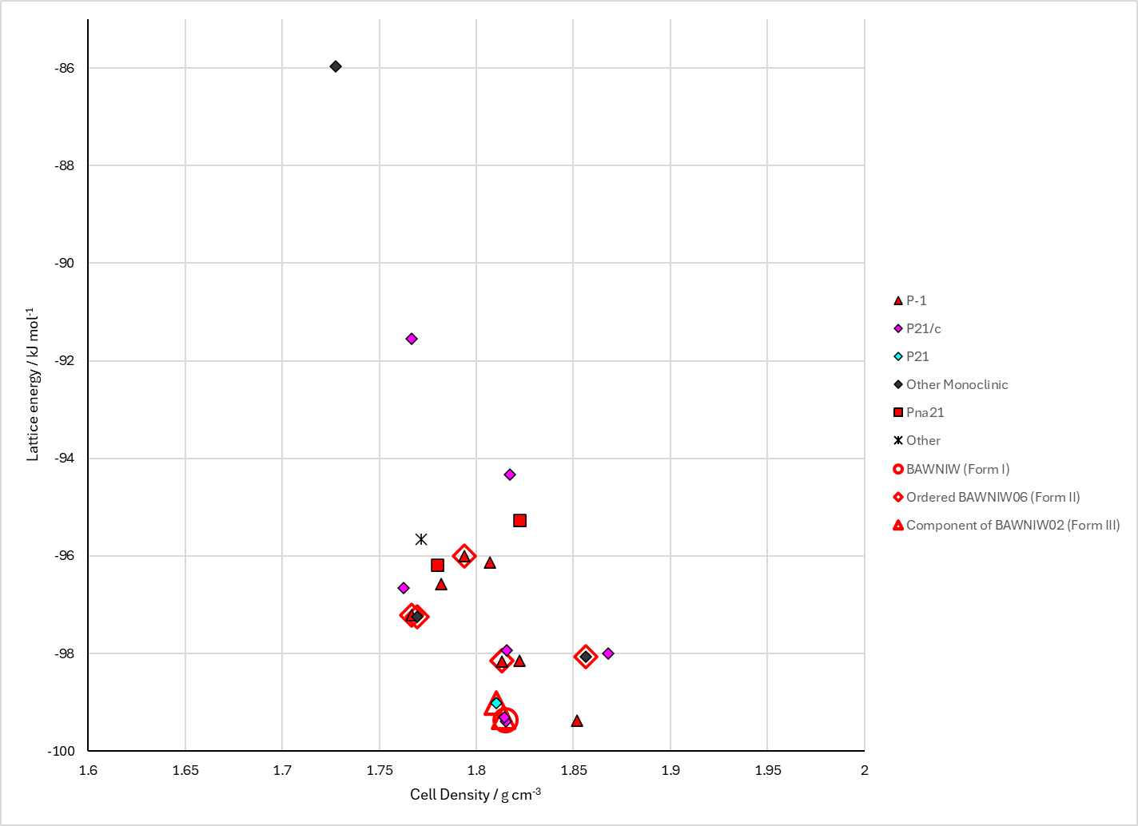

Figure . Crystal energy landscape of chlorothalonil from previous work.

# CSD structures (CSD version 5.46 with Feb 2025 updates)

Table . Crystallographic information for CSD entries for chlorothalonil. Different polymorphs are coloured differently.

|  |  |  |  |  |  |  |  |  |  |  |
| --- | --- | --- | --- | --- | --- | --- | --- | --- | --- | --- |
| REFCODE | space group | Z’ | a / Å | b / Å | c / Å | α / ° | β / ° | γ / ° | density / g cm-3 | Form |
| BAWNIW | P21/a | 1 | 24.753 | 6.226 | 6.34 | 90 | 95.41 | 90 | 1.816 | P21/a, 1 |
| BAWNIW01 | R-3m | 0.08 | 9.278 | 9.278 | 10.093 | 90 | 90 | 120 | 1.761 | R-3m, 2 |
| BAWNIW02 | P21 | 3 | 13.591 | 6.3033 | 18.429 | 90 | 109.448 | 90 | 1.78 | P21, 3 |
| BAWNIW03 | R-3m | 0.08 | 9.2392 | 9.2392 | 10.0969 | 90 | 90 | 120 | 1.775 | R-3m |
| BAWNIW04 | P1 | 1 | 6.3082 | 6.2995 | 6.3137 | 94.202 | 94.059 | 94.286 | 1.775 | P1 |
| BAWNIW05 | P21/c | 1 | 6.3177 | 6.1897 | 24.523 | 90 | 95.902 | 90 | 1.852 | P21/c |
| BAWNIW06 | R-3m | 0.08 | 9.2171 | 9.2171 | 9.935 | 90 | 90 | 120 | 1.812 | R-3m, 2 |
| BAWNIW07 | P21 | 1 | 8.1615 | 9.4191 | 6.4728 | 90 | 93.7307 | 90 | 1.779 | II |
| BAWNIW08 | P21 | 1 | 8.6003 | 9.2382 | 6.3024 | 90 | 96.2152 | 90 | 1.774 | III |

The last two structures are very similar to the R-3m structure, but not the same. Comparisons were done with 20% and 20° tolerances (ignoring smallest components, but allowing molecular differences), and structures with matches better than 0.15 Å considered the same. BAWNIW07 is slightly different.

Table . Experimental information for CSD entries for chlorothalonil.

|  |  |  |  |  |  |
| --- | --- | --- | --- | --- | --- |
| REFCODE | space group | R factor | T / K | Year | Comments |
| BAWNIW | P21/a | 3.3 | 295 | 1981 | Not online |
| BAWNIW01 | R-3m | 6.09 | 296 | 2004 | Disordered by symmetry. Slow cooling from butanol solution.1 |
| BAWNIW02 | P21 | 6.96 | 296 | 2004 | Slow cooling from ethyl acetate solution.1 |
| BAWNIW03 | R-3m | 2.5 | 295 | 2004 | No coordinates, reported as disordered. Not online. |
| BAWNIW04 | P1 | 2.4 | 295 | 2004 | No coordinates. Not online. |
| BAWNIW05 | P21/c | 4.51 | 174 | 2008 | Private communication. |
| BAWNIW06 | R-3m | 3.11 | 173 | 2009 | Disordered by symmetry. “Crystals from methylene chloride, chloroform and acetonitrile gave (M-I). Crystallization from acetone gave mostly (M-II) with a few crystals of (M-III). Crystallization from carbon tetrachloride gave (M-II)”2 |
| BAWNIW07 | P21 | 7.13 | 0 | 2004 | Cooled slowly (5 °C per minute) from 200 °C3 |
| BAWNIW08 | P21 | 6.24 | 0 | 2004 | Cooled from 200 °C in ice bath3 |

# Other notes

The R-3m structure of form II (BAWNIW06) does not show order in the cyano and chloro groups. Many structures matched the arrangement of the rings, with RMSD20 varying between 0.4 and 0.9 Å.

A number of structures matched double or single layers with form III (BAWNIW02). These are marked as components of form III.

(1) Tremayne, M.; Grice, L.; Pyatt, J. C.; Seaton, C. C.; Kariuki, B. M.; Tsui, H. H. Y.; Price, S. L.; Cherryman, J. C. Characterization of complicated new polymorphs of chlorothalonil by X-ray diffraction and computer crystal structure prediction. *Journal of the American Chemical Society* **2004**, *126* (22), 7071-7081.

(2) Britton, D. Planar packing of tetrachlorodicyanobenzenes. II. *Acta Crystallographica Section B - Structural Science* **2009**, *65*, 54-58.

(3) Hu, X. R.; Yuan, Z. Q.; Lu, G. L. Determination of crystal structures of polymorphic chlorothalonil using Monte Carlo simulated annealing and Rietveld refinement. *Powder Diffraction* **2004**, *19* (4), 325-328.