Coronene

(Last updated 1 May 2024)



Figure . The molecular diagram of Coronene.

# CSP studies

|  |  |
| --- | --- |
| REFCODE | CORONE |
| Formula | C24 H12 |
| Common Name | Coronene |
| IUPAC Systematic Name | Coronene |
| CSD Refcodes | CORONE03, CORONE04 |
| Search identifier | A |
| Energy model | 1 |
| Study_ID | 0 |
| Scientist | Rui Guo |
| Date | June 2017 |
| Publication | Potticary J, Hall CL, Guo R, Price SL, Hall SR, Cryst Growth Des, 2021, 21(11), 6254-6265 |
| Programs | Molpak, DMACRYS (2.0.8) |
| Location on S Drive | \CHEMISTRY_CPOSS\MagnaPharm\Coronene |
| Potential Description | GDMA2.2(PBE0/6-31G(d,p)) + FIT |

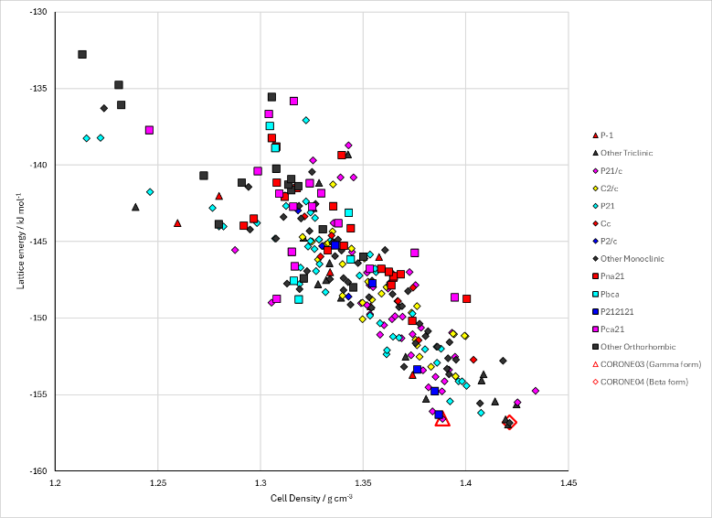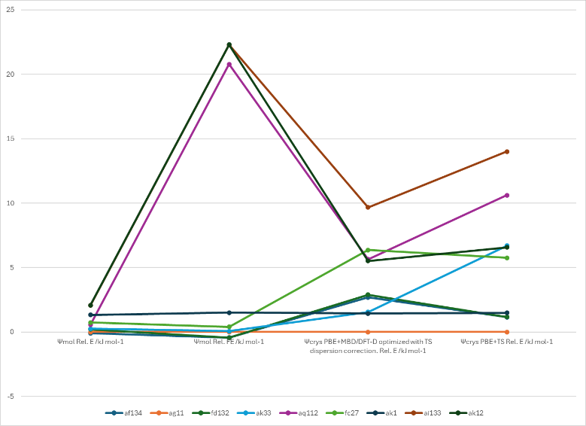

Figure . Crystal energy landscape of Coronene from previous work. Left, the lattice energy landscape and right, the relative energies and free energies with the ψmol method and relative energies with the ψcrys method.

# CSD structures (CSD version 5.43 with Mar, Jun, Sep and Nov 2022 updates)

Table . Crystallographic information for CSD entries for XXX. Different polymorphs are coloured differently.

|  |  |  |  |  |  |  |  |  |  |  |
| --- | --- | --- | --- | --- | --- | --- | --- | --- | --- | --- |
| REFCODE | space group | Z’ | a / Å | b / Å | c / Å | α / ° | β / ° | γ / ° | density / g cm-3 | Form |
| CORONE | P21/a | 0.5 | 16.119 | 4.702 | 10.102 | 90 | 110.9 | 90 | 1.394 | alpha |
| CORONE01 | P21/a | 0.5 | 16.1 | 4.695 | 10.15 | 90 | 110.8 | 90 | 1.39 | alpha |
| CORONE02 | P21/n | 0.5 | 10.122 | 4.694 | 15.718 | 90 | 106.02 | 90 | 1.39 | gamma |
| CORONE03 | P21/n | 0.5 | 10.0086 | 4.6651 | 15.5437 | 90 | 106.576 | 90 | 1.434 | gamma |
| CORONE04 | P21/n | 0.5 | 10.3855 | 3.8212 | 17.2111 | 90 | 96.235 | 90 | 1.469 | beta |
| CORONE05 | P21/n | 0.5 | 10.0143 | 4.6622 | 15.5757 | 90 | 106.534 | 90 | 1.431 | gamma |
| CORONE06 | P21/n | 0.5 | 10.034 | 4.6734 | 15.601 | 90 | 106.321 | 90 | 1.421 | gamma |
| CORONE07 | P21/n | 0.5 | 10.0328 | 4.6703 | 15.616 | 90 | 106.431 | 90 | 1.421 | gamma |
| CORONE08 | P21/n | 0.5 | 10.033 | 4.672 | 15.642 | 90 | 106.43 | 90 | 1.418 | gamma |
| CORONE09 | P21/n | 0.5 | 10.0372 | 4.6751 | 15.603 | 90 | 106.393 | 90 | 1.42 | gamma |
| CORONE10 | P21/n | 0.5 | 10.0372 | 4.6751 | 15.603 | 90 | 106.393 | 90 | 1.42 | gamma |
| CORONE11 | P21/n | 0.5 | 10.088 | 4.697 | 15.655 | 90 | 106.016 | 90 | 1.399 | gamma |
| CORONE12 | P21/n | 0.5 | 10.0981 | 4.6964 | 15.698 | 90 | 106.07 | 90 | 1.394 | gamma |

Table . Experimental information for CSD entries for Coronene.

|  |  |  |  |  |  |
| --- | --- | --- | --- | --- | --- |
| REFCODE | space group | R factor | T / K | Year | Comments |
| CORONE | P21/a | 15.7 | RT | 1966 | Slow crystallization from xylene1 |
| CORONE01 | P21/a | 14 | RT | 1945 | Not specified2 |
| CORONE02 | P21/n | 5.54 | RT | 1996 | Not specified3 |
| CORONE03 | P21/n | 4.54 | 100 | 2016 | Obtained during cocrystallization of coronene with F4-TCNQ4 |
| CORONE04 | P21/n | 7.52 | 80 | 2016 | Obtained by slow cooling of toluene solution in 1 Tesla magnetic field5  (gamma also obtained by slow cooling of toluene solution with no field) |
| CORONE05 | P21/n | 6.86 | 101 | 2021 | Twin Slow solvent evaporation from benzene. Jumping crystals and something to do with photoluminescence and cocrystals6 |
| CORONE06 | P21/n | 6.93 | 160 | 2021 | Slow solvent evaporation from benzene. Bending crystals.7 |
| CORONE07 | P21/n | 8.56 | 160 | 2021 | Slow solvent evaporation from benzene. Bending crystals. 7 |
| CORONE08 | P21/n | 12.12 | 160 | 2021 | Slow solvent evaporation from benzene. Bending crystals. 7 |
| CORONE09 | P21/n | 4.38 | 160 | 2021 | Private Communication |
| CORONE10 | P21/n | 4.38 | 160 | 2021 | Slow solvent evaporation from benzene. Bending crystals. 7 |
| CORONE11 | P21/n | 6.21 | RT | 2022 | Private Communication |
| CORONE12 | P21/n | 6.35 | RT | 2022 | Not specified (or it’s buried deep in the SI)8 |

# Other notes

1. J. K. Fawcett and J. Trotter, *Proceedings of the Royal Society of London. Series A. Mathematical and Physical Sciences*, 1966, **289**, 366-376.

2. J. M. Robertson and J. G. White, *Journal of the Chemical Society (Resumed)*, 1945, 607-617.

3. T. M. Krygowski, M. Cyrański, A. Ciesielski, B. Świrska and P. Leszczyński, *Journal of Chemical Information and Computer Sciences*, 1996, **36**, 1135-1141.

4. O. Kataeva, M. Khrizanforov, Y. Budnikova, D. Islamov, T. Burganov, A. Vandyukov, K. Lyssenko, B. Mahns, M. Nohr, S. Hampel and M. Knupfer, *Crystal Growth & Design*, 2016, **16**, 331-338.

5. J. Potticary, L. R. Terry, C. Bell, A. N. Papanikolopoulos, P. C. M. Christianen, H. Engelkamp, A. M. Collins, C. Fontanesi, G. Kociok-Kohn, S. Crampin, E. Da Como and S. R. Hall, *Nature Communications*, 2016, **7**.

6. Y. Chen, J. Li and J. Gong, *ACS Materials Letters*, 2021, **3**, 275-281.

7. Y. Chen, Z. Chang, J. Zhang and J. Gong, *Angewandte Chemie International Edition*, 2021, **60**, 22424-22431.

8. X. Zheng, Q. Han, Q. Lin, C. Li, J. Jiang, Q. Guo, X. Ye, W. Z. Yuan, Y. Liu and X. Tao, *Materials Horizons*, 2023, **10**, 197-208.