DiChloroNitroBenzenes

(Last updated 11 November 2024)



Figure . The molecular diagrams of 2,3-dichloronitrobenzene, 2,4-dichloronitrobenzene, 2.5-dichloronitrobenzene, 3.4-dichloronitrobenzene, and 3,5-dichloronitrobenzene.

# CSP studies

|  |  |
| --- | --- |
| REFCODE | DOXWIW |
| Formula | C6 H3 N1 O2 Cl2 |
| Common Name | 2,3-Dichloronitrobenzene |
| IUPAC Systematic Name | 1,2-Dichloro-3-nitrobenzene |
| Other Names | 1-Nitro-2,3-dichlorobenzene; 2,3-Dichloro-1-nitrobenzene |
| CSD Refcodes | DOXWIW |
| Search Identifier | A |
| Scientist | Sarah Barnett |
| Date | 2005-2008 |
| Publication | Barnett SA, Johnston A, Florence AJ, Price SL, Tocher DA, 2008. Cryst. Growth Des. 8, 24-36 |
| Energy Model | 1 |
| Study_ID | 0 (published) |
| Programs | Molpak, DMAREL (3.0) |
| Location on S Drive | \CHEMISTRY_CPOSS\0-EarlySearches\home\louise_price.eminerals\2,3-dichloronitrobenzene |
| Potential Description | Isotropic RiceDay potential. All parameters taken from the Rice potential. Isotropic chlorine parameters from Day potential added. |
| Search Identifier | B |
| Scientist | Louise Price |
| Date | January 2024 |
| Publication | No publication planned. |
| Energy Model | 1 |
| Study_ID | 20 |
| Programs | Flexible CrystalPredictor (2.4.3), DMACRYS (2.3.1.1) |
| Location on S Drive | /CHEMISTRY_CPOSS/DiChloroNitroBenzene/23dcnb/CrystPred/ |
| Potential Description | Flexible CrystalPredictor + DMACRYS with GDMA2.2(PBE0/6-31G(d,p)) + FIT |
| Energy Model | 2 |
| Study_ID | 10 |
| Programs | Study_ID=20, CrystalOptimizer (2.4.7.1), DMACRYS (2.3.1.1) |
| Location on S Drive | /CHEMISTRY_CPOSS/DiChloroNitroBenzene/23dcnb/CrystOpt/ |
| Potential Description | CrystalOptimizer with GDMA2.2(PBE0/6-31G(d,p)) + FIT |
| Energy Model | 3 |
| Study_ID | 30 |
| Programs | Study_ID=10, DMACRYS (2.3.1.1) |
| Location on S Drive | /CHEMISTRY_CPOSS/DiChloroNitroBenzene/23dcnb/PCM/ |
| Potential Description | GDMA2.2(PCMdielectric3(PBE0/6-31G(d,p))) + FIT |
|  |  |
| REFCODE | JIWQEM |
| Formula | C6 H3 N1 O2 Cl2 |
| Common Name | 2,4-Dichloronitrobenzene |
| IUPAC Systematic Name | 1,3-Dichloro-4-nitrobenzene |
| Other Names | 1-Nitro-2,4-dichlorobenzene |
| CSD Refcodes | JIWQEM |
| Search Identifier | A |
| Scientist | Sarah Barnett |
| Date | 2005-2008 |
| Publication | Barnett SA, Johnston A, Florence AJ, Price SL, Tocher DA, 2008. Cryst. Growth Des. 8, 24-36 |
| Energy Model | 1 |
| Study_ID | 0 (published) |
| Programs | Molpak, DMAREL (4.1.1) |
| Location on S Drive | \CHEMISTRY_CPOSS\0-EarlySearches\home\louise_price.eminerals\2,4-dichloronitrobenzene |
| Potential Description | Isotropic RiceDay potential. All parameters taken from the Rice potential. Isotropic chlorine parameters from Day potential added. |
| Search Identifier | B |
| Scientist | Louise Price |
| Date | January 2024 |
| Publication | No publication planned. |
| Energy Model | 1 |
| Study_ID | 20 |
| Programs | Flexible CrystalPredictor (2.4.3), DMACRYS (2.3.1.1) |
| Location on S Drive | /CHEMISTRY_CPOSS/DiChloroNitroBenzene/24dcnb/CrystPred/ |
| Potential Description | Flexible CrystalPredictor + DMACRYS with GDMA2.2(PBE0/6-31G(d,p)) + FIT |
| Energy Model | 2 |
| Study_ID | 10 |
| Programs | Study_ID=20, CrystalOptimizer (2.4.7.1), DMACRYS (2.3.1.1) |
| Location on S Drive | /CHEMISTRY_CPOSS/DiChloroNitroBenzene/24dcnb/CrystOpt/ |
| Potential Description | CrystalOptimizer with GDMA2.2(PBE0/6-31G(d,p)) + FIT |
| Energy Model | 3 |
| Study_ID | 30 |
| Programs | Study_ID=10, DMACRYS (2.3.1.1) |
| Location on S Drive | /CHEMISTRY_CPOSS/DiChloroNitroBenzene/24dcnb/PCM/ |
| Potential Description | GDMA2.2(PCMdielectric3(PBE0/6-31G(d,p))) + FIT |
|  |  |
| REFCODE | ZZZEKW |
| Formula | C6 H3 N1 O2 Cl2 |
| Common Name | 2,5-Dichloronitrobenzene |
| IUPAC Systematic Name | 1,4-Dichloro-2-nitrobenzene |
| Other Names | 1-Nitro-2,5-dichlorobenzene |
| CSD Refcodes | ZZZEKW02 |
| Search Identifier | A |
| Scientist | Sarah Barnett |
| Date | 2005-2008 |
| Publication | Barnett SA, Johnston A, Florence AJ, Price SL, Tocher DA, 2008. Cryst. Growth Des. 8, 24-36 |
| Energy model | 1 |
| Study_ID | 0 (published) |
| Programs | Molpak, DMAREL (4.1.1) |
| Location on S Drive | \CHEMISTRY_CPOSS\0-EarlySearches\home\louise_price.eminerals\2,5-dichloronitrobenzene |
| Potential Description | Isotropic RiceDay potential. All parameters taken from the Rice potential. Isotropic chlorine parameters from Day potential added. |
| Search Identifier | B |
| Scientist | Louise Price |
| Date | January 2024 |
| Publication | No publication planned. |
| Energy Model | 1 |
| Study_ID | 20 |
| Programs | Flexible CrystalPredictor (2.4.3), DMACRYS (2.3.1.1) |
| Location on S Drive | /CHEMISTRY_CPOSS/DiChloroNitroBenzene/25dcnb/CrystPred/ |
| Potential Description | Flexible CrystalPredictor + DMACRYS with GDMA2.2(PBE0/6-31G(d,p)) + FIT |
| Energy Model | 2 |
| Study_ID | 10 |
| Programs | Study_ID=20, CrystalOptimizer (2.4.7.1), DMACRYS (2.3.1.1) |
| Location on S Drive | /CHEMISTRY_CPOSS/DiChloroNitroBenzene/25dcnb/CrystOpt/ |
| Potential Description | CrystalOptimizer with GDMA2.2(PBE0/6-31G(d,p)) + FIT |
| Energy Model | 3 |
| Study_ID | 30 |
| Programs | Study_ID=10, DMACRYS (2.3.1.1) |
| Location on S Drive | /CHEMISTRY_CPOSS/DiChloroNitroBenzene/25dcnb/PCM/ |
| Potential Description | GDMA2.2(PCMdielectric3(PBE0/6-31G(d,p))) + FIT |
|  |  |
| REFCODE | CAGPUV |
| Formula | C6 H3 N1 O2 Cl2 |
| Common Name | 3,4-Dichloronitrobenzene |
| IUPAC Systematic Name | 1,2-Dichloro-4-nitrobenzene |
| Other Names | 1-Nitro-3,4-dichlorobenzene |
| CSD Refcodes | CAGPUV01 |
| Search Identifier | A |
| Scientist | Sarah Barnett |
| Date | 2005-2008 |
| Publication | Barnett SA, Johnston A, Florence AJ, Price SL, Tocher DA, 2008. Cryst. Growth Des. 8, 24-36. |
| Energy Model | 1 |
| Study_ID | 0 (published) |
| Programs | MOLPAK, DMAREL (3.0) |
| Location on S Drive | \CHEMISTRY_CPOSS\0-EarlySearches\home\louise_price.eminerals\3,5-dichloronitrobenzene |
| Potential Description | Isotropic RiceDay potential. All parameters taken from the Rice potential. Isotropic chlorine parameters from Day potential added. |
| Search Identifier | B |
| Scientist | Louise Price |
| Date | January 2024 |
| Publication | No publication planned. |
| Energy Model | 1 |
| Study_ID | 20 |
| Programs | Flexible CrystalPredictor (2.4.3), DMACRYS (2.3.1.1) |
| Location on S Drive | /CHEMISTRY_CPOSS/DiChloroNitroBenzene/34dcnb/CrystPred/ |
| Potential Description | Flexible CrystalPredictor + DMACRYS with GDMA2.2(PBE0/6-31G(d,p)) + FIT |
| Energy Model | 2 |
| Study_ID | 10 |
| Programs | Study_ID=20, CrystalOptimizer (2.4.7.1), DMACRYS (2.3.1.1) |
| Location on S Drive | /CHEMISTRY_CPOSS/DiChloroNitroBenzene/34dcnb/CrystOpt/ |
| Potential Description | CrystalOptimizer with GDMA2.2(PBE0/6-31G(d,p)) + FIT |
| Energy Model | 3 |
| Study_ID | 30 |
| Programs | Study_ID=10, DMACRYS (2.3.1.1) |
| Location on S Drive | /CHEMISTRY_CPOSS/DiChloroNitroBenzene/34dcnb/PCM/ |
| Potential Description | GDMA2.2(PCMdielectric3(PBE0/6-31G(d,p))) + FIT |
|  |  |
| REFCODE | HIBWEU |
| Formula | C6 H3 N1 O2 Cl2 |
| Common Name | 3,5-Dichloronitrobenzene |
| IUPAC Systematic Name | 1,3-Dichloro-5-nitrobenzene |
| Other Names | 1-Nitro-3,5-dichlorobenzene |
| CSD Refcodes | HIBWEU02 |
| Search Identifier | A |
| Scientist | Sarah Barnett |
| Date | 2005-2008 |
| Publication | Barnett SA, Johnston A, Florence AJ, Price SL, Tocher DA, 2008. Cryst. Growth Des. 8, 24-36. |
| Energy Model | 1 |
| Study_ID | 0 (published) |
| Programs | MOLPAK, DMAREL (4.1.1) |
| Location on S Drive | \CHEMISTRY_CPOSS\0-EarlySearches\home\louise_price.eminerals\3,5-dichloronitrobenzene |
| Potential Description | Isotropic RiceDay potential. All parameters taken from the Rice potential. Isotropic chlorine parameters from Day potential added. |
| Search Identifier | B |
| Scientist | Louise Price |
| Date | January 2024 |
| Publication | No publication planned. |
| Energy Model | 1 |
| Study_ID | 20 |
| Programs | Flexible CrystalPredictor (2.4.3), DMACRYS (2.3.1.1) |
| Location on S Drive | /CHEMISTRY_CPOSS/DiChloroNitroBenzene/35dcnb/CrystPred/ |
| Potential Description | Flexible CrystalPredictor + DMACRYS with GDMA2.2(PBE0/6-31G(d,p)) + FIT |
| Energy Model | 2 |
| Study_ID | 10 |
| Programs | Study_ID=20, CrystalOptimizer (2.4.7.1), DMACRYS (2.3.1.1) |
| Location on S Drive | /CHEMISTRY_CPOSS/DiChloroNitroBenzene/35dcnb/CrystOpt/ |
| Potential Description | CrystalOptimizer with GDMA2.2(PBE0/6-31G(d,p)) + FIT |
| Energy Model | 3 |
| Study_ID | 30 |
| Programs | Study_ID=10, DMACRYS (2.3.1.1) |
| Location on S Drive | /CHEMISTRY_CPOSS/DiChloroNitroBenzene/35dcnb/PCM/ |
| Potential Description | GDMA2.2(PCMdielectric3(PBE0/6-31G(d,p))) + FIT |

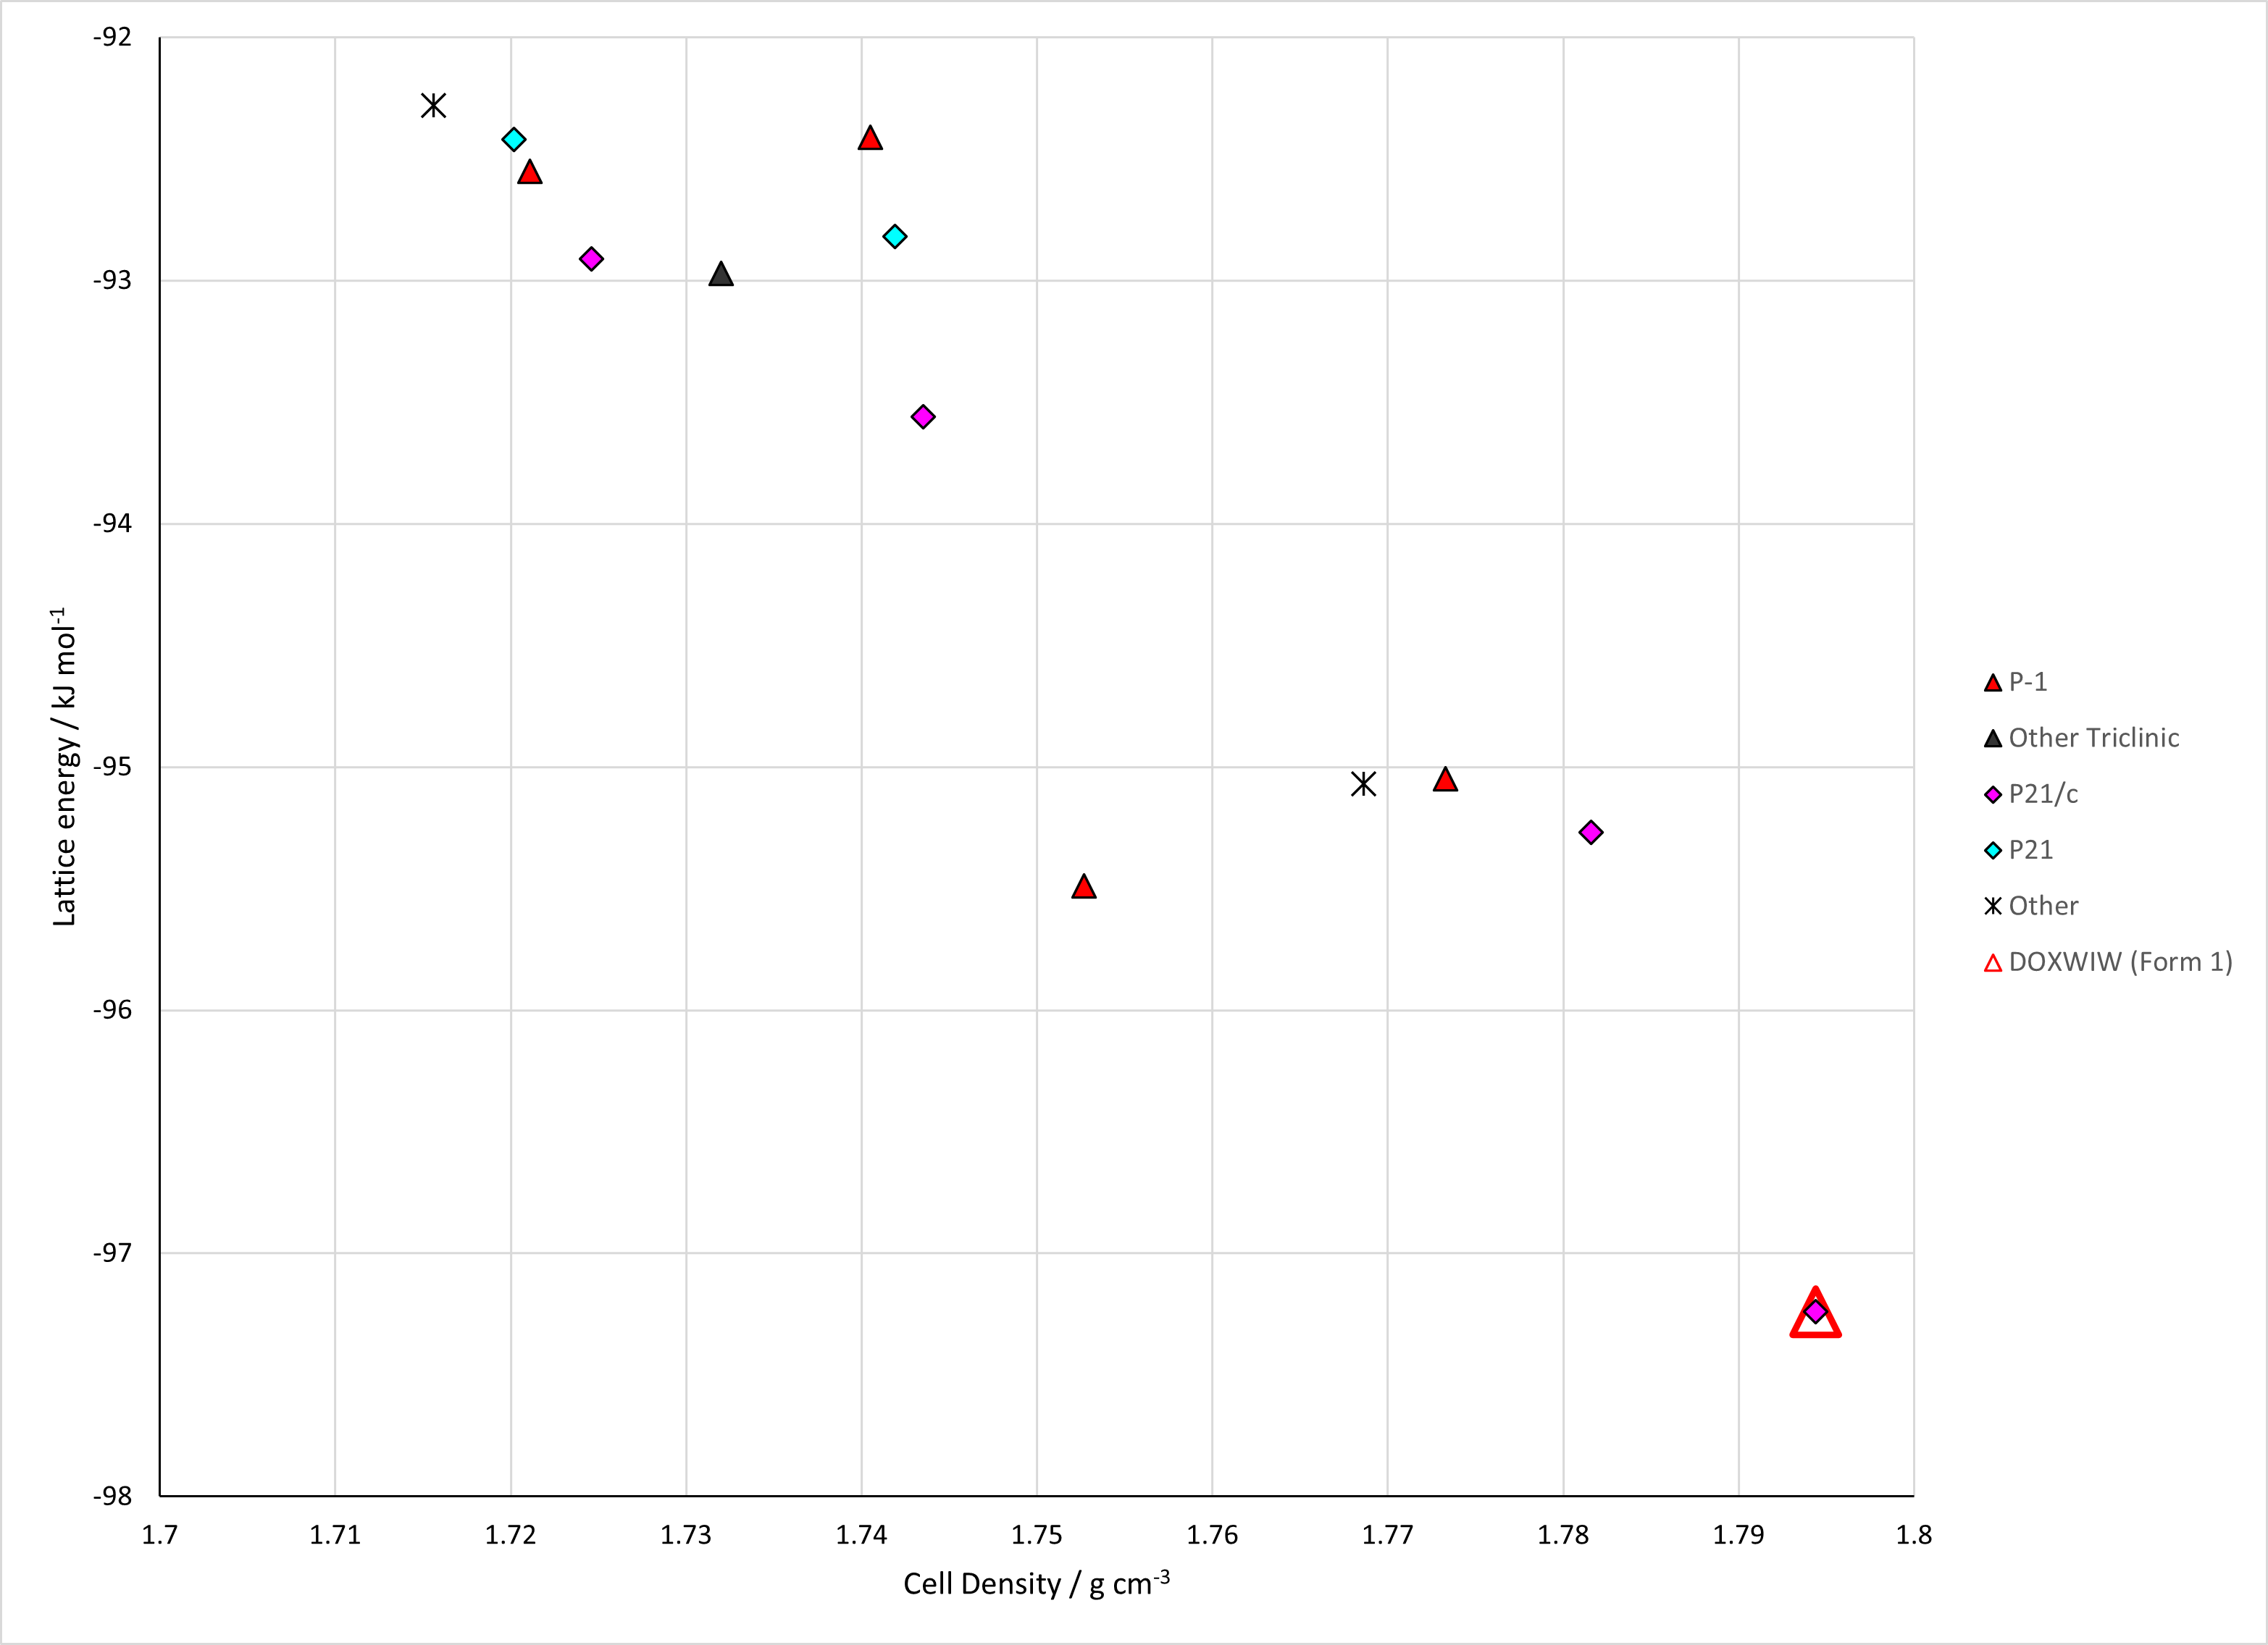

Figure . Crystal energy landscapes of dichloronitrobenzenes from previous work. Left: Published Search A landscapes. Right: Unpublished Search B/Energy Model 3 landscapes. Top: 2,3-dichloronitrobenzene. Second: 2,4-dichloronitrobenzene. Third: 2,5-dichloronitrobenzene. Fourth: 3,4-dichloronitrobenzene. Bottom: 3,5-dichloronotrobenzene.

# CSD structures (CSD version 5.44 with Jun and Sep 2023 updates)

Table . Crystallographic information for CSD entries for dichloronitrobenzenes. Different structures are coloured differently.

|  |  |  |  |  |  |  |  |  |  |  |
| --- | --- | --- | --- | --- | --- | --- | --- | --- | --- | --- |
| REFCODE | space group | Z’ | a / Å | b / Å | c / Å | α / ° | β / ° | γ / ° | density / g cm-3 | Form |
| DOXWIW | P21/c | 1 | 3.81 | 13.765 | 14.302 | 90 | 97.764 | 90 | 1.715 | 1 |
| JIWQEM | P21/n | 2 | 20.682 | 3.7484 | 20.961 | 90 | 118.235 | 90 | 1.782 | 1 |
| ZZZEKW | P* | 0 | 7.377 | 8.3336 | 7.355 | 110.58 | 113 | 72.9 | 0 | 1 |
| ZZZEKW01 | P-1 | 1 | 7.404 | 8.273 | 7.234 | 109.6 | 112.9 | 73.2 | 1.687 | 1 |
| ZZZEKW02 | P-1 | 1 | 7.1403 | 7.2638 | 8.2418 | 72.781 | 70.3 | 66.349 | 1.761 | 1 |
| CAGPUV | I41/a | 1 | 28.094 | 28.094 | 3.838 | 90 | 90 | 90 | 1.684 | 1 |
| CAGPUV01 | I41/a | 1 | 27.9342 | 27.9342 | 3.7655 | 90 | 90 | 90 | 1.736 | 1 |
| HIBWEU | P21/m | 0.5 | 3.873 | 13.687 | 7.013 | 90 | 92.94 | 90 | 1.717 | 1 |
| HIBWEU01 | P21/m | 0.5 | 3.8114 | 13.647 | 6.89 | 90 | 94.6 | 90 | 1.785 | 1 |
| HIBWEU02 | P21/m | 0.5 | 3.8115 | 13.6452 | 6.8976 | 90 | 94.632 | 90 | 1.783 | 1 |

Table . Experimental information for CSD entries for dichloronitrobenzenes.

|  |  |  |  |  |  |
| --- | --- | --- | --- | --- | --- |
| REFCODE | space group | R factor | T / K | Year | Comments |
| DOXWIW | P21/c | 3.3 | 295 | 1986 | Not online |
| JIWQEM | P21/n | 3.17 | 150 | 2008 | Slow evaporation from hexane solution.1 |
| ZZZEKW | P* | 0 | 295 | 1965 | Not online |
| ZZZEKW01 | P-1 | 5.73 | 295 | 1999 | Powder diffraction. Crystallization conditions not described. |
| ZZZEKW02 | P-1 | 2.4 | 150 | 2008 | Evaporation from saturated solutions in many solvents. Not specified which precise experiment led to the crystal whose structure was solved.1 |
| CAGPUV | I41/a | 7 | 295 | 1983 | Not online. |
| CAGPUV01 | I41/a | 4.28 | 150 | 2008 | Layering in some solvents with water or cyclohexane?1 |
| HIBWEU | P21/m | 4.6 | 295 | 1995 | Slow evaporation of a saturated acetonitrile solution.2 |
| HIBWEU01 | P21/m | 3.86 | 100 | 2019 | Private Communication |
| HIBWEU02 | P21/m | 2.75 | 100 | 2022 | Slow evaporation from chloroform solution.3 |

Make this table include whether polymorphs are solution-grown, sublimation grown, templated or otherwise. Add references.

# Other notes

There is also a 2,6-dcnb search by Sarah Barnett, but this compound cannot be synthesized.

1. S. A. Barnett, A. Johnson, A. J. Florence, S. L. Price and D. A. Tocher, *Crystal Growth & Design*, 2008, **8**, 24-36.

2. A. Bhar, J. P. Aune, N. Benalicherif, L. Benmenni and M. Giorgi, *Acta Crystallographica Section C - Crystal Structure Communications*, 1995, **51**, 256-260.

3. E. Bosch, N. P. Bowling and E. D. Speetzen, *Acta Crystallographica Section C*, 2022, **78**, 552-558.