Mefenamic Acid

(Last updated 26 November 2024)

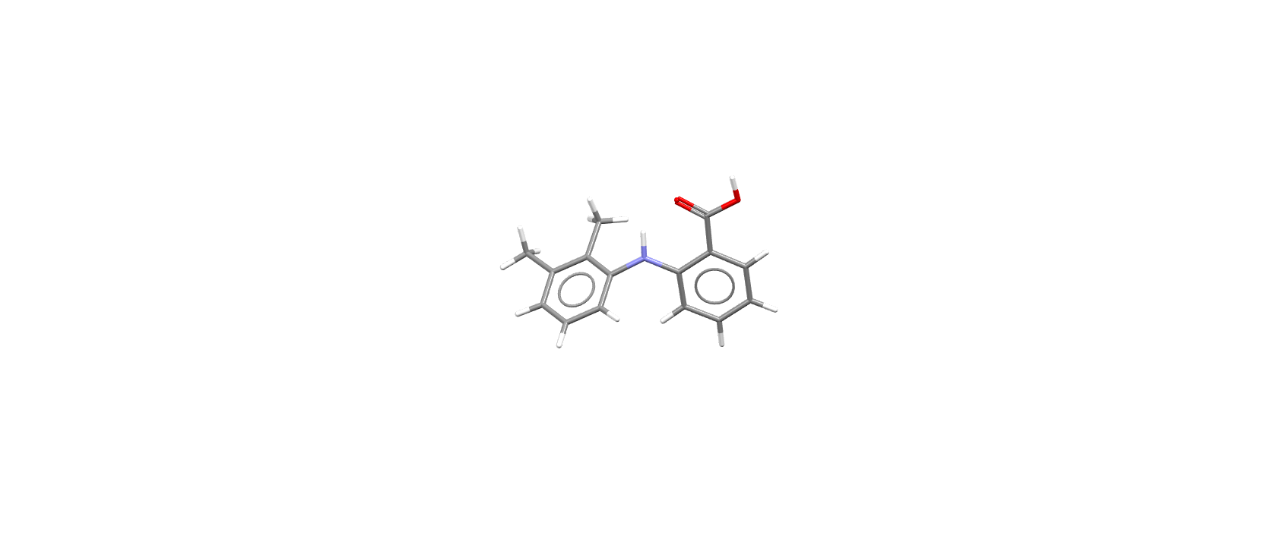

Figure . The molecular diagram of Mefenamic Acid.

# CSP studies

|  |  |
| --- | --- |
| REFCODE | XYANAC |
| Formula | C15 H15 N1 O2 |
| Common Name | Mefenamic Acid |
| IUPAC Systematic Name | 2-((2,3-Dimethylphenyl)amino)benzoic acid |
| Other Names | 2-(2,3-Dimethylanilino)benzoic acid, N-(2,3-Xylyl)anthranilic acid |
| CSD Refcodes | XYANAC06, XYANAC05, XYANAC03 |
| Search Identifier | A |
| Scientist | Rona Watson |
| Date | 2016 |
| Publication | Case, D. H.; Srirambhatla, V. K.; Guo, R.; Watson, R. E.; Price, L. S.; Polyzois, H.; Cockcroft, J. K.; Florence, A. J.; Tocher, D. A.; Price, S. L., Successful Computationally Directed Templating of Metastable Pharmaceutical Polymorphs. Crystal Growth & Design 2018, 18, (9), 5322-5331. |
| Energy Model | 1 |
| Study_ID | 20 |
| Programs | Flexible CrystalPredictor (1.6), DMACRYS (2.0.4) |
| Location on S Drive | /CHEMISTRY_CPOSS/Fenamates/MefenamicAcid/XYANAC_CP |
| Potential Description | CrystalPredictor / DMAflex-Q with 1 torsional degree of freedom + rotated multipoles from PBE1PBE/6-31+G(d) + FIT |
| Energy Model | 2 |
| Study_ID | 10 |
| Programs | Study_ID=20, CrystalOptimizer (2.3), DMACRYS (2.0.8RC1) |
| Location on S Drive | /CHEMISTRY_CPOSS/Fenamates/MefenamicAcid/XYANAC_CO |
| Potential Description | CrystalOptimizer with GDMA2.2(PBE0/6-31+G(d)) + FIT |
| Energy Model | 3 |
| Study_ID | 30 (published) |
| Programs | Study_ID=10, DMACRYS (2.0.8RC1) |
| Location on S Drive | /CHEMISTRY_CPOSS/Fenamates/MefenamicAcid/XYANAC_PCM |
| Potential Description | GDMA2.2(PCMdielectric3(PBE0/6-31+G(d))) + FIT |
| Scientist | Louise Price |
| Date | 2024 |
| Publication | Database updating paper |
| Energy Model | 4 |
| Study_ID | 11 (includes pDFT-D) |
| Programs | Study_ID=10, CrystalOptimizer (2.4.7), DMACRYS (2.3.1.1) |
| Location on S Drive | /CHEMISTRY_CPOSS/Fenamates/MefenamicAcid/XYANAC_DFT |
| Potential Description | CrystalOptimizer with GDMA2.2(PBE0/6-31+G(d)) + FIT |

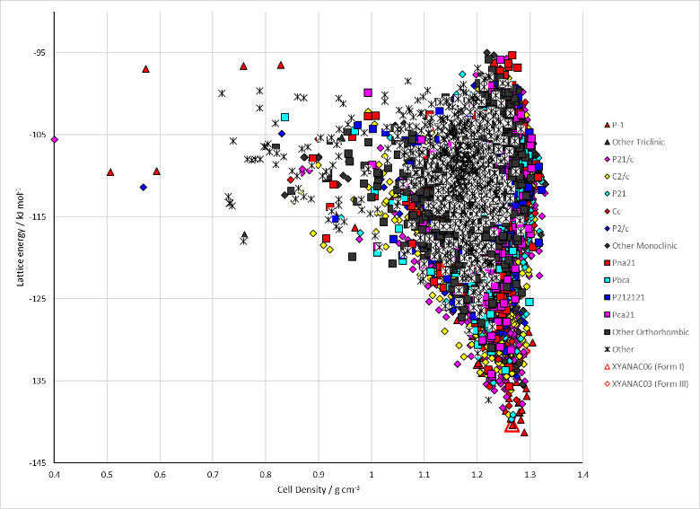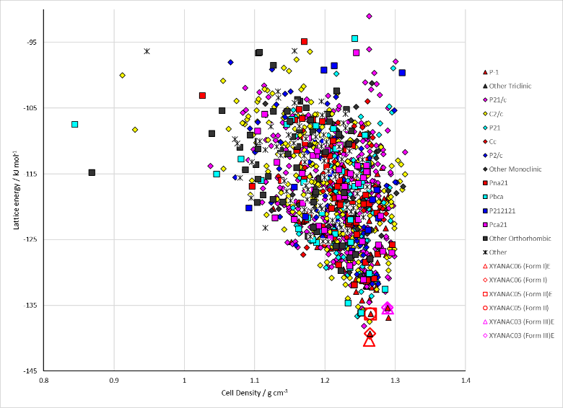

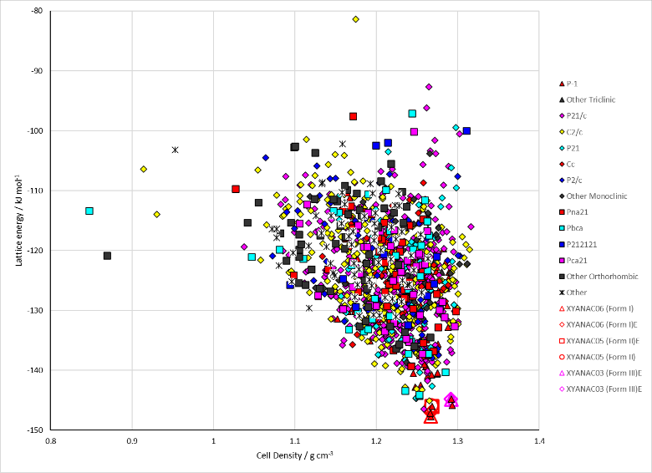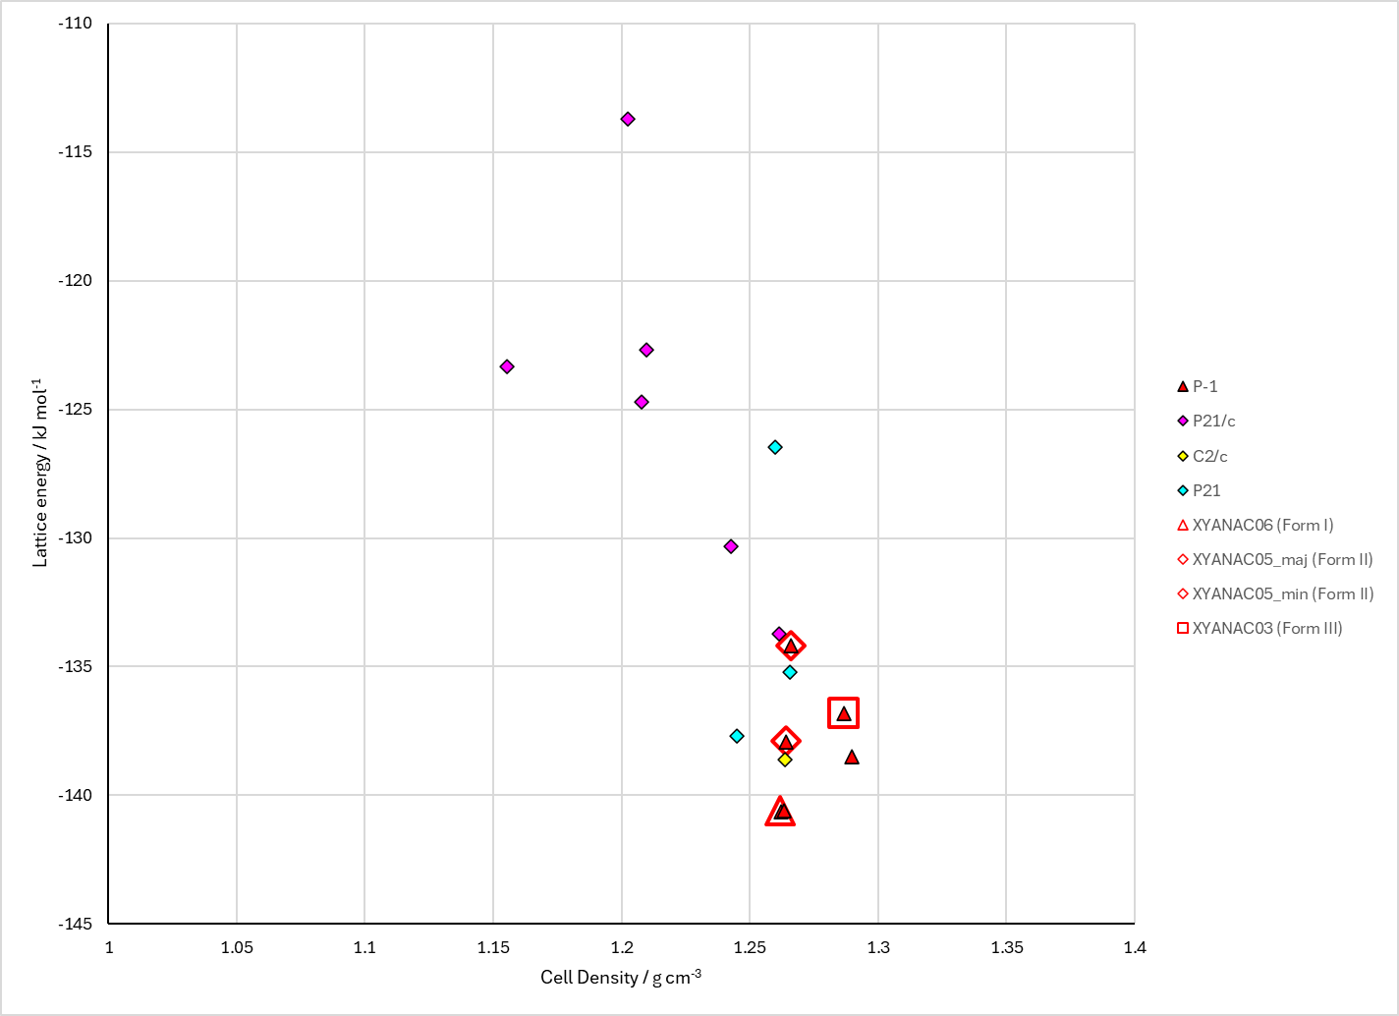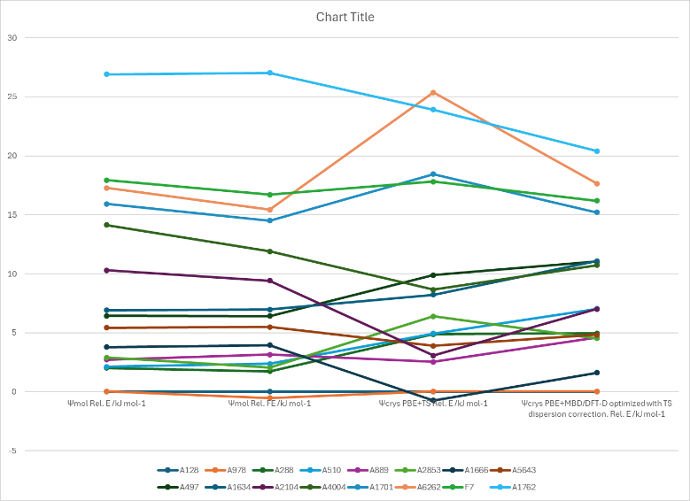

Figure . Crystal energy landscape of Mefenamic Acid from (top left) CrystalPredictor, (top right) CrystalOptimizer refinement, (middle) PCM refinement, (bottom left) limited repeated CrystalOptimizer calculations, and (bottom right) energy comparisons including DFT.

# CSD structures (CSD version 5.43 with Mar, Jun, Sep and Nov 2022 updates)

Table . Crystallographic information for CSD entries for Mefenamic Acid. Different polymorphs are coloured differently.

|  |  |  |  |  |  |  |  |  |  |  |
| --- | --- | --- | --- | --- | --- | --- | --- | --- | --- | --- |
| REFCODE | space group | Z’ | a / Å | b / Å | c / Å | α / ° | β / ° | γ / ° | density / g cm-3 | Form |
| XYANAC | P-1 | 1 | 14.556 | 6.811 | 7.657 | 119.57 | 103.93 | 91.3 | 1.268 | I |
| XYANAC01 | P-1 | 1 | 7.3371 | 14.306 | 6.7899 | 101.012 | 114.64 | 76.05 | 1.281 | I |
| XYANAC02 | P-1 | 1 | 7.6969 | 9.1234 | 9.4535 | 107.113 | 91.791 | 101.481 | 1.295 | II |
| XYANAC03 | P-1 | 1 | 7.723 | 7.934 | 11.232 | 83.59 | 80.94 | 67.51 | 1.278 | III |
| XYANAC04 | P-1 | 1 | 7.7584 | 9.2772 | 9.3991 | 106.308 | 91.847 | 101.856 | 1.267 | II |
| XYANAC05 | P-1 | 1 | 7.7063 | 9.1016 | 9.397 | 107.285 | 91.408 | 101.804 | 1.306 | II |
| XYANAC06 | P-1 | 1 | 6.7953 | 7.3737 | 13.967 | 77.072 | 79.912 | 64.746 | 1.304 | I |
| XYANAC07 | P-1 | 1 | 7.79 | 9.189 | 9.412 | 106.751 | 92.287 | 101.377 | 1.274 | II |
| XYANAC08 | P-1 | 1 | 6.8159 | 7.3183 | 14.4171 | 76.612 | 79.167 | 65.527 | 1.265 | I |

Table . Experimental information for CSD entries for Mefenamic Acid.

|  |  |  |  |  |  |
| --- | --- | --- | --- | --- | --- |
| REFCODE | space group | R factor | T / K | Year | Comments |
| XYANAC | P-1 | 4.5 | 295 | 1976 | 1 |
| XYANAC01 | P-1 | 7.8 | 296 | 2004 | Slow evaporation from ethanol at ambient temperature and pressure.2 |
| XYANAC02 | P-1 | 5.2 | 150 | 2006 | A supersaturate solution of mefenamic acid in ethanol, with flufenamic acid as an additive (to increase the solubility).3 |
| XYANAC03 | P-1 | 4.24 | 298 | 2012 | Cocrystallization attempts with adenine in a 1:1 DMF/methanol mixture, followed by slow evaporation at room temperature.4 |
| XYANAC04 | P-1 | 8.93 | 298 | 2012 | Slow evaporation of chloroform solution.4 |
| XYANAC05 | P-1 | 3.44 | 100 | 2012 | The 3.0 mg/g MA in methanol solution was prepared. We poured 20 mL of 3.5 mg/g MA solution into a 500 mL glass jar and covered the jar with parafilm to control the evaporation from the droplets of API solution on the patterned substrates. The bifunctional SAM substrates were placed inside the jar with a plastic support, which ensures that the substrates do not touch the liquid. After 3 h, the atmosphere inside the glass jar was saturated with methanol vapor. A 10 mL syringe with a 21G2 needle was used to punch a hole in the parafilm and drop the 3.0 mg/g solution on the substrates, and the jar was slightly tilted to get rid of additional MA solution on the surface. Droplets on islands started to evaporate and slowly became supersaturated. This slow evaporation of solvent resulted in the formation of crystals rather than amorphous solids, as confirmed by polarized light and Raman microscopy.5 |
| XYANAC06 | P-1 | 4.77 | 100 | 2017 | Private communication – no details. |
| XYANAC07 | P-1 | 9.24 | 298 | 2017 | Direct compression of Form I crystals in a diamond anvil cell; crystallization from ethanol under pressure.6 |
| XYANAC08 | P-1 | 4.61 | 295 | 2021 | Private communication – from DMF/acetone. |

# Other notes

REFCODES for solid solutions are SIMFEC (MFA:FFA), SIMFUS (25MFA:75TFA), SIMGAZ (57MFA:42TFA), SIMGED (42MFA:58TFA).

## Structural matches

XYANAC06 (Form I, Z’=1) = A128 (RMSD25=0.188 Å) = A978 (RMSD25=0.493 Å) = E1 (RMSD25=0.208 Å)  
XYANAC06~A540 (19/25); A288 (18/25); A1682 (18/25); A2924 (18/25); A5429 (18/25); A1592 (17/25); A2853 (17/25); A5611 (17/25); A7250 (17/25); A747 (16/25); A5092 (16/25); A237 (11/25); A1400 (11/25); A1655 (11/25); A1732 (11/25); A8199 (11/25); A1249 (10/25); A361 (9/25)

XYANAC05 (Form II, Z’=1) = A889 (RMSD25=0.464 Å) = E21 (RMSD25=0.488 Å)  
XYANAC05~A314 (11/25); A3117 (11/25); A7235 (11/25); A761 (9/25); A8391 (9/25)

XYANAC03 (Form III, Z’=1) = A1666 (RMSD25=0.635 Å) = E6 (RMSD25=0.619 Å)  
XYANAC03~A1117 (15/25); A3106 (12/25); A3698 (12/25)

|  |  |
| --- | --- |
| (a) (Form I from search) | (b) (Form I from search) |
| (c) (Form I experimental minimized) | (d) (Form II from search) |
| (e) (Form II major component minimized) | (f) (Form III from search) |
| (g) (Form III experimental minimized) |  |

Figure . Overlays of (a) XYANAC06 (by element) with A128 (green) (RMSD25=0.188 Å), (b) XYANAC06 (by element) with A978 (green) (RMSD25=0.493 Å), (c) XYANAC06 (by element) with E1 (green) (RMSD25=0.208 Å), (d) XYANAC05 (by element) with A889 (green) (RMSD25=0.464 Å), (e) XYANAC05 (by element) with E21 (green) (RMSD25=0.488 Å), (f) XYANAC03 (by element) with A1666 (green) (RMSD25=0.635 Å), (g) XYANAC03 (by element) with E3 (green) (RMSD25=0.619 Å)

# Previous CASTEP calculations

|  |  |  |  |
| --- | --- | --- | --- |
| ma128 |  |  | An optimization |
|  | opt2 |  | An optimization (continued from above?) |
|  |  | G06sp | A single point energy |
|  |  | phonon | A phonon calculation |
| ma1634 |  |  | An optimization |
|  | MBDstar |  | A single point energy |
| ma1666 |  |  | An optimization |
|  | opt2 |  | An optimization (continued from above?) |
|  |  | G06sp | A single point energy |
|  |  | phonon | A phonon calculation |
| ma1971 |  |  | An optimization |
|  | MBDstar |  | A single point energy |
| ma2104 |  |  | An optimization |
|  | MBDstar |  | A single point energy |
| ma237 |  |  | An optimization |
|  | opt2 |  | An optimization (continued from above?) |
|  |  | G06sp | A single point energy |
|  |  | phonon | A phonon calculation |
| ma2853 |  |  | An optimization |
|  | D02 |  | A single point energy |
|  | MBDstar |  | A single point energy |
| ma288 |  |  | An optimization |
|  | opt2 |  | An optimization (continued from above?) |
|  |  | G06sp | A single point energy |
|  |  | phonon | A phonon calculation |
| ma497 |  |  | An optimization with no -out.cell file |
|  | opt2 |  | An optimization (continued from above?) |
|  |  | G06sp | A single point energy |
|  |  | phonon | A phonon calculation |
| ma510 |  |  | An optimization |
|  | opt2 |  | An optimization (continued from above?) |
|  |  | G06sp | A single point energy |
|  |  | phonon | A phonon calculation |
| ma5643 |  |  | An optimization |
|  | opt2 |  | An optimization (continued from above?) |
|  |  | G06sp | A single point energy |
|  |  | phonon | A phonon calculation |
| ma889 |  |  | An optimization |
|  | opt2 |  | An optimization (continued from above?) |
|  |  | G06sp | A single point energy |
|  |  | phonon | A phonon calculation |
| ma978 |  |  | An optimization |
|  | opt2 |  | An optimization (continued from above?) |
|  |  | G06sp | A single point energy |
|  |  | phonon | A phonon calculation |
| ma_fpamca |  |  | An optimization |
|  | MBDstar |  | A single point energy |
| xyanac |  |  | An optimization with no -out.cell file |
|  | opt2 |  | An optimization (continued from above?) |
|  |  | G06sp | A single point energy |
|  |  | MBDstar | A single point energy |
|  |  | phonon | A phonon calculation |
|  |  | reopt | An optimization (continued from opt2?) |
| xyanac02mi |  |  | An optimization |
|  | opt2 |  | An optimization (continued from above?) |
|  |  | G06sp | A single point energy |
|  |  | MBDstar | A single point energy |
|  |  | phonon | A phonon calculation |
| xyanac02mj |  |  | An optimization |
|  | opt2 |  | An optimization (continued from above?) |
|  |  | G06sp | A single point energy |
|  |  | MBDstar | A single point energy |
|  |  | phonon | A phonon calculation |
| xyanac03 |  |  | An optimization |
|  | opt2 |  | An optimization (continued from above?) |
|  |  | G06sp | A single point energy |
|  |  | MBDstar | A single point energy |
|  |  | phonon | A phonon calculation |

1. J. F. McConnell, *Cryst.Struct.Commun*, 1976, **5**, 861-864.

2. L. Fang, S. Numajiri, D. Kobayashi, H. Ueda, K. Nakayama, H. Miyamae and Y. Morimoto, *Journal of Pharmaceutical Sciences*, 2004, **93**, 144-154.

3. E. H. Lee, S. R. Byrn and M. T. Carvajal, *Pharmaceutical Research*, 2006, **23**, 2375-2380.

4. S. SeethaLekshmi and T. N. Guru Row, *Crystal Growth & Design*, 2012, **12**, 4283-4289.

5. X. Yang, B. Sarma and A. S. Myerson, *Crystal Growth & Design*, 2012, **12**, 5521-5528.

6. N. Abbas, I. D. H. Oswald and C. R. Pulham, *Pharmaceutics*, 2017, **9**, 16.