Niflumic Acid

(Last updated 26 March 2024)

Figure . The molecular diagram of niflumic acid.

# CSP studies

Michael Lawrence studied niflumic acid for his final year MSci project.

|  |  |
| --- | --- |
| REFCODE | NIFLUM |
| Formula | C13 H9 F3 N2 O2 |
| Common Name | Niflumic Acid |
| IUPAC Systematic Name | 2-((3-(Trifluoromethyl)phenyl)amino)-3-pyridinecarboxylic acid |
| CSD Refcodes | NIFLUM11 |
| Search Identifier | A |
| Scientist | Michael Lawrence / Dave Case |
| Date | 2018 |
| Publication | No publication planned |
| Energy Model | 1 |
| Study_ID | 10 |
| Programs | Flexible CrystalPredictor (1.9), CrystalOptimizer (2.4.5), DMACRYS (2.2.1.0) |
| Location on S Drive | /CHEMISTRY_CPOSS/Fenamates/NiflumicAcid/NIFLUM_CO |
| Potential Description | CrystalOptimizer with GDMA2.2(PBE0/6-31+G(d)) + FIT |
| Scientist | Louise Price |
| Date | 2024 |
| Publication | Database updating paper |
| Energy Model | 2 |
| Study_ID | 11 (includes pDFT-D) |
| Programs | Study_ID=10, CrystalOptimizer (2.4.7), DMACRYS (2.3.1.1) |
| Location on S Drive | /CHEMISTRY_CPOSS/Fenamates/NiflumicAcid/NIFLUM_DFT |
| Potential Description | CrystalOptimizer with GDMA2.2(PBE0/6-31+G(d)) + FIT |

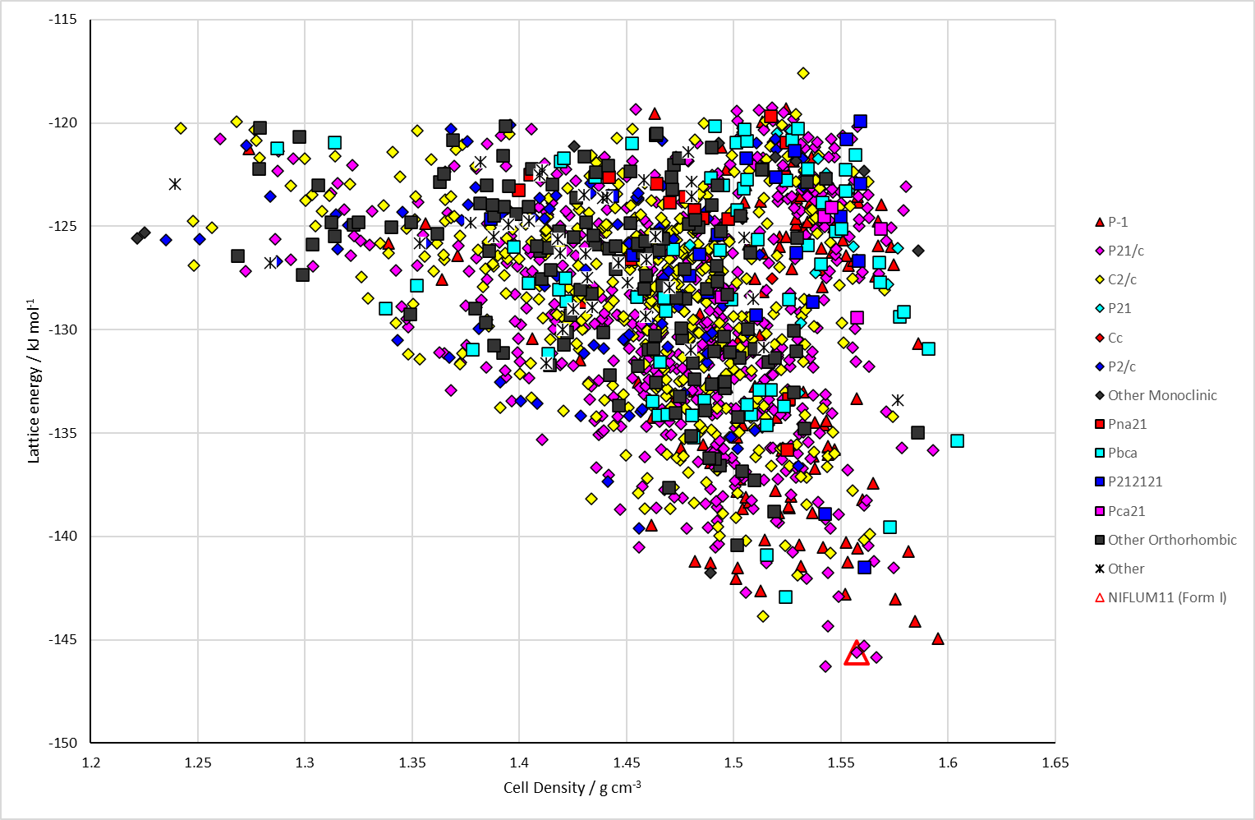

Figure . Crystal energy landscape of niflumic acid from previous work.

# CSD structures (CSD version 5.43 with Mar, Jun, Sep and Nov 2022 updates)

Table . Crystallographic information for CSD entries for niflumic acid.

|  |  |  |  |  |  |  |  |  |  |  |
| --- | --- | --- | --- | --- | --- | --- | --- | --- | --- | --- |
| REFCODE | space group | Z’ | a / Å | b / Å | c / Å | α / ° | β / ° | γ / ° | density / g cm-3 | Form |
| NIFLUM10 | P21/n | 1 | 5.11 | 15.33 | 15.48 | 90 | 95.50 | 90 | 1.55 | RT |
| NIFLUM11 | P21/n | 1 | 5.10 | 15.34 | 15.49 | 90 | 95.47 | 90 | 1.55 | RT |

Table . Experimental information for CSD entries for niflumic acid.

|  |  |  |  |  |  |
| --- | --- | --- | --- | --- | --- |
| REFCODE | space group | R factor | T / K | Year | Comments |
| NIFLUM10 | P21/n | 8.0 | RT | 1979 | Grown from a THF solution1 |
| NIFLUM11 | P21/n | 6.03 | RT | 2016 | Private communication |

Make this table include whether polymorphs are solution-grown, sublimation grown, templated or otherwise. Add references.

# Other notes

1. H. M. Krishna Murthy and M. Vijayan, *Acta Crystallographica Section B*, 1979, **35**, 262-263.