Fluorotoluenes

(Last updated 9 December 2024)



Figure . The molecular diagram of 2-, 3- and 4-fluorotoluene.

# CSP studies

MOLPAK searches were run, and structures minimized with the FIT potential. The .dmain and .sym files were then used to reminimize with the WILL01 potential or the FIT potential with various pressures. Structures were then checked for negative eigenvalues (with symmetry being reduced as necessary) and clustered, giving different crystal structures in the different landscapes.

The .sum files were edited to remove the PV term from the energies (to make them more compatible with the energies without pressure). The original energies are still recorded within the .sum files, but not uploaded to the database.

Hence the different energy models are not sequential, but all from the same (MOLPAK-generated) input files.

|  |  |
| --- | --- |
| REFCODE | YICFEX |
| Formula | C7 H7 F1 |
| Common Name | 2-fluorotoluene |
| IUPAC Systematic Name | 2-fluorotoluene |
| CSD Refcodes | YICFEX, YICFEX01 |
| Search Identifier | A |
| Scientist | Joe Ridout and Louise Price |
| Date | 2013 |
| Publication | No publication planned. |
| Energy Model | 1 |
| Study_ID | 0 |
| Programs | MOLPAK, DMACRYS (2.0.4) |
| Location on S Drive | CHEMISTRY_CPOSS\JoeRidout\2-fluorotoluene-FIT |
| Potential Description | GDMA(MP2/6-31G(d,p)) + FIT |
| Energy Model | 2 |
| Study_ID | 2 |
| Programs | Study_ID=0, unoptimized, DMACRYS (2.0.4) with 1 GPa |
| Location on S Drive | CHEMISTRY_CPOSS\JoeRidout\2-fluorotoluene-FIT1GPa |
| Potential Description | GDMA(MP2/6-31G(d,p)) + FIT, with pressure of 1.0 GPa |
| Energy Model | 3 |
| Study_ID | 3 |
| Programs | Study_ID=0, unoptimized, DMACRYS (2.0.4) with 2 GPa |
| Location on S Drive | CHEMISTRY_CPOSS\JoeRidout\2-fluorotoluene-FIT2GPa |
| Potential Description | GDMA(MP2/6-31G(d,p)) + FIT, with pressure of 2.0 GPa |
| Energy Model | 4 |
| Study_ID | 4 |
| Programs | Study_ID=0, unoptimized, DMACRYS (2.0.4) with 3 GPa |
| Location on S Drive | CHEMISTRY_CPOSS\JoeRidout\2-fluorotoluene-FIT3GPa |
| Potential Description | GDMA(MP2/6-31G(d,p)) + FIT, with pressure of 3.0 GPa |
| Energy Model | 5 |
| Study_ID | 5 |
| Programs | Study_ID=0, unoptimized, DMACRYS (2.0.4) with 4 GPa |
| Location on S Drive | CHEMISTRY_CPOSS\JoeRidout\2-fluorotoluene-FIT4GPa |
| Potential Description | GDMA(MP2/6-31G(d,p)) + FIT, with pressure of 4.0 GPa |
| Energy Model | 6 |
| Study_ID | 1 |
| Programs | Study_ID=0, unoptimized, DMACRYS (2.0.4) |
| Location on S Drive | CHEMISTRY_CPOSS\JoeRidout\2-fluorotoluene-WILL |
| Potential Description | GDMA(MP2/6-31G(d,p)) + Williams (with fluorine from FIT) |

|  |  |
| --- | --- |
| REFCODE | YICDUL |
| Formula | C7 H7 F1 |
| Common Name | 3-fluorotoluene |
| IUPAC Systematic Name | 3-fluorotoluene |
| CSD Refcodes | YICDUL, YICDUL01 |
| Search Identifier | A |
| Scientist | Joe Ridout and Louise Price |
| Date | 2013 |
| Publication | No publication planned. |
| Energy Model | 1 |
| Study_ID | 0 |
| Programs | MOLPAK, DMACRYS (2.0.4) |
| Location on S Drive | CHEMISTRY_CPOSS\JoeRidout\3-fluorotoluene-FIT |
| Potential Description | GDMA(MP2/6-31G(d,p)) + FIT |
| Energy Model | 2 |
| Study_ID | 2 |
| Programs | Study_ID=0, unoptimized, DMACRYS (2.0.4) with 1 GPa |
| Location on S Drive | CHEMISTRY_CPOSS\JoeRidout\3-fluorotoluene-FIT1GPa |
| Potential Description | GDMA(MP2/6-31G(d,p)) + FIT, with pressure of 1.0 GPa |
| Energy Model | 3 |
| Study_ID | 3 |
| Programs | Study_ID=0, unoptimized, DMACRYS (2.0.4) with 2 GPa |
| Location on S Drive | CHEMISTRY_CPOSS\JoeRidout\3-fluorotoluene-FIT2GPa |
| Potential Description | GDMA(MP2/6-31G(d,p)) + FIT, with pressure of 2.0 GPa |
| Energy Model | 4 |
| Study_ID | 4 |
| Programs | Study_ID=0, unoptimized, DMACRYS (2.0.4) with 3 GPa |
| Location on S Drive | CHEMISTRY_CPOSS\JoeRidout\3-fluorotoluene-FIT3GPa |
| Potential Description | GDMA(MP2/6-31G(d,p)) + FIT, with pressure of 3.0 GPa |
| Energy Model | 5 |
| Study_ID | 5 |
| Programs | Study_ID=0, unoptimized, DMACRYS (2.0.4) with 4 GPa |
| Location on S Drive | CHEMISTRY_CPOSS\JoeRidout\3-fluorotoluene-FIT4GPa |
| Potential Description | GDMA(MP2/6-31G(d,p)) + FIT, with pressure of 4.0 GPa |
| Energy Model | 6 |
| Study_ID | 6 |
| Programs | Study_ID=0, unoptimized, DMACRYS (2.0.4) with 0.1 GPa |
| Location on S Drive | CHEMISTRY_CPOSS\JoeRidout\3-fluorotoluene-FIT0.1GPa |
| Potential Description | GDMA(MP2/6-31G(d,p)) + FIT, with pressure of 0.1 GPa |

|  |  |
| --- | --- |
| REFCODE | YICDIZ |
| Formula | C7 H7 F1 |
| Common Name | 4-fluorotoluene |
| IUPAC Systematic Name | 4-fluorotoluene |
| CSD Refcodes | YICDIZ, YICDIZ01 |
| Search Identifier | A |
| Scientist | Joe Ridout and Louise Price |
| Date | 2013 |
| Publication | No publication planned. |
| Energy Model | 1 |
| Study_ID | 0 |
| Programs | MOLPAK, DMACRYS (2.0.4) |
| Location on S Drive | CHEMISTRY_CPOSS\JoeRidout\4-fluorotoluene-FIT |
| Potential Description | GDMA(MP2/6-31G(d,p)) + FIT |
| Energy Model | 2 |
| Study_ID | 2 |
| Programs | Study_ID=0, unoptimized, DMACRYS (2.0.4) with 1 GPa |
| Location on S Drive | CHEMISTRY_CPOSS\JoeRidout\4-fluorotoluene-FIT1GPa |
| Potential Description | GDMA(MP2/6-31G(d,p)) + FIT, with pressure of 1.0 GPa |
| Energy Model | 3 |
| Study_ID | 3 |
| Programs | Study_ID=0, unoptimized, DMACRYS (2.0.4) with 2 GPa |
| Location on S Drive | CHEMISTRY_CPOSS\JoeRidout\4-fluorotoluene-FIT2GPa |
| Potential Description | GDMA(MP2/6-31G(d,p)) + FIT, with pressure of 2.0 GPa |
| Energy Model | 4 |
| Study_ID | 4 |
| Programs | Study_ID=0, unoptimized, DMACRYS (2.0.4) with 3 GPa |
| Location on S Drive | CHEMISTRY_CPOSS\JoeRidout\4-fluorotoluene-FIT3GPa |
| Potential Description | GDMA(MP2/6-31G(d,p)) + FIT, with pressure of 3.0 GPa |
| Energy Model | 5 |
| Study_ID | 5 |
| Programs | Study_ID=0, unoptimized, DMACRYS (2.0.4) with 4 GPa |
| Location on S Drive | CHEMISTRY_CPOSS\JoeRidout\4-fluorotoluene-FIT4GPa |
| Potential Description | GDMA(MP2/6-31G(d,p)) + FIT, with pressure of 4.0 GPa |

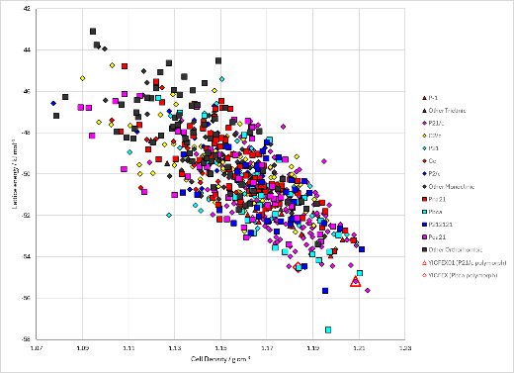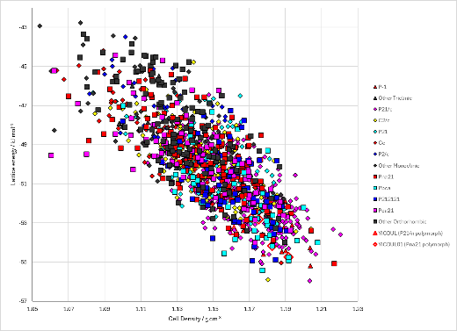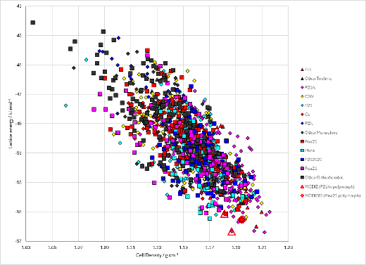

Figure . Crystal energy landscape of 2-fluorotoluene, 3-fluorotoluene and 4-fluorotoluene with the FIT potential and no applied pressure (energy model 1 in all cases) from previous work.

# CSD structures (CSD version 5.44 with Jun and Sep 2023 updates)

Table . Crystallographic information for CSD entries for 2-, 3- and 4-fluorotoluene. Different polymorphs are coloured differently.

|  |  |  |  |  |  |  |  |  |  |  |
| --- | --- | --- | --- | --- | --- | --- | --- | --- | --- | --- |
| REFCODE | space group | Z’ | a / Å | b / Å | c / Å | α / ° | β / ° | γ / ° | density / g cm-3 | Form |
| YICFEX | Pbca | 1 | 5.96 | 14.019 | 15.021 | 90 | 90 | 90 | 1.166 | Pbca |
| YICFEX01 | P21/n | 1 | 8.74 | 5.781 | 10.63 | 90 | 92.01 | 90 | 1.363 | P21/n |
| YICFEX02 | Pbca | 1 | 5.807 | 13.549 | 14.28 | 90 | 90 | 90 | 1.302 | Pbca |
| YICDUL | P21/n | 1 | 7.223 | 7.623 | 12.098 | 90 | 105.67 | 90 | 1.141 | P21/n |
| YICDUL01 | Pbca | 1 | 5.4526 | 13.538 | 14.735 | 90 | 90 | 90 | 1.345 | Pbca |
| YICDIZ | P21/n | 1 | 7.452 | 5.987 | 14.693 | 90 | 104 | 90 | 1.15 | P21/n |
| YICDIZ01 | Pna21 | 1 | 13.215 | 4.7872 | 8.9622 | 90 | 90 | 90 | 1.29 | Pna21 |
| YICDIZ02 | Pnma | 0.5 | 13.2486 | 8.9864 | 4.7937 | 90 | 90 | 90 | 1.282 | Pnma |
| YICDIZ03 | Pnma | 0.5 | 13.0915 | 8.8548 | 4.7275 | 90 | 90 | 90 | 1.335 | Pnma |
| YICDIZ04 | Pnma | 0.5 | 12.873 | 8.729 | 4.6135 | 90 | 90 | 90 | 1.411 |  |

Table . Experimental information for CSD entries for 2-, 3- and 4-fluorotoluene.

|  |  |  |  |  |  |
| --- | --- | --- | --- | --- | --- |
| REFCODE | space group | R factor | T / K | Year | Comments |
| YICFEX | Pbca | 4.77 | 205 | 2013 | Cooling pure liquid1 |
| YICFEX01 | P21/n | 7.47 | 296 | 2013 | Not described (but high pressure from table)1 |
| YICFEX02 | Pbca | 4.3 | 293 | 2013 | Compressing pure liquid1 |
| YICDUL | P21/n | 4.89 | 179 | 2013 | Cooling pure liquid1 |
| YICDUL01 | Pbca | 5.58 | 293 | 2013 | Pressure and temperature cycling in a diamond anvil cell and liquid nitrogen1 |
| YICDIZ | P21/n | 4.74 | 217 | 2013 | Cooling pure liquid1 |
| YICDIZ01 | Pna21 | 4.99 | 293 | 2013 | Compressing pure liquid1 |
| YICDIZ02 | Pnma | 5.56 | 295 | 2017 | 0.54 GPa. Compressing pure liquid2 |
| YICDIZ03 | Pnma | 7.09 | 295 | 2017 | 0.93 GPa. Compressing pure liquid2 |
| YICDIZ04 | Pnma | 7.01 | 295 | 2017 | 1.55 GPa. Compressing pure liquid2 |

# Other notes

1. J. Ridout and M. R. Probert, *Crystal Growth & Design*, 2013, **13**, 1943-1948.

2. S. Sutuła, R. Gajda and K. Woźniak, *Crystal Growth & Design*, 2017, **17**, 1493-1501.