5-fluorouracil

(Last updated 8 May 2024)



Figure . The molecular diagram of 5-fluorouracil.

# CSP studies

|  |  |
| --- | --- |
| REFCODE | FURACL |
| Formula | C4 H3 F1 N2 O2 |
| Common Name | Fluorouracil |
| IUPAC Systematic Name | 5-fluorouracil |
| Other Names | 2,4-dioxo-5-fluoropyrimidine, 5-fluoropyrimidine-2,4(1H,3H)-dione, 5-fluoro-2,4-pyrimidine dione |
| CSD Refcodes | FURACL01, FURACL03 |
| Search identifier | A |
| Scientist | Ashley Hulme (Weijia Zhu; Louise Price) |
| Date | 2005-7 |
| Publication | Barnett SA, Hulme AT, Issa N, Lewis TC, Price LS, Tocher DA, Price SL 2008. New J Chem 32-1761-1775. |
| Energy model | 1 |
| Study_ID | 0 |
| Programs | MOLPAK, DMAREL_3.0 |
| Location on S Drive | \CHEMISTRY_CPOSS\0-EarlySearches\home\louise_price.eminerals\fluorouracil |
| Potential Description | DMA + FIT + Williams F parameters |

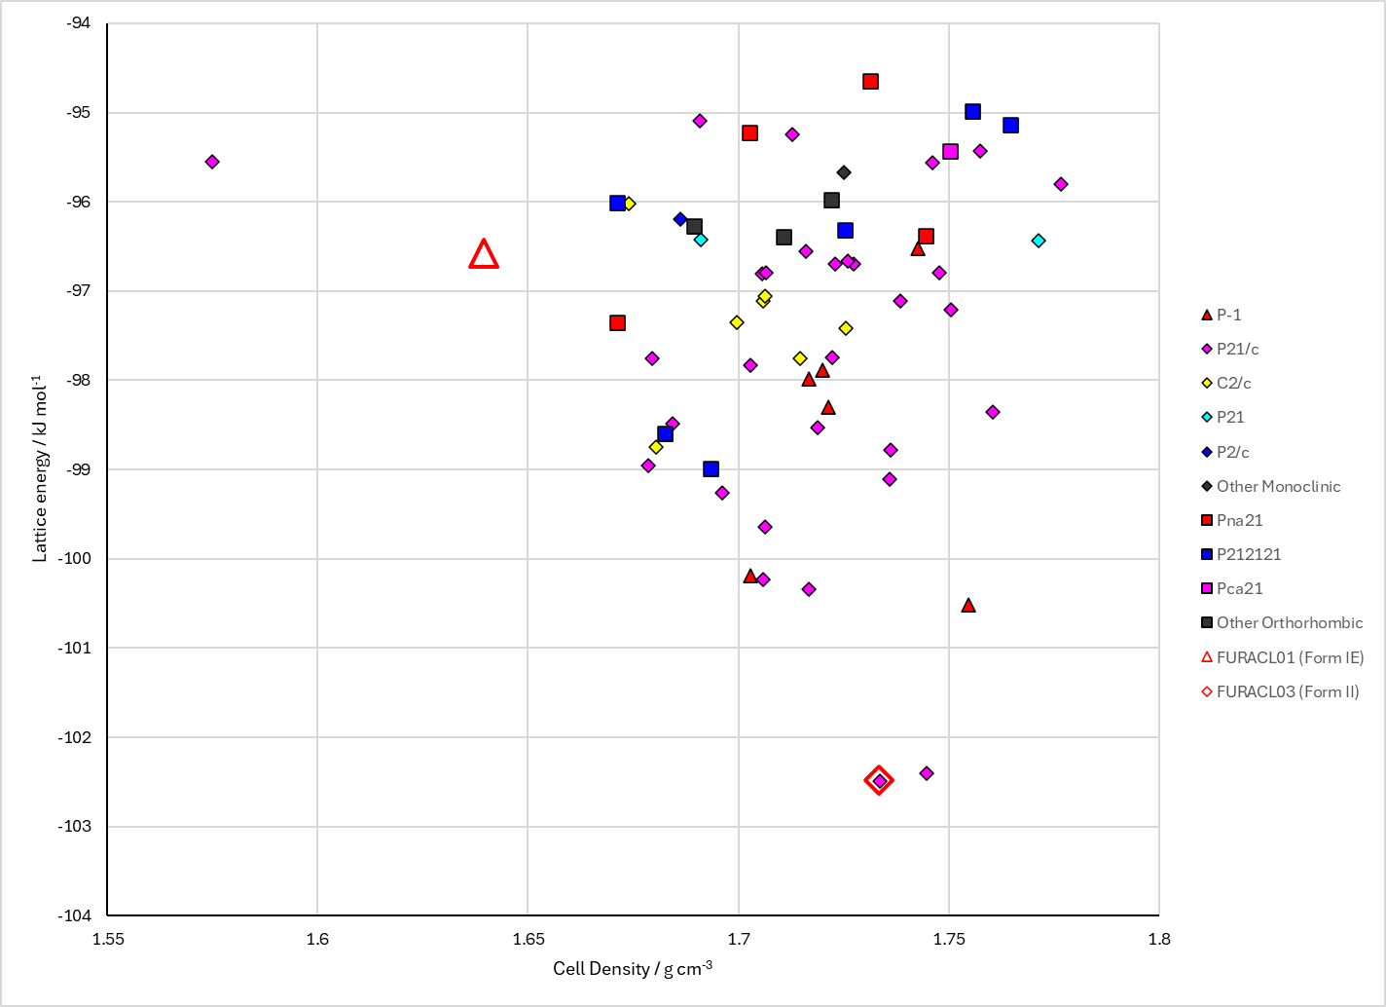

Figure . Crystal energy landscape of 5-fluorouracil from previous work.

# CSD structures (CSD version 5.45 with Mar 2024 updates)

Ashely measured a lot of unit cell dimensions and reported them in his paper. The CCDC decided to put them in as separate entries. Ashley was cross.

Table . Crystallographic information for CSD entries for 5-fluorouracil. Different polymorphs are coloured differently. Structures with no coordinates are omitted.

|  |  |  |  |  |  |  |  |  |  |  |
| --- | --- | --- | --- | --- | --- | --- | --- | --- | --- | --- |
| REFCODE | space group | Z’ | a / Å | b / Å | c / Å | α / ° | β / ° | γ / ° | density / g cm-3 | Form |
| FURACL | P-1 | 4 | 9.22 | 12.66 | 12.67 | 89.7 | 43.9 | 98.6 | 1.728 | 1 |
| FURACL01 | P-1 | 4 | 8.6329 | 9.156 | 12.5796 | 99.119 | 100.021 | 90.017 | 1.788 | 1 |
| FURACL02 | P21/c | 1 | 5.154 | 15.001 | 6.654 | 90 | 110.336 | 90 | 1.791 | 2 |
| FURACL03 | P21/c | 1 | 5.0433 | 14.935 | 6.6049 | 90 | 108.884 | 90 | 1.836 | 2 |
| FURACL14 | P-1 | 4 | 8.6224 | 9.1703 | 12.5769 | 99.34 | 100.163 | 90.303 | 1.79 | 1 |
| FURACL15 | P-1 | 4 | 8.7844 | 9.1992 | 12.642 | 81.319 | 80.615 | 89.234 | 1.734 | 1 |

Table . Experimental information for CSD entries for 5-fluorouracil.

|  |  |  |  |  |  |
| --- | --- | --- | --- | --- | --- |
| REFCODE | space group | R factor | T / K | Year | Comments |
| FURACL | P-1 | 9.2 | 295 | 1973 | Evaporation from aqueous solution1 |
| FURACL01 | P-1 | 4.91 | 150 | 2005 | The vast majority of crystallizations from the polymorph screen2 |
| FURACL02 | P21/c | 7.52 | 293 | 2005 | Solvent evaporation of a saturated solution in nitromethane2 |
| FURACL03 | P21/c | 5.44 | 150 | 2005 | Solvent evaporation of a saturated solution in nitromethane2 |
| FURACL14 | P-1 | 2.96 | 100 | 2012 | Evaporation from aqueous solution3 |
| FURACL15 | P-1 | 4.92 | 300 | 2020 | Recrystallized from distilled water4 |

Make this table include whether polymorphs are solution-grown, sublimation grown, templated or otherwise. Add references.

# Other notes

(1) Fallon Iii, L. The Crystal and Molecular Structure of 5-Fluorouracil. *Acta Crystallographica Section B - Structural Crystallography and Crystal Chemistry* **1973**, *29* (11), 2549-2556.

(2) Hulme, A. T.; Price, S. L.; Tocher, D. A. A New Polymorph of 5-Fluorouracil Found Following Computational Crystal Structure Predictions. *Journal of the American Chemical Society* **2005**, *127* (4), 1116-1117.

(3) Jarzembska, K. N.; Kubsik, M.; Kamiński, R.; Woźniak, K.; Dominiak, P. M. From a Single Molecule to Molecular Crystal Architectures: Structural and Energetic Studies of Selected Uracil Derivatives. *Crystal Growth & Design* **2012**, *12* (5), 2508-2524. DOI: 10.1021/cg300129z.

(4) Sasaki, T.; Miyamoto, Y.; Takamizawa, S. Strictly Regulated Two-Dimensional Slippage in a Lamellar Single Crystal of 5-Fluorouracil. *Crystal Growth & Design* **2020**, *20* (7), 4779-4782. DOI: 10.1021/acs.cgd.0c00535.