GSK269984B

(Last updated 18 March 2025)



Figure . The molecular diagram of GSK269984B.

# CSP studies

|  |  |
| --- | --- |
| REFCODE | BIFHOP |
| Formula | C20 H14 N1 O3 Cl2 F1 |
| Common Name | GSK Compound C |
| IUPAC Systematic Name | 6-[(5-Chloro-2-([(4-chloro-2-fluorophenyl)methyl]oxy)phenyl)methyl]-2-pyridinecarboxylic acid |
| Other Names |  |
| CSD Refcodes | BIFHOP |
|  |  |
| Search identifier | A |
| Scientist | Salima Ismail / Louise Price |
| Date | 2013 |
| Publication | See Study_ID=30 |
| Energy model | 1 |
| Study_ID | 0 |
| Programs | MOLPAK, DMACRYS (2.0.4) |
| Location on S Drive | \CHEMISTRY_CPOSS\GSK269984B\BIFHOP |
| Potential Description | GDMA2.2(MP2/6-31G**) + FIT |
|  |  |
| Search identifier | B |
| Scientist | Salima Ismail / Louise Price |
| Date | 2013 |
| Publication | See Study_ID=30 |
| Energy model | 1 |
| Study_ID | 1 |
| Programs | MOLPAK, DMACRYS (2.0.4) |
| Location on S Drive | \CHEMISTRY_CPOSS\GSK269984B\BIFHOP_Exp |
| Potential Description | GDMA2.2(MP2/6-31G**) + FIT |
|  |  |
| Search identifier | C |
| Scientist | Salima Ismail / Louise Price |
| Date | 2013 |
| Publication | Ismail SZ, Anderton CL, Copley RCB, Price LS, Price SL 2013. Cryst Growth Des 13, 2396-2406. |
| Energy model | 1 |
| Study_ID | 10 |
| Programs | Flexible CrystalPredictor (1.x), CrystalOptimizer (x), DMACRYS (2.0.4) |
| Location on S Drive | \CHEMISTRY_CPOSS\GSK269984B\CrystalOptimizer |
| Potential Description | CrystalOptimizer with GDMA2.2(PBE0/6-31G(d,p)) intermolecular optimization, PBE0/6-31G(d,p) intramolecular optimization + FIT |
| Energy model | 2 (published) |
| Study_ID | 30 |
| Programs | Study_ID=10, DMACRYS (2.0.4) |
| Location on S Drive | \CHEMISTRY_CPOSS\GSK269984B\BIFHOP_PCM |
| Potential Description | GDMA2.2(PCMdielectric3(PBE0/6-31G(d,p)) + FIT |
|  |  |
| Search identifier | D |
| Scientist | Luca Iuzzolino |
| Date | 2018 |
| Publication | Iuzzolino L, McCabe P, Price SL, Brandenburg JG, Faraday Discussions 2018, 211, 275-296. |
| Energy model | 1 (published) |
| Study_ID | 60 |
| Programs | Flexible CrystalPredictor (1.8), DFTB, DMACRYS (2.2.0.1) |
| Location on S Drive | \CHEMISTRY_CPOSS\LucasSearches\GSK_moleculeC |
| Potential Description | CrystalPredictor, followed by DFTB3-D3 refinement, followed by DMACRYS with GDMA2.2(PBE0/6-31G(d,p)) + FIT |

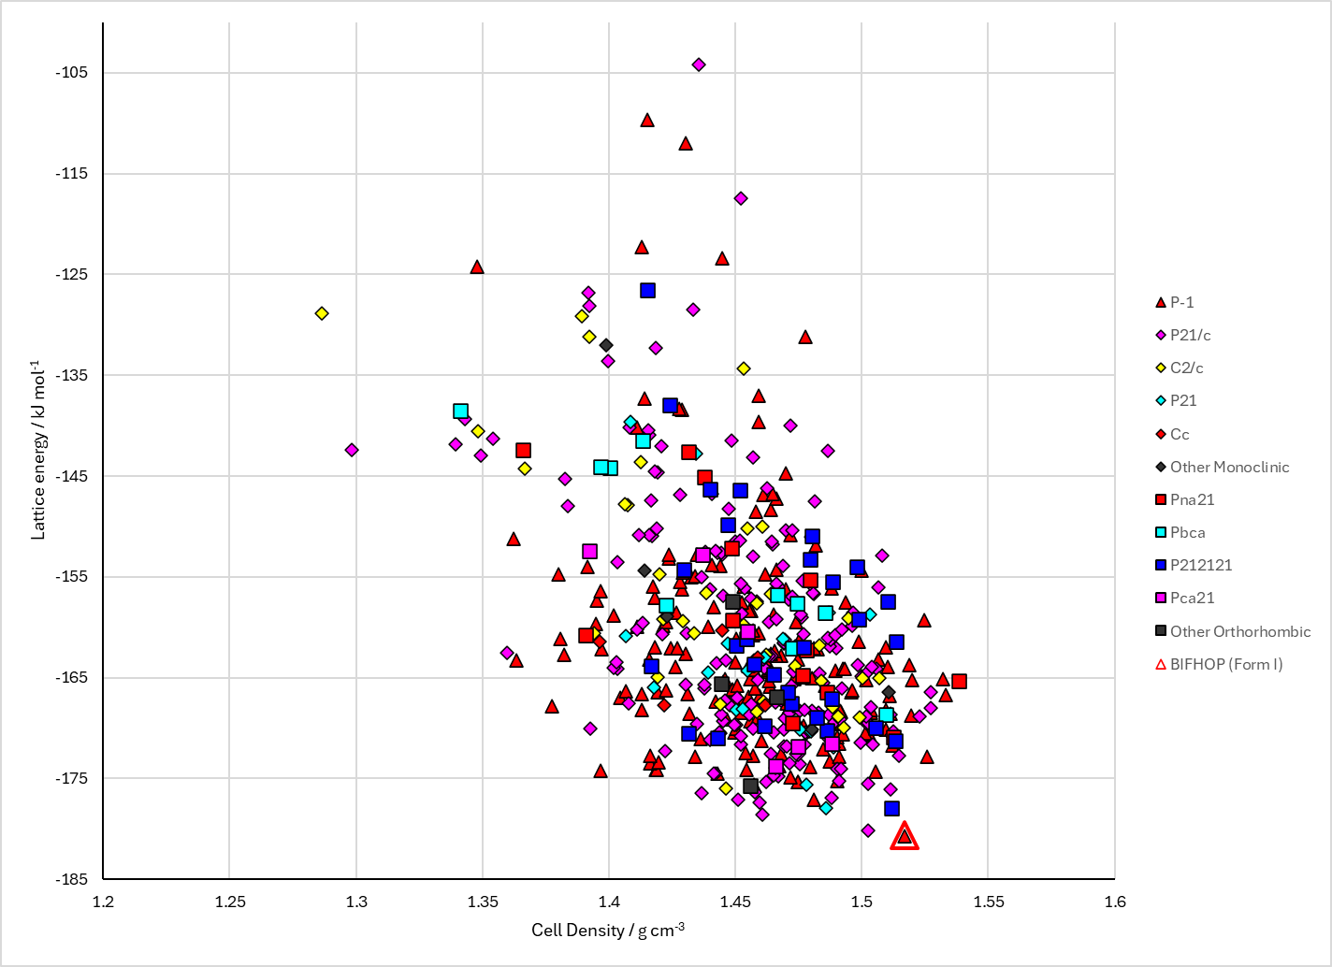

Figure . Crystal energy landscape of Search C Energy Model 2 of GSK269984B from previous work.

# CSD structures (CSD version 5.46 with Feb 2025 updates)

Table . Crystallographic information for CSD entries for GSK269984B.

|  |  |  |  |  |  |  |  |  |  |  |
| --- | --- | --- | --- | --- | --- | --- | --- | --- | --- | --- |
| REFCODE | space group | Z’ | a / Å | b / Å | c / Å | α / ° | β / ° | γ / ° | density / g cm-3 | Form |
| BIFHOP | P-1 | 1 | 7.854 | 7.972 | 16.033 | 81.02 | 77.28 | 66.56 | 1.506 | 1 |

Table . Experimental information for CSD entries for Saccharin.

|  |  |  |  |  |  |
| --- | --- | --- | --- | --- | --- |
| REFCODE | space group | R factor | T / K | Year | Comments |
| BIFHOP | P-1 | 3.84 | 150 | 2013 | “Form I was obtained from the majority of experiments including temperature cycling experiments in 42 out of 48 screening solvents and microemulsion crystallization”1 |

# Other notes

Search B.1 used conformational regions called 180A, 180B, 180I, 90A, 90B, 90I, 270A, 270B, 270I. To make things easier, and to allow these to form part of the structure name, these have been changed to AA, AB, AI, BA, BB, BI, CA, CB, CI.

Some structures from Search D had cell angles incompatible with the space group. These were C1s1450, C1s1939, C1s1019, C1s19, C1s51. These were edited to 90.0000.

1. S. Z. Ismail, C. L. Anderton, R. C. Copley, L. S. Price and S. L. Price, *Crystal Growth & Design*, 2013, **13**, 2396-2406.