Isonicotinamide

(Last updated 25 February 2025)



Figure 1. The molecular diagram of Isonicotinamide.

# CSP studies

|  |  |
| --- | --- |
| REFCODE | EHOWIH |
| Formula | C6 H6 N2 O1 |
| Common Name | Isonicotinamide |
| IUPAC Systematic Name | Pyridine-4-carboxylic acid amide |
| CSD Refcodes | EHOWIH, EHOWIH02, EHOWIH03, EHOWIH05, EHOWIH17 |
| Publication | No publication planned. |
|  |  |
| Search identifier | A |
| Scientist | Nizar Issa |
| Date | pre-2010 |
| Energy model | 1 |
| Study_ID | 0 |
| Programs | MOLPAK, DMAREL (4.1.1) |
| Location on S Drive | \CHEMISTRY_CPOSS\Isonicotinamide\MOLPAK |
| Potential Description | DMA + FIT |
|  |  |
| Search identifier | B |
| Scientist | Matthew Habgood |
| Date | 2010 |
| Energy model | 1 |
| Study_ID | 11 |
| Programs | Flexible CrystalPredictor (1.6), DMAFLEXquick (1.1), CrystalOptimizer (2.1), DMACRYS (2.0.8) |
| Location on S Drive | \CHEMISTRY_CPOSS\Isonicotinamide\CrystOpt_spli |
| Potential Description | CrystalOptimizer with 3 degrees of freedom, DMACRYS with splines and 15 A cutoff, GDMA2.2(PBE0/6-31G(d,p)) + FIT |
| Energy model | 2 |
| Study_ID | 30 |
| Programs | Study_ID=11, DMACRYS (2.0.4) |
| Location on S Drive | \CHEMISTRY_CPOSS\Isonicotinamide\PCM_spli |
| Potential Description | GDMA2.2(PCMdielectric3(PBE0/6-31G(d,p))) + FIT |
| Energy model | 3 |
| Study_ID | 10 |
| Programs | Flexible CrystalPredictor (1.6), DMAFLEXquick (1.1), CrystalOptimizer (2.1), DMACRYS (2.0.4) |
| Location on S Drive | \CHEMISTRY_CPOSS\Isonicotinamide\CrystOpt_nospli |
| Potential Description | CrystalOptimizer with 3 degrees of freedom, GDMA2.2(PBE0/6-31G(d,p)) + FIT |
| Energy model | 4 |
| Study_ID | 12 |
| Programs | Flexible CrystalPredictor (1.6), DMAFLEXquick (1.1), CrystalOptimizer (2.1), DMACRYS (2.0.8) |
| Location on S Drive | \CHEMISTRY_CPOSS\Isonicotinamide\CrystOpt_differentintra |
| Potential Description | CrystalOptimizer with 3 degrees of freedom, DMACRYS with splines and 15 A cutoff, GDMA2.2(PBE0/6-31G(d,p)) + FIT |
| Energy model | 5 |
| Study_ID | 13 |
| Programs | Flexible CrystalPredictor (1.6), DMAFLEXquick (1.1), CrystalOptimizer (2.1), DMACRYS (2.0.8) |
| Location on S Drive | \CHEMISTRY_CPOSS\Isonicotinamide\CrystOpt_bigbasissetDMA |
| Potential Description | CrystalOptimizer with 3 degrees of freedom, DMACRYS with splines and 15 A cutoff, GDMA2.2(PBE0/aug-cc-pVTZ) + FIT |

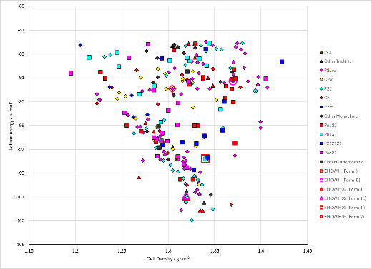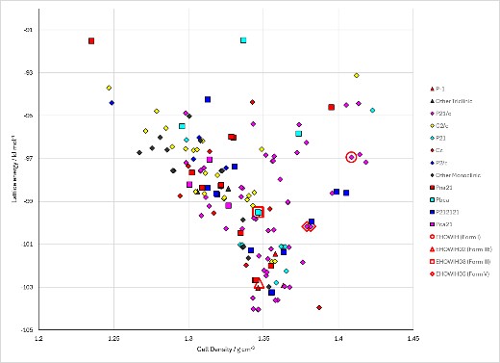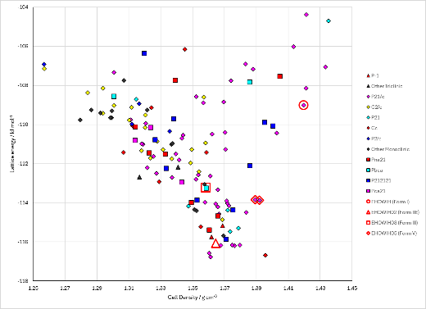

Figure 2. Crystal energy landscapes of Isonicotinamide from previous work. Left: Molpak search, middle: CrystOpt (with splines), right: PCM refinement of middle.

# CSD structures (CSD version 5.43 with Mar, Jun, Sep and Nov 2022 updates)

Table 1. Crystallographic information for CSD entries for XXX. Different polymorphs are coloured differently.

|  |  |  |  |  |  |  |  |  |  |  |
| --- | --- | --- | --- | --- | --- | --- | --- | --- | --- | --- |
| REFCODE | space group | Z’ | a / Å | b / Å | c / Å | α / ° | β / ° | γ / ° | density / g cm-3 | Form |
| EHOWIH | P21/c | 1 | 10.1664 | 5.7303 | 10.0329 | 90 | 98.169 | 90 | 1.402 | I |
| EHOWIH01 | P21/c | 1 | 10.1756 | 5.7319 | 10.034 | 90 | 98.042 | 90 | 1.4 | I |
| EHOWIH02 | P21/c | 2 | 15.735 | 7.9976 | 9.885 | 90 | 105.586 | 90 | 1.354 | II |
| EHOWIH03 | Pbca | 1 | 10.1603 | 7.3231 | 15.872 | 90 | 90 | 90 | 1.374 | III |
| EHOWIH04 | Pc | 3 | 11.0819 | 7.9976 | 9.985 | 90 | 94.048 | 90 | 1.378 | IV |
| EHOWIH05 | P21/c | 1 | 5.1923 | 9.466 | 12.259 | 90 | 91.217 | 90 | 1.347 | V |
| EHOWIH06 | Pca21 | 2 | 9.888 | 7.9929 | 15.162 | 90 | 90 | 90 | 1.354 | VI |
| EHOWIH07 | P21/c | 1 | 10.229 | 5.7538 | 10.095 | 90 | 97.277 | 90 | 1.376 | I |
| EHOWIH08 | P21/c | 1 | 9.599 | 5.6979 | 9.7492 | 90 | 103.402 | 90 | 1.564 | I |
| EHOWIH09 | P21/c | 1 | 9.629 | 5.7123 | 9.773 | 90 | 103.03 | 90 | 1.549 | I |
| EHOWIH10 | P21/c | 1 | 9.528 | 5.6786 | 9.709 | 90 | 104.08 | 90 | 1.592 | I |
| EHOWIH11 | P21/c | 1 | 9.4148 | 5.6817 | 9.6396 | 90 | 105.208 | 90 | 1.63 | I |
| EHOWIH12 | P21/c | 1 | 9.3656 | 5.6791 | 9.6213 | 90 | 105.642 | 90 | 1.646 | I |
| EHOWIH13 | P21/c | 1 | 9.3 | 5.6768 | 9.5955 | 90 | 106.32 | 90 | 1.668 |  |
| EHOWIH14 | P21/c | 1 | 9.2976 | 5.674 | 9.5819 | 90 | 106.29 | 90 | 1.672 |  |
| EHOWIH15 | P21/c | 1 | 9.2314 | 5.6679 | 9.5601 | 90 | 106.813 | 90 | 1.694 |  |
| EHOWIH16 | P21/c | 1 | 13.149 | 3.4103 | 10.173 | 90 | 93.11 | 90 | 1.781 |  |
| EHOWIH17 | P21/c | 1 | 13.177 | 3.4083 | 10.184 | 90 | 93.15 | 90 | 1.776 |  |

Forms II, IV and VI match 20 out of 20 molecules, but have different space groups.

Table 2. Experimental information for CSD entries for XXX.

|  |  |  |  |  |  |
| --- | --- | --- | --- | --- | --- |
| REFCODE | space group | R factor | T / K | Year | Comments |
| EHOWIH | P21/c | 3.64 | 153 | 2003 | Private communication, from methanol |
| EHOWIH01 | P21/c | 3.95 | 173 | 2003 | From nitrobenzene or nitromethane, [Do Polymorphic Compounds Make Good Cocrystallizing Agents? A Structural Case Study that Demonstrates the Importance of Synthon Flexibility | Crystal Growth & Design](https://pubs.acs.org/doi/10.1021/cg025593z) |
| EHOWIH02 | P21/c | 4.37 | 173 | 2003 | From a wide variety of other solvents, e.g., ethanol, water, tetrahydrofuran (THF), dioxane, etc., [Do Polymorphic Compounds Make Good Cocrystallizing Agents? A Structural Case Study that Demonstrates the Importance of Synthon Flexibility | Crystal Growth & Design](https://pubs.acs.org/doi/10.1021/cg025593z) |
| EHOWIH03 | Pbca | 4.53 | 173 | 2011 | Attempted cocrystallization with an anti-tubercular API, [New polymorphs of isonicotinamide and nicotinamide - Chemical Communications (RSC Publishing)](https://pubs.rsc.org/en/content/articlelanding/2011/cc/c0cc04117c) Some thermodynamic data is reported in this article. |
| EHOWIH04 | Pc | 3.52 | 100 | 2011 | Attempted cocrystallization with substituted 3-arylbutanoic acids in acetone. Three layers match form II, so these can be considered polytypes. [Expanding the crystal landscape of isonicotinamide: concomitant polymorphism and co-crystallisation - CrystEngComm (RSC Publishing)](https://pubs.rsc.org/en/content/articlelanding/2011/ce/c1ce06320k) |
| EHOWIH05 | P21/c | 3.73 | 300 | 2011 | Attempted cocrystallization with substituted 3-arylbutanoic acids in acetone. [Expanding the crystal landscape of isonicotinamide: concomitant polymorphism and co-crystallisation - CrystEngComm (RSC Publishing)](https://pubs.rsc.org/en/content/articlelanding/2011/ce/c1ce06320k) |
| EHOWIH06 | Pca21 | 5.32 | 173 | 2019 | Attempted cocrystallization with allopurinol in chloroform. [A new polymorph of the common coformer isonicotinamide - CrystEngComm (RSC Publishing)](https://pubs.rsc.org/en/content/articlelanding/2019/ce/c8ce01588k) |
| EHOWIH07 | P21/c | 4.19 | 298 | 2021 | Pressure-induced phase transformation. [Pressure-induced superelastic behaviour of isonicotinamide - Chemical Communications (RSC Publishing)](https://pubs.rsc.org/en/content/articlelanding/2021/cc/d1cc04692f) |
| EHOWIH08 | P21/c | 3.47 | 293 | 2021 | Pressure-induced phase transformation. [Pressure-induced superelastic behaviour of isonicotinamide - Chemical Communications (RSC Publishing)](https://pubs.rsc.org/en/content/articlelanding/2021/cc/d1cc04692f) |
| EHOWIH09 | P21/c | 3.79 | 296 | 2021 | Pressure-induced phase transformation. [Pressure-induced superelastic behaviour of isonicotinamide - Chemical Communications (RSC Publishing)](https://pubs.rsc.org/en/content/articlelanding/2021/cc/d1cc04692f) |
| EHOWIH10 | P21/c | 3.9 | 296 | 2021 | Pressure-induced phase transformation. [Pressure-induced superelastic behaviour of isonicotinamide - Chemical Communications (RSC Publishing)](https://pubs.rsc.org/en/content/articlelanding/2021/cc/d1cc04692f) |
| EHOWIH11 | P21/c | 3.64 | 296 | 2021 | Pressure-induced phase transformation. [Pressure-induced superelastic behaviour of isonicotinamide - Chemical Communications (RSC Publishing)](https://pubs.rsc.org/en/content/articlelanding/2021/cc/d1cc04692f) |
| EHOWIH12 | P21/c | 4.02 | 293 | 2021 | Pressure-induced phase transformation. [Pressure-induced superelastic behaviour of isonicotinamide - Chemical Communications (RSC Publishing)](https://pubs.rsc.org/en/content/articlelanding/2021/cc/d1cc04692f) |
| EHOWIH13 | P21/c | 4.68 | 293 | 2021 | Pressure-induced phase transformation. [Pressure-induced superelastic behaviour of isonicotinamide - Chemical Communications (RSC Publishing)](https://pubs.rsc.org/en/content/articlelanding/2021/cc/d1cc04692f) |
| EHOWIH14 | P21/c | 3.5 | 296 | 2021 | Pressure-induced phase transformation. [Pressure-induced superelastic behaviour of isonicotinamide - Chemical Communications (RSC Publishing)](https://pubs.rsc.org/en/content/articlelanding/2021/cc/d1cc04692f) |
| EHOWIH15 | P21/c | 3.87 | 296 | 2021 | Pressure-induced phase transformation. [Pressure-induced superelastic behaviour of isonicotinamide - Chemical Communications (RSC Publishing)](https://pubs.rsc.org/en/content/articlelanding/2021/cc/d1cc04692f) |
| EHOWIH16 | P21/c | 4.97 | 296 | 2021 | Pressure-induced phase transformation. [Pressure-induced superelastic behaviour of isonicotinamide - Chemical Communications (RSC Publishing)](https://pubs.rsc.org/en/content/articlelanding/2021/cc/d1cc04692f) |
| EHOWIH17 | P21/c | 4.52 | 296 | 2021 | Pressure-induced phase transformation. [Pressure-induced superelastic behaviour of isonicotinamide - Chemical Communications (RSC Publishing)](https://pubs.rsc.org/en/content/articlelanding/2021/cc/d1cc04692f) |

Make this table include whether polymorphs are solution-grown, sublimation grown, templated or otherwise. Add references.

# Other notes

The CrystalPredictor input files are in study_id=11. The files are currently still in /home/mh1/isonic/search_1/unique_pool/xxx-1 folders on cposs.

There were no matches to EHOWIH17 in any search, probably because it is a high pressure phase.