Phloroglucinol and hydrates

(Last updated 11 November 2024)



Figure . The molecular diagram of Phloroglucinol.

Phloroglucinol was studied by Doris Braun as part of a series of compounds which have hydrate and anhydrate crystal structures.

# CSP studies

|  |  |
| --- | --- |
| REFCODE | PHGLOL |
| Formula | C6 H6 O3 |
| Common Name | Phloroglucinol |
| IUPAC Systematic Name | 1,3,5-trihydroxybenzene |
| CSD Refcodes | PHGLOL01 |
| Search Identifier | A |
| Scientist | Doris Braun |
| Date | 2012 |
| Publication | Braun DE, Tocher DA, Price SL, Griesser UJ 2012. The Journal of Physical Chemistry B 116, 3961-3972. |
| Energy Model | 1 |
| Study_ID | 20 |
| Programs | Rigid CrystalPredictor, DMACRYS (2.0.2) |
| Location on S Drive | \CHEMISTRY_CPOSS\Phloroglucinol\Phloroglucinol_CP |
| Potential Description | CrystalPredictor GDMA2 (MP2/6-31G(d,p)) + FIT |
| Energy Model | 2 |
| Study_ID | 11 (published) |
| Programs | Study_ID=20, DMAflex (2.0), DMACRYS (1.1.1) |
| Location on S Drive | \CHEMISTRY_CPOSS\Phloroglucinol\Phloroglucinol_CO |
| Potential Description | CrystalOptimizer GDMA2 (MP2/6-31G(d,p)) + FIT |
| Scientist | Louise Price |
| Date | January 2024 |
| Energy Model | 2a |
| Study_ID | 12 |
| Programs | Study_ID=20, CrystalOptimizer (2.4.7.1), DMACRYS (2.3.1.1) |
| Location on S Drive | \CHEMISTRY_CPOSS\Phloroglucinol\Phloroglucinol_CO2 |
| Potential Description | CrystalOptimizer GDMA2 (MP2/6-31G(d,p)) + FIT |
| Energy Model | 3 |
| Study_ID | 30 |
| Programs | Study_ID=12, DMACRYS (2.3.1.1), BZ-averaged props |
| Location on S Drive | \CHEMISTRY_CPOSS\Phloroglucinol\Phloroglucinol_PCM |
| Potential Description | GDMA2.2(PCMdielectric3(MP2/6-31G(d,p))) + FIT |
|  |  |
| REFCODE | PHGLOH |
| Formula | C6 H6 O3 - 2(H2 O1) |
| Common Name | Phloroglucinol dihydrate |
| IUPAC Systematic Name | 1,3,5-trihydroxybenzene dihydrate |
| CSD Refcodes | PHGLOH02 (proton disordered) |
| Search Identifier | B |
| Scientist | Doris Braun |
| Date | 2012 |
| Publication | Braun DE, Tocher DA, Price SL, Griesser UJ 2012. J. Phys. Chem. B 116, 3961-3972. |
| Energy Model | 1 |
| Study_ID | 20 |
| Programs | Rigid CrystalPredictor (unknown), DMACRYS (2.0.2) |
| Location on S Drive | \CHEMISTRY_CPOSS\Phloroglucinol\Phloroglucinoldihydrate_CP |
| Potential Description | CrystalPredictor GDMA2 (MP2/6-31G(d,p)) (PBE1PBE/aug-cc-pvtz for water) + FIT |
| Energy Model | 2 |
| Study_ID | 10 |
| Programs | Study_ID=20, DMAflex (2.0), DMACRYS (1.1.1) |
| Location on S Drive | \CHEMISTRY_CPOSS\Phloroglucinol\Phloroglucinoldihydrate_CO |
| Potential Description | CrystalOptimizer GDMA2 (MP2/6-31G(d,p)) + FIT |

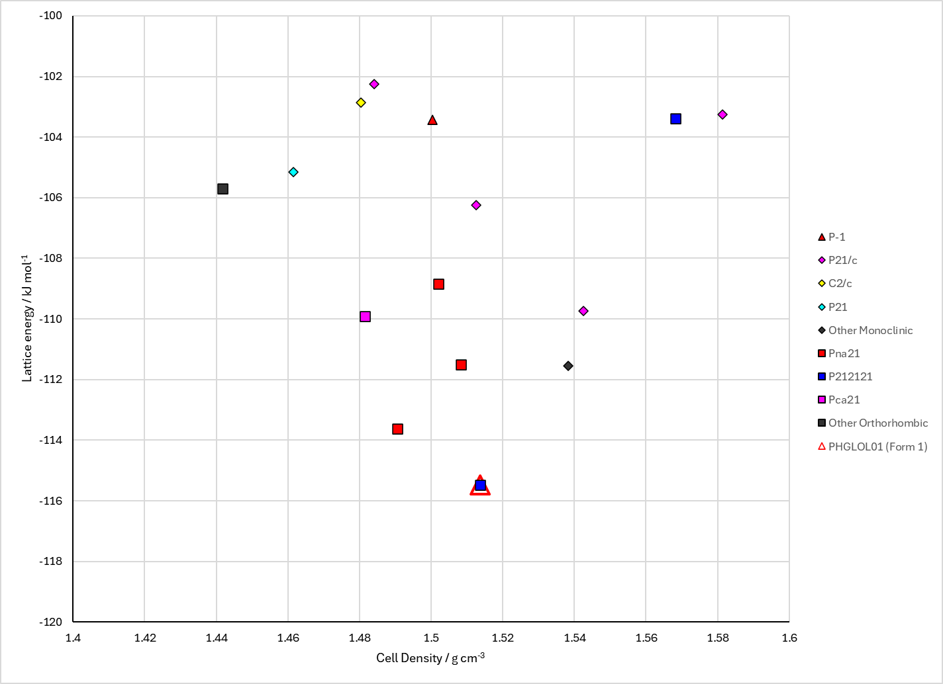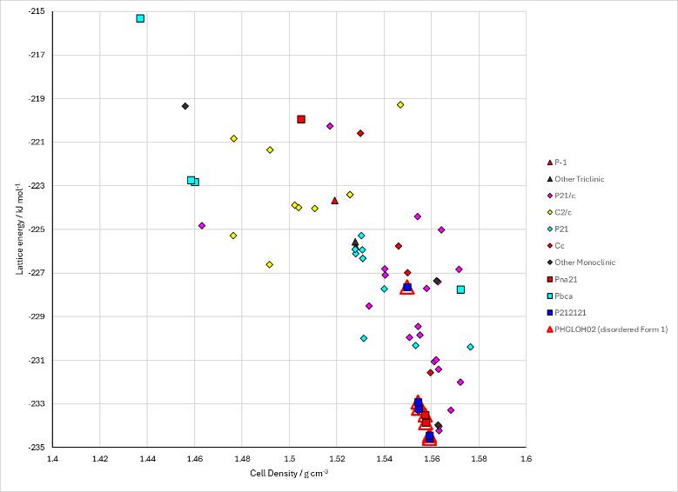

Figure . Crystal energy landscape of (left) phloroglucinol and (right) phloroglucinol dihydrate from previous work.

# CSD structures (CSD version 5.44 with Jun and Sep Nov 2023 updates)

Table . Crystallographic information for CSD entries for phloroglucinol. Different forms (including hydrates) are coloured differently.

|  |  |  |  |  |  |  |  |  |  |  |
| --- | --- | --- | --- | --- | --- | --- | --- | --- | --- | --- |
| REFCODE | space group | Z’ | a / Å | b / Å | c / Å | α / ° | β / ° | γ / ° | density / g cm-3 | Form |
| PHGLOH | Pnma | 0.5 | 6.73 | 13.58 | 8.09 | 90 | 90 | 90 | 1.457 | Dihydrate |
| PHGLOH01 | Pnma | 0.5 | 6.5841 | 13.5128 | 8.0382 | 90 | 90 | 90 | 1.506 | Dihydrate |
| PHGLOH02 | Pnma | 0.5 | 6.5942 | 13.5455 | 8.0423 | 90 | 90 | 90 | 1.499 | Dihydrate |
| PHGLOH03 | Pnma | 0.5 | 6.5876 | 13.517 | 8.0345 | 90 | 90 | 90 | 1.505 | Dihydrate |
| PHGLOH04 | Pnma | 0.5 | 6.6209 | 13.5606 | 8.0462 | 90 | 90 | 90 | 1.491 | Dihydrate |
| PHGLOL | P212121 | 1 | 4.83 | 9.37 | 12.56 | 90 | 90 | 90 | 1.474 | I |
| PHGLOL01 | P212121 | 1 | 4.7778 | 9.3581 | 12.4433 | 90 | 90 | 90 | 1.506 | I |

Table . Experimental information for CSD entries for phloroglucinol and phloroglucinol dihydrate.

|  |  |  |  |  |  |
| --- | --- | --- | --- | --- | --- |
| REFCODE | space group | R factor | T / K | Year | Comments |
| PHGLOH | Pnma | 23 | 295 | 1957 | Recrystallized from water.1 |
| PHGLOH01 | Pnma | 4.88 | 100 | 2009 | Hydrogen disorder. Private communication. |
| PHGLOH02 | Pnma | 3.57 | 100 | 2011 | Hydrogen disorder. Crystallization method not reported.2 |
| PHGLOH03 | Pnma | 4.63 | 100 | 2011 | Hydrogen disorder. Cocrystallization of 2,4,6-trihydroxybenzoic acid and benzamide (phloroglucinol is the main impurity in commercially available 2,4,6-trihydroxybenzoic acid).3 |
| PHGLOH04 | Pnma | 3.73 | 293 | 2012 | Hydrogen disorder. Slow cooling crystallization from water.4 |
| PHGLOL | P212121 | 7.5 | 295 | 1965 | Sublimation under vacuum.5 |
| PHGLOL01 | P212121 | 2.65 | 105 | 2008 | Crystallization method not reported.6 |

# Other notes

1. S. C. Wallwork and H. M. Powell, *Acta Crystallographica*, 1957, **10**, 48-52.

2. L. H. Thomas, G. A. Craig, C. A. Morrison, A. M. Reilly and C. C. Wilson, *Crystal Growth & Design*, 2011, **11**, 2045-2049.

3. C. C. Seaton and A. Parkin, *Crystal Growth & Design*, 2011, **11**, 1502-1511.

4. D. E. Braun, D. A. Tocher, S. L. Price and U. J. Griesser, *Journal of Physical Chemistry B*, 2012, **116**, 3961-3972.

5. K. Maartmann-Moe, *Acta Crystallographica*, 1965, **19**, 155-157.

6. C. H. Gorbitz, M. Kaboli, M. L. Read and K. Vestli, *Acta Crystallographica Section E*, 2008, **64**, o2023.