Phthalimide

(Last updated 20 June 2024)



Figure . The molecular diagram of Phthalimide.

# CSP studies

|  |  |
| --- | --- |
| REFCODE | PHALIM |
| Formula | C8 H5 N1 O2 |
| Common Name | Phthalimide |
| IUPAC Systematic Name | Isoindole-1,3-dione |
| CSD Refcodes | PHALIM |
| Search identifier | A |
| Scientist | Unknown |
| Date | 2006-10 |
| Publication | No publication planned. |
| Energy model | 1 |
| Study_ID | 0 |
| Programs | Molpak, DMAREL (4.1.1) |
| Location on S Drive | \CHEMISTRY_CPOSS\0-EarlySearches\home\louise_price.eminerals\phthalimide_fit_rigid |
| Potential Description | MP2 6-31G(d,p) DMA + fit.pots |

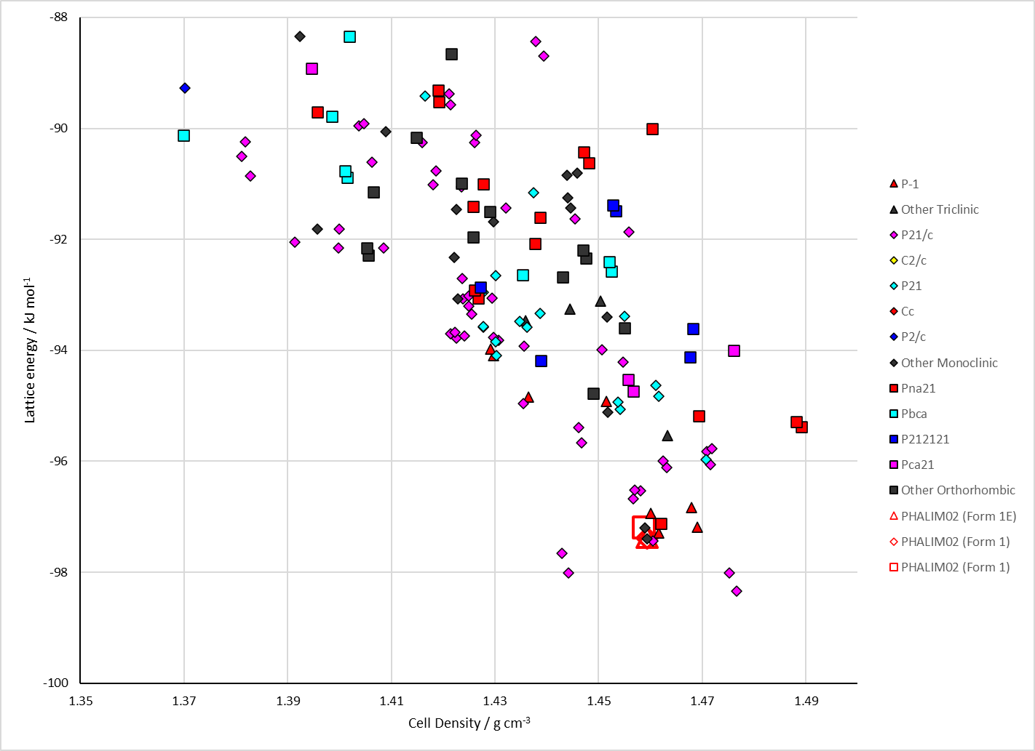

Figure . Crystal energy landscape of Phthalimide from previous work.

# CSD structures (CSD version 5.45 with Jun and Sep 2023 updates)

Table . Crystallographic information for CSD entries for Phthalimide. Different polymorphs are coloured differently.

|  |  |  |  |  |  |  |  |  |  |  |
| --- | --- | --- | --- | --- | --- | --- | --- | --- | --- | --- |
| REFCODE | space group | Z’ | a / Å | b / Å | c / Å | α / ° | β / ° | γ / ° | density / g cm-3 | Form |
| PHALIM | P21/n | 1 | 22.83 | 7.651 | 3.81 | 90 | 91.36 | 90 | 1.469 | 1 |
| PHALIM01 | P21/n | 1 | 3.8036 | 7.643 | 22.818 | 90 | 91.36 | 90 | 1.474 | 1 |
| PHALIM02 | P21/n | 1 | 3.7303 | 7.6638 | 22.6435 | 90 | 90.369 | 90 | 1.51 | 1 |
| PHALIM03 | P21/n | 1 | 3.7529 | 7.6619 | 22.694 | 90 | 90.617 | 90 | 1.498 | 1 |
| PHALIM04 | P21/n | 1 | 3.7194 | 7.6624 | 22.604 | 90 | 90.265 | 90 | 1.517 | 1 |
| PHALIM05 | P21/n | 1 | 3.808 | 7.6544 | 22.8625 | 90 | 91.38 | 90 | 1.467 | 1 |

Table . Experimental information for CSD entries for Phthalimide.

|  |  |  |  |  |  |
| --- | --- | --- | --- | --- | --- |
| REFCODE | space group | R factor | T / K | Year | Comments |
| PHALIM | P21/n | 7.2 | 295 | 1972 | “data collected from a large crystal of the mineral kladnoite” according to the 2002 paper (1972 paper was written in German) |
| PHALIM01 | P21/n | 3.8 | 295 | 1992 | No information given |
| PHALIM02 | P21/n | 4.29 | 120 | 2002 | Attempted crystallization of N,N′-dithiodiphthalimide from hot pyridine |
| PHALIM03 | P21/n | 3.29 | 173 | 2009 | Private communication |
| PHALIM04 | P21/n | 2.98 | 90 | 2015 | Private communication |
| PHALIM05 | P21/n | 4.71 | 293 | 2022 | Private communication |

# Other notes