Piracetam

(Last updated 4 December 2024)



Figure . The molecular diagram of piracetam.

# CSP studies

Harriott’s paper noted that the gas phase optimized conformation did not produce crystal structures that were energetically competitive. However, she did not store the intramolecular energy penalties in the .conf files (and the method was not consistent with the paper). Single point energies of each conformation (as extracted from a .res file) coupled with an unconstrained gas phase optimization starting from somewhere close to the conformation described in the paper gave intramolecular energies consistent with the information given in the SI. Hence the values and computational method from Harriott’s paper were added to the .conf files before reuploading.

|  |  |
| --- | --- |
| REFCODE | BISMEV |
| Formula | C6 H10 N2 02 |
| Common Name | Piracetam |
| IUPAC Systematic Name | 2-Oxo-1-pyrrolidinylacetamide |
| CSD Refcodes | BISMEV05, BISMEV11, BISMEV12, BISMEV04, BISMEV08 |
| Scientist | Harriott Nowell |
| Date | 2005 |
| Publication | Nowell H, Price SL, Acta Cryst B, 61, 558-568 (2005) |
| Study Identifier | A |
| Energy Model | 1 |
| Study_ID | 0 |
| Programs | MOLPAK, DMAREL (4.1.1) |
| Location on S Drive | CHEMISTRY_CPOSS\0-EarlySearches\home\louise_price.eminerals\piracetam |
| Potential Description | FIT |

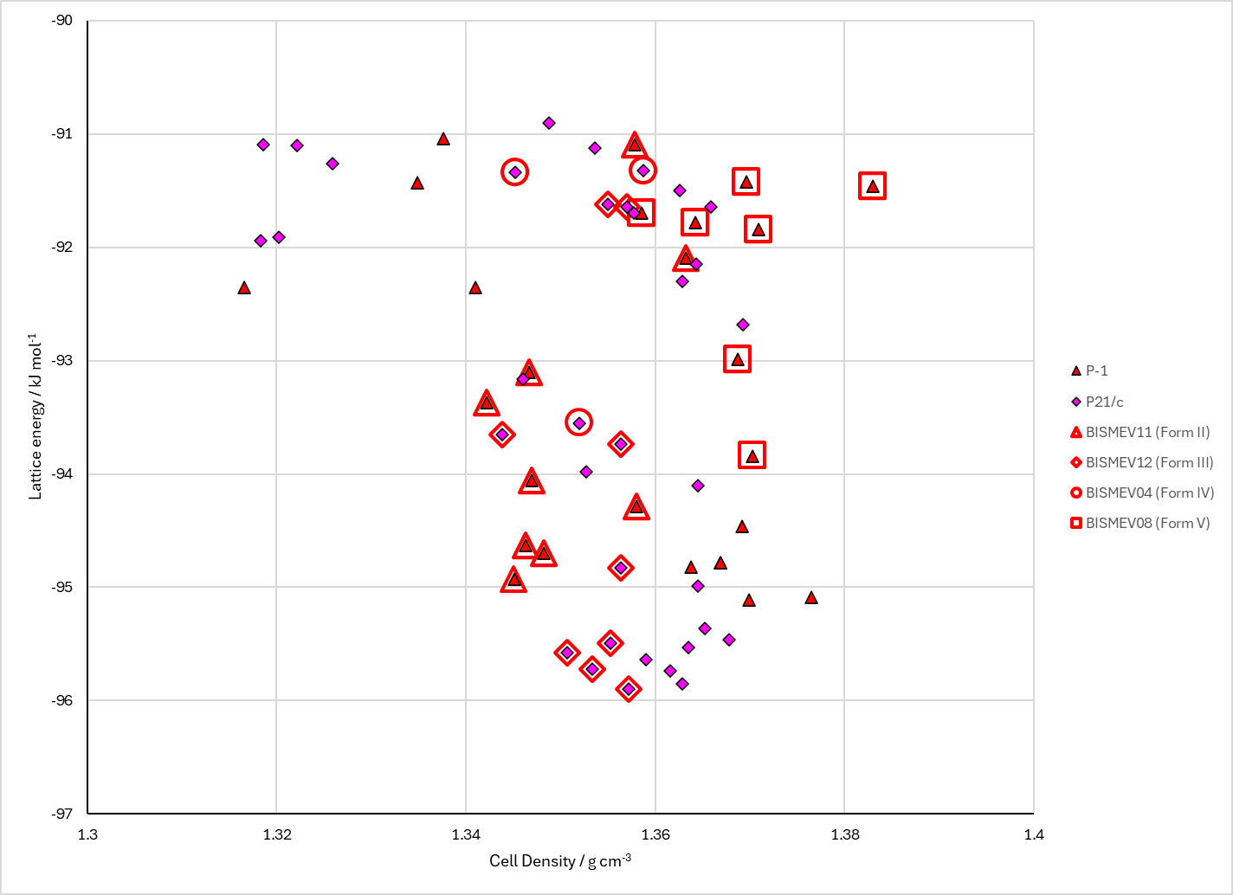

Figure . Crystal energy landscape of piracetam from previous work.

# CSD structures (CSD version 5.45 with Mar, Jun and Sep 2024 updates)

Table . Crystallographic information for CSD entries for piracetam. Different polymorphs are coloured differently.

|  |  |  |  |  |  |  |  |  |  |  |
| --- | --- | --- | --- | --- | --- | --- | --- | --- | --- | --- |
| REFCODE | space group | Z’ | a / Å | b / Å | c / Å | α / ° | β / ° | γ / ° | density / g cm-3 | Form |
| BISMEV | P-1 | 1 | 6.403 | 6.618 | 8.556 | 79.85 | 102.39 | 91.09 | 1.355 | II |
| BISMEV01 | P21/n | 1 | 6.525 | 6.44 | 16.463 | 90 | 92.19 | 90 | 1.366 | III |
| BISMEV02 | P21/n | 1 | 16.403 | 6.417 | 6.504 | 90 | 92.05 | 90 | 1.38 | III |
| BISMEV03 | P21/n | 1 | 6.747 | 13.418 | 8.09 | 90 | 99.01 | 90 | 1.305 | I |
| BISMEV04 | P21/c | 1 | 8.9537 | 5.4541 | 13.61 | 90 | 104.93 | 90 | 1.47 | IV |
| BISMEV05 | P21/n | 1 | 6.7254 | 13.2572 | 8.0529 | 90 | 98.603 | 90 | 1.33 | I |
| BISMEV06 | P-1 | 1 | 6.321 | 6.5597 | 8.38 | 79.82 | 102.34 | 90.94 | 1.413 | II |
| BISMEV07 | P-1 | 1 | 6.442 | 6.353 | 8.737 | 81.43 | 112.88 | 91.38 | 1.45 | V |
| BISMEV08 | P-1 | 1 | 6.3903 | 6.2932 | 8.645 | 81.106 | 113.68 | 91.295 | 1.502 | V |
| BISMEV09 | P-1 | 1 | 6.263 | 6.2063 | 8.412 | 80.77 | 114.69 | 91.12 | 1.612 | V |
| BISMEV10 | P-1 | 1 | 6.169 | 6.1602 | 8.287 | 80.41 | 115.33 | 91.15 | 1.685 | V |
| BISMEV11 | P-1 | 1 | 6.353 | 6.5278 | 8.3716 | 80.297 | 78.226 | 89.048 | 1.409 | II |
| BISMEV12 | P21/n | 1 | 6.4539 | 6.3857 | 16.1814 | 90 | 92.057 | 90 | 1.417 | P21/n |
| BISMEV13 | P21/n | 1 | 6.503 | 6.418 | 16.416 | 90 | 92.087 | 90 | 1.379 | III |
| BISMEV14 | P21 | 2 | 6.505 | 6.418 | 16.423 | 90 | 92.17 | 90 | 1.378 | III |

Table . Experimental information for CSD entries for piracetam.

|  |  |  |  |  |  |
| --- | --- | --- | --- | --- | --- |
| REFCODE | space group | R factor | T / K | Year | Comments |
| BISMEV | P-1 | 5.8 | 295 | 1982 | Slow cooling of a saturated solution in 2-propanol. Concomitant with BISMEV011 |
| BISMEV01 | P21/n | 6.4 | 295 | 1982 | Slow cooling of a saturated solution in 2-propanol. Concomitant with BISMEV1 |
| BISMEV02 | P21/n | 4.9 | 295 | 1983 | Not available online |
| BISMEV03 | P21/n | 3 | 295 | 1995 | From powder. From mixed triclinic and monoclinic phases (BISMEV and BISMEV01?), sample heated to 410 K and quenched to room temperature.2 |
| BISMEV04 | P21/c | 5.26 | 293 | 2005 | 6 M aqueous solution of piracetam loaded into diamond anvil cell. Pressurised to 0.4 GPa, when microcrystals appeared. Temperature cycling around 323 K and cooling to 293 K gave single crystal. Data collection within he diamond anvil cell under pressure.3 |
| BISMEV05 | P21/n | 4.19 | 150 | 2005 | Disorder in ring. Heating to 400 K, cooling to 298 K, coating with oil and rapidly cooling to 150 K.3 |
| BISMEV06 | P-1 | 11.49 | 293 | 2007 | Synchrotron @ 0.45 GPa. Slow evaporation of saturated solutions in either 2-propanol or 1,4-dioxane.4 |
| BISMEV07 | P-1 | 8.81 | 293 | 2007 | Synchrotron @ 0.7 GPa. Pressurizing Form II in DAC.4 |
| BISMEV08 | P-1 | 8.01 | 293 | 2007 | Synchrotron @ 0.9 GPa. Pressurizing Form II in DAC.4 |
| BISMEV09 | P-1 | 8.82 | 293 | 2007 | Synchrotron @ 2.5 GPa. Pressurizing Form II in DAC.4 |
| BISMEV10 | P-1 | 9.15 | 293 | 2007 | Synchrotron @ 4.0 GPa. Pressurizing Form II in DAC.4 |
| BISMEV11 | P-1 | 2.27 | 100 | 2011 | Slow evaporation of supersaturated solutions in 2-propanol.5 |
| BISMEV12 | P21/n | 2.59 | 100 | 2011 | Slow evaporation of supersaturated solutions in methanol.5 |
| BISMEV13 | P21/n | 3.45 | 290 | 2011 | Slow evaporation in a solution of dichloromethane.6 |
| BISMEV14 | P21 | 10.91 | 298 | 2015 | Synchrotron. From methanol solution (something about chips).7 |

# Other notes

Sally met someone somewhere who has a new form. They will contact me at some stage.

1. G. Admiraal, J. C. Eikelenboom and A. Vos, *Acta Crystallographica Section B-Structural Science*, 1982, **38**, 2600-2605.

2. D. Louer, M. Louer, A. V. Dzyabchenko, V. Agafonov and R. Ceolin, *Acta Crystallographica Section B - Structural Science*, 1995, **51**, 182-187.

3. F. P. A. Fabbiani, D. R. Allan, S. Parsons and C. R. Pulham, *CrystEngComm*, 2005, **7**, 179-186.

4. F. P. A. Fabbiani, D. R. Allan, W. I. F. David, A. J. Davidson, A. R. Lennie, S. Parsons, C. R. Pulham and J. E. Warren, *Crystal Growth & Design*, 2007, **7**, 1115-1124.

5. M.-H. Chambrier, N. Bouhmaida, F. Bonhomme, S. Lebègue, J.-M. Gillet, C. Jelsch and N. E. Ghermani, *Crystal Growth & Design*, 2011, **11**, 2528-2539.

6. A. Tilborg, D. Jacquemin, B. Norberg, E. Perpete, C. Michaux and J. Wouters, *Acta Crystallographica Section B*, 2011, **67**, 499-507.

7. E. M. Horstman, S. Goyal, A. Pawate, G. Lee, G. G. Z. Zhang, Y. Gong and P. J. A. Kenis, *Crystal Growth & Design*, 2015, **15**, 1201-1209.