Saccharin

(Last updated 11 January 2024)



Figure . The molecular diagram of Saccharin.

# CSP studies

|  |  |
| --- | --- |
| REFCODE | SCCHRN |
| Formula | C7 H5 N1 O3 S1 |
| Common Name | Saccharine |
| IUPAC Systematic Name | 1,2-Benzothiazol-3(2H)-one 1,1-dioxide |
| Other Names | o-Sulfobenzoimide |
| CSD Refcodes | SCCHRN02 |
| Search identifier | A |
| Scientist | Merina Corpinot (Rui Guo/Louise Price) |
| Date | 2015 |
| Publication | Corpinot M, Guo R, Tocher DA, Buanz A, Gaisford S, Price SL, Bucar DK, 2017, Cryst. Growth Des. 17, 827-833. |
| Energy model | 1 |
| Study_ID | 0 |
| Programs | Molpak, DMACRYS (2.0.8b) |
| Location on S Drive | \CHEMISTRY_CPOSS\Saccharin |
| Potential Description | GDMA2.2(PBE1PBE/6-31G(d,p)) + FIT + Scheraga's SO2 parameters |

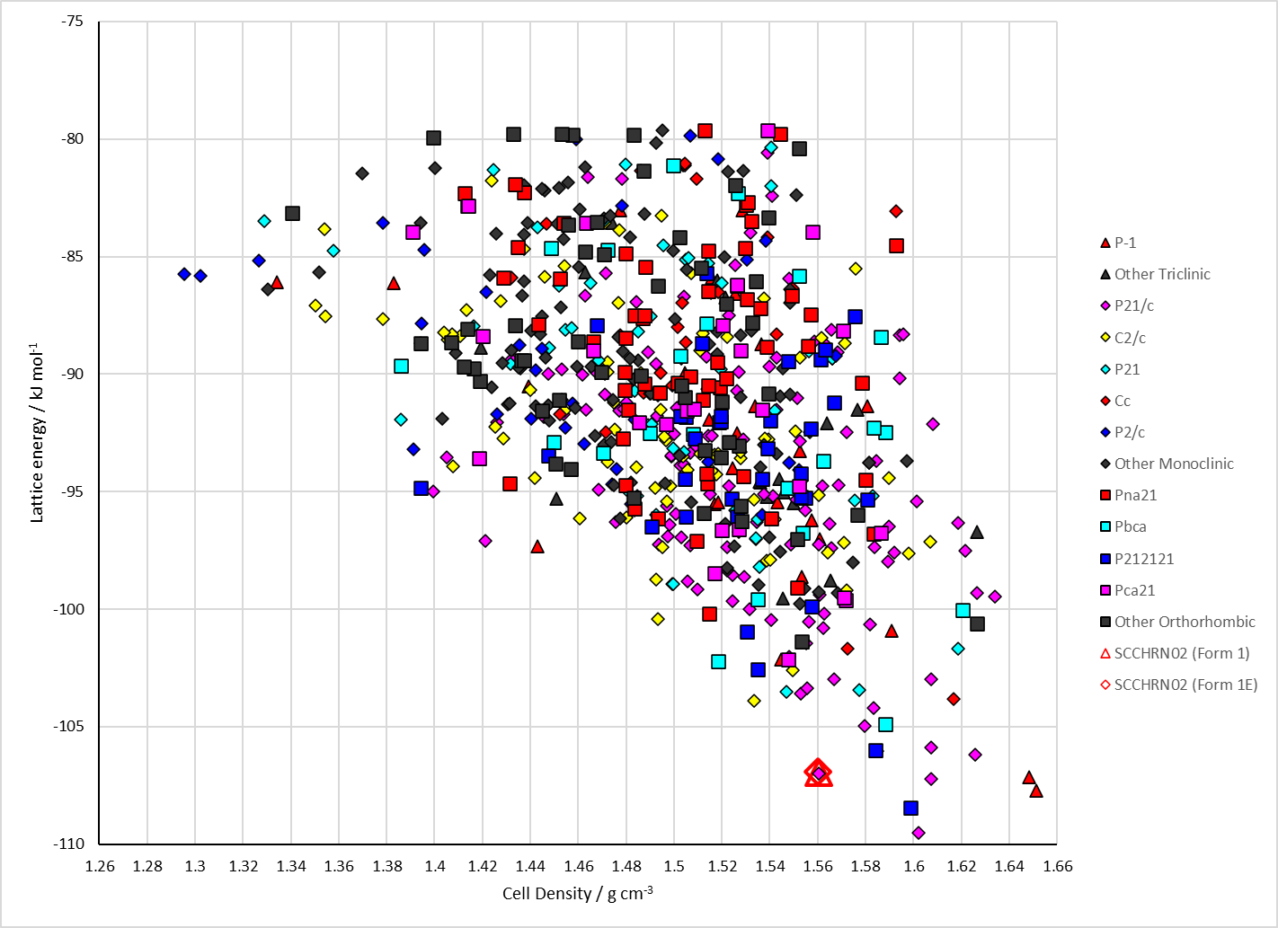

Figure . Crystal energy landscape of Saccharin from previous work.

# CSD structures (CSD version 5.44 with Jun and Sep 2023 updates)

Table . Crystallographic information for CSD entries for Saccharin. Different polymorphs are coloured differently.

|  |  |  |  |  |  |  |  |  |  |  |
| --- | --- | --- | --- | --- | --- | --- | --- | --- | --- | --- |
| REFCODE | space group | Z’ | a / Å | b / Å | c / Å | α / ° | β / ° | γ / ° | density / g cm-3 | Form |
| SCCHRN | P21/c | 1 | 9.563 | 6.913 | 11.822 | 90 | 103.85 | 90 | 1.603 | 1 |
| SCCHRN01 | P21/c | 1 | 9.552 | 6.919 | 11.803 | 90 | 103.9 | 90 | 1.607 | 1 |
| SCCHRN02 | P21/c | 1 | 9.4722 | 6.9227 | 11.7322 | 90 | 103.203 | 90 | 1.624 | 1 |
| SCCHRN03 | P21/c | 1 | 9.583 | 6.9252 | 11.8518 | 90 | 103.815 | 90 | 1.593 | 1 |
| SCCHRN04 | P21/c | 1 | 9.6083 | 6.9347 | 11.882 | 90 | 103.834 | 90 | 1.583 | 1 |
| SCCHRN05 | P21/c | 1 | 9.6083 | 6.9347 | 11.882 | 90 | 103.834 | 90 | 1.583 | 1 |
| SCCHRN06 | P21/c | 1 | 9.4632 | 6.9261 | 11.7063 | 90 | 103.115 | 90 | 1.628 | 1 |
| SCCHRN07 | P21/c | 1 | 9.444 | 6.921 | 11.684 | 90 | 103.05 | 90 | 1.635 | 1 |

Table . Experimental information for CSD entries for Saccharin.

|  |  |  |  |  |  |  |
| --- | --- | --- | --- | --- | --- | --- |
| REFCODE | space group | R factor | T / K | Year | Comments | Crystallization conditions |
| SCCHRN | P21/c | 5.2 | RT | 1968 | x-coordinate of O3 is incorrect | Slow evaporation from ethanol1 |
| SCCHRN01 | P21/c | 5.0 | RT | 1969 | y-coordinate of H1 is incorrect | Obtained from an ethyl alcohol solution2 |
| SCCHRN02 | P21/c | 3.87 | 120 | 2005 |  | Grown from an ethanol solution3 |
| SCCHRN03 | P21/c | 3.08 | RT | 2011 |  | Not reported4 |
| SCCHRN04 | P21/c | 3.86 | RT | 2011 | Correct structure solution | Not reported4 |
| SCCHRN05 | P21/c | 5.93 | RT | 2011 | Incorrect structure solution (undergraduate demonstration) | Not reported4 |
| SCCHRN06 | P21/c | 3.1 | 120 | 2016 | Private communication | Not reported |
| SCCHRN07 | P21/c | 2.21 | 150 | 2016 |  | Slow evaporation from acetone5 |

Make this table include whether polymorphs are solution-grown, sublimation grown, templated or otherwise. Add references.

# Other notes

1. J. C. J. Bart, *Journal of the Chemical Society B: Physical Organic*, 1968, 376-382.

2. Y. Okaya, *Acta Crystallographica*, 1969, **B**, 2257-2263.

3. J. L. Wardell, J. N. Low and C. Glidewell, *Acta Crystallographica Section E-Structure Reports Online*, 2005, **61**, O1944-O1946.

4. K. S. Eccles, S. P. Stokes, C. A. Daly, N. M. Barry, S. P. McSweeney, D. J. O'Neill, D. M. Kelly, W. B. Jennings, O. M. Ni Dhubhghaill, H. A. Moynihan, A. R. Maguire and S. E. Lawrence, *Journal of Applied Crystallography*, 2011, **44**, 213-215.

5. J. J. Du, L. Váradi, P. A. Williams, P. W. Groundwater, J. Overgaard, J. A. Platts and D. E. Hibbs, *RSC Advances*, 2016, **6**, 81578-81590.