Succinic Acid

(Last updated 29 October 2024)



Figure . The molecular diagram of succinic acid.

Nizar’s search wasn’t clustered. I am currently doing this. Otherwise, there will be >100 structures matching SUCACB03!

# CSP studies

Two sets of searches were carried out by Louise Price, one of which was written up in the publication on the gamma form.1 The difference between these searches was in the method of generating the database of LAM points for the CrystalPredictor search. The published search is called search A and the unpublished search is called search B.

A further search was caried out by Luca Iuzzolino as part of his PhD work on the CCDC’s Conformer Generator tool.2 This was not included in the paper though. This search is called C.

Early work was also carried out by Nizar Issa as part of his work on cocrystals of succinic acid.3 This search is called D, and included Z’=1 and Z’=2 searches with the planar conformation only.

|  |  |
| --- | --- |
| REFCODE | SUCACB |
| Formula | C4 H6 O4 |
| Common Name | Succinic Acid |
| IUPAC Systematic Name | Butanedioic acid |
| CSD Refcodes | SUCACB03, SUCACB07, SUCACB10, SUCACB19 |
|  |  |
| Search Identifier | A |
| Scientist | Louise Price |
| Date | 2018 |
| Publication | P Lucaioli, E Nauha, I Gimondi, LS Price, R Guo, L Iuzzolino, I Singh, M Salvalaglio, SL Price, N Blagden, CrystEngComm 2018, 20, 3971-3977. |
| Energy Model | 2 |
| Study_ID | 13 (published) |
| Programs | Study_ID=23, CrystalOptimizer (2.4.4), DMACRYS (2.2.1.0) |
| Location on S Drive | \CHEMISTRY_CPOSS\SuccinicAcid\CrystalOptimizer_bestLAM |
| Potential Description | CrystalOptimizer with GDMA2.2(PBE1PBE/6-31G(d,p)) + FIT |
| Energy Model | 1 |
| Study_ID | 23 |
| Programs | Flexible CrystalPredictor (2.2), DMACRYS (2.2.1.0) |
| Location on S Drive | \CHEMISTRY_CPOSS\SuccinicAcid\CrystalPredictor_bestLAM |
| Potential Description | CrystalPredictor + DMACRYS with GDMA2.2(PBE1PBE/6-31G(d,p)) + FIT |
| Energy Model | 3 |
| Study_ID | 33 |
| Programs | Study_ID=13, DMACRYS (2.2.0.1) |
| Location on S Drive | \CHEMISTRY_CPOSS\SuccinicAcid\PCM_bestLAM |
| Potential Description | GDMA2.2(PCMdielectric3(PBE1PBE/6-31G(d,p))) + FIT |
| Study_ID | 43 |
| Programs | Study_ID=13, DMACRYS (2.2.0.1), BZ-averaged props |
| Location on S Drive | \CHEMISTRY_CPOSS\SuccinicAcid\PCM_bestLAM_BZa |
| Potential Description | BZ-averaged GDMA2.2(PCMdielectric3(PBE1PBE/6-31G(d,p))) + FIT |
|  |  |
| Search Identifier | B |
| Scientist | Louise Price |
| Date | 2018 |
| Energy Model | 2 |
| Study_ID | 12 |
| Programs | Study_ID=22, CrystalOptimizer (2.4.4), DMACRYS (2.2.1.0) |
| Location on S Drive | \CHEMISTRY_CPOSS\SuccinicAcid\CrystalOptimizer_Uintra0 |
| Potential Description | CrystalOptimizer with GDMA2.2(PBE1PBE/6-31G(d,p)) + FIT |
| Energy Model | 1 |
| Study_ID | 22 |
| Programs | Flexible CrystalPredictor (2.2), DMACRYS (2.2.1.0) |
| Location on S Drive | \CHEMISTRY_CPOSS\SuccinicAcid\CrystalPredictor_Uintra0 |
| Potential Description | CrystalPredictor + DMACRYS with GDMA2.2(PBE1PBE/6-31G(d,p)) + FIT |
| Energy Model | 3 |
| Study_ID | 32 |
| Programs | Study_ID=12, DMACRYS (2.2.0.1) |
| Location on S Drive | \CHEMISTRY_CPOSS\SuccinicAcid\PCM_Uintra0 |
| Potential Description | GDMA2.2(PCMdielectric3(PBE1PBE/6-31G(d,p))) + FIT |
| Study_ID | 42 |
| Programs | Study_ID=12, DMACRYS (2.2.0.1), BZ-averaged props |
| Location on S Drive | \CHEMISTRY_CPOSS\SuccinicAcid\PCM_Uintra0_BZa |
| Potential Description | BZ-averaged GDMA2.2(PCMdielectric3(PBE1PBE/6-31G(d,p))) + FIT |
|  |  |
| Search Identifier | C |
| Scientist | Luca Iuzzolino |
| Date | 2018 |
| Energy Model | 1 |
| Study_ID | 11 |
| Programs | Rigid CrystalPredictor (unknown), CrystalOptimizer (2.4.4), DMACRYS (2.2.1.0) |
| Location on S Drive | \CHEMISTRY_CPOSS\SuccinicAcid\Conformer_Generator\CrystalOptimizer |
| Potential Description | CrystalOptimizer with GDMA2.2(PBE1PBE/6-31G(d,p)) + FIT |
| Energy Model | 2 |
| Study_ID | 31 |
| Programs | Study_ID=11, DMACRYS (2.2.1.0) |
| Location on S Drive | \CHEMISTRY_CPOSS\SuccinicAcid\Conformer_Generator\PCM |
| Potential Description | GDMA2.2(PCMdielectric3(PBE1PBE/6-31G(d,p))) + FIT |
|  |  |

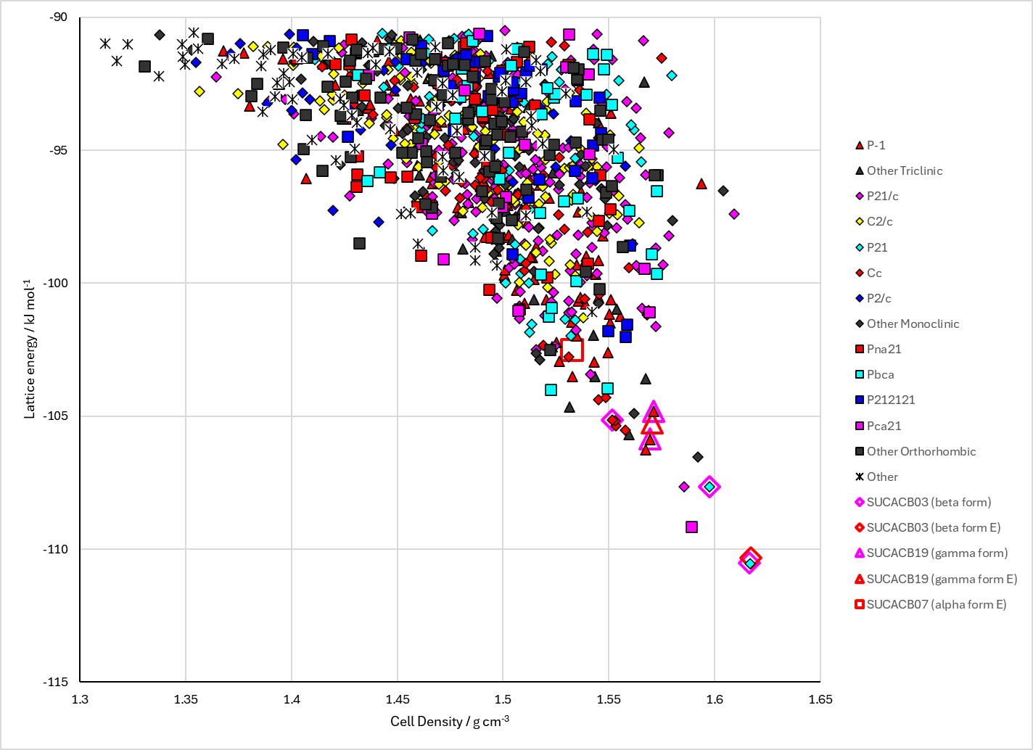

Figure . Crystal energy landscape of Succinic Acid from previous work.1

Some tetragonal crystal structures did not have unit cell parameters consistent with the spacegroup. These were adjusted in the .res files to make them consistent. (Always Z’>1 structures in the CrystalOptimizer refinements.) The cell parameters in the Excel spreadsheets are taken from the .sum files, so these are the incorrect output numbers. The structures affected were A2: A3733 and A8441. B2: A3168, A4647, A7951. These were also edited in the PCM structures. Some A2 crystal structures did not appear in the A1 set of structures. This affected a significant proportion. It is probable that clustering or energy limits were not introduced to the CrystalPredictor search until after CrystalOptimizer was run on all the structures. This does not affect search B.

# CSD structures (CSD version 5.45 with Mar, Jun and Sep 2024 updates)

Table . Crystallographic information for CSD entries for succinic acid. Different polymorphs are coloured differently.

|  |  |  |  |  |  |  |  |  |  |  |
| --- | --- | --- | --- | --- | --- | --- | --- | --- | --- | --- |
| REFCODE | space group | Z’ | a / Å | b / Å | c / Å | α / ° | β / ° | γ / ° | density / g cm-3 | Form |
| SUCACB01 | P-1 | 1 | 6.85 | 7.22 | 5.72 | 109.43 | 96.67 | 101.55 | 1.531 | alpha |
| SUCACB02 | P21/c | 0.5 | 5.519 | 8.862 | 5.101 | 90 | 91.59 | 90 | 1.573 | beta |
| SUCACB03 | P21/c | 0.5 | 5.464 | 8.766 | 5.004 | 90 | 93.29 | 90 | 1.639 | beta |
| SUCACB04 | P-1 | 1 | 5.72 | 6.85 | 7.57 | 106.16 | 116 | 83.33 | 1.532 | alpha |
| SUCACB05 | P21/a | 0.5 | 5.126 | 8.88 | 7.619 | 90 | 133.6 | 90 | 1.562 | beta |
| SUCACB06 | P21/a | 0.5 | 5.098 | 8.879 | 5.5201 | 90 | 91.53 | 90 | 1.57 | beta |
| SUCACB07 | P-1 | 1 | 6.867 | 7.198 | 5.727 | 109.1 | 97.18 | 101.84 | 1.531 | alpha |
| SUCACB08 | P21/c | 0.5 | 5.4773 | 8.7897 | 5.0269 | 90 | 92.905 | 90 | 1.623 | beta |
| SUCACB09 | P21/c | 0.5 | 5.4769 | 8.7817 | 5.028 | 90 | 92.928 | 90 | 1.624 | beta |
| SUCACB10 | P21/a | 0.5 | 5.126 | 8.88 | 7.619 | 90 | 133.6 | 90 | 1.562 | beta |
| SUCACB11 | P21/c | 0.5 | 5.5261 | 8.8807 | 5.1051 | 90 | 91.49 | 90 | 1.566 | beta |
| SUCACB12 | P21/a | 0.5 | 5.0993 | 8.8763 | 5.5198 | 90 | 91.508 | 90 | 1.57 | beta |
| SUCACB13 | P21/a | 0.5 | 5.075 | 8.8432 | 5.5072 | 90 | 91.878 | 90 | 1.588 | beta |
| SUCACB14 | P21/a | 0.5 | 5.0564 | 8.8113 | 5.4866 | 90 | 92.25 | 90 | 1.606 | beta |
| SUCACB15 | P21/a | 0.5 | 5.0442 | 8.794 | 5.4793 | 90 | 92.502 | 90 | 1.615 | beta |
| SUCACB16 | P21/a | 0.5 | 5.0287 | 8.7831 | 5.4768 | 90 | 92.862 | 90 | 1.623 | beta |
| SUCACB17 | P21/a | 0.5 | 5.0205 | 8.768 | 5.4662 | 90 | 93.043 | 90 | 1.632 | beta |
| SUCACB18 | P21/c | 0.5 | 5.4743 | 8.774 | 5.0319 | 90 | 92.819 | 90 | 1.625 | beta |
| SUCACB19 | C2/c | 0.5 | 5.7015 | 8.4154 | 10.3538 | 90 | 90.374 | 90 | 1.579 | gamma |
| SUCACB20 | P21/a | 0.5 | 5.1 | 8.88 | 7.61 | 90 | 133.6 | 90 | 1.571 | beta |
| SUCACB21 | P21/c | 0.5 | 5.5169 | 8.88 | 5.0987 | 90 | 91.493 | 90 | 1.571 | beta |

Table . Experimental information for CSD entries for succinic acid.

|  |  |  |  |  |  |
| --- | --- | --- | --- | --- | --- |
| REFCODE | space group | R factor | T / K | Year | Comments |
| SUCACB01 | P-1 | 0 | 295 | 1944 | Not available online for UCL |
| SUCACB02 | P21/c | 3.3 | 295 | 1981 | neutron diffraction. Slow evaporation of aqueous solution.4 |
| SUCACB03 | P21/c | 2.7 | 77 | 1981 | neutron diffraction. Slow evaporation of aqueous solution.4 |
| SUCACB04 | P-1 | 0 | 295 | 1983 | Not available online for UCL |
| SUCACB05 | P21/a | 0 | 295 | 1983 | Not available online for UCL |
| SUCACB06 | P21/a | 4 | 295 | 1998 | Private communication |
| SUCACB07 | P-1 | 6.3 | 295 | 1998 | Private communication, no details |
| SUCACB08 | P21/c | 4.54 | 130 | 2000 | Slow evaporation of ethyl acetate solution.5 |
| SUCACB09 | P21/c | 4.87 | 130 | 2000 | Slow cooling of saturated methanol solution.6 |
| SUCACB10 | P21/a | 12.4 | 295 | 1959 | This has the opposite configuration of the acid group. This may be incorrect, which may account for the high R factor.  Crystallization method not clear from paper. |
| SUCACB11 | P21/c | 4.23 | 295 | 2000 | Slow cooling of saturated methanol solution.6 |
| SUCACB12 | P21/a | 4.2 | 298 | 2013 | Crystallization from methanol.7 |
| SUCACB13 | P21/a | 4.01 | 260 | 2013 | Crystallization from methanol.7 |
| SUCACB14 | P21/a | 3.66 | 220 | 2013 | Crystallization from methanol.7 |
| SUCACB15 | P21/a | 3.39 | 180 | 2013 | Crystallization from methanol.7 |
| SUCACB16 | P21/a | 3.37 | 140 | 2013 | Crystallization from methanol.7 |
| SUCACB17 | P21/a | 3.61 | 120 | 2013 | Crystallization from methanol.7 |
| SUCACB18 | P21/c | 2.71 | 150 | 2015 | Slow evaporation of isopropanol or acetone solutions at room temperature.8 |
| SUCACB19 | C2/c | 4.72 | 173 | 2018 | Failed cocrystallization experiment with l-Leu-Leu-COOH dipeptide.1 |
| SUCACB20 | P21/a | 22 | 0 | 1949 | No data has been deposited at CCDC for this structure. The orthogonal coordinates from the paper have been converted to fractional coordinates to get the correct structure |
| SUCACB21 | P21/c | 5.03 | 296 | 2024 |  |

# Other notes

1. P. Lucaioli, E. Nauha, I. Gimondi, L. S. Price, R. Guo, L. Iuzzolino, I. Singh, M. Salvalaglio, S. L. Price and N. Blagden, *CrystEngComm*, 2018, **20**, 3971-3977.

2. L. Iuzzolino, A. M. Reilly, P. McCabe and S. L. Price, *Journal of Chemical Theory and Computation*, 2017, **13**, 5163-5171.

3. N. Issa, S. A. Barnett, S. Mohamed, D. E. Braun, R. C. B. Copley, D. A. Tocher and S. L. Price, *CrystEngComm*, 2012, **14**, 2454-2464.

4. J. L. Leviel, G. Auvert and J. M. Savariault, *Acta Crystallographica Section B - Structural Crystallography and Crystal Chemistry*, 1981, **37**, 2185-2189.

5. R. S. Gopalan, P. Kumaradhas, G. U. Kulkarni and C. N. R. Rao, *Journal of Molecular Structure*, 2000, **521**, 97-106.

6. V. R. Thalladi, M. Nusse and R. Boese, *Journal of the American Chemical Society*, 2000, **122**, 9227-9236.

7. S. Bhattacharya, V. G. Saraswatula and B. K. Saha, *Crystal Growth & Design*, 2013, **13**, 3651-3656.

8. M. K. Mishra, U. Ramamurty and G. R. Desiraju, *Chemistry – An Asian Journal*, 2015, **10**, 2176-2181.