2,6-diamino-3,5-dinitropyridine-1-oxide
(Last updated June 2026)
Figure 1. The molecular diagram of 2,6-diamino-3,5-dinitropyridine-1-oxide.

CSP studies
REFCODE | TIBMIA
Formula | C5 H5 N5 O5
Common Name | 2,6-diamino-3,5-dinitropyridine-1-oxide
IUPAC Systematic Name | 2,6-diamino-3,5-dinitropyridine-1-oxide
Other Names
CSD Refcodes | TIBMIA
Search Identifier | A
Scientist | Harriott Nowell
Date | pre-2010
Publication | No publication planned.
Energy model | 1
Study_ID | 0
Programs | MOLPAK, DMAREL (3.0)
Location on S Drive | \CHEMISTRY_CPOSS\0-EarlySearches\home\louise_price.eminerals\2,6-diamino-3,5-dinitropyridine-1-oxide
Potential Description | DMA + FIT
Intramolecular Description | MP2/6-31G(d,p)

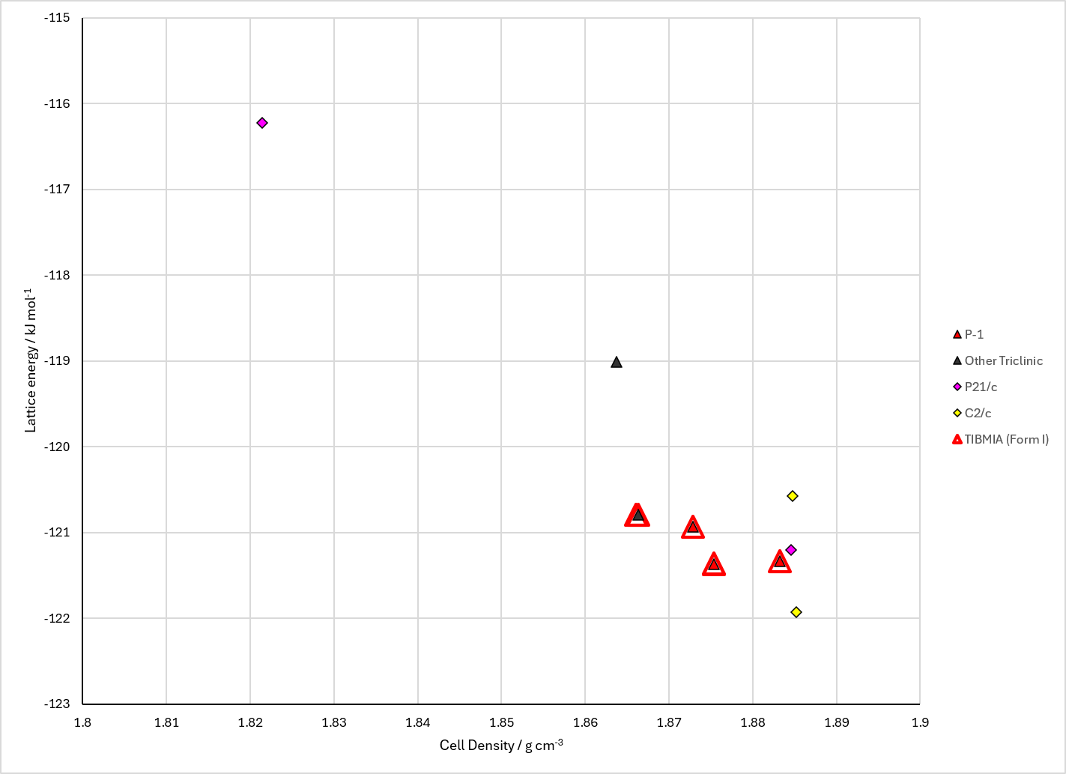
Figure 2. Crystal energy landscape of 2,6-diamino-3,5-dinitropyridine-1-oxide from previous work.

CSD structures (CSD version 6.01 with Feb 2026 update)

Table 1. Crystallographic information for CSD entries for 2,6-diamino-3,5-dinitropyridine-1-oxide. Different polymorphs are coloured differently.
REFCODE | space group | Z’ | a / Å | b / Å | c / Å | α / ° | β / ° | γ / ° | density / g cm⁻³ | Form
TIBMIA | C2/c | 0.5 | 14.864 | 7.336 | 7.509 | 90.0 | 111.67 | 90.0 | 1.8778 | None
TIBMIA01 | C2/c | 0.5 | 14.74 | 7.29200 | 7.57400 | 90.0 | 111.61 | 90.0 | 1.8878 | None
TIBMIA02 | C2/c | 0.5 | 14.74 | 7.29200 | 7.57400 | 90.0 | 111.61 | 90.0 | 0.0 | None

Table 2. Experimental information for CSD entries for 2,6-diamino-3,5-dinitropyridine-1-oxide.
REFCODE | space group | R factor | T / K | Year | Comments
TIBMIA | C2/c | 3.550 | None | 1996 | 10.1002/jhet.5570330357
TIBMIA01 | C2/c | 4.93 | at 293 K | 2013 | 10.1039/c2ra22839d
TIBMIA02 | C2/c | 4.93 | at 293 K | 2013 | 10.1016/j.jssc.2013.01.014

Make this table include whether polymorphs are solution-grown, sublimation grown, templated or otherwise. Add references.

Other notes

