Blind Test XXIII (XAFPAY)
(Last updated January 2026)
Figure 1. The molecular diagram of Blind Test XXIII.

CSP studies
REFCODE | XAFPAY
Formula | C21 H17 N1 O2 Cl2
Common Name
IUPAC Systematic Name | 2-({4-[2-(3,4-dichlorophenyl)ethyl]phenyl}amino)benzoic acid
Other Names | Blind Test XXIII
CSD Refcodes | XAFPAY, XAFPAY01, XAFPAY02, XAFPAY03, XAFPAY04
Search Identifier | A
Scientist | Louise Price
Date | 2015
Publication | Reilly, A. M. et al, Acta Crystallographica Section B Structural Science, Crystal Engineering and Materials, 2016, Volume B72, pages 439-45
Energy model | 3
Study_ID | 30
Programs | Study_ID=10, DMACRYS (2.2.0.1)
Location on S Drive | \CHEMISTRY_CPOSS\BlindTest2015\XAFPAY\PCM
Potential Description | GDMA2.2(PCMdielectric3(PBE1PBE/6-31G(d,p))) + FIT
Intramolecular Description | PBE0/6-31G(d,p)
Energy model | 2
Study_ID | 10
Programs | Study_ID=20, CrystalOptimizer (2.4.m), DMACRYS (2.2.0.1)
Location on S Drive | \CHEMISTRY_CPOSS\BlindTest2015\XAFPAY\CrystOpt
Potential Description | CrystalOptimizer with GDMA2.2(PBE1PBE/6-31G(d,p)) + FIT
Intramolecular Description | PBE1PBE/6-31G(d,p)
Energy model | 1
Study_ID | 20
Programs | CrystalPredictor (2.1.01), DMACRYS (2.2.0.1)
Location on S Drive | \CHEMISTRY_CPOSS\BlindTest2015\XAFPAY\CrystPred
Potential Description | CrystalPredictor + DMACRYS with GDMA2.2(PBE1PBE/6-31G(d,p)) + FIT
Intramolecular Description | PBE1PBE/6-31G(d,p)
Energy model | 4
Study_ID | 11
Programs | Study_ID=10, CrystalOptimizer (2.4.m), DMACRYS (2.2.0.1)
Location on S Drive | \CHEMISTRY_CPOSS\BlindTest2015\XAFPAY\CrystOpt_321G
Potential Description | CrystalOptimizer with GDMA2.2(PBE1PBE/3-21G) + FIT
Intramolecular Description | PBE1PBE/3-21G
Energy model | 5
Study_ID | 12
Programs | Study_ID=10, CrystalOptimizer (2.4.m), DMACRYS (2.2.0.1)
Location on S Drive | \CHEMISTRY_CPOSS\BlindTest2015\XAFPAY\CrystOpt_B3LYP
Potential Description | CrystalOptimizer with GDMA2.2(B3LYP/6-31G(d,p)) + FIT
Intramolecular Description | B3LYP/6-31G(d,p)
Energy model | 6
Study_ID | 13
Programs | Study_ID=10, CrystalOptimizer (2.4.m), DMACRYS (2.2.0.1)
Location on S Drive | \CHEMISTRY_CPOSS\BlindTest2015\XAFPAY\CrystOpt_Will
Potential Description | CrystalOptimizer with GDMA2.2(PBE1PBE/6-31G(d,p)) + Will
Intramolecular Description | PBE1PBE/6-31G(d,p)
Energy model | 7
Study_ID | 14
Programs | Study_ID=10, CrystalOptimizer (2.4.m), DMACRYS (2.2.0.1)
Location on S Drive | \CHEMISTRY_CPOSS\BlindTest2015\XAFPAY\Anis
Potential Description | CrystalOptimizer with GDMA2.2(PBE1PBE/6-31G(d,p)) + Will with Day Anisotropic parameters on Cl
Intramolecular Description | PBE1PBE/6-31G(d,p)
Energy model | 8
Study_ID | 15
Programs | Study_ID=10, CrystalOptimizer (2.4.m), DMACRYS (2.2.0.1)
Location on S Drive | \CHEMISTRY_CPOSS\BlindTest2015\XAFPAY\Anis_C-Cl
Potential Description | CrystalOptimizer with GDMA2.2(PBE1PBE/6-31G(d,p)) + Will with Day Anisotropic parameters on Cl and C
Intramolecular Description | PBE1PBE/6-31G(d,p)
Search Identifier | B
Scientist | Luca Iuzzolino
Date | 2018
Publication | Iuzzolino, L.; McCabe, P.; Price, S. L.; Brandenburg, J. G., Faraday Discussions 2018, 211, 275-296.
Energy model | 1
Study_ID | 60
Programs | CrystalPredictor (1.8), DFTB3-D3 (1.0.1), DMACRYS (2.2.0.1)
Location on S Drive | \CHEMISTRY_CPOSS\LucasSearches\BlindTest_XXIII
Potential Description | CrystalPredictor, followed by DFTB3-D3 refinement, followed by DMACRYS with GDMA2.2(PBE0/6-31G(d,p)) + FIT
Intramolecular Description | PBE1/6-31G(d,p)

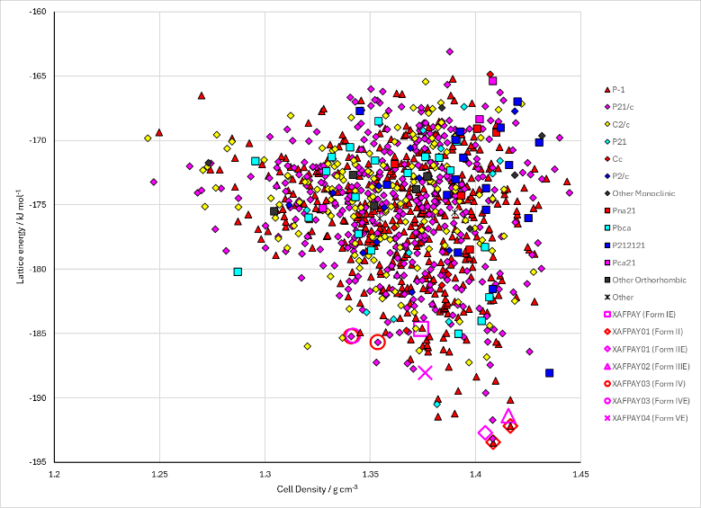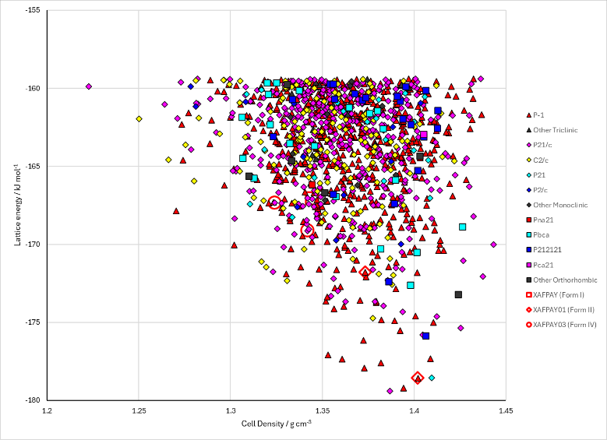
Figure 2. Crystal energy landscape of Blind Test XXIII from previous work. Left: from Study_ID=30. Right: from Study_ID=60.

CSD structures (CSD version 6.01)

Table 1. Crystallographic information for CSD entries for Blind Test XXIII. Different polymorphs are coloured differently.
REFCODE | space group | Z’ | a / Å | b / Å | c / Å | α / ° | β / ° | γ / ° | density / g cm⁻³ | Form
XAFPAY | P21/c | 1.0 | 11.1637 | 10.5295 | 16.2358 | 90.0 | 95.749 | 90.0 | 1.3511 | I
XAFPAY01 | P-1 | 1.0 | 7.0061 | 7.8047 | 18.893 | 85.277000 | 80.753000 | 65.769 | 1.3798 | II
XAFPAY02 | P-1 | 2.0 | 7.6375 | 12.0393 | 20.443 | 84.79 | 85.379 | 80.091000 | 1.3943 | III
XAFPAY03 | P21/n | 1.0 | 13.8860 | 10.728 | 14.0780 | 90.0 | 113.63200 | 90.0 | 1.3353 | IV
XAFPAY04 | P-1 | 2.0 | 6.687 | 12.18 | 24.39 | 102.88 | 96.69 | 97.215 | 1.3506 | V

Table 2. Experimental information for CSD entries for Blind Test XXIII.
REFCODE | space group | R factor | T / K | Year | Comments
XAFPAY | P21/c | 5.29 | 299 K | 2016 | Private communication, see also Reilly, A. M. et al, Acta Crystallographica Section B: Structural Science, Crystal Engineering and Materials, 2016, Volume B72, pages 439-459 (List 2)
XAFPAY01 | P-1 | 5.24 | 299 K | 2016 | Private communication, see also Reilly, A. M. et al, Acta Crystallographica Section B: Structural Science, Crystal Engineering and Materials, 2016, Volume B72, pages 439-459 (List 2)
XAFPAY02 | P-1 | 6.86 | 301 K | 2016 | Private communication, see also Reilly, A. M. et al, Acta Crystallographica Section B: Structural Science, Crystal Engineering and Materials, 2016, Volume B72, pages 439-459 (List 2)
XAFPAY03 | P21/n | 6.72 | 301 K | 2016 | Private communication, see also Reilly, A. M. et al, Acta Crystallographica Section B: Structural Science, Crystal Engineering and Materials, 2016, Volume B72, pages 439-459 (List 2)
XAFPAY04 | P-1 | 10.38 | 292 K | 2016 | Private communication, see also Reilly, A. M. et al, Acta Crystallographica Section B: Structural Science, Crystal Engineering and Materials, 2016, Volume B72, pages 439-459 (List 2)

Make this table include whether polymorphs are solution-grown, sublimation grown, templated or otherwise. Add references.

Other notes
The CrystalPredictor search (Study_ID=20) has over 20,000 structures. Only the lowest 20 kJ mol ⁻¹ were stored on Github. The rest are available from Louise on request.

