1-((4-chlorophenyl)sulfonyl)-2-oxopropylidene)diazenium (Blind Test XVIII)
(Last updated March 2026)
Figure 1. The molecular diagram of 1-((4-chlorophenyl)sulfonyl)-2-oxopropylidene)diazenium.

CSP studies
REFCODE | OBEQET
Formula | C9 H7 N2 O3 Cl1 S1
Common Name | Blind Test 18
IUPAC Systematic Name | (1-((4-chlorophenyl)sulfonyl)-2-oxopropylidene)diazenium)
Other Names | Blind Test 18
CSD Refcodes | OBEQET
Search Identifier | A
Scientist | Louise Price
Date | 2010
Publication | See Study_ID=10
Energy model | 1
Study_ID | 0
Programs | MOLPAK, DMACRYS (2.0.1)
Location on S Drive | \CHEMISTRY_CPOSS\0-EarlySearches\home\louise_price.eminerals\OBEQET\CONDOR_FIT13
Potential Description | GDMA2 (MP2 6-31G(d,p)) + FIT potential, with Williams nitrogen atoms (N1 is type W4 and N2 is type W1) and Price-Lommerse sulfur parameters.
Intramolecular Description | MP2/6-31G(d,p)
Energy model | 2
Study_ID | 1
Programs | Study_ID=0, DMACRYS (2.0.1)
Location on S Drive | \CHEMISTRY_CPOSS\0-EarlySearches\home\louise_price.eminerals\OBEQET\CONDOR_WILL_SS
Potential Description | GDMA2 (MP2 6-31G(d,p)) + Williams potential (with N1 being type W4 and N2 type W1) and Scheraga's sulfur parameters.
Intramolecular Description | MP2/6-31G(d,p)
Energy model | 3
Study_ID | 2
Programs | Study_ID=1, DMACRYS (2.0.2)
Location on S Drive | \CHEMISTRY_CPOSS\0-EarlySearches\home\louise_price.eminerals\OBEQET\OBEQETfitSO
Potential Description | GDMA2 (MP2 6-31G(d,p)) + FIT potential (including FIT nitrogens) and Scheraga's sulfur and SO2 oxygen parameters. (Study_id=1 structures refined, except Z'>1)
Intramolecular Description | MP2/6-31G(d,p)
Search Identifier | B
Scientist | Louise Price
Date | 2010
Publication | Bardwell DA, et al. 2011. Acta Crystallogr , Sect B 67, 535-551.
Energy model | 2
Study_ID | 10
Programs | Study_ID=20, CrystalOptimizer, DMACRYS (2.0.2)
Location on S Drive | \CHEMISTRY_CPOSS\0-EarlySearches\home\louise_price.eminerals\OBEQET\OBEQET_CO
Potential Description | GDMA2 (MP2 6-31G(d,p)) + FIT potential (with N1 being type W4 and N2 type W1) and Scheraga's sulfur and oxygen parameters.
Intramolecular Description | HF/6-31G(d,p)
Energy model | 1
Study_ID | 20
Programs | Flexible CrystalPredictor, dmaflex-Quick, DMACRYS (2.0.2)
Location on S Drive | \CHEMISTRY_CPOSS\0-EarlySearches\home\louise_price.eminerals\OBEQET\OBEQET_CP
Potential Description | CrystalPredictor flexible search, with the Williams potential, refined with DMAflex-Quick using rotated multipoles from an MP2 6-31Gdp GDMA
Intramolecular Description | MP2/6-31G(d,p)

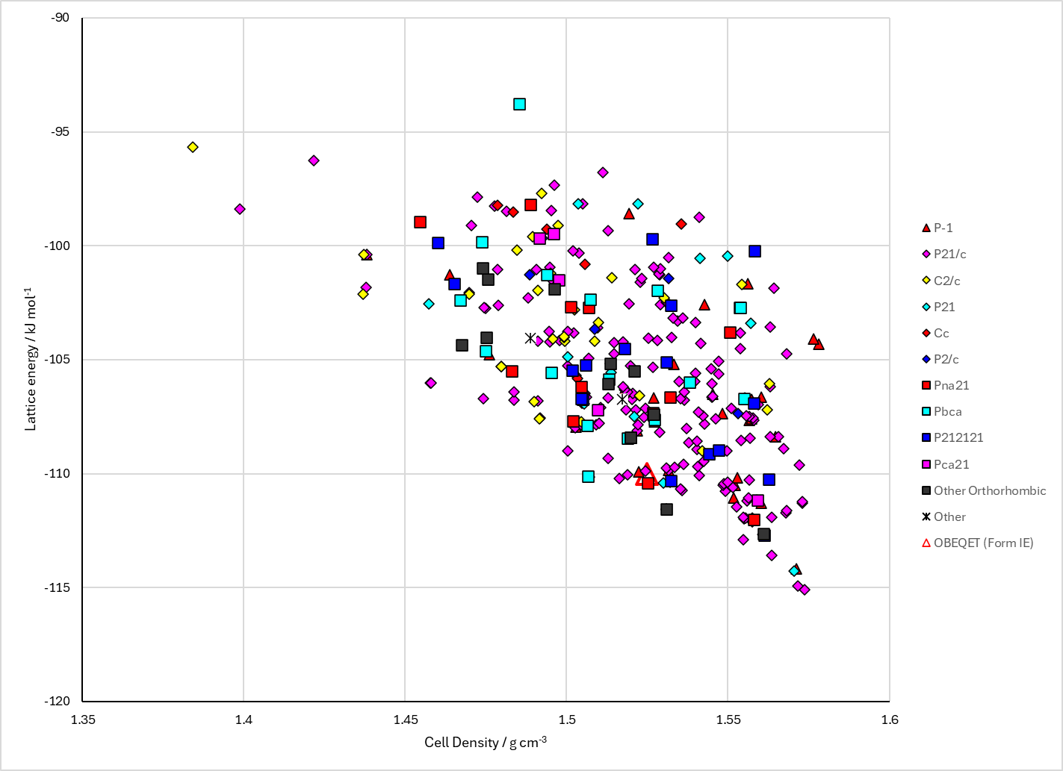
Figure 2. Crystal energy landscape of 1-((4-chlorophenyl)sulfonyl)-2-oxopropylidene)diazenium from previous work (Study_ID=10).

CSD structures (CSD version 6.01)

Table 1. Crystallographic information for CSD entries for 1-((4-chlorophenyl)sulfonyl)-2-oxopropylidene)diazenium. Different polymorphs are coloured differently.
REFCODE | space group | Z’ | a / Å | b / Å | c / Å | α / ° | β / ° | γ / ° | density / g cm⁻³ | Form
OBEQET | Pbca | 1.0 | 9.8888 | 8.8869 | 24.969 | 90.0 | 90.0 | 90.0 | 1.5660 | None

Table 2. Experimental information for CSD entries for 1-((4-chlorophenyl)sulfonyl)-2-oxopropylidene)diazenium.
REFCODE | space group | R factor | T / K | Year | Comments
OBEQET | Pbca | 2.92 | at 150 K | 2011 | None

Make this table include whether polymorphs are solution-grown, sublimation grown, templated or otherwise. Add references.

Other notes
In the CrystalPredictor search, the conformational energy penalty is not included. The whole higher energy Region is given an energy penalty of 3.06 kJ mol⁻¹, which is presumable the energy difference between the optimized conformers of the Region.

