Mebendazole
(Last updated December 2025)
Figure 1. The molecular diagram of (left) Mebendazole A and (right) Mebendazole C.

CSP studies
REFCODE | TUXPEJ
Formula | C16 H13 N3 O3
Common Name | Mebendazole form A
IUPAC Systematic Name | Methyl (6-benzoyl-1H-benzimidazol-2-yl)carbamate
CSD Refcodes | TUXPEJ
Search Identifier | A
Scientist | Luca Iuzzolino
Date | 2018
Publication | Kreso Bucar is leading
Energy model | 3
Study_ID | 30
Programs | Study_ID=10, DMACRYS (2.2.0.1)
Location on S Drive | CHEMISTRY_CPOSS\Mebendazole\A\PCM
Potential Description | GDMA2.2(PCMdielectric3(PBE1PBE/6-31G(d,p))) + FIT
Intramolecular Description | PCM3(PBE0/6-31G(d,p))
Energy model | 2
Study_ID | 10
Programs | Study_ID=11, CrystalOptimizer (2.4.m), DMACRYS (2.2.0.1)
Location on S Drive | CHEMISTRY_CPOSS\Mebendazole\A\CrystOpt
Potential Description | CrystalOptimizer with GDMA2.2(PBE1PBE/6-31G(d,p)) + FIT
Intramolecular Description | PBE0/6-31G(d,p)
Energy model | 4
Study_ID | 12
Programs | Study_ID=10, CrystalOptimizer (2.4.m), DMACRYS (2.2.0.1)
Location on S Drive | CHEMISTRY_CPOSS\Mebendazole\A\Will
Potential Description | CrystalOptimizer with GDMA2.2(PBE1PBE/6-31G(d,p)) + Williams
Intramolecular Description | PBE0/6-31G(d,p)
Energy model | 1
Study_ID | 11
Programs | Flexible CrystalPredictor (1.8), CrystalOptimizer single iteration (2.4.m), DMACRYS (2.2.0.1)
Location on S Drive | CHEMISTRY_CPOSS\Mebendazole\SingleIterationCO\A
Potential Description | CrystalOptimizer with GDMA2.2(PBE1PBE/6-31G(d,p)) + FIT
Intramolecular Description | PBE0/6-31G(d,p)
Search Identifier | B
Scientist | Luca Iuzzolino
Date | 2018
Publication | Iuzzolino, L.; McCabe, P.; Price, S. L.; Brandenburg, J. G., Faraday Discussions 2018, 211, 275-296.
Energy model | 1
Study_ID | 60
Programs | Rigid CrystalPredictor, DFTB3-D3, DMACRYS (2.2.0.1)
Location on S Drive | \CHEMISTRY_CPOSS\LucasSearches\MebendazoleA
Potential Description | CrystalPredictor, followed by DFTB3-D3 refinement, followed by DMACRYS with GDMA2.2(PBE0/6-31G(d,p)) + FIT
Intramolecular Description | PBE0/6-31G(d,p)
REFCODE | YULGIW
Formula | C16 H13 N3 O3
Common Name | Mebendazole form C
IUPAC Systematic Name | Methyl (5-benzoyl-1H-benzimidazol-2-yl)carbamate
CSD Refcodes | YULGIW
Search Identifier | A
Scientist | Luca Iuzzolino
Date | 2018
Publication | Kreso Bucar is leading
Energy model | 3
Study_ID | 30
Programs | Study_ID=10, DMACRYS (2.2.0.1)
Location on S Drive | CHEMISTRY_CPOSS\Mebendazole\C\PCM
Potential Description | GDMA2.2(PCMdielectric3(PBE1PBE/6-31G(d,p))) + FIT
Intramolecular Description | PCM3(PBE0/6-31G(d,p))
Energy model | 2
Study_ID | 10
Programs | Study_ID=11, CrystalOptimizer (2.4.m), DMACRYS (2.2.0.1)
Location on S Drive | CHEMISTRY_CPOSS\Mebendazole\C\CrystOpt
Potential Description | CrystalOptimizer with GDMA2.2(PBE1PBE/6-31G(d,p)) + FIT
Intramolecular Description | PBE0/6-31G(d,p)
Energy model | 4
Study_ID | 12
Programs | Study_ID=10, CrystalOptimizer (2.4.m), DMACRYS (2.2.0.1)
Location on S Drive | CHEMISTRY_CPOSS\Mebendazole\C\Will
Potential Description | CrystalOptimizer with GDMA2.2(PBE1PBE/6-31G(d,p)) + Williams
Intramolecular Description | PBE0/6-31G(d,p)
Energy model | 1
Study_ID | 11
Programs | Flexible CrystalPredictor (1.8), CrystalOptimizer single iteration (2.4.m), DMACRYS (2.2.0.1)
Location on S Drive | CHEMISTRY_CPOSS\Mebendazole\SingleIterationCO\C
Potential Description | CrystalOptimizer with GDMA2.2(PBE1PBE/6-31G(d,p)) + FIT
Intramolecular Description | PBE0/6-31G(d,p)
Search Identifier | B
Scientist | Luca Iuzzolino
Date | 2018
Publication | Iuzzolino, L.; McCabe, P.; Price, S. L.; Brandenburg, J. G., Faraday Discussions 2018, 211, 275-296.
Energy model | 1
Study_ID | 60
Programs | Rigid CrystalPredictor, DFTB3-D3, DMACRYS (2.2.0.1)
Location on S Drive | \CHEMISTRY_CPOSS\LucasSearches\MebendazoleC
Potential Description | CrystalPredictor, followed by DFTB3-D3 refinement, followed by DMACRYS with GDMA2.2(PBE0/6-31G(d,p)) + FIT
Intramolecular Description | PBE0/6-31G(d,p)

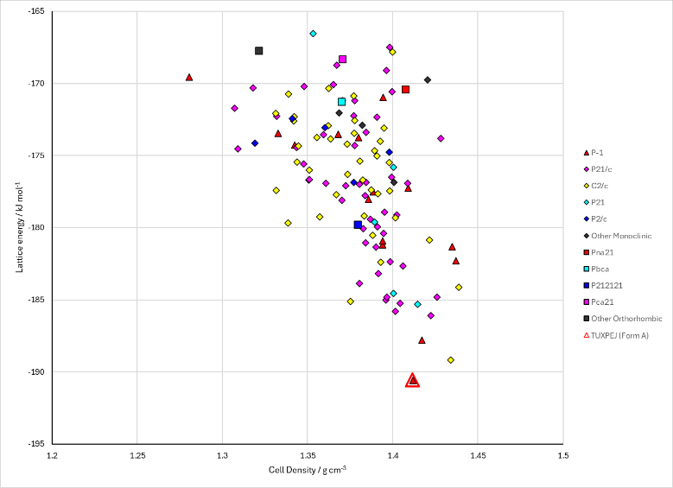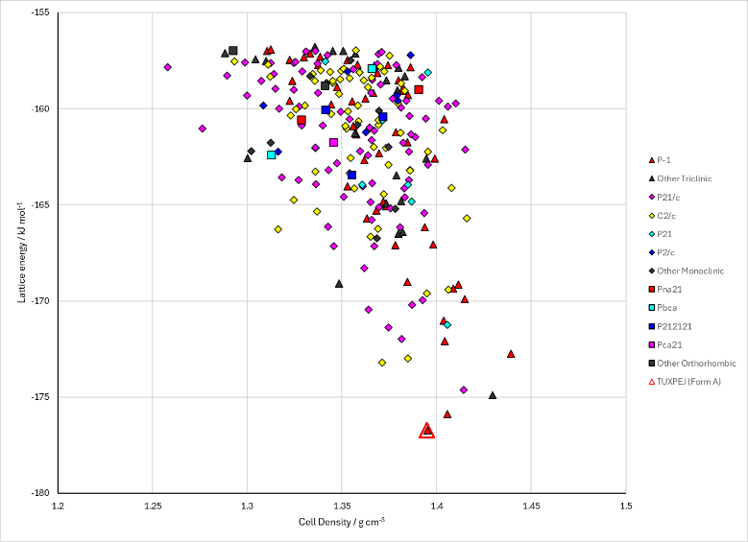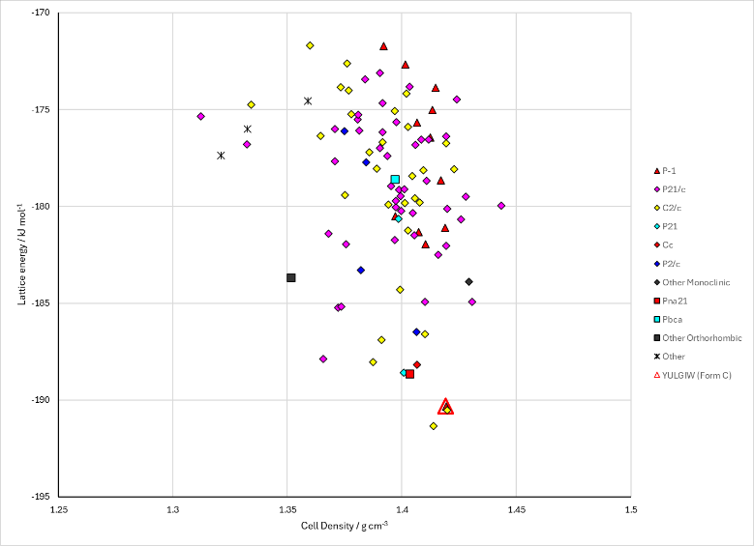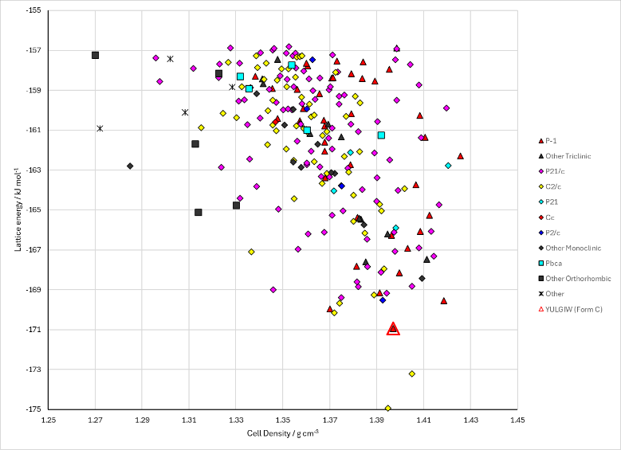
Figure 2. Crystal energy landscapes of Mebendazole from previous work. (Top) Mebendazole A and (bottom) Mebendazole C; (left) PCM Study_ID=30 and (right) ConformerGenerator search Study_ID=60.

CSD structures (CSD version 6.01)

Table 1. Crystallographic information for CSD entries for Mebendazole. Different polymorphs are coloured differently.
REFCODE | space group | Z’ | a / Å | b / Å | c / Å | α / ° | β / ° | γ / ° | density / g cm⁻³ | Form
TUXPEJ | P-1 | 1.0 | 5.5044 | 11.2872 | 12.5276 | 66.694 | 82.959 | 78.444 | 1.4019 | Form A
YULGIW | P-1 | 1.0 | 5.14800 | 7.8779 | 17.907 | 82.425 | 82.743 | 71.091 | 1.4457 | Form C

Table 2. Experimental information for CSD entries for Mebendazole.
REFCODE | space group | R factor | T / K | Year | Comments
TUXPEJ | P-1 | 4.37 | at 295 K | 2010 | 10.1002/jps.21902
YULGIW | P-1 | 13.25 | at 150 K | 2009 | 10.1002/jps.21593

Make this table include whether polymorphs are solution-grown, sublimation grown, templated or otherwise. Add references.

Other notes

