Anthracene
(Last updated June 2026)
Figure 1. The molecular diagram of Anthracene.

CSP studies
REFCODE | ANTCEN
Formula | C14 H10
Common Name | Anthracene
IUPAC Systematic Name | Anthracene
Other Names
CSD Refcodes | ANTCEN; ANTCEN17; ANTCEN18
Search Identifier | A
Scientist | Not sure
Date | pre-2010
Publication | No publication planned.
Energy model | 1
Study_ID | 0
Programs | MOLPAK, DMAREL (4.1.1)
Location on S Drive | \CHEMISTRY_CPOSS\0-EarlySearches\home\louise_price.eminerals\Anthracene
Potential Description | FIT + DMA(MP2 6-31G**)
Intramolecular Description | MP2/6-31G(d,p)

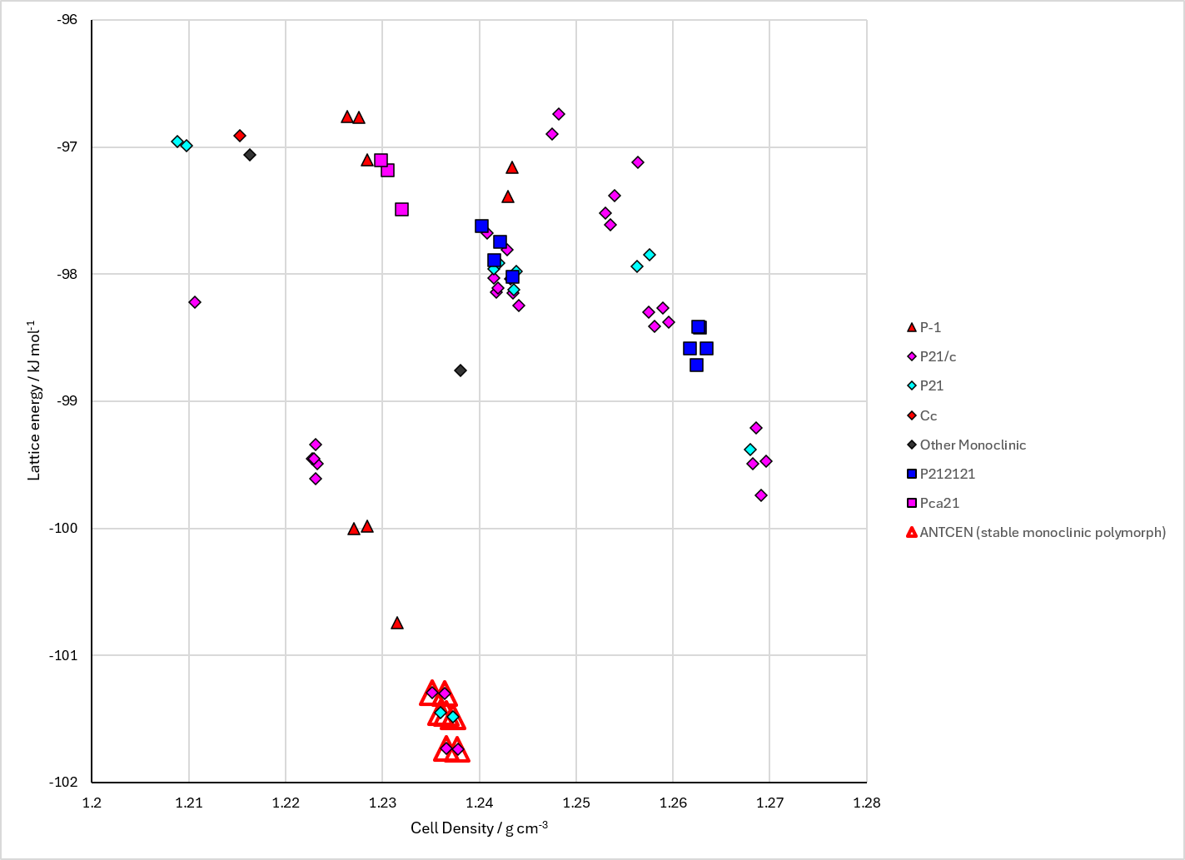
Figure 2. Crystal energy landscape of Anthracene from previous work.

CSD structures (CSD version 6.01 with Feb 2026 update)

Table 1. Crystallographic information for CSD entries for Anthracene. Different polymorphs are coloured differently.
REFCODE | space group | Z’ | a / Å | b / Å | c / Å | α / ° | β / ° | γ / ° | density / g cm⁻³ | Form
ANTCEN | P21/a | 0.5 | 8.562 | 6.038 | 11.184 | 90.0 | 124.7 | 90.0 | 1.2452 | stable monoclinic polymorph
ANTCEN01 | P21/a | 0.5 | 8.443 | 6.002 | 11.124 | 90.0 | 125.6 | 90.0 | 1.2913 | stable monoclinic polymorph
ANTCEN02 | P21/a | 0.5 | 8.561 | 6.036 | 11.163 | 90.0 | 124.7 | 90.0 | 1.2481 | stable monoclinic polymorph
ANTCEN04 | P21/a | 0.5 | 8.561 | 6.036 | 11.163 | 90.0 | 124.7 | 90.0 | 1.2481 | stable monoclinic polymorph
ANTCEN07 | P1121/b | 0.5 | 11.174 | 8.554 | 6.016 | 90.0 | 90.0 | 124.60 | 1.2505 | stable monoclinic polymorph
ANTCEN08 | P1121/b | 0.5 | 11.092 | 8.407 | 6.006 | 90.0 | 90.0 | 125.31 | 1.2951 | stable monoclinic polymorph
ANTCEN09 | P21/a | 0.5 | 8.4144 | 5.9903 | 11.0953 | 90.0 | 125.293 | 90.0 | 1.2967 | stable monoclinic polymorph
ANTCEN10 | P21/a | 0.5 | 8.4414 | 5.9958 | 11.1123 | 90.0 | 125.175 | 90.0 | 1.2875 | stable monoclinic polymorph
ANTCEN11 | P21/a | 0.5 | 8.4673 | 5.99940 | 11.1244 | 90.0 | 125.056 | 90.0 | 1.2795 | stable monoclinic polymorph
ANTCEN12 | P21/a | 0.5 | 8.4959 | 6.0033 | 11.1407 | 90.0 | 124.907 | 90.0 | 1.2702 | stable monoclinic polymorph
ANTCEN13 | P21/a | 0.5 | 8.5254 | 6.0088 | 11.1548 | 90.0 | 124.757 | 90.0 | 1.2607 | stable monoclinic polymorph
ANTCEN14 | P21/a | 0.5 | 8.5526 | 6.0158 | 11.172 | 90.0 | 124.596 | 90.0 | 1.2509 | stable monoclinic polymorph
ANTCEN17 | P21/n | 1.0 | 8.553 | 6.021 | 22.333 | 90.0 | 124.54 | 90.0 | 2.4991 | metastable monoclinic polymorph
ANTCEN18 | P-1 | 0.0 | 8.342 | 5.89 | 11.282 | 123.34 | 96.7 | 85.91 | None | metastable triclinic polymorph
ANTCEN19 | P21/c | 0.5 | 9.4583 | 6.0100 | 8.5576 | 90.0 | 103.583 | 90.0 | 1.2518 | stable monoclinic polymorph
ANTCEN20 | P21/c | 0.5 | 9.2689 | 5.9954 | 8.4104 | 90.0 | 102.478 | 90.0 | 1.2971 | monoclinic polymorph
ANTCEN21 | P21/c | 0.5 | 9.2838 | 5.9992 | 8.4210 | 90.0 | 102.487 | 90.0 | 1.2926 | monoclinic polymorph
ANTCEN22 | P21/c | 0.5 | 9.2627 | 5.9923 | 8.4088 | 90.0 | 102.608 | 90.0 | 1.2995 | monoclinic polymorph
ANTCEN23 | P21/c | 0.5 | 9.2949 | 5.9651 | 8.4141 | 90.0 | 102.616 | 90.0 | 1.3001 | monoclinic polymorph
ANTCEN24 | P21/c | 0.5 | 9.3056 | 5.9879 | 8.4252 | 90.0 | 102.62 | 90.0 | 1.2920 | monoclinic polymorph
ANTCEN25 | P21/c | 0.5 | 9.2877 | 5.9902 | 8.4127 | 90.0 | 102.526 | 90.0 | 1.2954 | None
ANTCEN26 | P21/c | 0.5 | 9.452 | 6.0074 | 8.5421 | 90.0 | 103.512 | 90.0 | 1.2550 | None
ANTCEN27 | P21/c | 0.5 | 9.3003 | 5.9986 | 8.4345 | 90.0 | 102.604 | 90.0 | 1.2889 | None
ANTCEN and ANTCEN17 overlay 20 molecules. ANTCEN18 has no coordinates.
Table 2. Experimental information for CSD entries for Anthracene.
REFCODE | space group | R factor | T / K | Year | Comments
ANTCEN | P21/a | 4.3 | None | 1964 | 10.1107/S0365110X64001281
ANTCEN01 | P21/a | None | at 95 K | 1964 | 10.1107/S0365110X64001281
ANTCEN02 | P21/a | 19.6 | None | 1950 | 10.1107/S0365110X50000641
ANTCEN04 | P21/a | 10.9 | None | 1956 | 10.1107/S0365110X56002588
ANTCEN07 | P1121/b | 7.100 | None | 1983 | None
ANTCEN08 | P1121/b | 6.100 | at 100 K | 1983 | None
ANTCEN09 | P21/a | 4.1 | at 94 K | 1990 | 10.1107/S0108768190008382
ANTCEN10 | P21/a | 3.9 | at 140 K | 1990 | 10.1107/S0108768190008382
ANTCEN11 | P21/a | 3.9 | at 181 K | 1990 | 10.1107/S0108768190008382
ANTCEN12 | P21/a | 3.7 | at 220 K | 1990 | 10.1107/S0108768190008382
ANTCEN13 | P21/a | 3.5 | at 259 K | 1990 | 10.1107/S0108768190008382
ANTCEN14 | P21/a | 4.4 | None | 1990 | 10.1107/S0108768190008382
ANTCEN17 | P21/n | 4.3 | at 293 K | 2002 | 10.1080/10587250210538
ANTCEN18 | P-1 | None | None | 2002 | 10.1080/10587250210538
ANTCEN19 | P21/c | 4.96 | 295 K | 2013 | None
ANTCEN20 | P21/c | 5.21 | 100 K | 2015 | 10.1021/acs.cgd.5b00685
ANTCEN21 | P21/c | 4.82 | 100 K | 2015 | 10.1021/acs.cgd.5b00685
ANTCEN22 | P21/c | 6.279 | 100 K | 2015 | 10.1021/acs.cgd.5b00685
ANTCEN23 | P21/c | 3.769 | 90 K | 2017 | 10.1246/bcsj.20160337
ANTCEN24 | P21/c | 4.569 | 150 K | 2021 | None
ANTCEN25 | P21/c | 5.24 | 100 K | 2020 | 10.1002/adma.201908028
ANTCEN26 | P21/c | 8.42 | 293 K | 2020 | 10.1002/adma.201908028
ANTCEN27 | P21/c | 3.65 | 123 K | 2022 | None

Make this table include whether polymorphs are solution-grown, sublimation grown, templated or otherwise. Add references.

Other notes

