Carbonic Acid
(Last updated June 2026)
Figure 1. The molecular diagram of Carbonic Acid.

CSP studies
REFCODE | CBNCAC
Formula | C1 H2 O3
Common Name | Carbonic acid
IUPAC Systematic Name | Carbonic acid
Other Names
CSD Refcodes
Search Identifier | A
Scientist | Not sure
Date | pre-2010
Publication | No publication planned.
Energy model | 1
Study_ID | 0
Programs | MOLPAK, DMAREL (4.1.1)
Location on S Drive | \CHEMISTRY_CPOSS\0-EarlySearches\home\louise_price.eminerals\carbonic_acid
Potential Description | DMA + FIT
Intramolecular Description | MP2/6-31G(d,p)

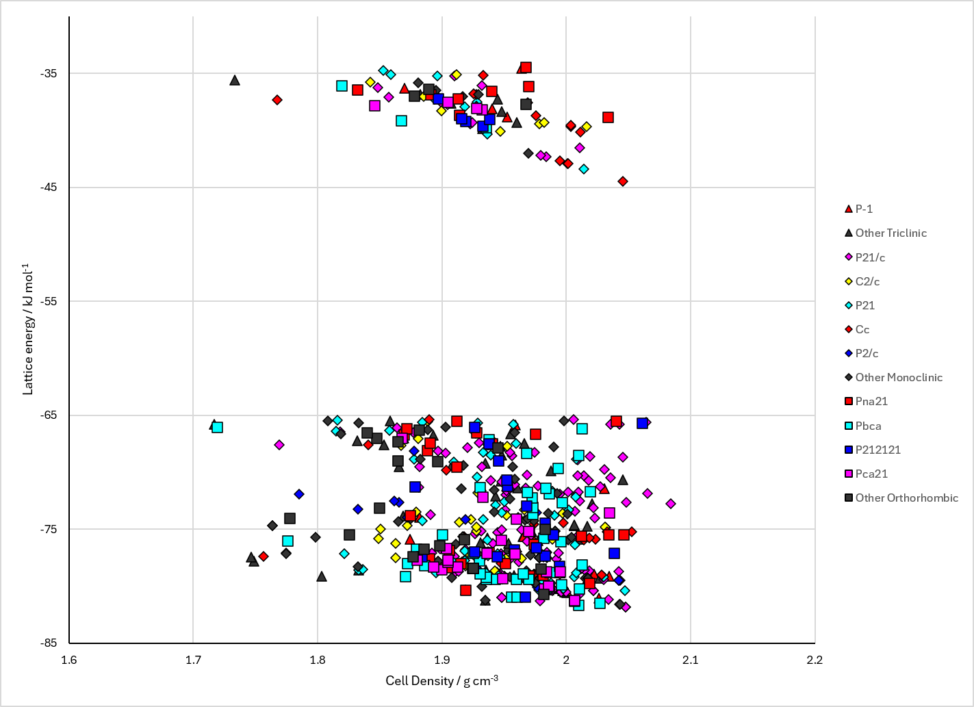
Figure 2. Crystal energy landscape of Carbonic Acid from previous work.

CSD structures (CSD version 6.01 with Feb 2026 update)

Table 1. Crystallographic information for CSD entries for Carbonic Acid. Different polymorphs are coloured differently.
REFCODE | space group | Z’ | a / Å | b / Å | c / Å | α / ° | β / ° | γ / ° | density / g cm⁻³ | Form

Table 2. Experimental information for CSD entries for Carbonic Acid.
REFCODE | space group | R factor | T / K | Year | Comments

Make this table include whether polymorphs are solution-grown, sublimation grown, templated or otherwise. Add references.

Other notes

