Dipicolinic Acid
(Last updated June 2026)
Figure 1. The molecular diagram of Dipicolinic Acid.

CSP studies
REFCODE | AFEBUI
Formula | C8 H5 N1 O4
Common Name | Dipicolinic Acid
IUPAC Systematic Name | Pyridine-2,6-dicarboxylic acid
Other Names
CSD Refcodes | AFEBUI03
Search Identifier | A
Scientist | Not sure
Date | pre-2010
Publication | No publication planned.
Energy model | 1
Study_ID | 0
Programs | MOLPAK, DMACRYS (2.0.4)
Location on S Drive | \CHEMISTRY_CPOSS\DipicolinicAcid
Potential Description | GDMA2.2 MP2/6-31G(d,p) + FIT
Intramolecular Description | MP2/6-31G(d,p)

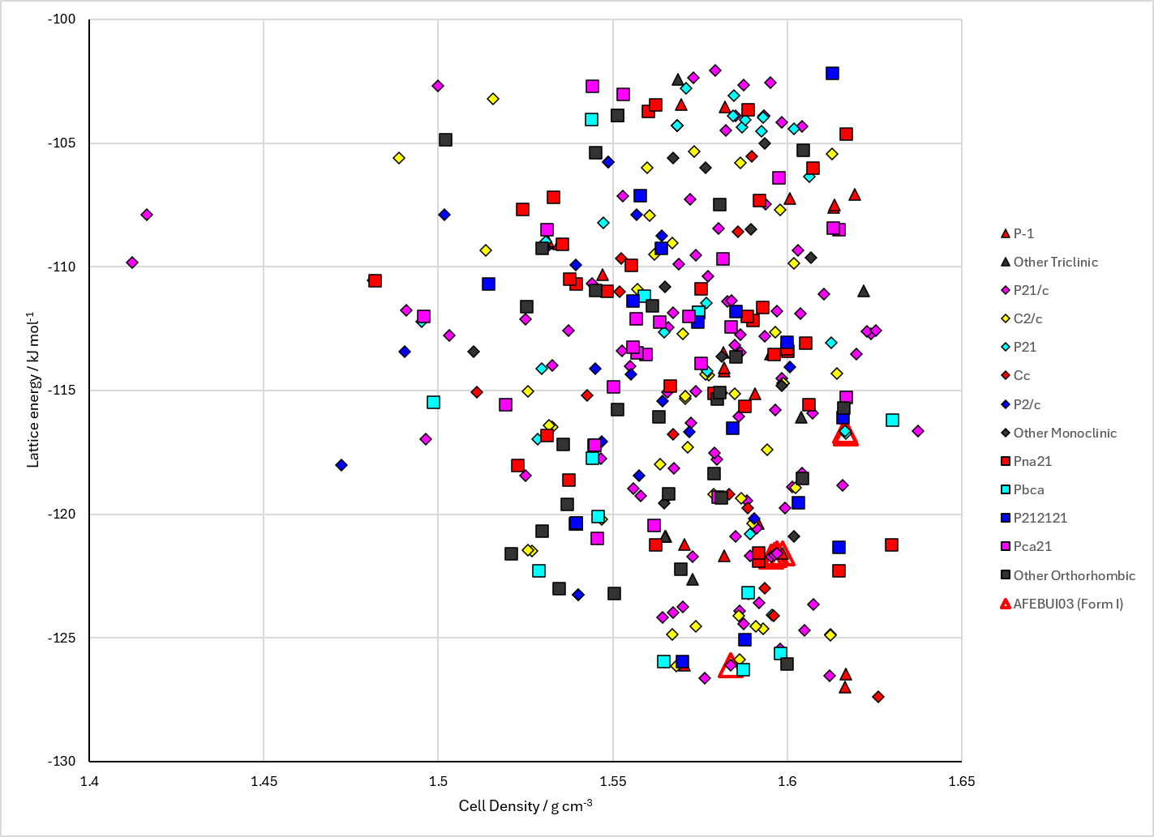
Figure 2. Crystal energy landscape of Dipicolinic Acid from previous work.

CSD structures (CSD version 6.01 with Feb 2026 update)

Table 1. Crystallographic information for CSD entries for Dipicolinic Acid. Different polymorphs are coloured differently.
REFCODE | space group | Z’ | a / Å | b / Å | c / Å | α / ° | β / ° | γ / ° | density / g cm⁻³ | Form
AFEBUI | P21/m | 0.5 | 3.7663 | 16.1667 | 5.5705 | 90.0 | 93.156 | 90.0 | 1.6388 | None
AFEBUI01 | Pna21 | 1.0 | 14.034 | 13.205 | 3.69900 | 90.0 | 90.0 | 90.0 | 1.6095 | None
AFEBUI02 | P21/m | 0.5 | 3.68110 | 16.1614 | 5.5228 | 90.0 | 92.221 | 90.0 | 1.6904 | None
AFEBUI03 | P21/m | 0.5 | 3.758 | 16.163 | 5.566 | 90.0 | 93.13 | 90.0 | 1.6441 | None

Table 2. Experimental information for CSD entries for Dipicolinic Acid.
REFCODE | space group | R factor | T / K | Year | Comments
AFEBUI | P21/m | 4.0 | at 300 K | 2002 | 10.1107/S0108270102002172
AFEBUI01 | Pna21 | 5.91 | 120 K | 2006 | 10.1039/b516387k
AFEBUI02 | P21/m | 3.62 | 123 K | 2018 | None
AFEBUI03 | P21/m | 3.989 | 293 K | 2024 | 10.1016/j.molstruc.2024.138433

Make this table include whether polymorphs are solution-grown, sublimation grown, templated or otherwise. Add references.

Other notes

