N-acetyl-iminostilbene
(Last updated June 2026)
Figure 1. The molecular diagram of N-acetyl-iminostilbene.

CSP studies
REFCODE | BOWWAL
Formula | C16 H13 N1 O1
Common Name | N-acetyl-iminostilbene
IUPAC Systematic Name | N-acetyl-iminostilbene
Other Names
CSD Refcodes | BOWWAL
Search Identifier | A
Scientist | Not sure
Date | pre-2010
Publication | No publication planned.
Energy model | 1
Study_ID | 0
Programs | MOLPAK, DMAREL (4.1.1)
Location on S Drive | CHEMISTRY_CPOSS\0-EarlySearches\home\louise_price.eminerals\N-Acetyldibenz-b,f-azepine
Potential Description | DMA + FIT
Intramolecular Description | MP2/6-31G(d,p)

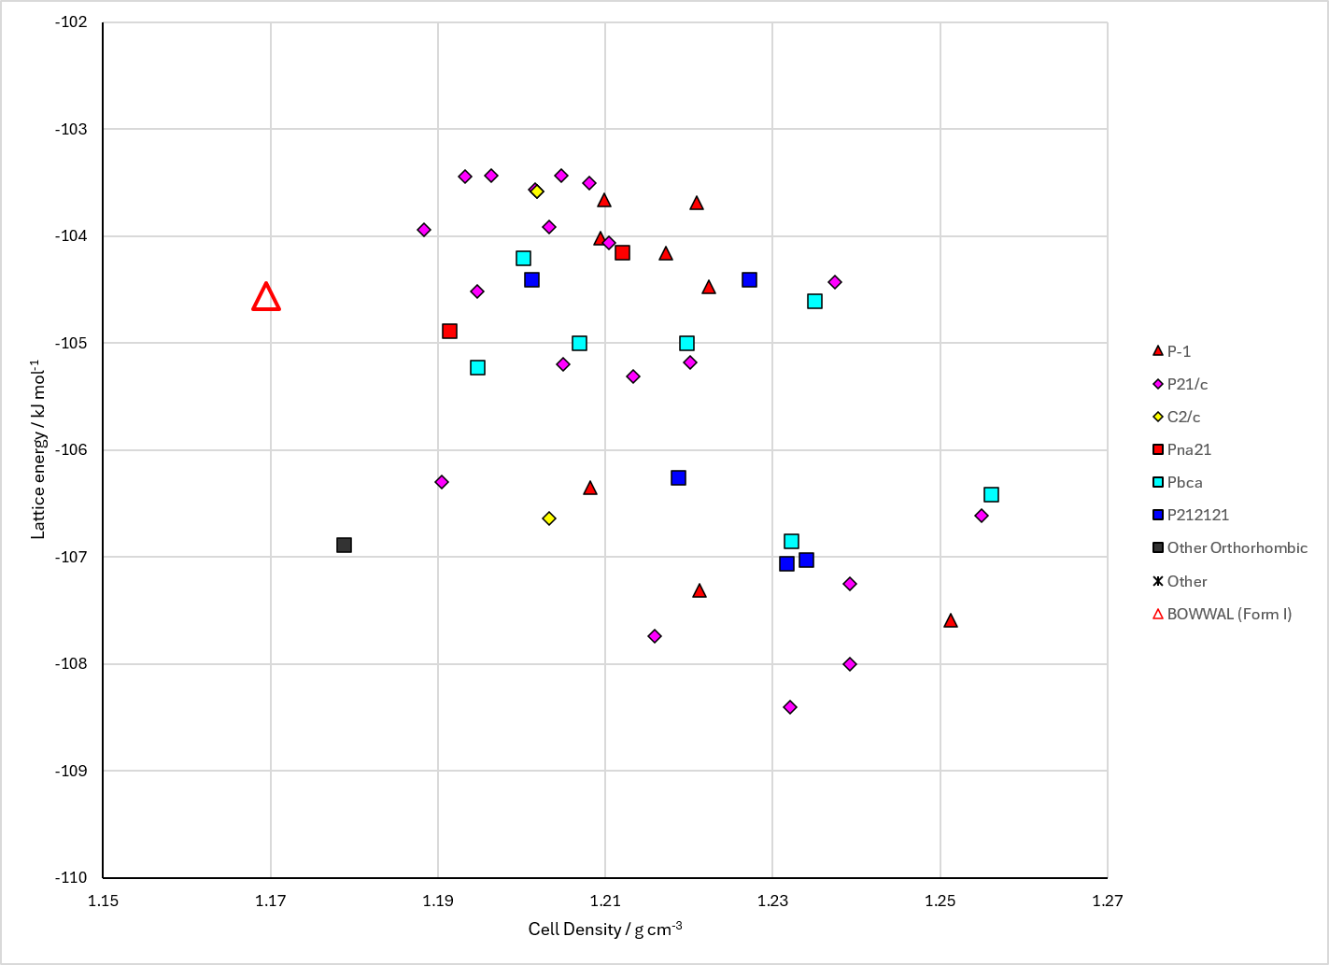
Figure 2. Crystal energy landscape of N-acetyl-iminostilbene from previous work.

CSD structures (CSD version 6.01 with Feb 2026 update)

Table 1. Crystallographic information for CSD entries for N-acetyl-iminostilbene. Different polymorphs are coloured differently.
REFCODE | space group | Z’ | a / Å | b / Å | c / Å | α / ° | β / ° | γ / ° | density / g cm⁻³ | Form
BOWWAL | R-3 | 1.0 | 36.0 | 36.0 | 5.43 | 90.0 | 90.0 | 120 | 1.1539 | None

Table 2. Experimental information for CSD entries for N-acetyl-iminostilbene.
REFCODE | space group | R factor | T / K | Year | Comments
BOWWAL | R-3 | 8.1 | None | 1983 | 10.1107/S0108270183004886

Make this table include whether polymorphs are solution-grown, sublimation grown, templated or otherwise. Add references.

Other notes

