Dihydrocarbamazepine
(Last updated December 2025)
Figure 1. The molecular diagram of Dihydrocarbamazepine.

CSP Studies
REFCODE | VACTAU
Formula | C15 H14 N2 O1
Common Name | dihydrocarbamazepine
IUPAC Systematic Name | 10,11-Dihydro-5H-dibenzo(b,f)azepine-5-carboxamide
Other Names
CSD Refcodes | VACTAU01, VACTAU02, VACTAU03, VACTAU04
Search Identifier | A
Scientist | Rui Guo
Date | 2016
Publication | Rui is working on it
Energy model | 1
Study_ID | 10
Programs | Flexible CrystalPredictor (2.1.01), CrystalOptimizer (2.4.m), DMACRYS (2.2.0.1)
Location on S Drive | /CHEMISTRY_CPOSS/CarbamazepineSeries/Dihydrocarbamazepine_CO
Potential Description | CrystalOptimizer with GDMA2.2(PBE1PBE/6-31G(d,p)) + FIT
Energy model | 2
Study_ID | 30
Programs | Study_ID=10, DMACRYS (2.2.0.1)
Location on S Drive | /CHEMISTRY_CPOSS/CarbamazepineSeries/Dihydrocarbamazepine_PCM
Potential Description | GDMA2.2(PCMdielectric3(PBE1PBE/6-31G(d,p))) + FIT
Search Identifier | B
Scientist | Sally Price
Date | 2010
Publication | No publication planned
Energy model | 1
Study_ID | 0
Programs | MOLPAK DMAREL (4.1.1)
Location on S Drive | CHEMISTRY_CPOSS\0-EarlySearches\home\louise_price.eminerals\dihydrocarbamazepine
Potential Description | MP2 6-31G(d,p) DMA + fit.pots
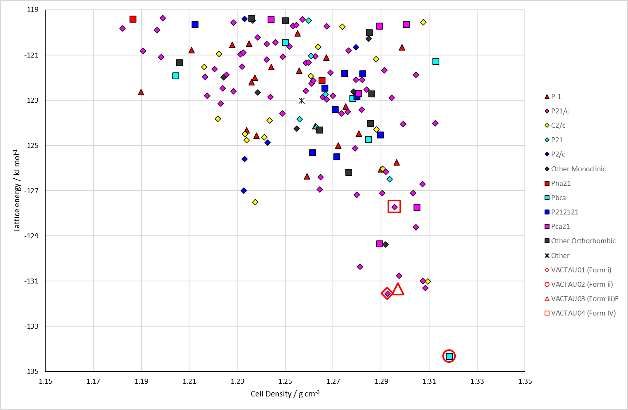
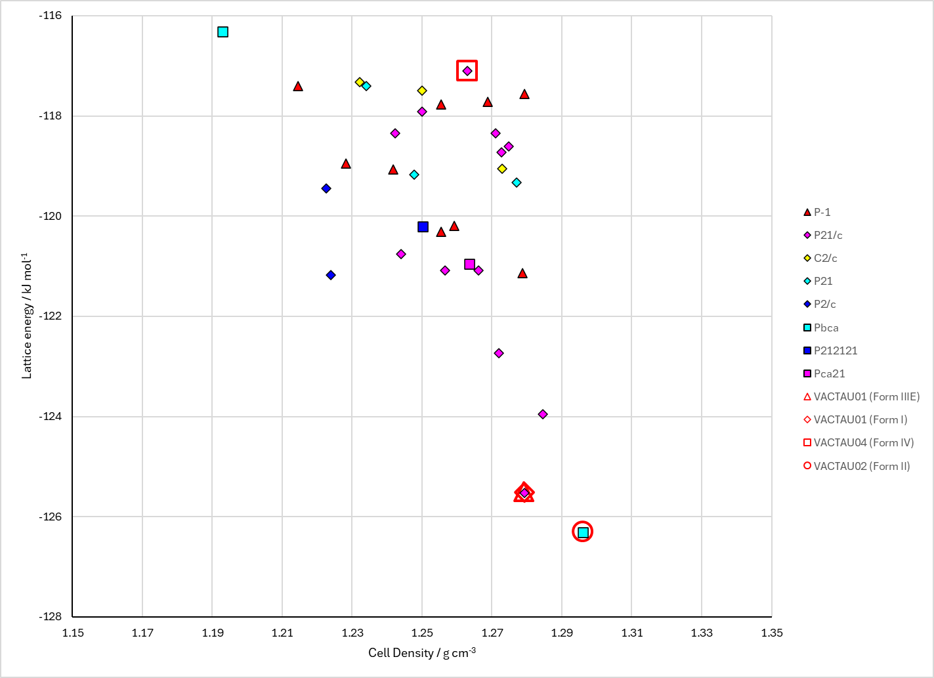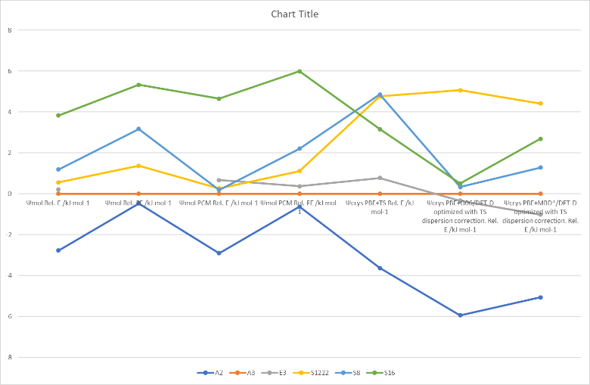
Figure 2. (Top) crystal energy landscape of Dihydrocarbamazepine from Study_ID=10. (Bottom left) crystal energy landscape of Dihydrocarbamazepine from Study_ID=0. (Bottom right) relative energies by method of key structures.

CSD structures (version 6.01)
Table 1. Crystallographic information for CSD entries for Dihydrocarbamazepine. Different polymorphs are coloured differently.
REFCODE | space group | Z’ | a / Å | b / Å | c / Å | α / ° | β / ° | γ / ° | density / g cm⁻³ | Form
VACTAU01 | P21/c | 1 | 5.505 | 9.158 | 24.266 | 90 | 95.95 | 90 | 1.301 | i
VACTAU02 | Pbca | 1 | 9.0592 | 10.3156 | 25.0534 | 90 | 90 | 90 | 1.352 | ii
VACTAU03 | P-1 | 2 | 5.4233 | 9.2 | 24.189 | 87.59 | 84.23 | 88.93 | 1.319 | iii
VACTAU04 | P21/c | 1 | 13.207 | 5.347 | 18.891 | 90 | 116.37 | 90 | 1.324 | IV

Table 2. Experimental information for CSD entries for Dihydrocarbamazepine.
REFCODE | space group | R factor | T / K | Year | Comments
VACTAU01 | P21/c | 4.1 |  | 1992 | Recrystallized from ethanol¹
VACTAU02 | Pbca | 4.16 | 120 | 2006 | Recrystallized from acetonitrile²
VACTAU03 | P-1 | 4.08 | 150 | 2007 | Recrystallized from methanol³
VACTAU04 | P21/c | 4.27 | 123 | 2010 | Grown from the vapour by sublimation⁴

Other notes
There is also a 1:1 solid solution of Carbamazepine and Dihydrocarbamazepine.⁵

1. G. Bandoli, M. Nicolini, A. Ongaro, G. Volpe and A. Rubello, Journal of Crystallographic and Spectroscopic Research, 1992, 22, 177-183.
2. W. T. A. Harrison, H. S. Yathirajan and H. G. Anilkumar, Acta Crystallographica Section C - Crystal Structure Communications, 2006, 62, o240-o242.
3. C. K. Leech, A. J. Florence, K. Shankland, N. Shankland and A. Johnston, Acta Crystallographica Section E - Structure Reports Online, 2007, 63, o675-o677.
4. J. B. Arlin, A. Johnston, G. J. Miller, A. R. Kennedy, S. L. Price and A. J. Florence, CrystEngComm, 2010, 12, 64-66.
5. A. J. Florence, C. K. Leech, N. Shankland, K. Shankland and A. Johnston, CrystEngComm, 2006, 8, 746-747.

