Chalcone
(Last updated January 2026)
Figure 1. The molecular diagram of Chalcone.

CSP studies
REFCODE | BZYACO
Formula | C15 H12 O1
Common Name | Chalcone
IUPAC Systematic Name | (2E)-1,3-diphenylprop-2-en-1-one
Other Names | Benzylidene acetophenone
CSD Refcodes | BZYACO, BZYACO03
Search Identifier | A
Scientist | Louise Price
Date | 2018
Publication | Price LS, Price SL 2022 Cryst Growth Des 22, 1801-1816
Energy model | 1
Study_ID | 10
Programs | flexible CrystalPredictor (2.2), CrystalOptimizer (2.4.7), DMACRYS (2.3.0)
Location on S Drive | \CHEMISTRY_CPOSS\MagnaPharm\Chalcones\CrystalOptimizer
Potential Description | CrystalOptimizer with GDMA2.2(PBE0/6-31G(d,p)) + FIT
Intramolecular Description | PBE0/6-31G(d,p)

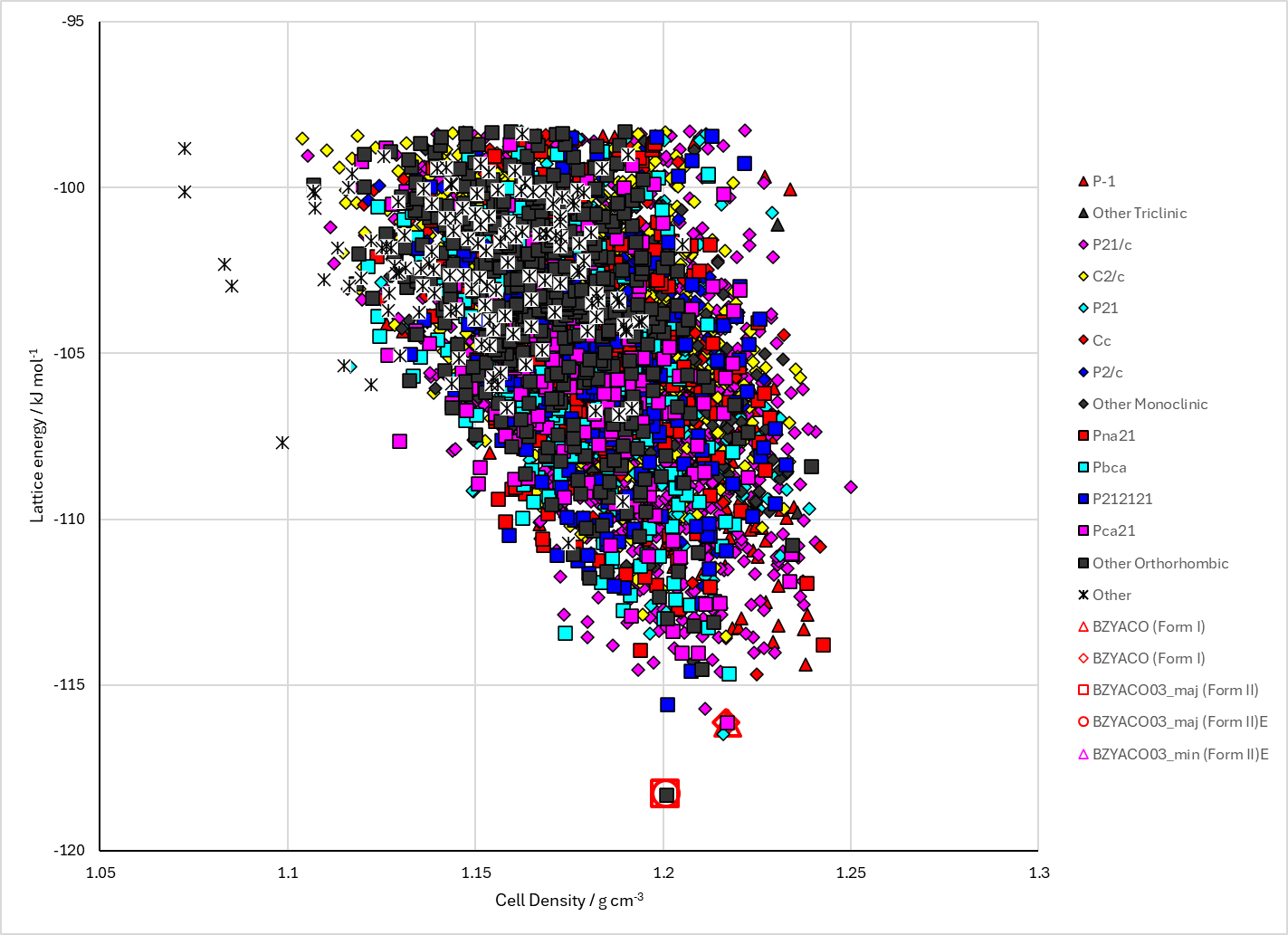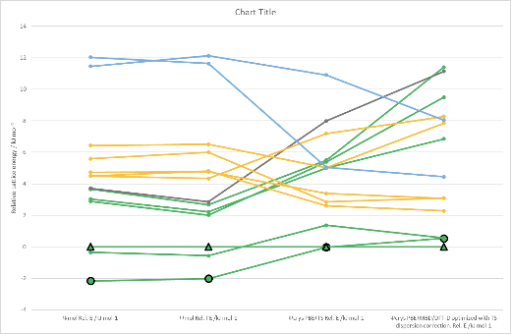
Figure 2. Crystal energy landscape of Chalcone from previous work.

CSD structures (CSD version 5.45 with Nov 2023 updates)
Table 1. Crystallographic information for CSD entries for Chalcone. Different polymorphs are coloured differently.
REFCODE | space group | Z’ | a / Å | b / Å | c / Å | α / ° | β / ° | γ / ° | density / g cm⁻³ | Form
BZYACO | Pbc21 | 1 | 12.747 | 11.553 | 7.689 | 90 | 90 | 90 | 1.222 | Pbc21
BZYACO01 | Pbcn | 1 | 10.9 | 11.9 | 17.93 | 90 | 90 | 90 | 1.19 | Pbcn
BZYACO02 | Pca21 | 1 | 11.553 | 12.769 | 7.689 | 90 | 90 | 90 | 1.22 | Pca21
BZYACO03 | Pbcn | 1 | 10.9322 | 11.86 | 17.996 | 90 | 90 | 90 | 1.186 | Pbcn
BZYACO04 | Pbcn | 1 | 10.982 | 11.919 | 18.029 | 90 | 90 | 90 | 1.172 | Pbcn

Table 2. Experimental information for CSD entries for Chalcone.
REFCODE | space group | R factor | T / K | Year | Comments
BZYACO | Pbc21 | 5.5 | 295 | 1970 | Grown from slowly cooled ethanol solutions¹
BZYACO01 | Pbcn | 11 | 295 | 1973 | Slow evaporation from ether solution²
BZYACO02 | Pca21 | 0 | 295 | 1994 | Synthesis intermediate³
BZYACO03 | Pbcn | 6.25 | 292 | 2006 | Recrystallized from 2-propanol, 88:12 disorder of oxygen atom⁴
BZYACO04 | Pbcn | 7.19 | 296 | 2012 | Private comminication

Make this table include whether polymorphs are solution-grown, sublimation grown, templated or otherwise. Add references.

Other notes

1. D. Rabinovich, Journal of the Chemical Society B: Physical Organic, 1970, 11-16.
2. K. Ohkura, S. Kashino and M. Haisa, Bulletin of the Chemical Society of Japan, 1973, 46, 627-628.
3. H. Arai, Y. Higashigaki, M. Gotoh and S. Yano, Japanese Journal of Applied Physics, 1994, 33, 5755-5758.
4. M. H. Wu, X. H. Yang, W. D. Zou, W. J. Liu and C. Li, Zeitschrift Fur Kristallographie-New Crystal Structures, 2006, 221, 323-324.

