Caffeine Paracetamol cocrystal
(Last updated May 2026)
Figure 1. The molecular diagrams of Caffeine and Paracetamol.

CSP studies
REFCODE | UCLDKB
Formula | C8 H10 N4 O2 - C8 H9 N1 O2
Common Name | Caffeine paracetamol cocrystal
IUPAC Systematic Name | 1,3,7-trimethyl-2,6-dioxypurine - N-(4-hydroxyphenyl)acetamide
Other Names
CSD Refcodes
Search Identifier | A
Scientist | Louise Price
Date | 2019
Publication | Kreso Bucar is leading
Energy model | 1
Study_ID | 60
Programs | Flexible CrystalPredictor (2), DFTB3-D3, DMACRYS (2.3.0)
Location on S Drive | \CHEMISTRY_CPOSS\Caffeine_Paracetamol\Caffeine_Paracetamol
Potential Description | CrystalPredictor, followed by DFTB3-D3 refinement, followed by DMACRYS with GDMA2.2(PBE0/6-31G(d,p)) + FIT
Intramolecular Description | PBE0/6-31G(d,p)

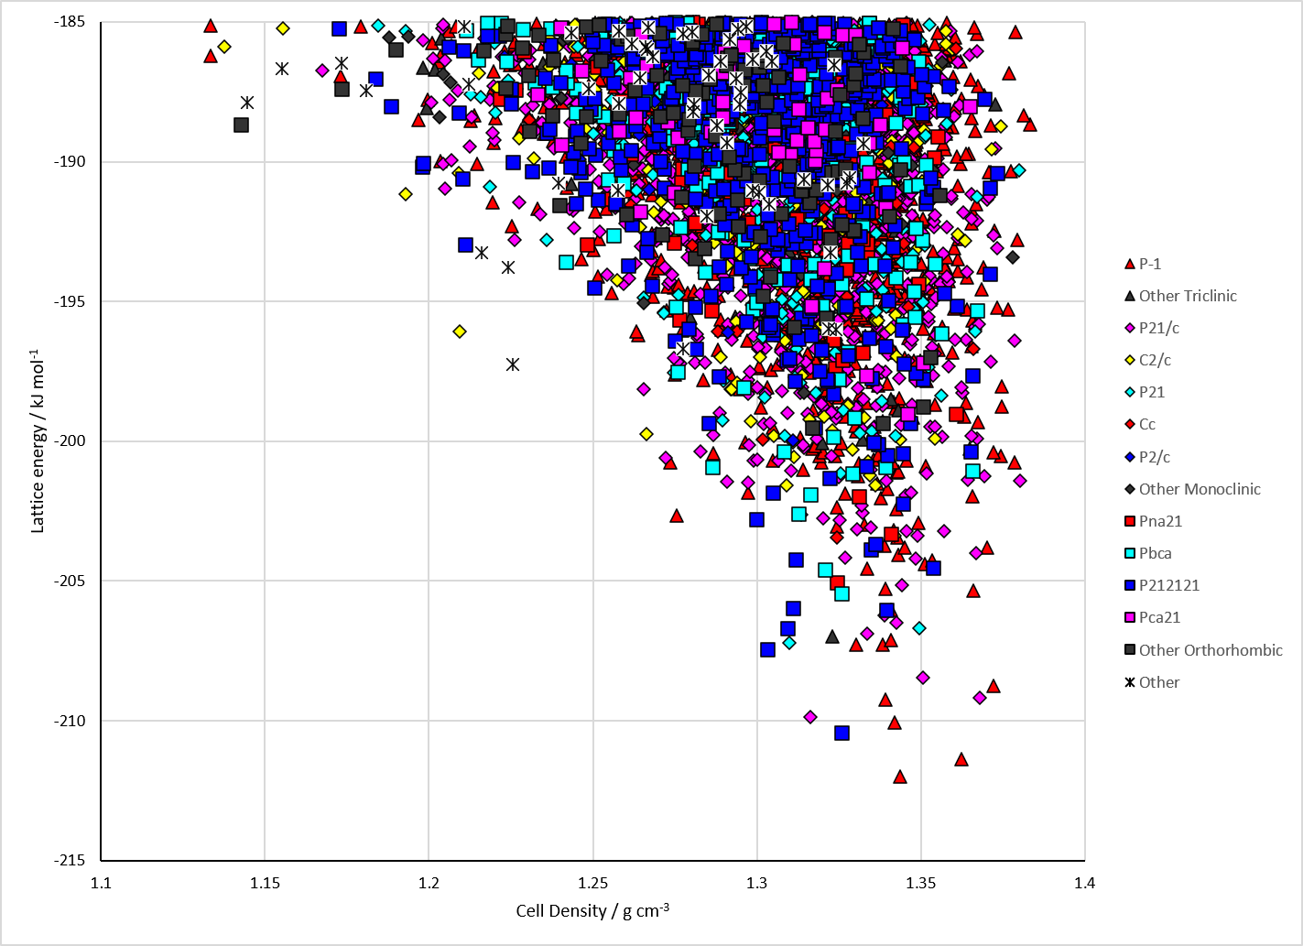
Figure 2. Crystal energy landscape of Caffeine Paracetamol cocrystal from previous work.

CSD structures (CSD version 6.01 with Feb 2026 update)

Table 1. Crystallographic information for CSD entries for Caffeine Paracetamol cocrystal. Different polymorphs are coloured differently.
REFCODE | space group | Z’ | a / Å | b / Å | c / Å | α / ° | β / ° | γ / ° | density / g cm⁻³ | Form

Table 2. Experimental information for CSD entries for Caffeine Paracetamol cocrystal.
REFCODE | space group | R factor | T / K | Year | Comments

Make this table include whether polymorphs are solution-grown, sublimation grown, templated or otherwise. Add references.

Other notes

