Caffeine Hydroxybenzoic Acid cocrystals
(Last updated May 2026)
Figure 1. The molecular diagrams of Caffeine and Hydroxybenzoic Acids.

CSP studies
REFCODE | XOBCAT
Formula | C8 H10 N4 O2 - C7 H6 O3
Common Name | caffeine - salicylic acid
IUPAC Systematic Name | 3,7-dihydro-1,3,7-trimethyl-1H-purine-2,6-dione - 2-hydroxybenzoic acid
Other Names | caffeine - 2-hydroxybenzoic acid
CSD Refcodes | XOBCAT
Search Identifier | A
Scientist | Matthew Habgood
Date | 2010
Publication | Habgood M, Price SL 2010. Cryst Growth Des 10, 3263-3272.
Energy model | 1
Study_ID | 20
Programs | Rigid CrystalPrecictor, DMACRYS (1.1.1)
Location on S Drive | \CHEMISTRY_CPOSS\0-EarlySearches\home\louise_price.eminerals\Caffeine_SalicylicAcid
Potential Description | DMA + FIT
Intramolecular Description | MP2/6-31G(d,p)
REFCODE | MOZCOU
Formula | C8 H10 N4 O2 - C7 H6 O3
Common Name | caffeine - 3-hydroxybenzoic acid
IUPAC Systematic Name | 3,7-dihydro-1,3,7-trimethyl-1H-purine-2,6-dione - 3-hydroxybenzoic acid
Other Names
CSD Refcodes | MOZCOU
Search Identifier | A
Scientist | Matthew Habgood
Date | 2010
Publication | Habgood M, Price SL 2010. Cryst Growth Des 10, 3263-3272.
Energy model | 1
Study_ID | 20
Programs | Rigid CrystalPrecictor, DMACRYS (1.1.1)
Location on S Drive | \CHEMISTRY_CPOSS\0-EarlySearches\home\louise_price.eminerals\Caffeine_3HydroxyBenzoicAcid
Potential Description | DMA + FIT
Intramolecular Description | MP2/6-31G(d,p)
REFCODE | UCLMHC
Formula | C8 H10 N4 O2 - C7 H6 O3
Common Name | caffeine - 4-hydroxybenzoic acid
IUPAC Systematic Name | 3,7-dihydro-1,3,7-trimethyl-1H-purine-2,6-dione - 4-hydroxybenzoic acid
Other Names
CSD Refcodes | MOZCUA & MOZDAH are 2-1 and 1-2 cocrystals
Search Identifier | A
Scientist | Matthew Habgood
Date | 2010
Publication | Habgood M, Price SL 2010. Cryst Growth Des 10, 3263-3272.
Energy model | 1
Study_ID | 20
Programs | Rigid CrystalPrecictor, DMACRYS (1.1.1)
Location on S Drive | \CHEMISTRY_CPOSS\0-EarlySearches\home\louise_price.eminerals\Caffeine_4HydroxyBenzoicAcid
Potential Description | DMA + FIT
Intramolecular Description | MP2/6-31G(d,p)
REFCODE | MOZDAH
Formula | C8 H10 N4 O2 - 2(C7 H6 O3)
Common Name | caffeine - bis 4-hydroxybenzoic acid
IUPAC Systematic Name | 3,7-dihydro-1,3,7-trimethyl-1H-purine-2,6-dione - bis(4-hydroxybenzoic acid)
Other Names
CSD Refcodes | MOZDAH
Search Identifier | A
Scientist | Matthew Habgood
Date | 2010
Publication | Habgood M, Price SL 2010. Cryst Growth Des 10, 3263-3272.
Energy model | 1
Study_ID | 20
Programs | Rigid CrystalPrecictor, DMACRYS (1.1.1)
Location on S Drive | \CHEMISTRY_CPOSS\0-EarlySearches\home\louise_price.eminerals\Caffeine_bis4HydroxyBenzoicAcid
Potential Description | DMA + FIT
Intramolecular Description | MP2/6-31G(d,p)

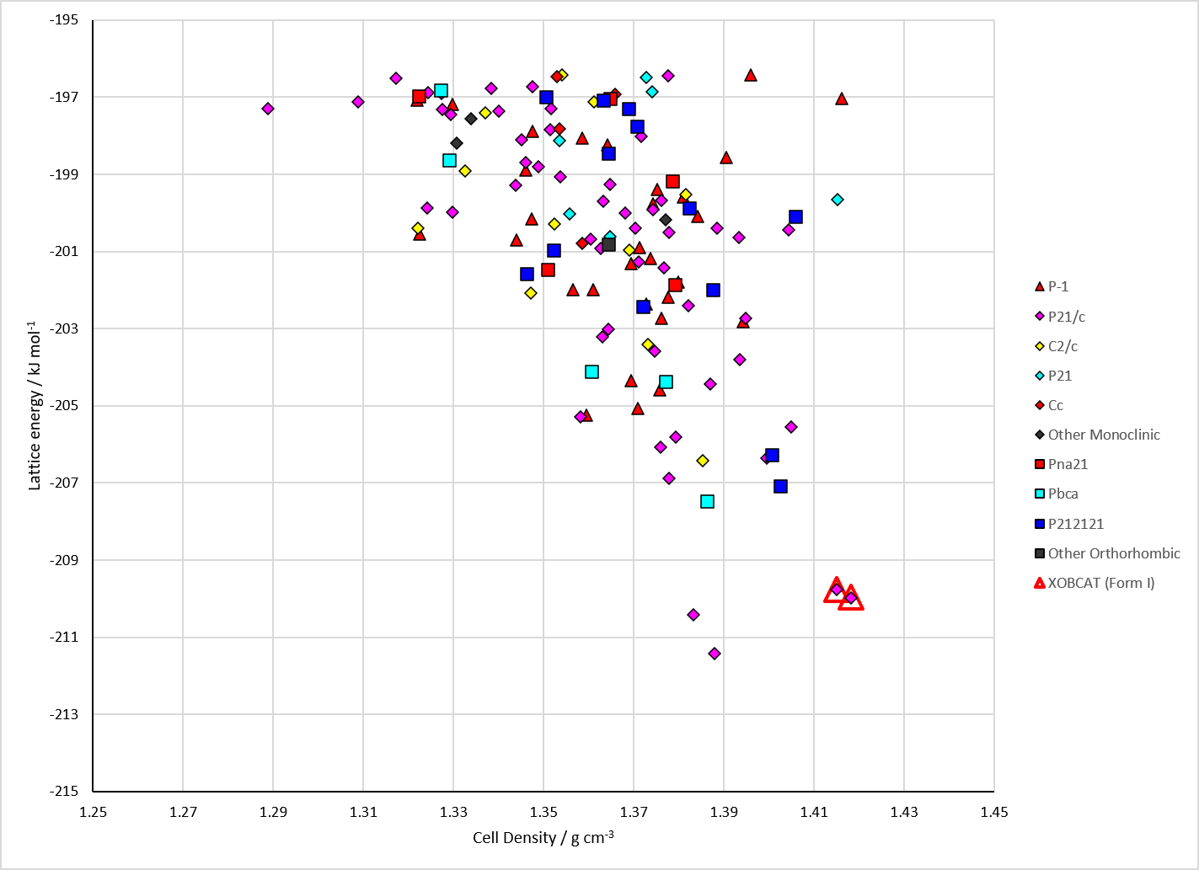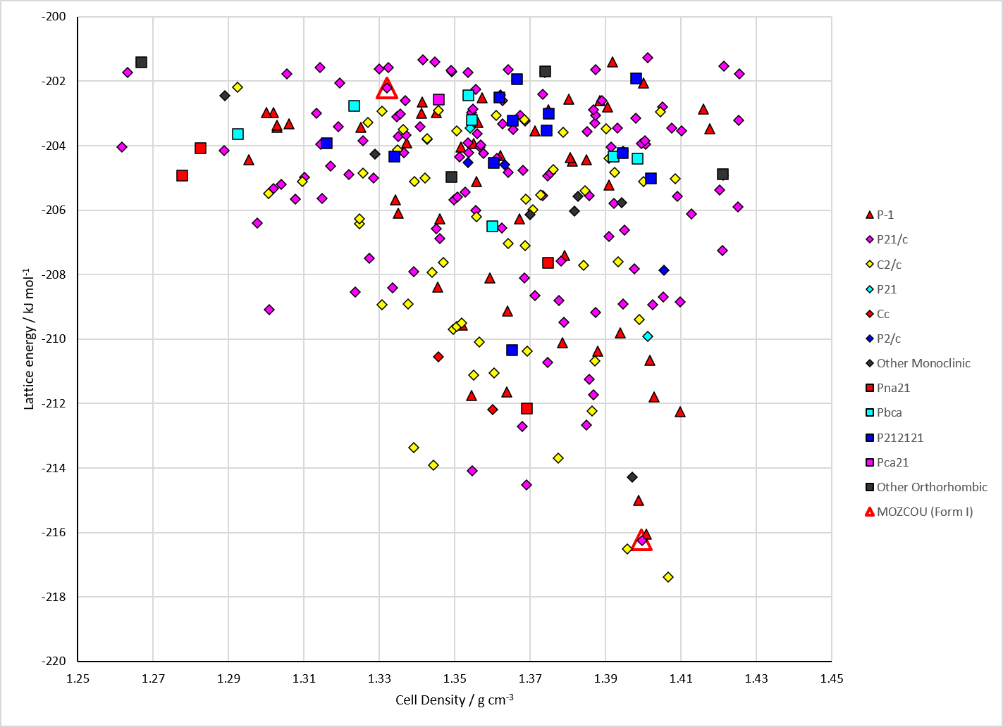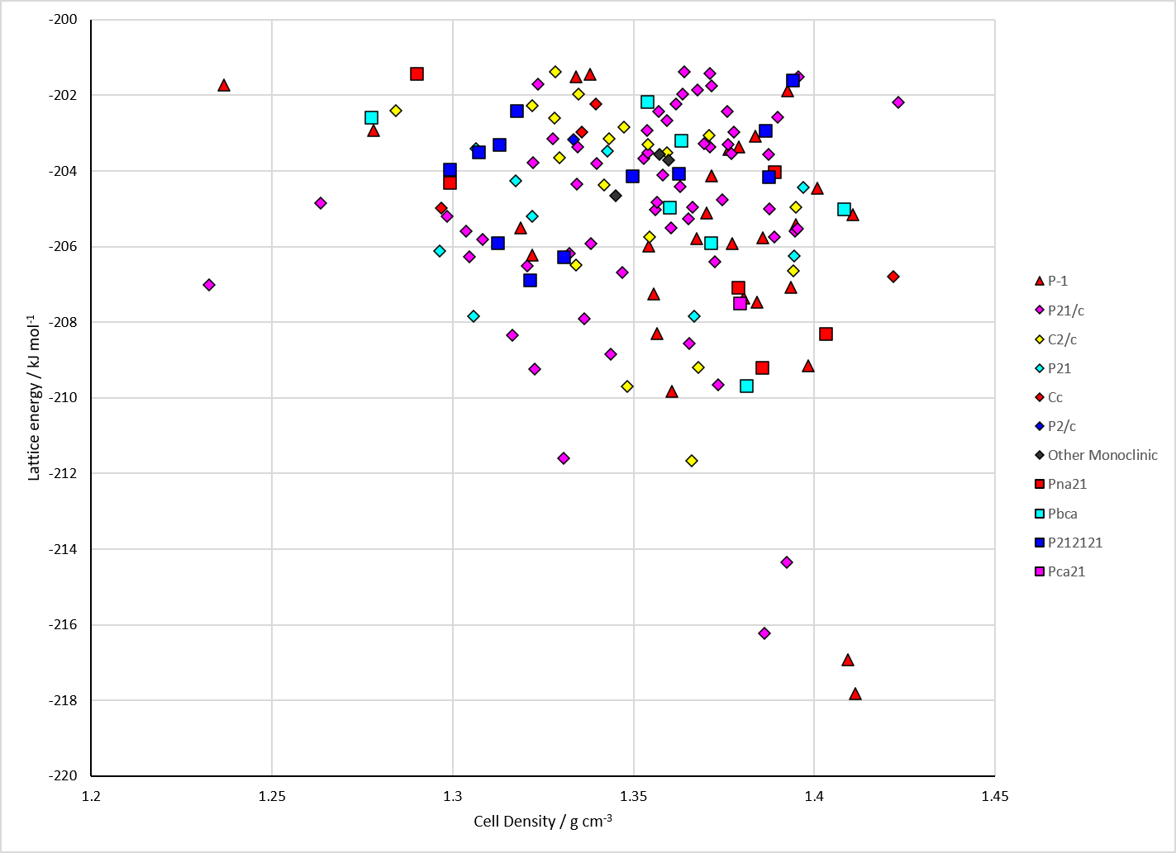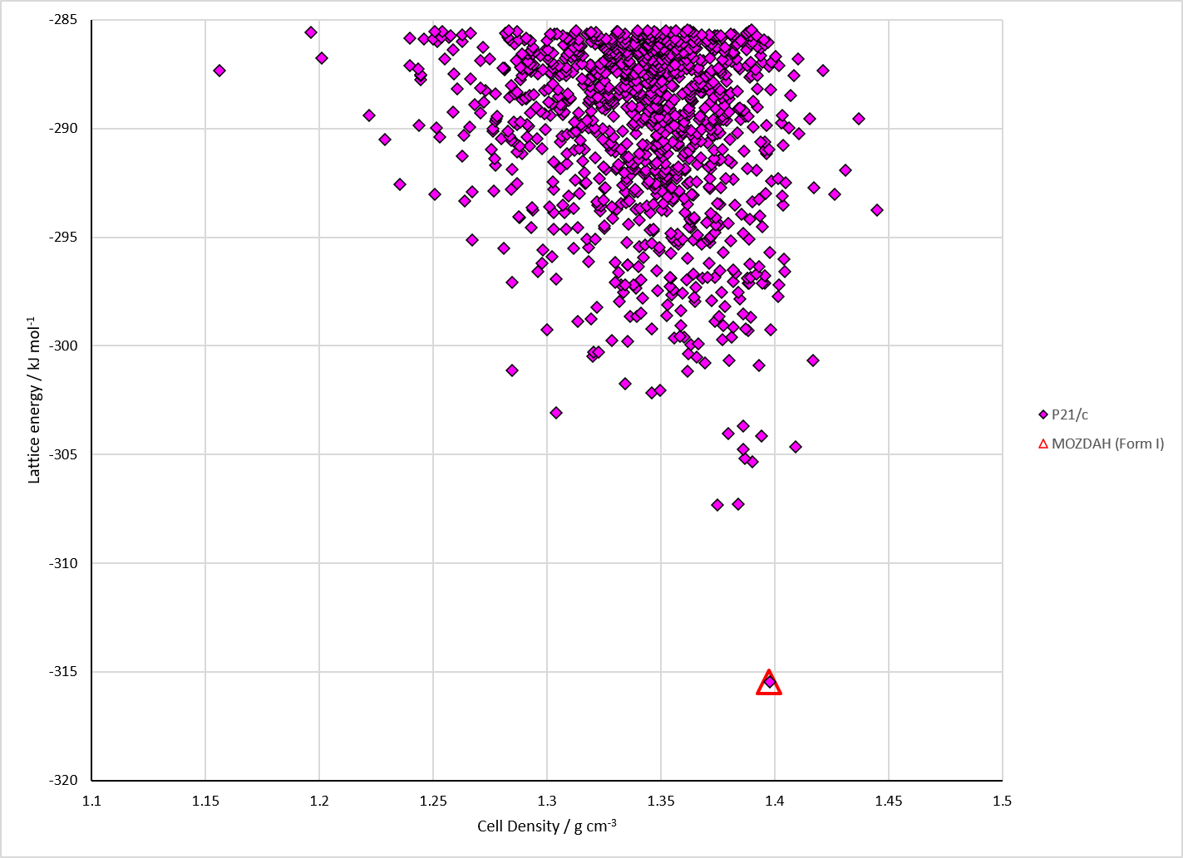
Figure 2. Crystal energy landscape of Caffeine Hydroxybenzoic Acid cocrystals from previous work. Top left: Caffeine 2-hydroxybenzoic acid (salicylic acid). Top right: Caffeine 3-hydroxybenzoic acid. Bottom left: Caffeine 4-hydroxybenzoic acid. Bottom right: Caffeine 4-hydroxybenzoic acid 1:2 cocrystal.

CSD structures (CSD version 6.01 with Feb 2026 update)

Table 1. Crystallographic information for CSD entries for Caffeine Hydroxybenzoic Acid cocrystals. Different polymorphs are coloured differently.
REFCODE | space group | Z’ | a / Å | b / Å | c / Å | α / ° | β / ° | γ / ° | density / g cm⁻³ | Form
XOBCAT | P21/n | 1.0 | 14.728 | 6.99700 | 16.148 | 90.0 | 117.07400 | 90.0 | 1.4896 | None
XOBCAT01 | P21/c | 1.0 | 14.771 | 7.0212 | 16.209 | 90.0 | 117.194 | 90.0 | 1.4762 | None
MOZCOU | P21/c | 1.0 | 7.687 | 6.948 | 28.098 | 90.0 | 95.029 | 90.0 | 1.4765 | None
MOZCUA | P21/n | 1.0 | 9.938 | 16.537 | 14.7580 | 90.0 | 101.096 | 90.0 | 1.4693 | None
MOZDAH | P21/c | 1.0 | 7.421 | 22.494 | 12.939 | 90.0 | 92.242 | 90.0 | 1.4477 | None

Table 2. Experimental information for CSD entries for Caffeine Hydroxybenzoic Acid cocrystals.
REFCODE | space group | R factor | T / K | Year | Comments
XOBCAT | P21/n | 4.58 | at 173 K | 2008 | 10.1039/B801713C
XOBCAT01 | P21/c | 5.73 | at 173 K | 2009 | 10.1021/cg801178m
MOZCOU | P21/c | 6.36 | at 173 K | 2009 | 10.1021/cg801178m
MOZCUA | P21/n | 4.46 | at 173 K | 2009 | 10.1021/cg801178m
MOZDAH | P21/c | 9.24 | at 173 K | 2009 | 10.1021/cg801178m

Make this table include whether polymorphs are solution-grown, sublimation grown, templated or otherwise. Add references.

Other notes
OPoint and NPoint at the names of the rigid conformations of CAFFEINE. They relate to one methyl group having a hydrogen on the side of CO or N in the plane of the molecule. There is only one conformation of hydroxybenzoic acid, although there should probably be more.

