DiChloroNitroBenzenes
(Last updated April 2026)
Figure 1. The molecular diagrams of 2,3-dichloronitrobenzene, 2,4-dichloronitrobenzene, 2,5-dichloronitrobenzene, 2,6-dichloronitrobenzene, 3,4-dichloronitrobenzene, and 3,5-dichloronitrobenzene.

CSP studies

REFCODE | DOXWIW
Formula | C6 H3 N1 O2 Cl2
Common Name | 2,3-Dichloronitrobenzene
IUPAC Systematic Name | 1,2-Dichloro-3-nitrobenzene
Other Names | 1-Nitro-2,3-dichlorobenzene; 2,3-Dichloro-1-nitrobenzene
CSD Refcodes | DOXWIW
Search Identifier | A
Scientist | Sarah Barnett
Date | 2005-2008
Publication | Barnett SA, Johnston A, Florence AJ, Price SL, Tocher DA, 2008. Cryst. Growth Des. 8, 24-36
Energy Model | 1
Study_ID | 0 (published)
Programs | Molpak, DMAREL (3.0)
Location on S Drive | \CHEMISTRY_CPOSS\0-EarlySearches\home\louise_price.eminerals\2,3-dichloronitrobenzene
Potential Description | Isotropic RiceDay potential. All parameters taken from the Rice potential. Isotropic chlorine parameters from Day potential added.
Search Identifier | B
Scientist | Louise Price
Date | January 2024
Publication | No publication planned.
Energy Model | 1
Study_ID | 20
Programs | Flexible CrystalPredictor (2.4.3), DMACRYS (2.3.1.1)
Location on S Drive | /CHEMISTRY_CPOSS/DiChloroNitroBenzene/23dcnb/CrystPred/
Potential Description | Flexible CrystalPredictor + DMACRYS with GDMA2.2(PBE0/6-31G(d,p)) + FIT
Energy Model | 2
Study_ID | 10
Programs | Study_ID=20, CrystalOptimizer (2.4.7.1), DMACRYS (2.3.1.1)
Location on S Drive | /CHEMISTRY_CPOSS/DiChloroNitroBenzene/23dcnb/CrystOpt/
Potential Description | CrystalOptimizer with GDMA2.2(PBE0/6-31G(d,p)) + FIT
Energy Model | 3
Study_ID | 30
Programs | Study_ID=10, DMACRYS (2.3.1.1)
Location on S Drive | /CHEMISTRY_CPOSS/DiChloroNitroBenzene/23dcnb/PCM/
Potential Description | GDMA2.2(PCMdielectric3(PBE0/6-31G(d,p))) + FIT
REFCODE | JIWQEM
Formula | C6 H3 N1 O2 Cl2
Common Name | 2,4-Dichloronitrobenzene
IUPAC Systematic Name | 1,3-Dichloro-4-nitrobenzene
Other Names | 1-Nitro-2,4-dichlorobenzene
CSD Refcodes | JIWQEM
Search Identifier | A
Scientist | Sarah Barnett
Date | 2005-2008
Publication | Barnett SA, Johnston A, Florence AJ, Price SL, Tocher DA, 2008. Cryst. Growth Des. 8, 24-36
Energy Model | 1
Study_ID | 0 (published)
Programs | Molpak, DMAREL (4.1.1)
Location on S Drive | \CHEMISTRY_CPOSS\0-EarlySearches\home\louise_price.eminerals\2,4-dichloronitrobenzene
Potential Description | Isotropic RiceDay potential. All parameters taken from the Rice potential. Isotropic chlorine parameters from Day potential added.
Search Identifier | B
Scientist | Louise Price
Date | January 2024
Publication | No publication planned.
Energy Model | 1
Study_ID | 20
Programs | Flexible CrystalPredictor (2.4.3), DMACRYS (2.3.1.1)
Location on S Drive | /CHEMISTRY_CPOSS/DiChloroNitroBenzene/24dcnb/CrystPred/
Potential Description | Flexible CrystalPredictor + DMACRYS with GDMA2.2(PBE0/6-31G(d,p)) + FIT
Energy Model | 2
Study_ID | 10
Programs | Study_ID=20, CrystalOptimizer (2.4.7.1), DMACRYS (2.3.1.1)
Location on S Drive | /CHEMISTRY_CPOSS/DiChloroNitroBenzene/24dcnb/CrystOpt/
Potential Description | CrystalOptimizer with GDMA2.2(PBE0/6-31G(d,p)) + FIT
Energy Model | 3
Study_ID | 30
Programs | Study_ID=10, DMACRYS (2.3.1.1)
Location on S Drive | /CHEMISTRY_CPOSS/DiChloroNitroBenzene/24dcnb/PCM/
Potential Description | GDMA2.2(PCMdielectric3(PBE0/6-31G(d,p))) + FIT
REFCODE | ZZZEKW
Formula | C6 H3 N1 O2 Cl2
Common Name | 2,5-Dichloronitrobenzene
IUPAC Systematic Name | 1,4-Dichloro-2-nitrobenzene
Other Names | 1-Nitro-2,5-dichlorobenzene
CSD Refcodes | ZZZEKW02
Search Identifier | A
Scientist | Sarah Barnett
Date | 2005-2008
Publication | Barnett SA, Johnston A, Florence AJ, Price SL, Tocher DA, 2008. Cryst. Growth Des. 8, 24-36
Energy model | 1
Study_ID | 0 (published)
Programs | Molpak, DMAREL (4.1.1)
Location on S Drive | \CHEMISTRY_CPOSS\0-EarlySearches\home\louise_price.eminerals\2,5-dichloronitrobenzene
Potential Description | Isotropic RiceDay potential. All parameters taken from the Rice potential. Isotropic chlorine parameters from Day potential added.
Search Identifier | B
Scientist | Louise Price
Date | January 2024
Publication | No publication planned.
Energy Model | 1
Study_ID | 20
Programs | Flexible CrystalPredictor (2.4.3), DMACRYS (2.3.1.1)
Location on S Drive | /CHEMISTRY_CPOSS/DiChloroNitroBenzene/25dcnb/CrystPred/
Potential Description | Flexible CrystalPredictor + DMACRYS with GDMA2.2(PBE0/6-31G(d,p)) + FIT
Energy Model | 2
Study_ID | 10
Programs | Study_ID=20, CrystalOptimizer (2.4.7.1), DMACRYS (2.3.1.1)
Location on S Drive | /CHEMISTRY_CPOSS/DiChloroNitroBenzene/25dcnb/CrystOpt/
Potential Description | CrystalOptimizer with GDMA2.2(PBE0/6-31G(d,p)) + FIT
Energy Model | 3
Study_ID | 30
Programs | Study_ID=10, DMACRYS (2.3.1.1)
Location on S Drive | /CHEMISTRY_CPOSS/DiChloroNitroBenzene/25dcnb/PCM/
Potential Description | GDMA2.2(PCMdielectric3(PBE0/6-31G(d,p))) + FIT
REFCODE | UCLSBA
Formula | C6 H3 N1 O2 Cl2
Common Name | 2,6-Dichloronitrobenzene
IUPAC Systematic Name | 1,3-Dichloro-2-nitrobenzene
Other Names | 1-Nitro-2,6-dichlorobenzene
CSD Refcodes
Search Identifier | A
Scientist | Sarah Barnett
Date | 2005-8
Publication | Barnett, S.A.; Johnston, A.; Florence, A.J.; Price, S.L.; Tocher, D.A. 2008. Cryst. Growth Des. 8, 24-36.
Energy model | 1
Study_ID | 0
Programs | MOLPAK, DMAREL (4.1.1)
Location on S Drive | \CHEMISTRY_CPOSS\0-EarlySearches\home\louise_price.eminerals\2,6-dichloronitrobenzene
Potential Description | Isotropic RiceDay potential. All parameters taken from the Rice potential. Isotropic chlorine parameters from Day potential added.
Intramolecular Description | MP2/6-31G(d,p)
REFCODE | CAGPUV
Formula | C6 H3 N1 O2 Cl2
Common Name | 3,4-Dichloronitrobenzene
IUPAC Systematic Name | 1,2-Dichloro-4-nitrobenzene
Other Names | 1-Nitro-3,4-dichlorobenzene
CSD Refcodes | CAGPUV01
Search Identifier | A
Scientist | Sarah Barnett
Date | 2005-2008
Publication | Barnett SA, Johnston A, Florence AJ, Price SL, Tocher DA, 2008. Cryst. Growth Des. 8, 24-36.
Energy Model | 1
Study_ID | 0 (published)
Programs | MOLPAK, DMAREL (3.0)
Location on S Drive | \CHEMISTRY_CPOSS\0-EarlySearches\home\louise_price.eminerals\3,5-dichloronitrobenzene
Potential Description | Isotropic RiceDay potential. All parameters taken from the Rice potential. Isotropic chlorine parameters from Day potential added.
Search Identifier | B
Scientist | Louise Price
Date | January 2024
Publication | No publication planned.
Energy Model | 1
Study_ID | 20
Programs | Flexible CrystalPredictor (2.4.3), DMACRYS (2.3.1.1)
Location on S Drive | /CHEMISTRY_CPOSS/DiChloroNitroBenzene/34dcnb/CrystPred/
Potential Description | Flexible CrystalPredictor + DMACRYS with GDMA2.2(PBE0/6-31G(d,p)) + FIT
Energy Model | 2
Study_ID | 10
Programs | Study_ID=20, CrystalOptimizer (2.4.7.1), DMACRYS (2.3.1.1)
Location on S Drive | /CHEMISTRY_CPOSS/DiChloroNitroBenzene/34dcnb/CrystOpt/
Potential Description | CrystalOptimizer with GDMA2.2(PBE0/6-31G(d,p)) + FIT
Energy Model | 3
Study_ID | 30
Programs | Study_ID=10, DMACRYS (2.3.1.1)
Location on S Drive | /CHEMISTRY_CPOSS/DiChloroNitroBenzene/34dcnb/PCM/
Potential Description | GDMA2.2(PCMdielectric3(PBE0/6-31G(d,p))) + FIT
REFCODE | HIBWEU
Formula | C6 H3 N1 O2 Cl2
Common Name | 3,5-Dichloronitrobenzene
IUPAC Systematic Name | 1,3-Dichloro-5-nitrobenzene
Other Names | 1-Nitro-3,5-dichlorobenzene
CSD Refcodes | HIBWEU02
Search Identifier | A
Scientist | Sarah Barnett
Date | 2005-2008
Publication | Barnett SA, Johnston A, Florence AJ, Price SL, Tocher DA, 2008. Cryst. Growth Des. 8, 24-36.
Energy Model | 1
Study_ID | 0 (published)
Programs | MOLPAK, DMAREL (4.1.1)
Location on S Drive | \CHEMISTRY_CPOSS\0-EarlySearches\home\louise_price.eminerals\3,5-dichloronitrobenzene
Potential Description | Isotropic RiceDay potential. All parameters taken from the Rice potential. Isotropic chlorine parameters from Day potential added.
Search Identifier | B
Scientist | Louise Price
Date | January 2024
Publication | No publication planned.
Energy Model | 1
Study_ID | 20
Programs | Flexible CrystalPredictor (2.4.3), DMACRYS (2.3.1.1)
Location on S Drive | /CHEMISTRY_CPOSS/DiChloroNitroBenzene/35dcnb/CrystPred/
Potential Description | Flexible CrystalPredictor + DMACRYS with GDMA2.2(PBE0/6-31G(d,p)) + FIT
Energy Model | 2
Study_ID | 10
Programs | Study_ID=20, CrystalOptimizer (2.4.7.1), DMACRYS (2.3.1.1)
Location on S Drive | /CHEMISTRY_CPOSS/DiChloroNitroBenzene/35dcnb/CrystOpt/
Potential Description | CrystalOptimizer with GDMA2.2(PBE0/6-31G(d,p)) + FIT
Energy Model | 3
Study_ID | 30
Programs | Study_ID=10, DMACRYS (2.3.1.1)
Location on S Drive | /CHEMISTRY_CPOSS/DiChloroNitroBenzene/35dcnb/PCM/
Potential Description | GDMA2.2(PCMdielectric3(PBE0/6-31G(d,p))) + FIT

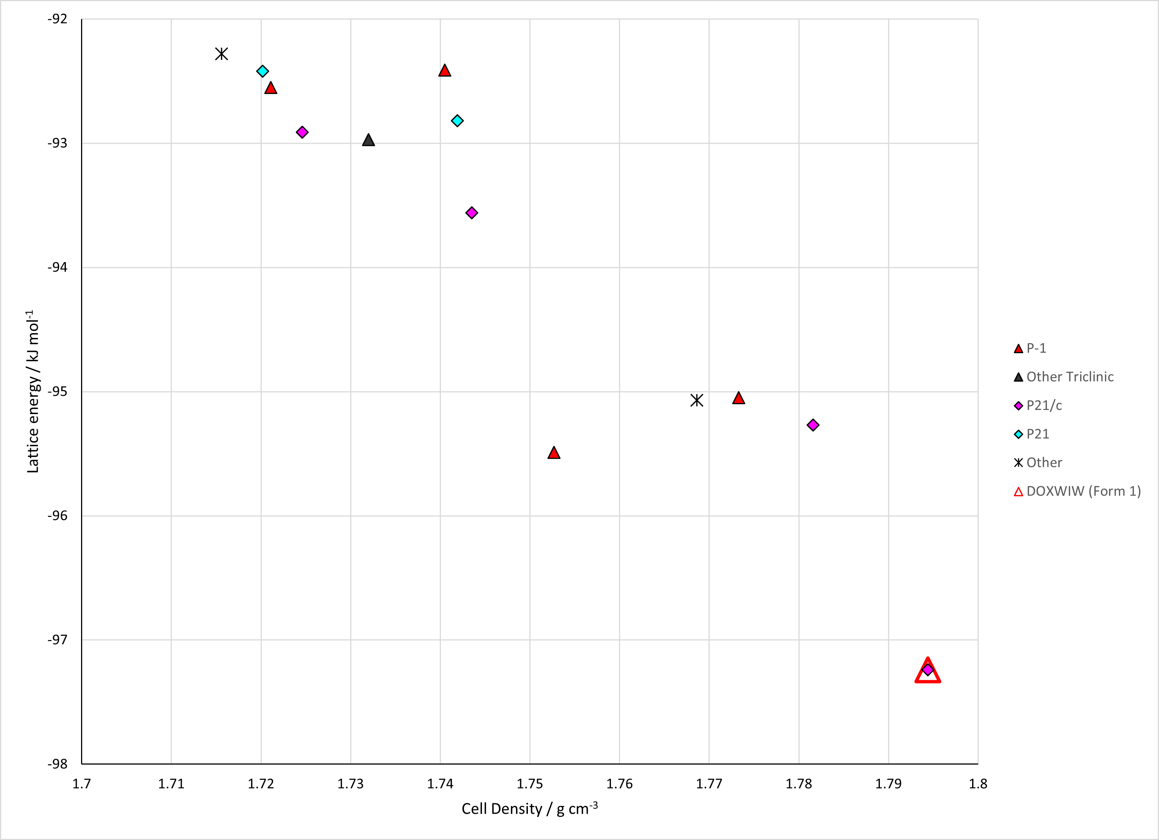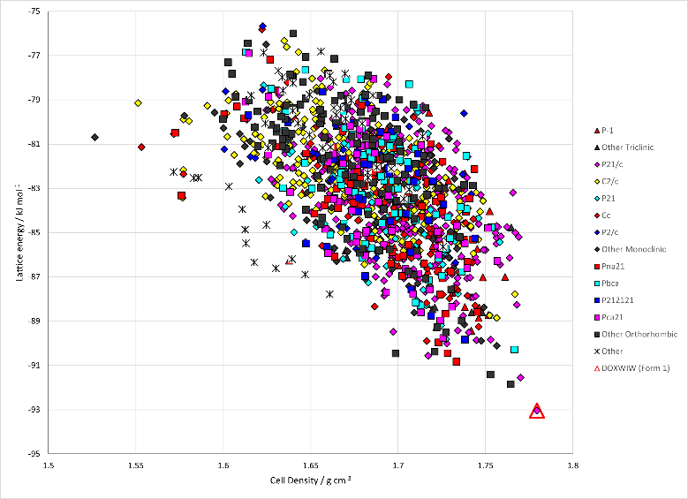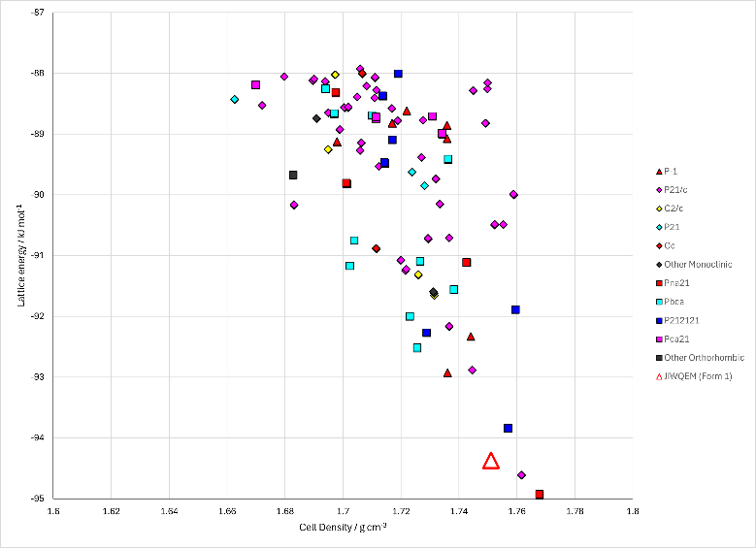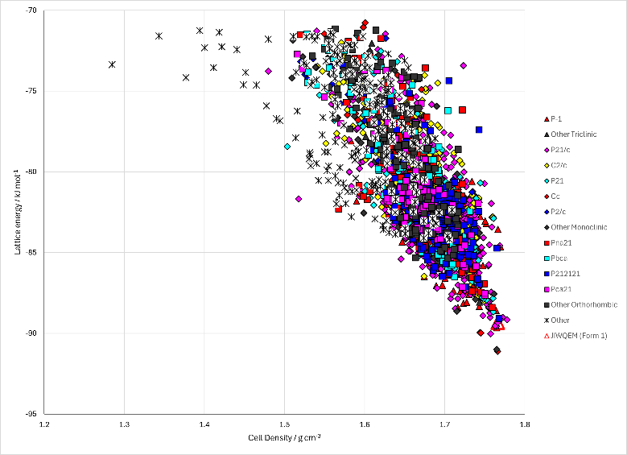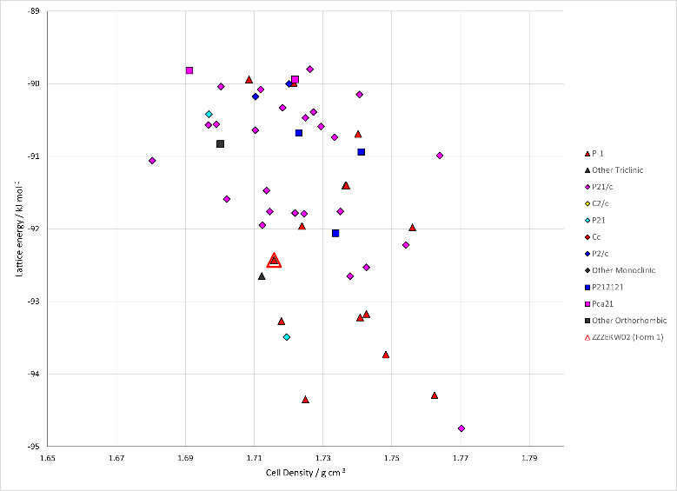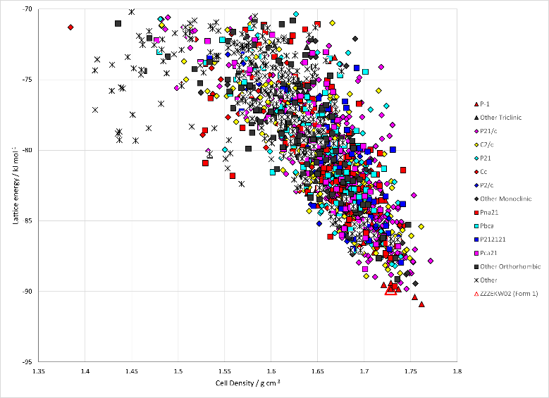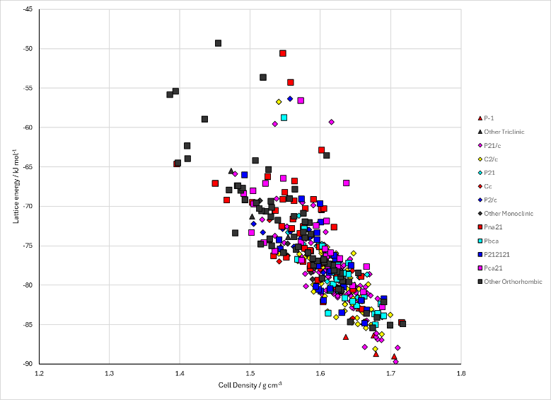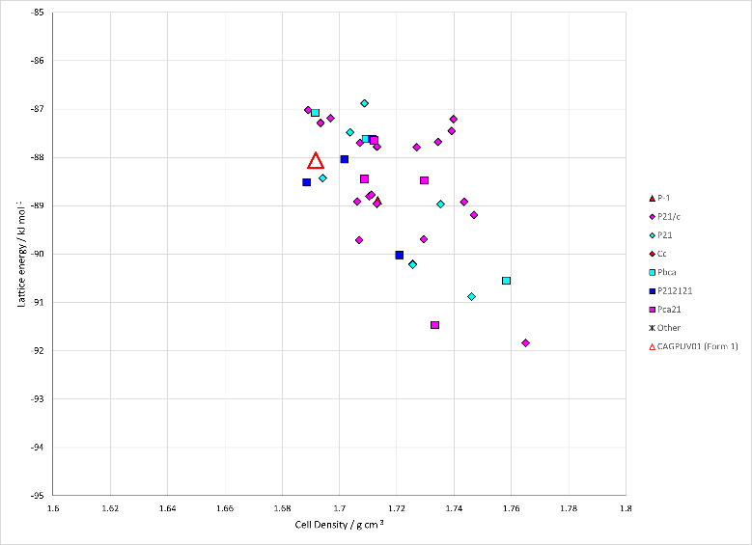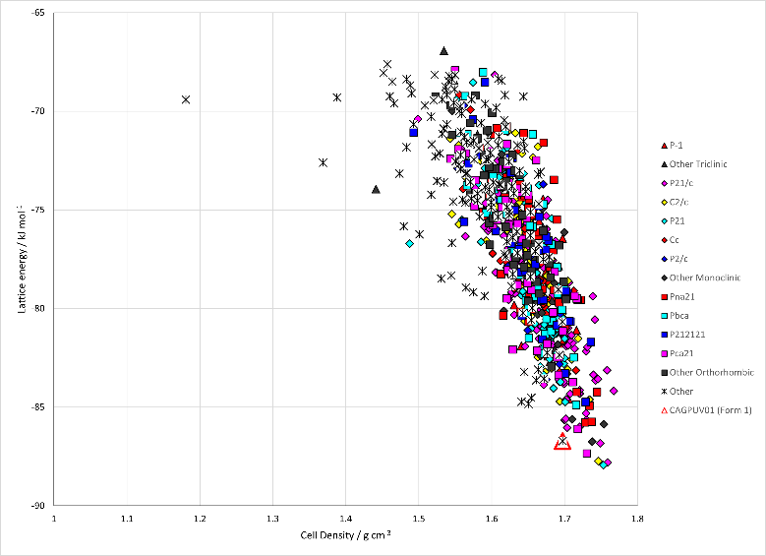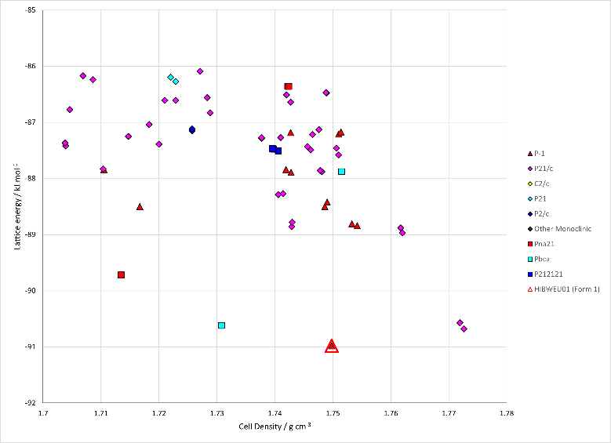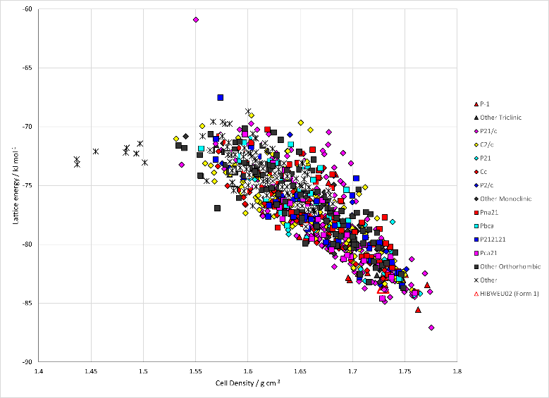
Figure 2. Crystal energy landscapes of dichloronitrobenzenes from previous work. Left: Published Search A landscapes. Right: Unpublished Search B/Energy Model 3 landscapes. Top: 2,3-dichloronitrobenzene. Second: 2,4-dichloronitrobenzene. Third: 2,5-dichloronitrobenzene. Fourth: 2,6--dichloronitrobenzene. Fifth: 3,4-dichloronitrobenzene. Bottom: 3,5-dichloronotrobenzene.

CSD structures (CSD version 5.44 with Jun and Sep 2023 updates)

Table 1. Crystallographic information for CSD entries for dichloronitrobenzenes. Different structures are coloured differently.
REFCODE | space group | Z’ | a / Å | b / Å | c / Å | α / ° | β / ° | γ / ° | density / g cm⁻³ | Form
DOXWIW | P21/c | 1 | 3.81 | 13.765 | 14.302 | 90 | 97.764 | 90 | 1.715 | 1
JIWQEM | P21/n | 2 | 20.682 | 3.7484 | 20.961 | 90 | 118.235 | 90 | 1.782 | 1
ZZZEKW | P* | 0 | 7.377 | 8.3336 | 7.355 | 110.58 | 113 | 72.9 | 0 | 1
ZZZEKW01 | P-1 | 1 | 7.404 | 8.273 | 7.234 | 109.6 | 112.9 | 73.2 | 1.687 | 1
ZZZEKW02 | P-1 | 1 | 7.1403 | 7.2638 | 8.2418 | 72.781 | 70.3 | 66.349 | 1.761 | 1
CAGPUV | I41/a | 1 | 28.094 | 28.094 | 3.838 | 90 | 90 | 90 | 1.684 | 1
CAGPUV01 | I41/a | 1 | 27.9342 | 27.9342 | 3.7655 | 90 | 90 | 90 | 1.736 | 1
HIBWEU | P21/m | 0.5 | 3.873 | 13.687 | 7.013 | 90 | 92.94 | 90 | 1.717 | 1
HIBWEU01 | P21/m | 0.5 | 3.8114 | 13.647 | 6.89 | 90 | 94.6 | 90 | 1.785 | 1
HIBWEU02 | P21/m | 0.5 | 3.8115 | 13.6452 | 6.8976 | 90 | 94.632 | 90 | 1.783 | 1

Table 2. Experimental information for CSD entries for dichloronitrobenzenes.
REFCODE | space group | R factor | T / K | Year | Comments
DOXWIW | P21/c | 3.3 | 295 | 1986 | Not online
JIWQEM | P21/n | 3.17 | 150 | 2008 | Slow evaporation from hexane solution.¹
ZZZEKW | P* | 0 | 295 | 1965 | Not online
ZZZEKW01 | P-1 | 5.73 | 295 | 1999 | Powder diffraction. Crystallization conditions not described.
ZZZEKW02 | P-1 | 2.4 | 150 | 2008 | Evaporation from saturated solutions in many solvents. Not specified which precise experiment led to the crystal whose structure was solved.¹
CAGPUV | I41/a | 7 | 295 | 1983 | Not online.
CAGPUV01 | I41/a | 4.28 | 150 | 2008 | Layering in some solvents with water or cyclohexane?¹
HIBWEU | P21/m | 4.6 | 295 | 1995 | Slow evaporation of a saturated acetonitrile solution.²
HIBWEU01 | P21/m | 3.86 | 100 | 2019 | Private Communication
HIBWEU02 | P21/m | 2.75 | 100 | 2022 | Slow evaporation from chloroform solution.³

Make this table include whether polymorphs are solution-grown, sublimation grown, templated or otherwise. Add references.

Other notes
There is also a 2,6-dcnb search by Sarah Barnett, but this compound cannot be synthesized.

1. S. A. Barnett, A. Johnson, A. J. Florence, S. L. Price and D. A. Tocher, Crystal Growth & Design, 2008, 8, 24-36.
2. A. Bhar, J. P. Aune, N. Benalicherif, L. Benmenni and M. Giorgi, Acta Crystallographica Section C - Crystal Structure Communications, 1995, 51, 256-260.
3. E. Bosch, N. P. Bowling and E. D. Speetzen, Acta Crystallographica Section C, 2022, 78, 552-558.

