FOX7 and Trans-FOX7
(Last updated 16 January 2025)
Figure 1. The molecular diagram of (left) 1,1-diamino-2,2-dinitroethene and (right) (Z)-1,2-diamino-1,2-dinitroethene.
There are phase transitions at 389 and 446 K.

CSP studies
REFCODE | SEDTUQ
Formula | C2 H4 N4 O4
Common Name | FOX-7
IUPAC Systematic Name | 1,1-diamino-2,2-dinitroethene
CSD Refcodes | SEDTUQ30, SEDTUQ26, SEDTUQ25, SEDTUQ33
Scientist | Sally Price
Date | 2008
Publication | No publication planned.
Search Identifier | A
Energy Model | 1
Study_ID | 0
Programs | MOLPAK, DMAREL (4.1.1)
Location on S Drive | \CHEMISTRY_CPOSS\FOX7\ConOpt
Potential Description | GDMA2(MP2 6-31G(d,p)) + FIT
Search Identifier | B
Energy Model | 1
Study_ID | 1
Programs | MOLPAK, DMACRYS (2.0.1)
Location on S Drive | \CHEMISTRY_CPOSS\FOX7\Opt
Potential Description | GDMA2(MP2 6-31G(d,p)) + FIT
REFCODE | TRFOXS
Formula | C2 H4 N4 O4
Common Name | TransFOX-7
IUPAC Systematic Name | (Z)-1,2-diamino-1,2-dinitroethene
CSD Refcodes | N/A
Scientist | Sally Price
Date | 2008
Publication | No publication planned.
Search Identifier | A
Energy Model | 1
Study_ID | 0
Programs | MOLPAK, DMACRYS (2.0.1)
Location on S Drive | \CHEMISTRY_CPOSS\FOX7\TransSearch
Potential Description | GDMA2(MP2 6-31G(d,p)) + FIT

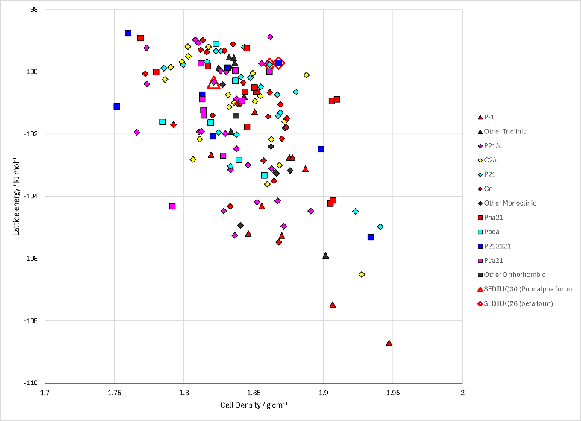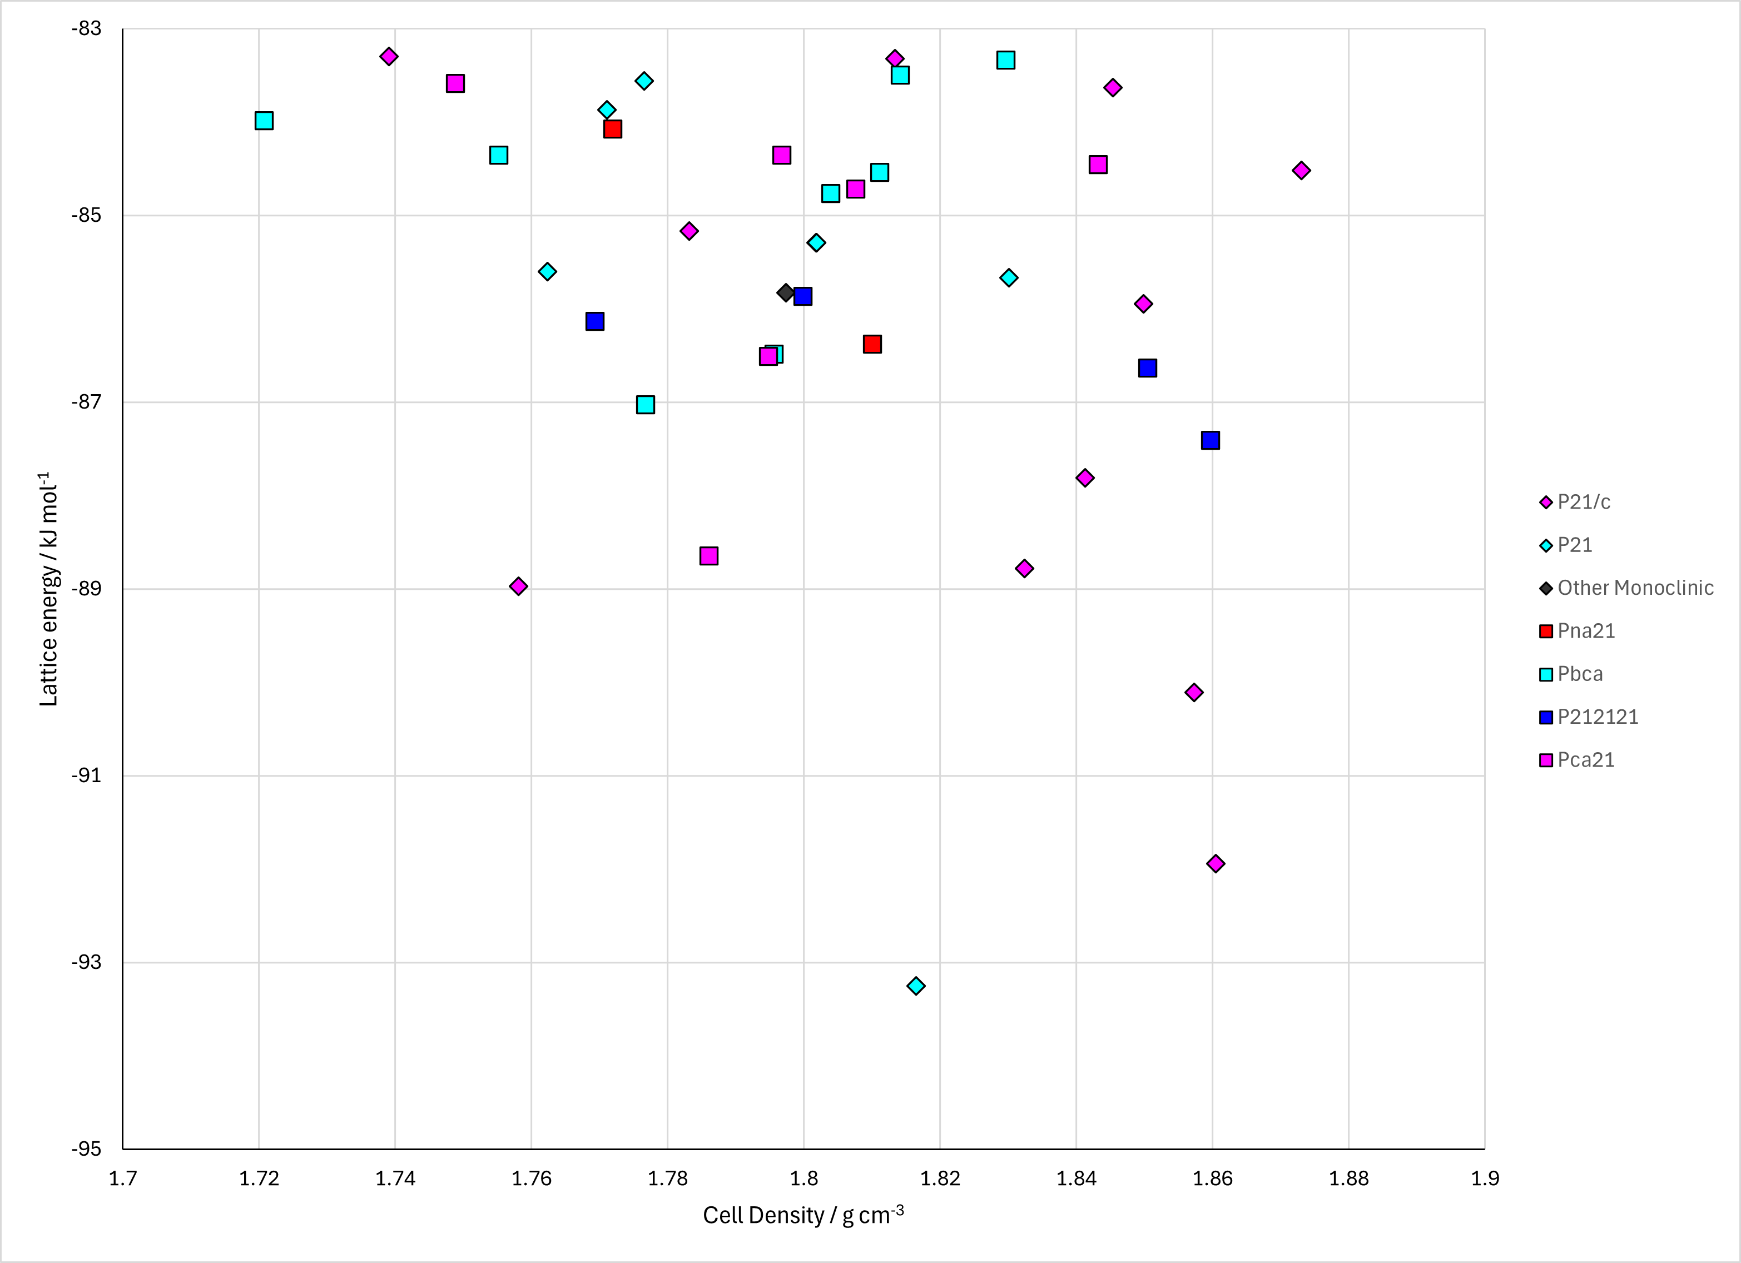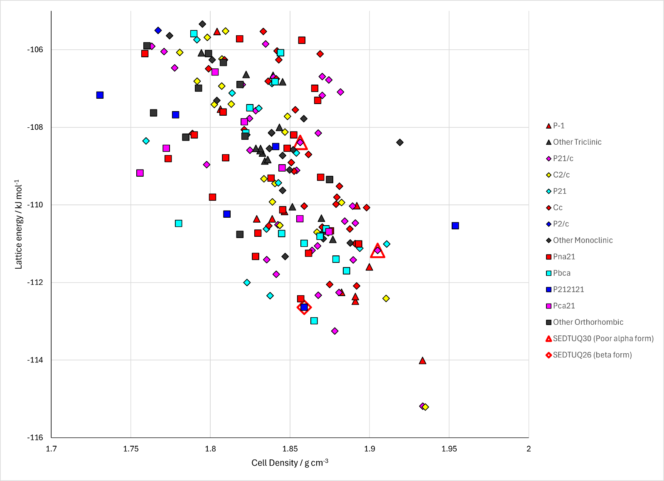
Figure 2. Crystal energy landscape of FOX7 with the unconstrained optimized conformation, Trans-FOX7 with the unconstrained optimized conformation and FOX7 with the conformation constrained to have planar NH₂ groups.

CSD structures (CSD version 5.43 with Mar, Jun, Sep and Nov 2022 updates)

Table 1. Crystallographic information for CSD entries for XXX. Different polymorphs are coloured differently.
REFCODE | space group | Z’ | a / Å | b / Å | c / Å | α / ° | β / ° | γ / ° | density / g cm⁻³ | Form
SEDTUQ | P21/n | 1 | 6.941 | 6.569 | 11.315 | 90 | 90.55 | 90 | 1.907 | alpha
SEDTUQ01 | P21/n | 1 | 6.9396 | 6.6374 | 11.3406 | 90 | 90.611 | 90 | 1.883 | alpha
SEDTUQ02 | P21/n | 1 | 6.9209 | 6.5515 | 11.2741 | 90 | 90.06 | 90 | 1.924 | alpha
SEDTUQ03 | P21/n | 1 | 6.934 | 6.6228 | 11.3119 | 90 | 90.065 | 90 | 1.893 | alpha
SEDTUQ04 | P21/n | 1 | 6.9414 | 6.6534 | 11.3316 | 90 | 90.082 | 90 | 1.879 | alpha
SEDTUQ05 | P21/n | 1 | 6.9467 | 6.6887 | 11.35 | 90 | 90.143 | 90 | 1.865 | alpha
SEDTUQ06 | P212121 | 1 | 6.9738 | 6.635 | 11.6475 | 90 | 90 | 90 | 1.825 | beta
SEDTUQ07 | P212121 | 1 | 6.972 | 6.663 | 11.666 | 90 | 90 | 90 | 1.815 | beta
SEDTUQ08 | P212121 | 1 | 6.974 | 6.675 | 11.673 | 90 | 90 | 90 | 1.81 | beta
SEDTUQ09 | P21/n | 1 | 6.922 | 6.501 | 11.262 | 90 | 90.485 | 90 | 1.941 | alpha
SEDTUQ10 | P212121 | 1 | 6.66 | 6.985 | 11.672 | 90 | 90 | 90 | 1.811 | beta
SEDTUQ11 | P21/n | 1 | 6.922 | 6.501 | 11.262 | 90 | 90.485 | 90 | 1.941 | alpha
SEDTUQ12 | P21/n | 1 | 6.9295 | 6.5301 | 11.275 | 90 | 90.53 | 90 | 1.928 | alpha
SEDTUQ13 | P21/n | 1 | 6.7118 | 6.0361 | 10.9581 | 90 | 90.077 | 90 | 2.215 | a'
SEDTUQ15 | P21/n | 1 | 6.9129 | 6.4872 | 11.2465 | 90 | 90.4816 | 90 | 1.95 | alpha
SEDTUQ16 | P21/n | 1 | 6.9146 | 6.4963 | 11.252 | 90 | 90.49 | 90 | 1.946 | alpha
SEDTUQ17 | P21/n | 1 | 6.9165 | 6.5072 | 11.2575 | 90 | 90.4987 | 90 | 1.941 | alpha
SEDTUQ18 | P21/n | 1 | 6.9184 | 6.5187 | 11.2646 | 90 | 90.5108 | 90 | 1.936 | alpha
SEDTUQ19 | P21/n | 1 | 6.9209 | 6.5336 | 11.2726 | 90 | 90.5215 | 90 | 1.93 | alpha
SEDTUQ20 | P21/n | 1 | 6.9254 | 6.5582 | 11.2866 | 90 | 90.5441 | 90 | 1.919 | alpha
SEDTUQ21 | P21/n | 1 | 6.9303 | 6.5873 | 11.3017 | 90 | 90.5672 | 90 | 1.906 | alpha
SEDTUQ22 | P21/n | 1 | 6.935 | 6.619 | 11.3172 | 90 | 90.5886 | 90 | 1.893 | alpha
SEDTUQ23 | P21/n | 1 | 6.9413 | 6.6532 | 11.3353 | 90 | 90.608 | 90 | 1.879 | alpha
SEDTUQ24 | P21/n | 1 | 6.9484 | 6.6942 | 11.3547 | 90 | 90.618 | 90 | 1.862 | alpha
SEDTUQ25 | P21/n | 2 | 13.354 | 6.895 | 12.05 | 90 | 111.102 | 90 | 1.9 | gamma
SEDTUQ26 | P212121 | 1 | 6.986 | 6.686 | 11.687 | 90 | 90 | 90 | 1.802 | beta
SEDTUQ27 | P21/n | 1 | 6.922 | 6.501 | 11.262 | 90 | 90.485 | 90 | 1.941 | alpha
SEDTUQ28 | P21/n | 1 | 6.922 | 6.501 | 11.262 | 90 | 90.485 | 90 | 1.941 | alpha
SEDTUQ29 | P21/n | 1 | 6.922 | 6.501 | 11.262 | 90 | 90.485 | 90 | 1.941 | alpha
SEDTUQ30 | P21/n | 1 | 6.922 | 6.501 | 11.262 | 90 | 90.485 | 90 | 1.941 | alpha
SEDTUQ31 | P212121 | 1 | 6.986 | 6.671 | 11.681 | 90 | 90 | 90 | 1.807 | gamma
SEDTUQ32 | P212121 | 1 | 6.986 | 6.66 | 11.674 | 90 | 90 | 90 | 1.811 | beta
SEDTUQ33 | P1 | 2 | 6.0745 | 6.6924 | 6.6972 | 119.505 | 93.913 | 110.042 | 2.308 | polymorph
SEDTUQ34 | P1 | 2 | 6.0745 | 6.6924 | 6.6972 | 119.505 | 93.913 | 110.042 | 2.308 | polymorph
SEDTUQ35 | P21/n | 1 | 6.948 | 6.6364 | 11.3413 | 90 | 90.569 | 90 | 1.881
SEDTUQ36 | P21/n | 1 | 6.8931 | 6.5058 | 11.2567 | 90 | 90.48 | 90 | 1.948
SEDTUQ37 | P21/n | 1 | 6.8358 | 6.3591 | 11.163 | 90 | 90.314 | 90 | 2.027
SEDTUQ38 | P21/n | 1 | 6.822 | 6.3249 | 11.1378 | 90 | 90.263 | 90 | 2.047
SEDTUQ39 | P21/n | 1 | 6.8011 | 6.2779 | 11.1042 | 90 | 90.249 | 90 | 2.075
SEDTUQ40 | P21/n | 1 | 6.7982 | 6.2473 | 11.1067 | 90 | 90.215 | 90 | 2.085
SEDTUQ41 | P21/n | 1 | 6.7789 | 6.7789 | 11.0632 | 90 | 90.2 | 90 | 1.935
SEDTUQ42 | P21/n | 1 | 6.7562 | 6.1435 | 11.0371 | 90 | 90.166 | 90 | 2.147
SEDTUQ43 | P21/n | 1 | 6.7472 | 6.1083 | 11.0236 | 90 | 90.141 | 90 | 2.165
SEDTUQ44 | P21/n | 1 | 6.7111 | 6.0339 | 10.9621 | 90 | 90.086 | 90 | 2.216
SEDTUQ45 | P1 | 2 | 5.9859 | 6.6716 | 6.6854 | 119.463 | 94.11 | 110.145 | 2.358
SEDTUQ46 | P1 | 2 | 5.8965 | 6.6394 | 6.6545 | 119.395 | 94.308 | 110.262 | 2.421
SEDTUQ47 | P1 | 2 | 5.8695 | 6.6197 | 6.6343 | 119.409 | 94.338 | 110.317 | 2.449
SEDTUQ48 | P1 | 2 | 5.7268 | 6.603 | 6.6195 | 119.381 | 94.429 | 110.739 | 2.534
SEDTUQ49 | P1 | 2 | 5.6947 | 6.5793 | 6.5961 | 119.356 | 94.461 | 110.881 | 2.57

Table 2. Experimental information for CSD entries for XXX.
REFCODE | space group | R factor | T / K | Year | Comments
SEDTUQ | P21/n | 3.12 | 173 | 1998 | Crystallized from cold N,N-dimethylformamide¹
SEDTUQ01 | P21/n | 3.02 | 295 | 1999 | Private communication
SEDTUQ02 | P21/n | 3.61 | 200 | 2006 | Slow cooling from DMF or DMSO; Oxford Cryosystems temperature controller on diffractometer²
SEDTUQ03 | P21/n | 4.02 | 298 | 2006 | Slow cooling from DMF or DMSO; Oxford Cryosystems temperature controller on diffractometer²
SEDTUQ04 | P21/n | 4.1 | 333 | 2006 | Slow cooling from DMF or DMSO; Oxford Cryosystems temperature controller on diffractometer²
SEDTUQ05 | P21/n | 5.42 | 373 | 2006 | Slow cooling from DMF or DMSO; Oxford Cryosystems temperature controller on diffractometer²
SEDTUQ06 | P212121 | 3.59 | 393 | 2006 | Slow cooling from DMF or DMSO; Oxford Cryosystems temperature controller on diffractometer²
SEDTUQ07 | P212121 | 12.3 | 403 | 2006 | Powder data; finely ground²
SEDTUQ08 | P212121 | 12.4 | 423 | 2006 | Powder data; finely ground²
SEDTUQ09 | P21/n | 2.1 | 100 | 2008 | Synchrotron radiation; recrystallized from 2-propanol³
SEDTUQ10 | P212121 | 4.08 | 400 | 2012 | Private communication
SEDTUQ11 | P21/n | 2.14 | 100 | 2016 | Re-refinement of data collected in SEDTUQ09⁴
SEDTUQ12 | P21/n | 3.92 | 153 | 2018 | Crystallized concomitantly with phenanthroline cocrystal⁵
SEDTUQ13 | P21/n | 11.04 | 293 | 2016 | Synchrotron; Grown from DMSO solution⁶
SEDTUQ15 | P21/n | 2.67 | 80 | 2022 | Synchrotron; Slow evaporation from DMSO⁷
SEDTUQ16 | P21/n | 2.61 | 100 | 2022 | Synchrotron; Slow evaporation from DMSO⁷
SEDTUQ17 | P21/n | 2.79 | 120 | 2022 | Synchrotron; Slow evaporation from DMSO⁷
SEDTUQ18 | P21/n | 2.99 | 140 | 2022 | Synchrotron; Slow evaporation from DMSO⁷
SEDTUQ19 | P21/n | 3.09 | 164 | 2022 | Synchrotron; Slow evaporation from DMSO⁷
SEDTUQ20 | P21/n | 3.34 | 200 | 2022 | Synchrotron; Slow evaporation from DMSO⁷
SEDTUQ21 | P21/n | 3.87 | 240 | 2022 | Synchrotron; Slow evaporation from DMSO⁷
SEDTUQ22 | P21/n | 5.74 | 280 | 2022 | Synchrotron; Slow evaporation from DMSO⁷
SEDTUQ23 | P21/n | 7.74 | 320 | 2022 | Synchrotron; Slow evaporation from DMSO⁷
SEDTUQ24 | P21/n | 9.49 | 360 | 2022 | Synchrotron; Slow evaporation from DMSO⁷
SEDTUQ25 | P21/n | 6.02 | 200 | 2007 | Slow heating on diffractometer of crystal prepared for SEDTUQ26⁸ (does not revert to other phases on cooling carefully)
SEDTUQ26 | P212121 | 2.82 | 423 | 2007 | Slow cooling of DMF or DMSO solutions⁸
SEDTUQ27 | P21/n | 2.49 | 100 | 2020 | Re-refinement of data collected in SEDTUQ09⁹
SEDTUQ28 | P21/n | 2.64 | 100 | 2020 | Re-refinement of data collected in SEDTUQ09⁹
SEDTUQ29 | P21/n | 1.95 | 100 | 2020 | Re-refinement of data collected in SEDTUQ09⁹
SEDTUQ30 | P21/n | 1.38 | 100 | 2020 | Re-refinement of data collected in SEDTUQ09⁹
SEDTUQ31 | P212121 | 2.96 | 413 | 2007 | Intermediate data collections between SEDTUQ26 and SEDTUQ25⁸
SEDTUQ32 | P212121 | 2.89 | 403 | 2007 | Intermediate data collections between SEDTUQ26 and SEDTUQ25⁸
SEDTUQ33 | P1 | 14.9 | 293 | 2016 | Synchrotron data, 5.9 GPa⁶ According to a different reference, this is called epsilon
SEDTUQ34 | P1 | 14.9 | 293 | 2016 | Synchrotron data, 5.9 GPa⁶
SEDTUQ35 | P21/n | 0 | 298 | 2016 | Synchrotron data, I don’t understand the publication reference⁶
SEDTUQ36 | P21/n | 0 | 298 | 2016 | Synchrotron data, I don’t understand the publication reference⁶
SEDTUQ37 | P21/n | 0 | 298 | 2016 | Synchrotron data, I don’t understand the publication reference⁶
SEDTUQ38 | P21/n | 0 | 298 | 2016 | Synchrotron data, I don’t understand the publication reference⁶
SEDTUQ39 | P21/n | 0 | 298 | 2016 | Synchrotron data, I don’t understand the publication reference⁶
SEDTUQ40 | P21/n | 0 | 298 | 2016 | Synchrotron data, I don’t understand the publication reference⁶
SEDTUQ41 | P21/n | 0 | 298 | 2016 | Synchrotron data, I don’t understand the publication reference⁶
SEDTUQ42 | P21/n | 0 | 298 | 2016 | Synchrotron data, I don’t understand the publication reference⁶
SEDTUQ43 | P21/n | 0 | 298 | 2016 | Synchrotron data, I don’t understand the publication reference⁶
SEDTUQ44 | P21/n | 0 | 298 | 2016 | Synchrotron data, I don’t understand the publication reference⁶
SEDTUQ45 | P1 | 0 | 298 | 2016 | Synchrotron data, I don’t understand the publication reference⁶
SEDTUQ46 | P1 | 0 | 298 | 2016 | Synchrotron data, I don’t understand the publication reference⁶
SEDTUQ47 | P1 | 0 | 298 | 2016 | Synchrotron data, I don’t understand the publication reference⁶
SEDTUQ48 | P1 | 0 | 298 | 2016 | Synchrotron data, I don’t understand the publication reference⁶
SEDTUQ49 | P1 | 0 | 298 | 2016 | Synchrotron data, I don’t understand the publication reference⁶

(1) Bemm, U.; Ostmark, H. 1,1-Diamino-2,2-dinitroethylene: a Novel Energetic Material with Infinite Layers in Two Dimensions. Acta Crystallographica Section C 1998, 54 (12), 1997-1999.
(2) Evers, J.; Klapötke, T. M.; Mayer, P.; Oehlinger, G.; Welch, J. α- and β-FOX-7, Polymorphs of a High Energy Density Material, Studied by X-ray Single Crystal and Powder Investigations in the Temperature Range from 200 to 423 K. Inorganic Chemistry 2006, 45 (13), 4996-5007. DOI: 10.1021/ic052150m.
(3) Meents, A.; Dittrich, B.; Johnas, S. K. J.; Thome, V.; Weckert, E. F. Charge-density studies of energetic materials: CL-20 and FOX-7. Acta Crystallographica Section B 2008, 64 (1), 42-49.
(4) Woińska, M.; Grabowsky, S.; Dominiak, P. M.; Woźniak, K.; Jayatilaka, D. Hydrogen atoms can be located accurately and precisely by x-ray crystallography. Science Advances 2016, 2 (5), e1600192. DOI: doi:10.1126/sciadv.1600192.
(5) Li, K.; Ren, X.; Fu, S.; Zhu, J. Cocrystal structure, thermal behavior, and DFT calculations between FOX–7 and 1,10–Phenanthroline. Journal of Molecular Structure 2018, 1173, 26-32. DOI: https://doi.org/10.1016/j.molstruc.2018.06.090.
(6) Dreger, Z. A.; Stash, A. I.; Yu, Z.-G.; Chen, Y.-S.; Tao, Y.; Gupta, Y. M. High-Pressure Crystal Structures of an Insensitive Energetic Crystal: 1,1-Diamino-2,2-dinitroethene. The Journal of Physical Chemistry C 2016, 120 (2), 1218-1224. DOI: 10.1021/acs.jpcc.5b10644.
(7) Aree, T.; McMonagle, C. J.; Michalchuk, A. A. L.; Chernyshov, D. Low-frequency lattice vibrations from atomic displacement parameters of [alpha]-FOX-7, a high energy density material. Acta Crystallographica Section B 2022, 78 (3 Part 1), 376-384. DOI: doi:10.1107/S2052520622002700.
(8) Crawford, M.-J.; Evers, J.; Göbel, M.; Klapötke, T. M.; Mayer, P.; Oehlinger, G.; Welch, J. M. γ-FOX-7: Structure of a High Energy Density Material Immediately Prior to Decomposition. Propellants, Explosives, Pyrotechnics 2007, 32 (6), 478-495. DOI: https://doi.org/10.1002/prep.200700240 (acccessed 2025/01/16).
(9) Jha, K. K.; Gruza, B.; Kumar, P.; Chodkiewicz, M. L.; Dominiak, P. M. TAAM: a reliable and user friendly tool for hydrogen-atom location using routine X-ray diffraction data. Acta Crystallographica Section B 2020, 76 (3), 296-306. DOI: doi:10.1107/S2052520620002917.

