Fluorotoluenes
(Last updated 9 December 2024)
Figure 1. The molecular diagram of 2-, 3- and 4-fluorotoluene.

CSP studies
MOLPAK searches were run, and structures minimized with the FIT potential. The .dmain and .sym files were then used to reminimize with the WILL01 potential or the FIT potential with various pressures. Structures were then checked for negative eigenvalues (with symmetry being reduced as necessary) and clustered, giving different crystal structures in the different landscapes.
The .sum files were edited to remove the PV term from the energies (to make them more compatible with the energies without pressure). The original energies are still recorded within the .sum files, but not uploaded to the database.
Hence the different energy models are not sequential, but all from the same (MOLPAK-generated) input files.
REFCODE | YICFEX
Formula | C7 H7 F1
Common Name | 2-fluorotoluene
IUPAC Systematic Name | 2-fluorotoluene
CSD Refcodes | YICFEX, YICFEX01
Search Identifier | A
Scientist | Joe Ridout and Louise Price
Date | 2013
Publication | No publication planned.
Energy Model | 1
Study_ID | 0
Programs | MOLPAK, DMACRYS (2.0.4)
Location on S Drive | CHEMISTRY_CPOSS\JoeRidout\2-fluorotoluene-FIT
Potential Description | GDMA(MP2/6-31G(d,p)) + FIT
Energy Model | 2
Study_ID | 2
Programs | Study_ID=0, unoptimized, DMACRYS (2.0.4) with 1 GPa
Location on S Drive | CHEMISTRY_CPOSS\JoeRidout\2-fluorotoluene-FIT1GPa
Potential Description | GDMA(MP2/6-31G(d,p)) + FIT, with pressure of 1.0 GPa
Energy Model | 3
Study_ID | 3
Programs | Study_ID=0, unoptimized, DMACRYS (2.0.4) with 2 GPa
Location on S Drive | CHEMISTRY_CPOSS\JoeRidout\2-fluorotoluene-FIT2GPa
Potential Description | GDMA(MP2/6-31G(d,p)) + FIT, with pressure of 2.0 GPa
Energy Model | 4
Study_ID | 4
Programs | Study_ID=0, unoptimized, DMACRYS (2.0.4) with 3 GPa
Location on S Drive | CHEMISTRY_CPOSS\JoeRidout\2-fluorotoluene-FIT3GPa
Potential Description | GDMA(MP2/6-31G(d,p)) + FIT, with pressure of 3.0 GPa
Energy Model | 5
Study_ID | 5
Programs | Study_ID=0, unoptimized, DMACRYS (2.0.4) with 4 GPa
Location on S Drive | CHEMISTRY_CPOSS\JoeRidout\2-fluorotoluene-FIT4GPa
Potential Description | GDMA(MP2/6-31G(d,p)) + FIT, with pressure of 4.0 GPa
Energy Model | 6
Study_ID | 1
Programs | Study_ID=0, unoptimized, DMACRYS (2.0.4)
Location on S Drive | CHEMISTRY_CPOSS\JoeRidout\2-fluorotoluene-WILL
Potential Description | GDMA(MP2/6-31G(d,p)) + Williams (with fluorine from FIT)

REFCODE | YICDUL
Formula | C7 H7 F1
Common Name | 3-fluorotoluene
IUPAC Systematic Name | 3-fluorotoluene
CSD Refcodes | YICDUL, YICDUL01
Search Identifier | A
Scientist | Joe Ridout and Louise Price
Date | 2013
Publication | No publication planned.
Energy Model | 1
Study_ID | 0
Programs | MOLPAK, DMACRYS (2.0.4)
Location on S Drive | CHEMISTRY_CPOSS\JoeRidout\3-fluorotoluene-FIT
Potential Description | GDMA(MP2/6-31G(d,p)) + FIT
Energy Model | 2
Study_ID | 2
Programs | Study_ID=0, unoptimized, DMACRYS (2.0.4) with 1 GPa
Location on S Drive | CHEMISTRY_CPOSS\JoeRidout\3-fluorotoluene-FIT1GPa
Potential Description | GDMA(MP2/6-31G(d,p)) + FIT, with pressure of 1.0 GPa
Energy Model | 3
Study_ID | 3
Programs | Study_ID=0, unoptimized, DMACRYS (2.0.4) with 2 GPa
Location on S Drive | CHEMISTRY_CPOSS\JoeRidout\3-fluorotoluene-FIT2GPa
Potential Description | GDMA(MP2/6-31G(d,p)) + FIT, with pressure of 2.0 GPa
Energy Model | 4
Study_ID | 4
Programs | Study_ID=0, unoptimized, DMACRYS (2.0.4) with 3 GPa
Location on S Drive | CHEMISTRY_CPOSS\JoeRidout\3-fluorotoluene-FIT3GPa
Potential Description | GDMA(MP2/6-31G(d,p)) + FIT, with pressure of 3.0 GPa
Energy Model | 5
Study_ID | 5
Programs | Study_ID=0, unoptimized, DMACRYS (2.0.4) with 4 GPa
Location on S Drive | CHEMISTRY_CPOSS\JoeRidout\3-fluorotoluene-FIT4GPa
Potential Description | GDMA(MP2/6-31G(d,p)) + FIT, with pressure of 4.0 GPa
Energy Model | 6
Study_ID | 6
Programs | Study_ID=0, unoptimized, DMACRYS (2.0.4) with 0.1 GPa
Location on S Drive | CHEMISTRY_CPOSS\JoeRidout\3-fluorotoluene-FIT0.1GPa
Potential Description | GDMA(MP2/6-31G(d,p)) + FIT, with pressure of 0.1 GPa

REFCODE | YICDIZ
Formula | C7 H7 F1
Common Name | 4-fluorotoluene
IUPAC Systematic Name | 4-fluorotoluene
CSD Refcodes | YICDIZ, YICDIZ01
Search Identifier | A
Scientist | Joe Ridout and Louise Price
Date | 2013
Publication | No publication planned.
Energy Model | 1
Study_ID | 0
Programs | MOLPAK, DMACRYS (2.0.4)
Location on S Drive | CHEMISTRY_CPOSS\JoeRidout\4-fluorotoluene-FIT
Potential Description | GDMA(MP2/6-31G(d,p)) + FIT
Energy Model | 2
Study_ID | 2
Programs | Study_ID=0, unoptimized, DMACRYS (2.0.4) with 1 GPa
Location on S Drive | CHEMISTRY_CPOSS\JoeRidout\4-fluorotoluene-FIT1GPa
Potential Description | GDMA(MP2/6-31G(d,p)) + FIT, with pressure of 1.0 GPa
Energy Model | 3
Study_ID | 3
Programs | Study_ID=0, unoptimized, DMACRYS (2.0.4) with 2 GPa
Location on S Drive | CHEMISTRY_CPOSS\JoeRidout\4-fluorotoluene-FIT2GPa
Potential Description | GDMA(MP2/6-31G(d,p)) + FIT, with pressure of 2.0 GPa
Energy Model | 4
Study_ID | 4
Programs | Study_ID=0, unoptimized, DMACRYS (2.0.4) with 3 GPa
Location on S Drive | CHEMISTRY_CPOSS\JoeRidout\4-fluorotoluene-FIT3GPa
Potential Description | GDMA(MP2/6-31G(d,p)) + FIT, with pressure of 3.0 GPa
Energy Model | 5
Study_ID | 5
Programs | Study_ID=0, unoptimized, DMACRYS (2.0.4) with 4 GPa
Location on S Drive | CHEMISTRY_CPOSS\JoeRidout\4-fluorotoluene-FIT4GPa
Potential Description | GDMA(MP2/6-31G(d,p)) + FIT, with pressure of 4.0 GPa

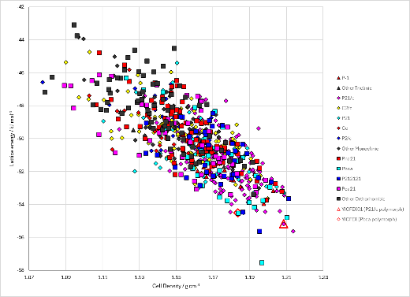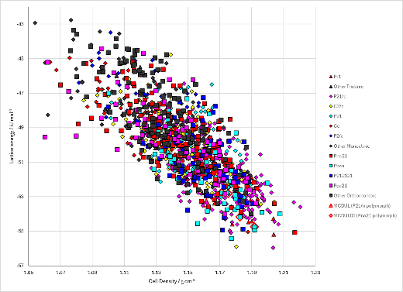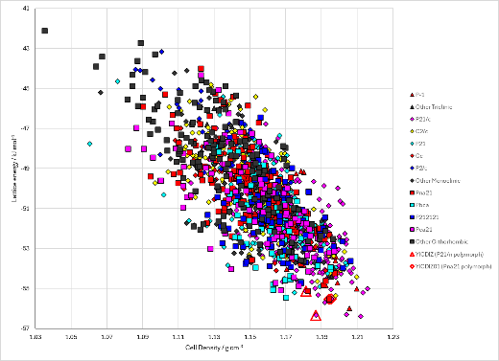
Figure 2. Crystal energy landscape of 2-fluorotoluene, 3-fluorotoluene and 4-fluorotoluene with the FIT potential and no applied pressure (energy model 1 in all cases) from previous work.

CSD structures (CSD version 5.44 with Jun and Sep 2023 updates)

Table 1. Crystallographic information for CSD entries for 2-, 3- and 4-fluorotoluene. Different polymorphs are coloured differently.
REFCODE | space group | Z’ | a / Å | b / Å | c / Å | α / ° | β / ° | γ / ° | density / g cm⁻³ | Form
YICFEX | Pbca | 1 | 5.96 | 14.019 | 15.021 | 90 | 90 | 90 | 1.166 | Pbca
YICFEX01 | P21/n | 1 | 8.74 | 5.781 | 10.63 | 90 | 92.01 | 90 | 1.363 | P21/n
YICFEX02 | Pbca | 1 | 5.807 | 13.549 | 14.28 | 90 | 90 | 90 | 1.302 | Pbca
YICDUL | P21/n | 1 | 7.223 | 7.623 | 12.098 | 90 | 105.67 | 90 | 1.141 | P21/n
YICDUL01 | Pbca | 1 | 5.4526 | 13.538 | 14.735 | 90 | 90 | 90 | 1.345 | Pbca
YICDIZ | P21/n | 1 | 7.452 | 5.987 | 14.693 | 90 | 104 | 90 | 1.15 | P21/n
YICDIZ01 | Pna21 | 1 | 13.215 | 4.7872 | 8.9622 | 90 | 90 | 90 | 1.29 | Pna21
YICDIZ02 | Pnma | 0.5 | 13.2486 | 8.9864 | 4.7937 | 90 | 90 | 90 | 1.282 | Pnma
YICDIZ03 | Pnma | 0.5 | 13.0915 | 8.8548 | 4.7275 | 90 | 90 | 90 | 1.335 | Pnma
YICDIZ04 | Pnma | 0.5 | 12.873 | 8.729 | 4.6135 | 90 | 90 | 90 | 1.411

Table 2. Experimental information for CSD entries for 2-, 3- and 4-fluorotoluene.
REFCODE | space group | R factor | T / K | Year | Comments
YICFEX | Pbca | 4.77 | 205 | 2013 | Cooling pure liquid¹
YICFEX01 | P21/n | 7.47 | 296 | 2013 | Not described (but high pressure from table)¹
YICFEX02 | Pbca | 4.3 | 293 | 2013 | Compressing pure liquid¹
YICDUL | P21/n | 4.89 | 179 | 2013 | Cooling pure liquid¹
YICDUL01 | Pbca | 5.58 | 293 | 2013 | Pressure and temperature cycling in a diamond anvil cell and liquid nitrogen¹
YICDIZ | P21/n | 4.74 | 217 | 2013 | Cooling pure liquid¹
YICDIZ01 | Pna21 | 4.99 | 293 | 2013 | Compressing pure liquid¹
YICDIZ02 | Pnma | 5.56 | 295 | 2017 | 0.54 GPa. Compressing pure liquid²
YICDIZ03 | Pnma | 7.09 | 295 | 2017 | 0.93 GPa. Compressing pure liquid²
YICDIZ04 | Pnma | 7.01 | 295 | 2017 | 1.55 GPa. Compressing pure liquid²

Other notes

1. J. Ridout and M. R. Probert, Crystal Growth & Design, 2013, 13, 1943-1948.
2. S. Sutuła, R. Gajda and K. Woźniak, Crystal Growth & Design, 2017, 17, 1493-1501.

